Zewail City of Science, Technology and Innovation
University of Science and Technology
School of Computational Sciences and Artificial Intelligence

CSAI 203 - Fall 2025
Introduction to Software Engineering
Time Enhance

Software Requirements Specification (SRS) Document

Team#: 40
Team members:
Marwan Abdelhamid 202401466

Representative Contact Info:
s-marwan.abdel-hamid@zewailcity.edu.eg

Time Enhance

1.Introduction
  - Purpose
This Software Requirements Specification (SRS) describes the functional and non-functional requirements for Time Enhance, a time-management software that uses tools like a to-do list, custom schedules, and a gamified reward system allowing the user to buy more cosmetics and collectibles in a virtual currency. The primary audience for this SRS is the development team and testers. This SRS will be used to help with design, implementation and verification.
1.2 Scope
Time Enhance enables users to manage their time and make life easier by allowing them to create and manage tasks, set deadlines and reminders, track progress and earn rewards in the shape of virtual currency to buy cosmetics in the software. The system will support:
Task creation, editing, deletion and categorization
Scheduling with due dates, optional reminders with a simple calendar view
Virtual Currency and leveling systems, badges and a virtual store to redeem the
earned said currency for cosmetic rewards
User account management

1.3 Definitions, Acronyms, and Abbreviation
Term/ Acronym | Definition
SRS | Software Requirements Specification. A document describing all system requirements.
UI | User Interface. The elements that the user interacts with directly
DB | Database. Stores Tasks , progress and the virtual currency
XP | Virtual points called experience that the user collects to level up
FR | Functional Requirement. Describes what the system should do
NFR | Non-functional requirements. Describes system qualities like security for example

1.4 References

1. CSAI 203 – Course Project Requirements, Phase 2: SRS Document, Zewail City University, Fall 2025.
2. Lecture slides: "Software Requirements Specification (SRS)" and "UML Use Case Description Template", Dr. Mohamed Sami Rakha, Fall 2025.
3. IEEE Std 830-1998 – IEEE Recommended Practice for Software Requirements Specifications.
4. Draw.io (diagrams.net) – Tool used for creating UML diagrams. https://app.diagrams.net/

1.5 Overview

This document is organized into four main sections.
Section 1 introduces the Software Requirements Specification (SRS), including the purpose of the document, the system scope, and key definitions used throughout the report.
Section 2 provides an overall description of the system, including the product perspective, major features, user characteristics, operating environment, constraints, and assumptions.
Section 3 details the specific requirements of the system, including all functional requirements, use case diagrams, use case descriptions, the domain model, and class descriptions.
Section 4 contains supporting appendices such as the data dictionary and glossary.

2. Overall Description
2.1 Product Perspective
Time Enhance is a standalone web application that follows a client-server architecture.
The system consists of a basic HTML/CSS frontend and a backend implemented using Python Flask, which communicates with a database to store user data such as tasks, progress, and virtual currency.
The application does not integrate with external enterprise systems. Optional browser notification APIs may be used for reminders. All interaction with the system occurs through the web-based user interface, and no specialized hardware is required. The system will run in any modern web browser. Future enhancements, such as mobile app support or cloud synchronization, are outside the scope of this phase.

2.2 Product Functions
Time enhance provides the following main functions to the user:
- Create, Edit and delete tasks
- Assign due dates and optional reminders to each task
- Track Task completion progress
- Earn XP to level up
- Leveling up unlocks new cosmetics
- Earn virtual currency
- Buy Unlocked Cosmetics with said Currency in a cosmetics shop
- View overall progress, total earned currency and purchase history
- Manage personal account (Sign in, log in, log out)

2.3 User classes and characteristics
Time enhance is designed for a single user type:
User (Primary and only actor):
Individuals who want to manage their time efficiently by creating and tracking tasks. Users are not required to have any technical background. The system assumes that the user can perform basic actions such as entering text, selecting dates, and navigating through a simple web interface. The user’s primary goals are to organize tasks, receive reminders, complete tasks on time, earn virtual currency, and spend it on cosmetic rewards in the application.

2.4 Operating environment
Time enhance will operate as a web-based application.
The system requires a device with internet access and a modern web browser.
The following operating environment is expected:
Client Side:
- Runs on any modern web browser.
- Supports windows, macOS, and Linux devices.
- Requires Basic HTML for the user interface.

Server Side:
- Implemented using Python Flask.
- Runs on any machine capable of running Python 3.x.
- Uses a Database to store user data.

Hardware requirements
- Standard laptop or desktop with internet connection
- No specific hardware is necessary other than the already specified

2.5 Design and Implementation constraints.
The development of Time Enhance is subject to the following constraints:
Technology Constraints:
- The backend must be implemented using Python Flask as required by the course project guidelines.
- The frontend must use basic HTML and a bonus for CSS without relying on advanced frameworks
- The system must run on a web browser (no desktop or mobile native application).
Resource Constraints:
- The whole software is developed only by one person with limited experience in large-scale software systems
- The project must be completed within the academic semester timeline.
Database Constraints:
- A lightweight database will be used to store tasks, user progress and virtual currency
- No cloud synchronization or external service integration

Design Constraints:
- The system must remain simple and easy to use by non-technical users
- All features must align with what is documented in the SRS; unapproved features will not be implemented.

2.6 User Documentation
The system will include basic user documentation to support users during interaction with the application. This documentation may include:
- A simple “Help” page within the web
- A short “README” file explaining how to use the systems, create tasks etc.

The documentation will be concise and user-friendly, focusing on guiding new users through the task management process and the reward system.

2.7 Assumptions and Dependencies
The following assumptions and dependencies apply to Time Enhance:
User Assumptions:
- Users have access to devices with internet connection
- Users have basic computer knowledge
- Users are responsible for entering accurate tasks and dates
Technical Assumptions:
- The Backend Flask server and DB are functioning during system use
- A modern Web browser is available
- The server environment supports Python 3.x and the required libraries
Dependencies:
- The system depends on Flask to handle HTTP requests and communication between frontend and backend.
- The system depends on a DB to store user data
- Browser notification APIs may be used to trigger reminders (optional feature).

3. Specific Requirements
3.1 Functional Requirements
FR-1 Create Task
ID: FR-1
Title: Create a task
Description: The user will be able to create tasks so they can track their work
Preconditions: User must be logged in
Main success scenario:
- User selects New Task
- System displays a form with fields: Title (required), Description (optional), Due date (optional), Tag/Category (optional), Estimated effort/difficulty (optional).
- User fills fields and clicks Save.
- System validates the Title (non-empty).
- System persists the task to the database and displays it in the task list.
Alternate Flows:
- Title is empty. Shows Validation error and prevents saving
- User cancels so no data is saved
Postconditions: Task exists in the user's active task list.
Acceptance test: Create 10 tasks with combinations of fields; after reload, all tasks persist and appear in list (100% success).

FR-2 Edit Task
ID: FR-2
Title: Edit Task
Description: Users will be able to edit an already saved Task
Preconditions: Task exists and user is logged in
Main success scenario
- User selects a task and chooses Edit
- System displays current task data in editable form
- User modifies fields and clicks Save
- System validates and updates the record
- UI refreshes to show the changes
Alternate Flows:
- Validation fails. Shows an error and prevents saving
- User cancels. No changes have occurred
Postconditions: Task record updated in DB
Acceptance test: Modify title and due date then refresh the page 5 times. Changes must appear after refreshing

FR-3 Delete Task
ID: FR-3
Title: Delete Task
Description: Users are able to remove tasks
Preconditions: Task already exists and the user is logged in
Main success scenario:
- User selects a Task and chooses Delete
- System asks for confirmation
- User confirms
- Task flagged deleted
Alternate Flows:
- User cancels so Task remains
Postconditions: Task removed from DB
Acceptance test: Delete 5 tasks and verify its absent after reload

FR-4 Mark Task Completed & Award Rewards
Title: Complete Task and Reward User
Description: Completing tasks should update the progress and award the
User
Preconditions: User is logged in and the task exists and not already completed
Main success scenario:
- User selects a task and chooses Completed
- System marks task status as completed and moves it to Completed view
- System calculates reward (XP and Time Coins) based on task difficulty
- System displays a confirmation and updates the dashboard totals
Alternate Flows:
- If the task was already completed, system shows a message and does not award rewards again.
Postconditions: Task status updates and user XP and Time Coins are updated
Acceptance test: Create a task with difficulty=Medium, mark complete → verify XP and Coins increased by the expected values (e.g., XP=50, Coins=10). Verify attempting to complete same task again does not change rewards.

FR-5 Task Reminders
ID: FR-5
Title: Set and trigger Task Reminders
Description: Users are able to request reminders so they don’t miss deadlines
Preconditions: User is logged in, A task is already created and has a due date
Main success scenario:
- User selects a task then chooses edit
- User sets a reminder time so the reminder is triggered in the chosen time before the deadline
- At the chosen time, system triggers a browser notification
- Notification contains task title and a link to the task as well as a fun motivational quote
Alternate Flows:
- User cancels so no reminder is set
- Notifications permission is denied so the system will show an in-app alert when user opens app.
Postconditions: Reminder will be shown at the chosen time
Acceptance test: Set a reminder for 1 minute from now and verify notification appears

FR-6 Browse and Purchase Cosmetics (Store)
ID: FR-6
Title: Browse and Purchase Cosmetics with Time Coins
Description: Users are able to spend Time Coins to personalize UI or avatars which encourages continued use.
Preconditions: User is logged in and Time Coins are available at the account
Main success scenario:
- User opens Store and browses items (each with price in Coins).
- User selects an item and clicks Buy.
- System checks user balance; if sufficient, deducts Coins, adds item to user inventory, and confirms purchase.
Alternate Flows: If the balance us Insufficient system shows error and suggested actions to earn more coins
Postconditions: Item added to user inventory and coins deducted
Acceptance test: But two items priced at 50. Make sure coins are deducted after each transaction.

FR-7 View Progress and Streaks / Dashboard
ID: FR-7
Title View Progress and Stats
Description: Users are able to see a dashboard with the amount of XP, Coins, level, completed tasks and streaks to motivate them.
Preconditions: User is logged in and has activity history
Main success scenario:
- User navigates to Dashboard.
- System displays: total XP, total Coins, number of completed tasks, current streak (days with at least one completed task), and simple charts for recent activity.
Alternate flows:
- No activity. System shows a motivational message
Postconditions: Dashboard presents current metrics
Acceptance test: Complete tasks on 3 consecutive days and ensure the dashboard streak shows 3

FR-8 Search and Filter Tasks
ID: FR-8
Description: Users are able to find tasks faster using filtering and sorting.
Preconditions: User is logged in and has tasks
Main success scenario:
- User types a keyword in search box or selects filters
- System returns a filtered task matching as requested
Alternate flows: There are no results for said search. Shows a message. “No matching tasks.
Postconditions: Task list displays matching items.
Acceptance test: Create tasks with tags and search for these said tags. Ensure the tasks are shown.

FR-9 Account Management
ID: FR-9
Title: User Account management.
Description: Users are able to create accounts, log in, log out
Preconditions: None.
Main success scenario:
- User signs up with email and password. System validates email format and password strength and creates account (passwords stored hashed).
- User logs in with credentials; system creates a session and displays user-specific data.
- User logs out and session ends.
Alternate flows: If the credentials are Invalid an error message is shown
Postconditions: User data is stored and associated with the account
Acceptance test: Sign up then create tasks log out then log in and verify tasks are associated with the account

  - Use case model
3.2.1 Use case diagrams
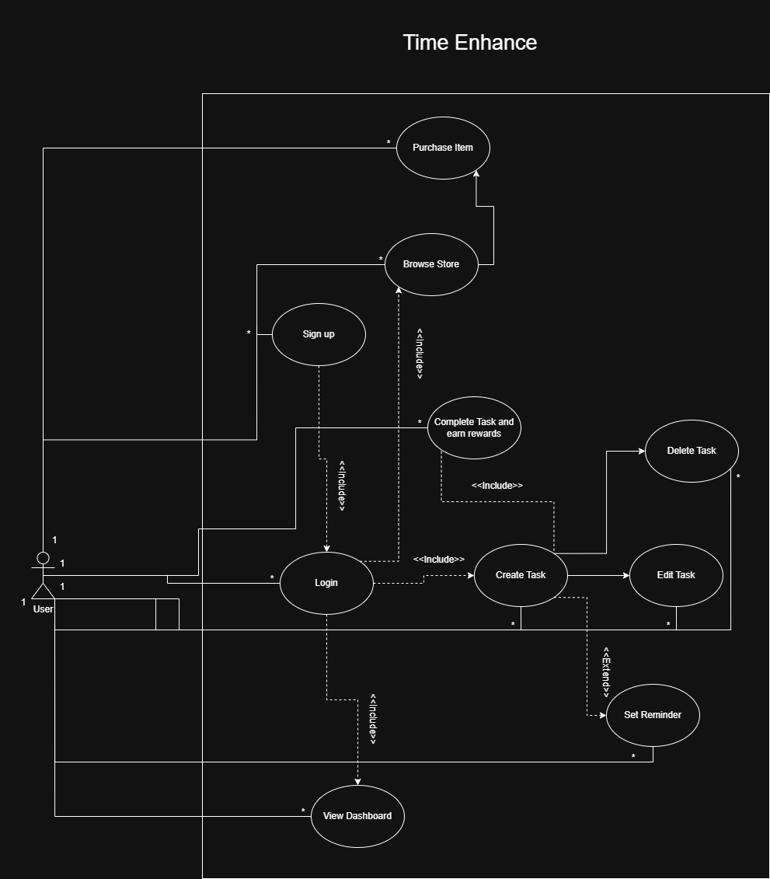
High-Level Use Case Diagram for TimeEnhance System

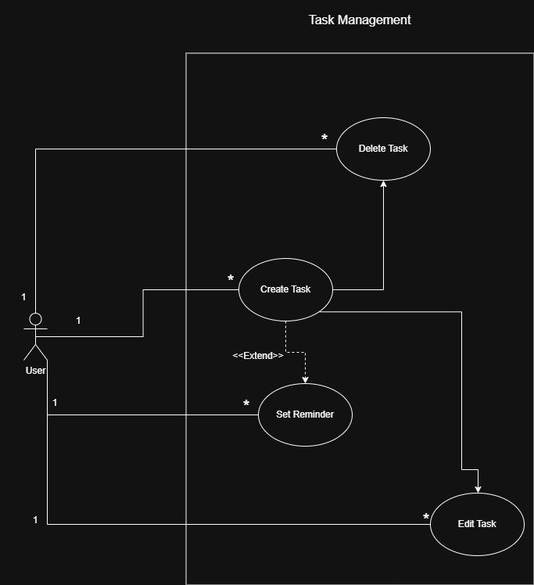

Task Management Use Case Diagram

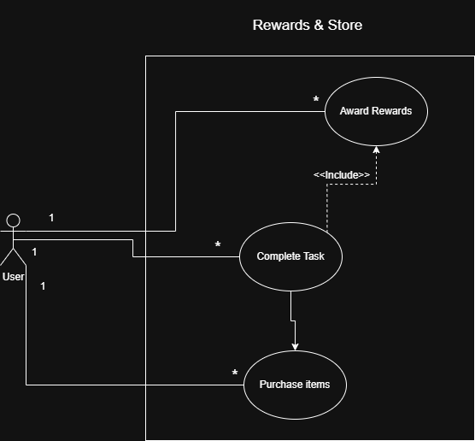
Reward and Store Use Case Diagram

3.2.2 Use Case Descriptions
Use Case Name: Create Task
Actor: User

Preconditions:
User is logged in.

Postconditions:
A new task is saved in the system and visible in the task list.

Basic Flow:
1. The user selects “Create New Task”.
2. The system prompts the user to enter task fields (title, description, deadline).
3. The user confirms and submits the task.
4. The system validates the input.
5. The task is stored in the database and displayed in the user’s task list.

Alternate Flow:
User enters invalid or missing information. System displays an error message and asks the user to enter valid data.

Exceptions:
System loses database connection. System shows an error: “Task could not be created. Please try again later.”

Use Case Name: Complete Task
Actor: User

Preconditions:
The task exists in the task list.
User is logged in.

Postconditions:
The task is marked as completed.
The user receives XP and Coins from the system.

Basic Flow:
1. The user selects a task from the task list.
2. The user clicks “Mark as Completed”.
3. The system updates the task status.
4. The system triggers the “Award Rewards” use case automatically.
5. Updated XP/Coins are displayed to the user.

Alternate Flow:
The user tries to complete a task that is already completed.
System displays: “Task already completed.”

Exceptions:
Database failure prevents saving the update. System displays an error message.

Use Case Name: Purchase Item
Actor: User

Preconditions:
User is logged in.
User has enough Coins to purchase the item.

Postconditions:
Item is added to the user’s inventory.
Coins are deducted from the user’s balance.

Basic Flow:
1. The user opens the Store page.
2. The system displays available items and their prices.
3. The user selects an item to purchase.
4. The system verifies that the user has enough Coins.
5. Coins are deducted, and the item is added to the user’s inventory.

Alternate Flow:
User cancels the purchase.
System returns to the Store screen without making changes.

Exceptions:
User does not have enough Coins. System displays: “Insufficient balance.”

3.3 Domain Model
3.3.1 Conceptual Class Diagram
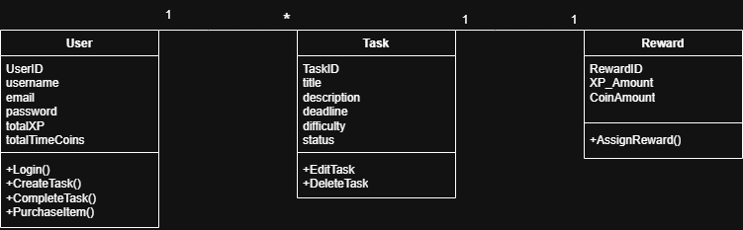

3.3.2 Class Descriptions

Class Name: User
Purpose:
Represents the person using the system. The User can create tasks, complete them, and receive rewards.

Attributes:
- userID
- username
- email
- password
- totalXP
- totalCoins

Association Relationships:
- One User can have many Tasks (1 to * relationship).
- Each Reward is given to a User when they complete a Task.

Class Name: Task
Purpose:
Represents a to-do item created by the User. A Task contains the required information for scheduling and productivity tracking.

Attributes:
- taskID
- title
- description
- deadline
- status

Association Relationships:
- A Task belongs to exactly one User (each task is created by one User).
- Each Task results in exactly one Reward when completed (1 to 1 relationship).

Class Name: Reward
Purpose:
Represents the XP and Coins given to a User after completing a Task. Rewards motivate the User to finish tasks.

Attributes:
- rewardID
- xpAmount
- coinAmount

Association Relationships:
- Each Reward is associated with exactly one Task.
- Rewards increase the User’s totalXP and totalCoins.

3.4 Non-Functional Requirements
Performance:
The system should load task lists, dashboards, and rewards within 2 seconds. Creating, completing, or deleting a task should update the UI immediately.
Testing / Success Criteria:
Use browser developer tools to measure load and update times. All operations must complete in ≤ 2 seconds.

Reliability / Availability:
The system must be available at least 99% of the time. Task data, progress, and rewards must persist after page refreshes or restarting the browser.
Testing / Success Criteria:
Reload or close/open the browser and verify that no data is lost. Trigger controlled failures and verify that the system shows clear error messages.

Usability / User Experience:
The interface should be intuitive and simple to navigate. Core actions (create, complete, delete task) must be achievable within 3 clicks or fewer.
Testing / Success Criteria:
Observe users performing tasks for the first time and verify that they can complete actions without assistance and within the click limit.

Security:
User credentials must be securely stored (hashed and never in plain text). Access to private data (tasks, rewards) should be restricted by authentication.
Testing / Success Criteria:
Attempt invalid logins to ensure the system rejects them. Inspect the database to verify password hashing. Ensure restricted data cannot be accessed without login.

Maintainability / Reusability / Flexibility:
The system code must be modular and follow a clear structure to support future enhancements or scalability.
Testing / Success Criteria:
Perform a code review to ensure separation of concerns (e.g., frontend, backend functions). Attempt adding a mock feature to validate flexibility.

Portability / Compatibility:
The application must function on major browsers (Chrome, Firefox, Edge) and different screen sizes (desktop/tablet/mobile).
Testing / Success Criteria:
Run the system on multiple browsers/devices and ensure consistent layout and functionality across all of them.

Recoverability / Data Integrity:
Stored data must remain accurate and recoverable in case of an unexpected failure, crash, or interruption.
Testing / Success Criteria:
Simulate connection loss or unexpected refresh and verify that data remains correct and intact in the database.

Interoperability:
The system must work with browser APIs (such as notifications) without errors or conflicts.
Testing / Success Criteria:
Enable reminders/notifications and test across different browsers to confirm consistent behavior.

Compliance / Legal:
The system must respect user data privacy and comply with browser permission rules (e.g., notification permissions).
Testing / Success Criteria:
Review the code and database to confirm secure data handling and correct use of browser permission prompts.

3.5 External Interface Requirements
3.5.1 User Interface
The system will be a simple web application with the following main screens:

1. Login / Registration Screen
- Contains fields for email, username, and password.
- Buttons: “Login”, “Create Account”.
- Error messages appear if the login fails or fields are empty.

2. Dashboard Screen
- Displays user XP, Coins, and total completed tasks.
- Provides quick access buttons to: “Create Task”, “View Tasks”, and “Store”.

3. Task List Screen
- Shows all tasks in a list format (title + deadline + status).
- Each task contains buttons: “Edit”, “Delete”, and “Mark as Completed”.
- Tasks are visually separated based on status (pending / completed).

4. Create / Edit Task Screen
- Contains input fields: Task Title, Description, Deadline.
- Buttons: “Save Task” or “Update Task”.

5. Store / Rewards Screen
- Displays items available for purchase with Coins.
- Shows item name, required Coins, and “Purchase” button.
- Displays confirmation or error message based on availability of Coins.

6. Profile / Progress Screen (optional / simple)
- Displays current XP and Coins.
- Shows progress toward next XP level or milestone.

3.5.2 Hardware Interface
The system does not require or interact with any external hardware devices such as printers, scanners, or sensors.

The only required hardware is:
- A device capable of running a modern web browser (e.g., laptop, desktop, tablet).

No special hardware communication, drivers, or peripherals are needed.

3.5.3 Software Interface
The system interacts with the following software components:

1. Web Browser (Chrome, Firefox, Edge)
- The application runs entirely through the browser.
- No installation is required.

2. Backend Framework (Python Flask)
- Handles business logic (creating tasks, saving progress, awarding rewards).
- Provides REST API endpoints that communicate with the frontend.

3. Database System (SQLite or MySQL)
- Stores user accounts, tasks, progress, XP, and Coins.
- The application performs standard CRUD operations (Create, Read, Update, Delete).

4. Operating System (Windows, Linux, macOS)
- Only used to host and run the browser and backend server.
- No OS-level special modules or permissions required.

Communication Between Components:
- The frontend sends requests to the backend using HTTP/HTTPS.
- The backend interacts with the database using SQL queries.

3.5.4 Communication Interface
The system communicates using standard web protocols.

- The frontend (browser) communicates with the backend (Flask server) using HTTP/HTTPS requests.
- All data between the client and server is transferred using RESTful API calls (GET, POST, PUT, DELETE).
- HTTPS will be used to ensure secure encrypted communication whenever deployed online.

No other network services (FTP, Telnet, SSH) are required.

4. Appendices
4.1 Appendix A: Data Dictionary
The following are the database tables used in the TimeEnhance system:

Table Name: Users
Description:
Stores user account information (email, username, password) and the user's progress (total XP and Coins).

Table Name: Tasks
Description:
Stores all tasks created by the user, including task title, description, deadline, and status (pending or completed).

Table Name: Rewards
Description:
Stores XP and Coins that are awarded when a task is completed.

Table Name: Inventory
Description:
Stores items purchased by the user from the Store and links them to the user's account.

4.2 Appendix B: Glossary

Term / Acronym | Definition
SRS | Software Requirements Specification. A document describing all system requirements.
UI | User Interface. The elements that the user interacts with directly.
DB | Database. Stores Tasks, progress and the virtual currency.
XP | Virtual points called experience that the user collects to level up.
FR | Functional Requirement. Describes what the system should do.
NFR | Non-functional requirements. Describes system qualities like security, performance, etc.
Authentication | Process of verifying a user’s identity (e.g., email/password).
Authorization | Process of granting access rights to resources after authentication.
Session | Temporary server-side record of a logged-in user’s interaction.
REST API | Backend interface following REST principles (GET/POST/PUT/DELETE).
Endpoint | A specific URL in the REST API that performs an operation (e.g., /tasks).
Reminder | A scheduled alert for a task (browser notification or in-app alert).
Streak | Consecutive-day metric showing days with at least one completed task.
Inventory Item | A purchased cosmetic stored in the user’s inventory.
Badge Criteria | Rules that determine when a user earns a badge or achievement.
Level Threshold | XP amount required to reach the next user level.
XP Curve | Formula or table defining XP awarded per task difficulty.
Database Migration | Scripts or steps to change database schema safely between versions.
Backup | Periodic copy of the database or user data for recovery purposes.
Data Integrity | Assurance that stored data is accurate, consistent, and uncorrupted.
Transaction | Grouped DB operations that succeed or fail together
Hashing | Irreversible transformation used to store passwords securely.
Encryption | Process of encoding data so only authorized parties can read it.
HTTPS | Secure HTTP; encrypts client-server communication.
Accessibility | Design that makes the app usable by people with disabilities.

