Zewail City of Science, Technology and Innovation
University of Science and Technology
School of Computational Sciences and Artificial Intelligence

CSAI 203 - Fall 2025

Introduction to Software Engineering

Time Enhance

Design document
Team Number: #40
Team Members:
Marwan Abdelhamid 202401466

Representative Contact info:
Write one email to be able to contact your team.
11/22/2025

1.Introduction
1.1 Purpose of the document
This Design Document specifies the architecture, detailed design decisions, and component-level structure for Time Enhance. It translates the SRS into concrete design artifacts (system architecture diagram, UML class and sequence diagrams, MVC mapping, UI wireframes, and database schema) that the development team will use to implement, test, and deploy the application. The document is intended to ensure consistency between requirements and implementation, support maintainability and extensibility.

1.2 Scope of the Design Phase
This design phase covers all structural and technical aspects of the Time Enhance system, including the system architecture, module and component design, UI layout and wireframes, data storage structure, and the MVC organization used throughout the project. The scope defines how each part of the system will operate, interact, and support the functional and non-functional requirements specified in the SRS, providing a clear blueprint for implementation.

1.3 Intended Audience
This document is intended for the development team, the course instructor, and the TAs who will review, evaluate, and verify the system’s design. It guides developers during implementation and helps evaluators understand the system’s structure and design decisions.

1.4 Overview of the Contents
This document is organized into several sections. Section 1 introduces the purpose, scope, audience, and structure of the design document. Section 2 provides a high-level overview of the system and its main goals. Section 3 presents the system architecture, including diagrams and chosen technologies. Section 4 details the MVC design, class diagram, sequence diagrams, UI wireframes, and data design. Section 5 concludes with a summary of the design phase.

2 System Overview
2.1 Brief Description of the System
Time Enhance is a web-based productivity and time-management system designed to help users organize tasks, track progress, and stay motivated through a built-in reward system. The software allows users to create, edit, delete, and complete tasks while earning XP and virtual currency that can be used to unlock cosmetic items. The goal of the system is to improve productivity through simple task management combined with light gamification.
At a high level, the system provides task management tools, reminders, a dashboard for viewing progress, a virtual store for cosmetic items, and basic account management. All interactions take place through a browser-based interface, with a Python Flask backend handling logic and a database storing user data, tasks, rewards, and inventory.

2.2 Key Design Goals and Constraints
The main design goals of Time Enhance are modularity, simplicity, and maintainability, ensuring the system is easy to extend and aligns with the MVC pattern. The design prioritizes a clean separation of concerns, straightforward user interaction, and efficient handling of tasks and rewards.
Key constraints include the mandatory use of Python Flask, basic HTML for the frontend, and a lightweight database. The system must operate as a monolithic web application, meet performance expectations from the SRS, and remain simple enough to implement within the course timeline and skill limitations.
3. Architectural Design
3.1 System Architecture Diagram
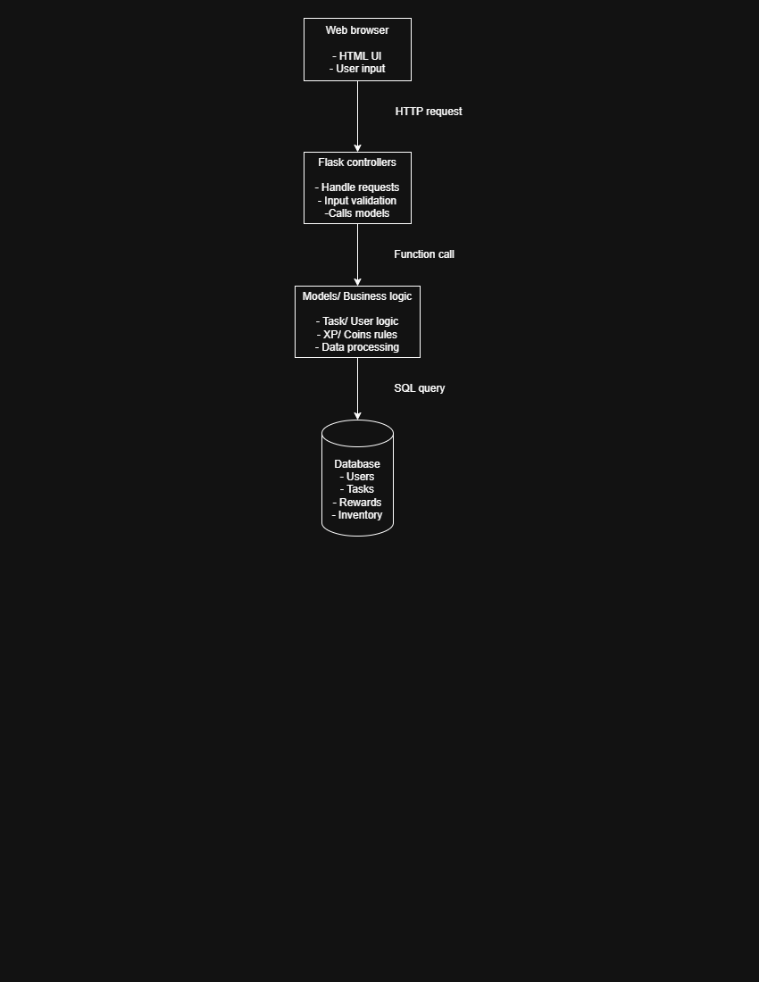
System Architecture Diagram (Monolithic Architecture)

3.2 Discussion of Architectural Style and Components
The Time Enhance system uses a Monolithic Architecture, where all application components frontend interface, backend logic, and data storage are built and deployed as a single unified system. This architecture is simple to develop, easy to maintain within the course scope, and aligns with the MVC structure required for the project. All user interactions flow through one Flask application, which centralizes routing, logic execution, and database access.
The architecture consists of four main components:
- Web Browser (Client):
Displays the HTML-based user interface and sends user actions (such as creating or completing tasks) to the server through HTTP requests.
- Flask Controllers (Routes):
Act as the system’s entry point. They receive requests from the browser, validate inputs, manage navigation between pages, and coordinate with the model layer to execute required operations.
- Models / Business Logic:
Contain the core functionality of the system. This component handles task operations, user progress tracking, XP/coin calculations, and inventory updates. It encapsulates the system’s rules and ensures consistency between user actions and stored data.
- Database:
Stores persistent information, including users, tasks, rewards, and inventory items. Models interact with the database through SQL queries to retrieve or update data based on controller requests.
This combination ensures a clean separation of responsibilities while maintaining the simplicity and cohesiveness of a monolithic system.

3.3 Technology Stack and Tools
The Time Enhance system is developed using a lightweight web-based technology stack. The backend is implemented in Python using the Flask framework, while the frontend is constructed with basic HTML to support user interaction. The application uses SQLite as the database for storing users, tasks, rewards, and inventory data.
For development, the team utilizes Visual Studio Code as the primary coding environment and Git/GitHub for version control. Draw.io is used to create diagrams such as the architecture and UML models. Testing and validation are performed using the Flask development server and manual testing through the web browser.

4. Detailed Design
4.1 Model–View–Controller (MVC) Design Pattern
4.1.1 Description of MVC Pattern
The Time Enhance system uses the Model–View–Controller (MVC) architectural pattern to separate the application into three independent layers. The Model handles the core logic and data operations, the View represents the HTML pages displayed to the user, and the Controller manages user requests and connects the views with the models.
MVC was chosen because it keeps the system organized, improves maintainability, and allows each part of the application to be developed and updated independently. This structure fits well with Flask’s routing system and supports a clean workflow for handling user interactions and updating application data.

4.1.2 Mapping of Project Components to MVC
In the Time Enhance system, each part of the application is organized according to the MVC structure:
- Model Layer:
Contains the core logic and data-handling functions, including modules responsible for managing users, tasks, rewards, XP/coin calculations, and inventory updates. These components interact directly with the database to store and retrieve information.
- View Layer:
Consists of the HTML templates that form the user interface, such as the login page, dashboard, task list, and store pages. These views display data prepared by the controllers and present the results of user actions.
- Controller Layer:
Implemented through Flask route functions. Each route receives user requests, validates inputs, calls the appropriate model functions, and returns the correct HTML page. Examples include routes for creating tasks, completing tasks, logging in, and accessing the store.
This mapping ensures a clear separation of responsibilities and supports a clean, maintainable project structure.

4.1.3 Responsibilities of Model, View, and Controller
Model:
- Handles all core logic and data operations.
- Manages users, tasks, rewards, XP/coin calculations, and inventory.
- Interacts directly with the database to store and retrieve information.
View:
- Provides the HTML interface displayed to the user.
- Shows task lists, dashboards, store pages, and feedback messages.
- Presents data prepared by the controller.
Controller:
- Receives and processes user requests via Flask routes.
- Validates inputs and calls the required model functions.
- Selects and returns the appropriate HTML view to the user.

4.1.4 Interaction Between Components
In the Time Enhance system, data flows through the MVC layers in a straightforward sequence. When a user performs an action on an HTML page (View), the browser sends a request to the Flask route responsible for that action (Controller). The controller processes the request, validates the inputs, and calls the appropriate model function. The Model executes the required logic, updates or retrieves information from the database, and returns the results to the controller. Finally, the Controller selects the correct HTML page and sends it back to the browser to display updated information to the user.

4.2 UML Diagrams

4.2.1 Detailed Class Diagram
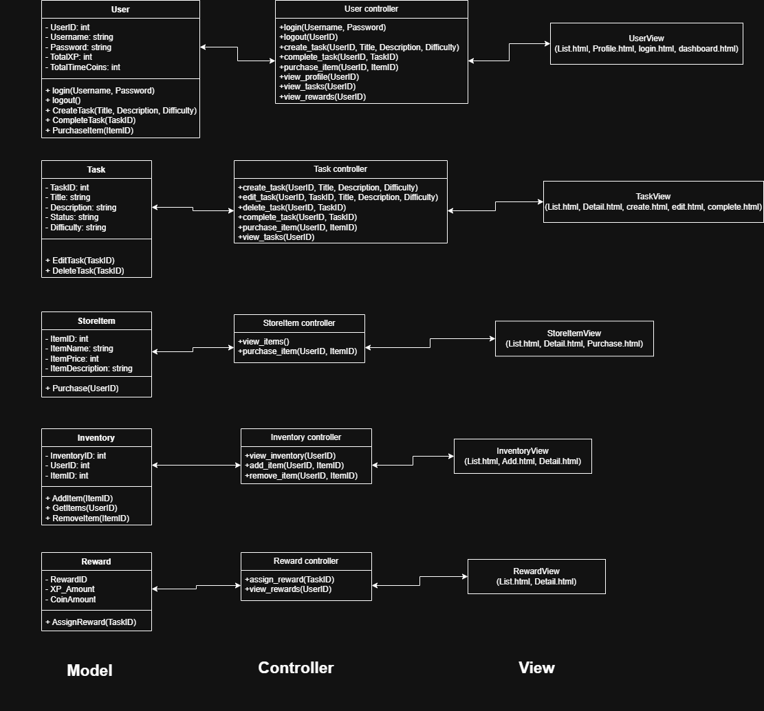

4.2.2 Sequence Diagrams

