Winklebury Hill experiment
The aim of this study was to use seeds and plug plants to create different plant communities on the bare chalk on Winklebury Hill. We would then test the resulting carbon and nutrient cycling rates and compare these to the characteristics of the plant groups. The experiment ran from March 2013 to September 2016.
The species expected to be present in this grassland type were grouped into three groups of species expected to have similar effects upon their surroundings, based on characteristics known as ‘functional effects traits’. These groups are expected to have measurably different effects upon carbon storage, soil fertility and ecosystem health.
The three plant groups were (FG):
- Deep, thick tap roots. Simple root structure. Thin, large leaves. Group contains species that are annuals and biennials as well as long lived species.
- Predictions: Lots of carbon storage in the soil. Plant roots putting carbon deeper into the soil so it’s less accessible for bacteria etc. to use.
- Species include: Sanguisorba minor (salad burnet), Daucus carota (wild carrot), Dactylis glomerata (cocksfoot).

- Small rosettes with very small tap roots.
- Not much going on in terms of carbon and nitrogen- very small so not a very big physical presence.
- Species include: Bellis perennis (daisy), Festuca rubra (red fescue), Primula veris (primrose), Thymus pulegioides (broad-leaved thyme).

- Big plants, lots of shallow thin roots, big fleshy leaves. Long lived.
- Very fast carbon and nitrogen cycling, lots of microbial activity in the soil, leaves and roots root away very fast. Possibly bad for carbon storage because it’s used by bacteria and fungi so quickly. Also likely to be released in simple sugar forms rather than woody forms, which makes it easier to digest.
- Species include: Vicia cracca (tufted vetch), Avenula spp. (oat grasses), Ranunculus spp. (various buttercups).

Groups | Plant Species
1 | Achillea.millefolium.
1 | Agrimonia.eupatoria.
1 | Arctium.minus.
1 | Arrhenatherum.elatius.
1 | Asperula.cynanchica.
1 | Blackstonia.perfoliata.
1 | Carduus.nutans.
1 | Carlina.vulgaris.
1 | Centaurea.scabiosa.
1 | Centaurium.erythraea.
1 | Crepis.capillaris.
1 | Dactylis.glomerata.
1 | Daucus.carota.
1 | Euphrasia.officinalis.agg.
1 | Galium.verum.
1 | Helianthemum.nummularium.
1 | Holcus.lanatus.
1 | Hypochaeris.radicata.
1 | Leontodon.hispidus.
1 | Linaria vulgaris
1 | Linum.catharticum.
1 | Lotus.corniculatus.
1 | Medicago.lupulina.
1 | Ononis.repens.
1 | Ononis.spinosa.
1 | Origanum.vulgare.
1 | Phleum bertolonii
1 | Phleum.pratense.
1 | Pimpinella.saxifraga.
1 | Plantago.lanceolata.
1 | Poa.pratensis.sens.lat..
1 | Sanguisorba.minor.
1 | Scabiosa.columbaria.
1 | Serratula.tinctoria
2 | Acinos arvensis
2 | Agrostis stolonifera
2 | Agrostis.capillaris.
2 | Anthoxanthum odoratum
2 | Bellis.perennis.
2 | Briza.media.
2 | Campanula.rotundifolia.
2 | Carex.caryophyllea.
2 | Carex.flacca.
2 | Cerastium.fontanum.
2 | Cirsium acaule
2 | Clinopodium.vulgare.
2 | Cruciata.laevipes.
2 | Festuca.rubra.agg.
2 | Filipendula.vulgaris.
2 | Hieracium.pilosella.
2 | Hippocrepis.comosa.
2 | Lathyrus.pratensis.
2 | Plantago.media.
2 | Poa subcaerulea
2 | Potentilla.reptans.
2 | Primula.veris.
2 | Prunella.vulgaris.
2 | Ranunculus repens
2 | Taraxacum officinale
2 | Thymus.pulegioides.
2 | Trifolium repens
2 | Trifolium.pratense.
2 | Viola.hirta.
3 | Anthyllis.vulneraria.
3 | Avenula.pratensis.
3 | Avenula.pubescens.
3 | Bromopsis.erecta.
3 | Campanula.glomerata.
3 | Centaurea.nigra
3 | Cynosurus.cristatus.
3 | Danthonia.decumbens.
3 | Festuca pratensis
3 | Festuca.ovina.
3 | Galium.mollugo.sens.lat.
3 | Gentianella.amarella.
3 | Hypochaeris.maculata.
3 | Knautia.arvensis.
3 | Koeleria.macrantha.
3 | Leucanthemum.vulgare.
3 | Lolium perenne
3 | Onobrychis.viciifolia.
3 | Picris.hieracioides.
3 | Polygala.vulgaris.
3 | Pulsatilla.vulgaris.
3 | Ranunculus acris
3 | Ranunculus.bulbosus.
3 | Reseda.lutea.
3 | Rumex.acetosa.
3 | Stachys.officinalis.
3 | Succisa.pratensis.
3 | Thesium.humifusum.
3 | Thymus.praecox.
3 | Tragopogon.pratensis.
3 | Trisetum.flavescens.
3 | Veronica.chamaedrys.
3 | Vicia.cracca.

We created a grid of plots in the field, 7 across and 6 down. The seven across had each combination of the three groups. This was repeated in each row so we had replicated the treatments six times.

Plot layout
Each plot is 8m x 8m, with a 2m gap in between each one. FG refers to the plant group, and every combination of the three groups is included.

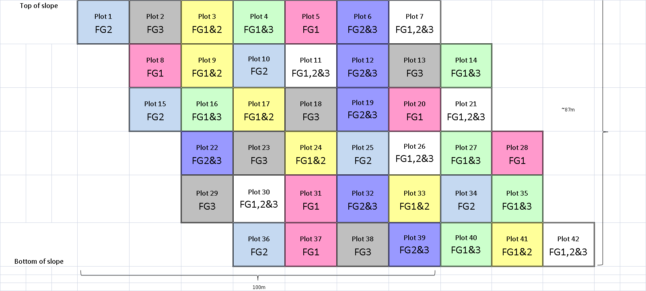
From 2015 onwards we added rain shelters to the plots to look at the effect of drought.
This is the layout of the rain shelters in the plots. The shelters stayed on from the beginning of June until mid-July, mimicking an extreme (once in 100 years) drought.

