# Sitemap

<https://www.gloomaps.com/em3kVYsjNF>

# Pagina ontwerp wireframes

## Home

<https://wireframe.cc/NpuMFr>

## Create account

<https://wireframe.cc/qaRUSy>

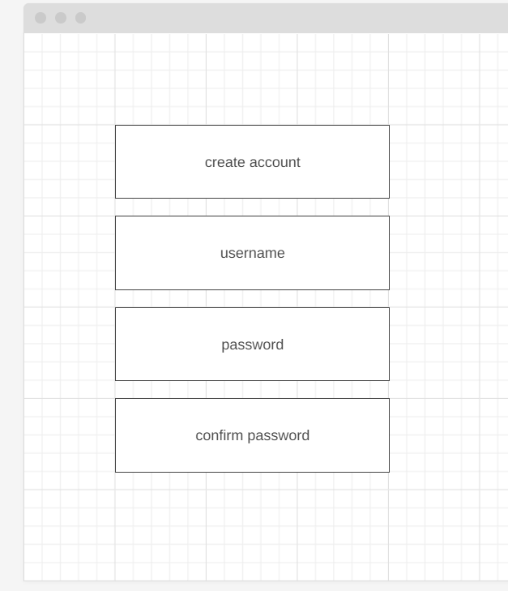

## Login

<https://wireframe.cc/hHWem6>

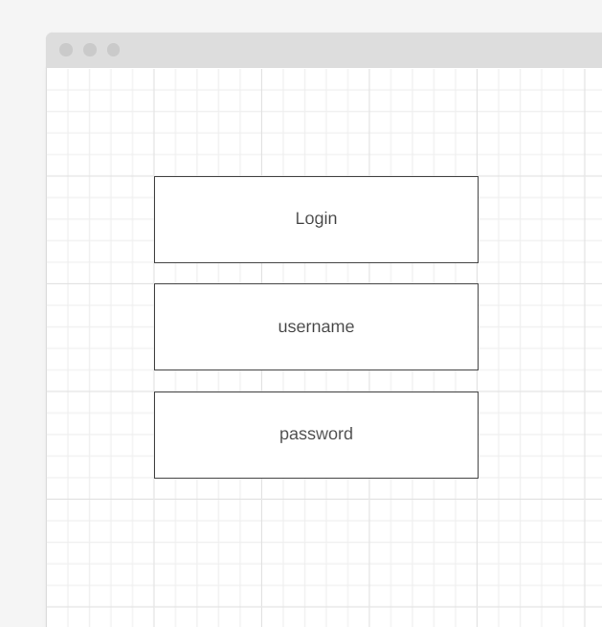

## Todos

<https://wireframe.cc/MOsVvx>

