Assignment 2 — Software Fault-Tolerant Design
AITU Student Scholarship and Tuition Payment Processing
Astana IT University | Fault Tolerance | Academic Year 2026–2027
Context note: All operational data in this assignment are synthetic educational data. They are designed to represent a realistic Kazakhstan/Astana university context and do not describe actual AITU infrastructure, incidents, or internal systems.

Scenario
Consider a synthetic digital service used by an Astana university to process student payment-related transactions. The service must continue processing independent transactions when network, timeout, or database faults occur.
Each transaction follows: Validate → Process → Record.
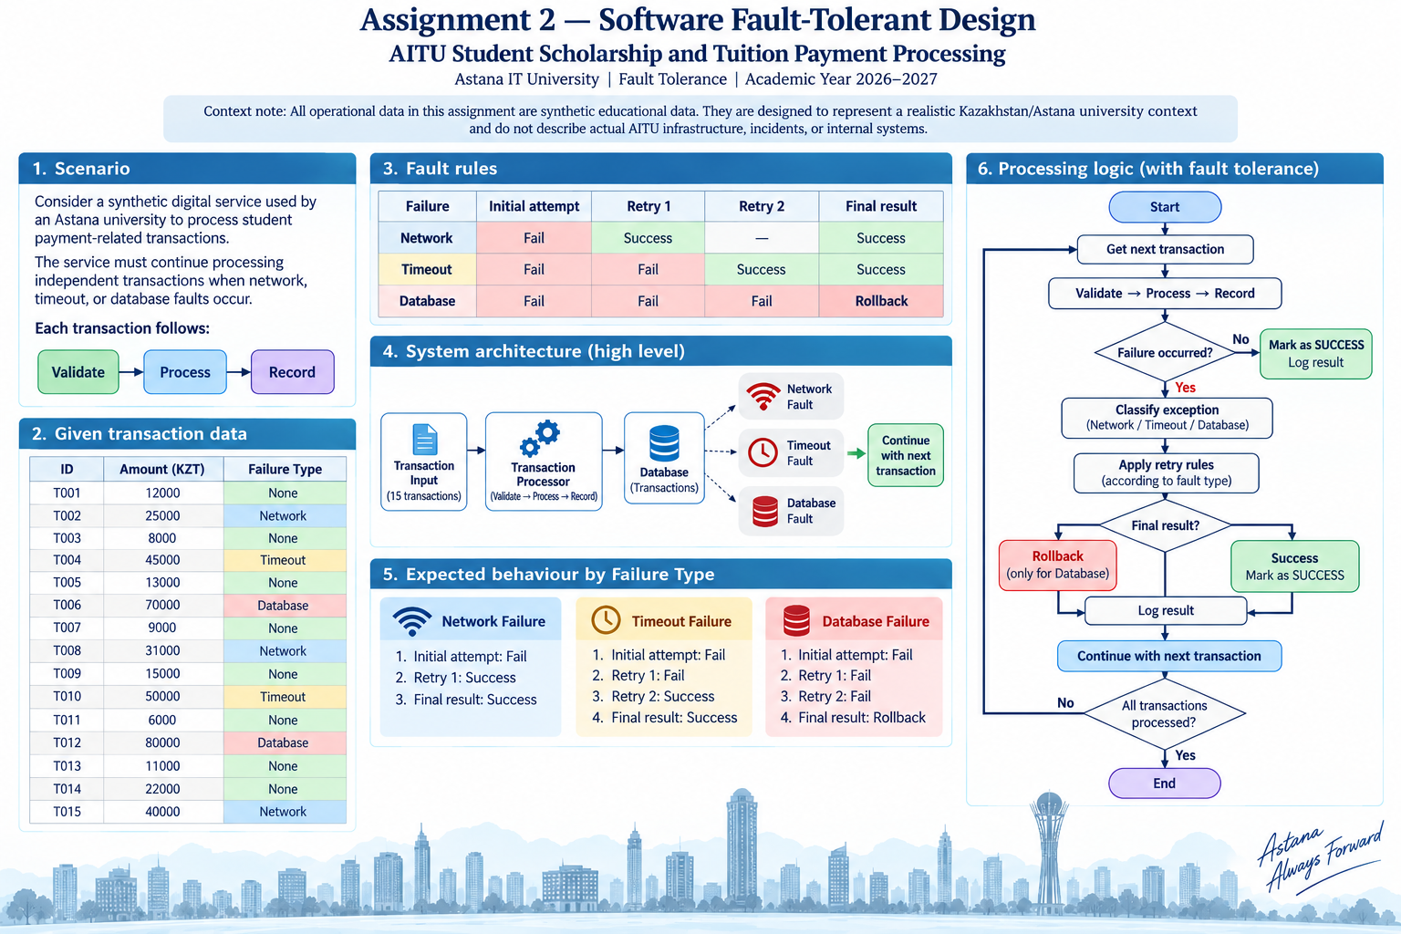

Given transaction data
ID | Amount (KZT) | Failure Type
T001 | 12000 | None
T002 | 25000 | Network
T003 | 8000 | None
T004 | 45000 | Timeout
T005 | 13000 | None
T006 | 70000 | Database
T007 | 9000 | None
T008 | 31000 | Network
T009 | 15000 | None
T010 | 50000 | Timeout
T011 | 6000 | None
T012 | 80000 | Database
T013 | 11000 | None
T014 | 22000 | None
T015 | 40000 | Network

Fault rules
Failure | Initial attempt | Retry 1 | Retry 2 | Final result
Network | Fail | Success | — | Success
Timeout | Fail | Fail | Success | Success
Database | Fail | Fail | Fail | Rollback

Part A — Baseline Implementation (5 points)
Implement a baseline Python processor without fault tolerance. It stops when a failure occurs.
Metric | Result
Transactions attempted | 2
Successful transactions | 1
Transactions lost | 14
Processed amount (KZT) | 12000
Lost amount (KZT) | 425000

Part B — Exception Handling (5 points)
Modify the program so one failed transaction does not terminate the application. Use try/except, failure classification, structured logging, and continuation.
Transaction | Failure | Exception | Recovery Action | Final Status
T002 | Network | NetworkFailure | Retry once; continue | Success
T004 | Timeout | TimeoutFailure | Retry twice; continue | Success
T006 | Database | DatabaseFailure | Rollback to latest checkpoint; continue | Rollback
T008 | Network | NetworkFailure | Retry once; continue | Success
T010 | Timeout | TimeoutFailure | Retry twice; continue | Success
T012 | Database | DatabaseFailure | Rollback to latest checkpoint; continue | Rollback
T015 | Network | NetworkFailure | Retry once; continue | Success

Part C — Retry Mechanism (7 points)
Implement the exact retry policy provided in the input. Generate an attempt log automatically.
Timestamp/Step | Transaction | Attempt | Failure | Action | Result
2026-09-28T04:22:40+00:00 | T001 | 1 | None | Process and record | Success
2026-09-28T04:22:40+00:00 | T002 | 1 | Network | Retry | Fail
2026-09-28T04:22:40+00:00 | T002 | 2 | Network | Process and record | Success
2026-09-28T04:22:40+00:00 | T003 | 1 | None | Process and record | Success
2026-09-28T04:22:40+00:00 | T004 | 1 | Timeout | Retry | Fail
2026-09-28T04:22:40+00:00 | T004 | 2 | Timeout | Retry | Fail

Part D — Checkpoint and Rollback (8 points)
Create a checkpoint after every 5 successfully processed transactions. On a database failure, rollback to the latest valid checkpoint and continue.
Checkpoint | Successful transactions | Total amount (KZT) | State saved
CP1 | 5 | 103,000 | T001, T002, T003, T004, T005
CP2 | 10 | 214,000 | T001, T002, T003, T004, T005, T007, T008, T009, T010, T011
CP3 | — | — | Not created: only 13 successful transactions

Part E — Before/After Analysis (5 points)
Metric | Baseline | Fault-tolerant | Improvement
Successful transactions | 1 | 13 | +12
Failed transactions | 1 | 2 | Database rollbacks preserve consistency
Lost amount (KZT) | 425,000 | 150,000 | 64.71% reduction
Retries | 0 | 11 | 11 retry attempts
Rollbacks | 0 | 2 | +2
Completion rate | 6.67% | 86.67% | +80.00 percentage points

- Calculate recovery improvement.
- Calculate transaction-loss reduction.
- Which mechanism contributed most?
- When is retry unsafe or inappropriate?
- Why is rollback required for database failure?
- Why is idempotency important in student payment processing?

Submission
- Python source code
- Generated transaction and retry logs
- Completed tables
- Before/after analysis
- Short technical conclusion
- Oral defense

STUDENT TECHNICAL WORK REPORT / SUBMISSION RECORD
Assignment 2 — Software Fault-Tolerant Design
Purpose: This form is a formal submission record. The student must complete every applicable field and attach evidence of their own work. Short generic explanations are not sufficient.

1. Student and Submission Information
Required field | Student entry
Student full name | Jeleubay Aslan
Student ID | 255132
Group / cohort | CSE-2503M
Instructor | Serek Azamat
Date of submission | 28.09.2026
Git repository
Attached code / file names

2. Work Period and Task Record
Item | Student entry
Work start date/time | 28/09/2026 - 09:00
Work completion date/time | 28/09/2026 - 19:00
Main task completed | 28/09/2026 - 16:00
Tools / technologies used | Edge, python, vscode
Main technical output produced

3. Report Structure to Complete
For each section below, write the requested evidence in your own words. Include calculations, diagrams, code references, screenshots, logs, or experimental evidence where applicable.

1. Baseline Implementation
Describe your baseline processor, the stopping behavior after a failure, and provide the required metrics from your own execution.
Required content | Student response / evidence
Summary | Processor stops at T002, the first failure. 2 attempted, 1 successful, 14 lost; 12,000 KZT processed and 425,000 KZT lost.
Evidence / calculation / artifact reference | fault_tolerant_processor.py; execution_summary.json.
Student-specific decision or observation | No recovery is intentionally used in the baseline.

2. Exception Handling
Explain your exception classes/handling logic and show how processing continues after an individual transaction failure.
Required content | Student response / evidence
Summary | Failures are classified as Network, Timeout, and Database; one failed transaction does not terminate the application
Evidence / calculation / artifact reference | Part B table; fault_tolerant_processor.py; attempt_log.csv.
Student-specific decision or observation | Database failure is handled separately because its required final action is rollback.

3. Retry Mechanism
Document the exact retry policy, generate the attempt log, and explain how the implementation follows the provided network/timeout/database rules.
Required content | Student response / evidence
Summary | Network gets one retry; Timeout gets two retries; Database gets two retries and then rollback.
Evidence / calculation / artifact reference | 26 generated attempts: 15 initial + 3 network retries + 4 timeout retries + 4 database retries.
Student-specific decision or observation | Retry limits are encoded by failure type.

4. Checkpoint and Rollback
Show where checkpoints are created, what state is saved, and how rollback works after database failure.
Required content | Student response / evidence
Summary | CP1 after T005: 5 successful transactions, 103,000 KZT. CP2 after T011: 10 successful transactions, 214,000 KZT. T006 rolls back to CP1; T012 rolls back to CP2.
Evidence / calculation / artifact reference | fault_tolerant_processor.py; execution_summary.json.
Student-specific decision or observation | CP3 is not created because only 13 transactions succeed.

5. Before/After Analysis
Compare baseline and fault-tolerant execution using the required metrics. Show calculations for recovery improvement and transaction-loss reduction.
Required content | Student response / evidence
Summary | Completion rises from 6.67% to 86.67%; lost amount falls from 425,000 to 150,000 KZT.
Evidence / calculation / artifact reference | Recovery improvement: +80 percentage points. Transaction-loss reduction: 85.71%. Lost-amount reduction: 64.71%.
Student-specific decision or observation | Transient-fault retries allow processing to continue; database failures remain rolled back.

6. Technical Reflection
Explain retry safety, rollback, and idempotency specifically in the context of your implementation.
Required content | Student response / evidence
Summary | Retry is suitable for transient faults when repeating is safe. Rollback restores consistent state after database failure. Idempotency prevents duplicate payment effects.
Evidence / calculation / artifact reference | Network and Timeout transactions recover under the supplied rules; T006 and T012 roll back after three failed attempts.
Student-specific decision or observation | The implementation separates transient retryable faults from database faults requiring state restoration.

4. Individual Work and Anti-Plagiarism Record
Because the assignment uses a common educational scenario and dataset, the submitted report must contain verifiable evidence of the individual student's work. Copying another student's wording, calculations, architecture, code, logs, screenshots, or conclusions is not acceptable.
- Submit a run-generated log, not a manually typed log.
- Include the exact source filename and commit/version used for the reported results.
- Record at least one implementation decision that differs from the simplest possible solution.
- Include one failed test/debugging issue that you personally resolved.
- During oral defense, be ready to modify or explain one recovery rule in your code.
Individual evidence | Student entry
My unique technical decision | Checkpoint state is explicitly restored after DatabaseFailure.
My own implementation / calculation evidence | Generated attempt_log.csv contains all 26 attempts; execution_summary.json contains calculated results.
Exact file, code, commit, notebook, or log reference | fault_tolerant_processor.py; attempt_log.csv; execution_summary.json
One problem I personally encountered and how I solved it | [Replace with a real debugging issue you personally encountered and solved.]
One limitation of my own solution | The simulation uses deterministic synthetic failure rules and does not model real network/database latency.

5. Evidence Checklist
- ☐ Completed required tables and calculations
- ☐ Architecture / RBD / FTA / security diagram where applicable
- ☐ Source code or configuration files where applicable
- ☐ Execution logs / experiment results where applicable
- ☐ Screenshots or other reproducible evidence where applicable
- ☐ Links to code, datasets, notebooks, or artifacts
- ☐ Before/after comparison where applicable
- ☐ Final technical conclusion

6. Student Declaration
I confirm that this report describes my own work. I have not copied another student's report, code, calculations, diagrams, logs, screenshots, or conclusions. Any external source or reused material has been identified. I understand that I may be asked to reproduce or explain any part of this submission during the oral defense.
Role | Name | Signature | Date
Student / Executor |  |  | ____________
Instructor / Accepted by |  |  | ____________

7. Instructor Acceptance Record
Check | Status / comment
Report structure completed | ☐ Yes ☐ No Comment: __________________________________________
Evidence is sufficient | ☐ Yes ☐ No Comment: __________________________________________
Individual contribution is identifiable | ☐ Yes ☐ No Comment: __________________________________________
Oral defense completed | ☐ Yes ☐ No Comment: __________________________________________
Final status | ☐ Accepted ☐ Revision required

