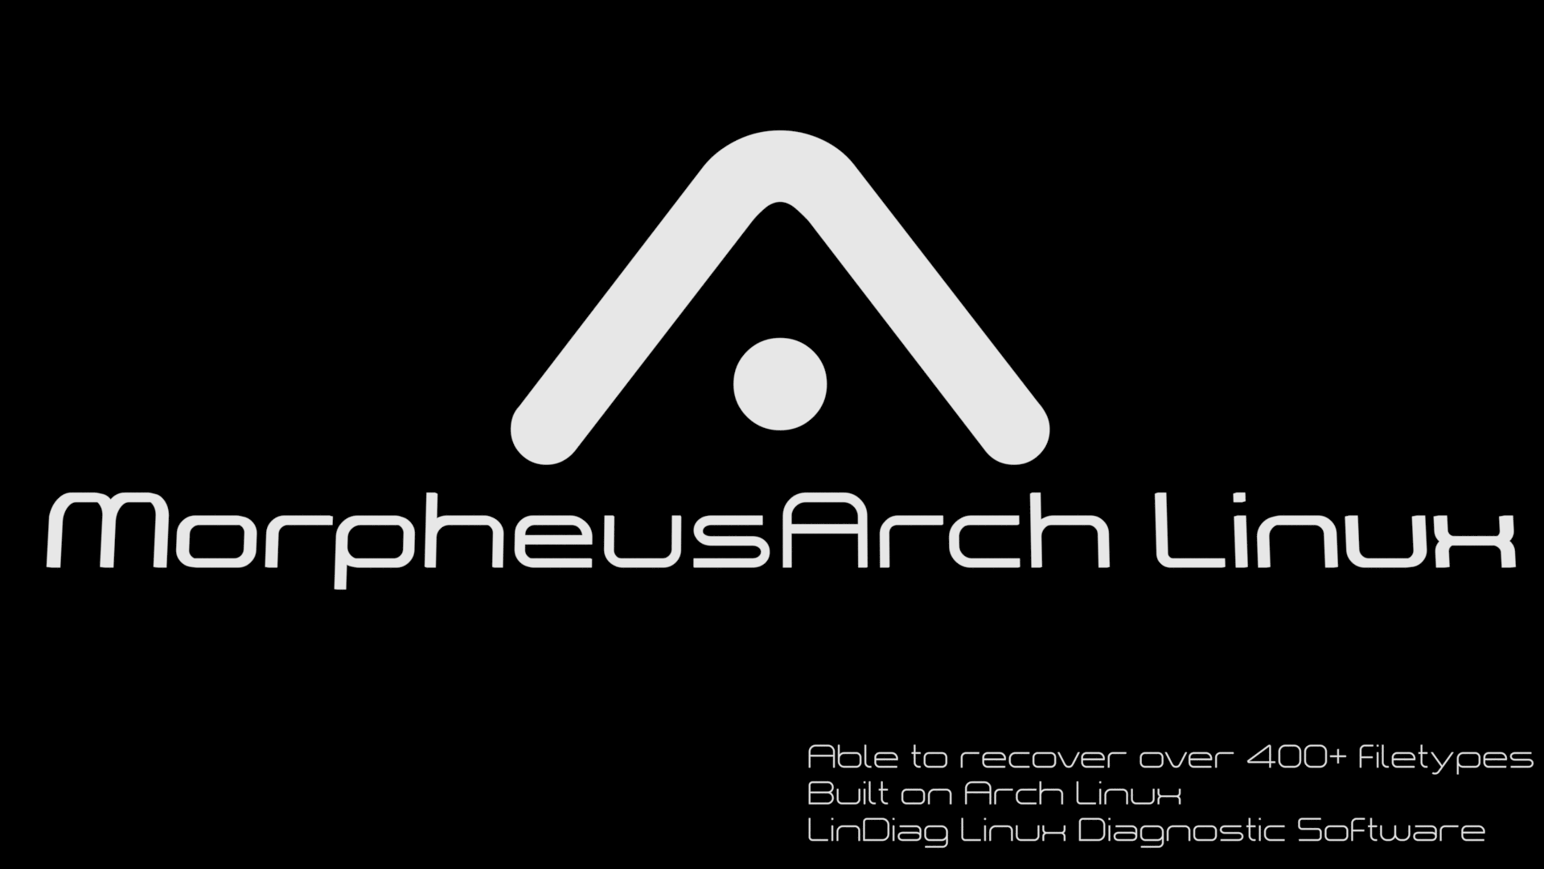

MorpheusArch Linux Documentation
This linux distribution is loaded with photorec and testdisk, ddrescue and other data recovery tools so you can recover 400+ file types.
All you need to do is create a bootable USB stick / CD and log in as:
username: morpheus
password: arch
From there you can start lightdm with systemctl start lightdm and then login again with the above credentials as normal with lxqt
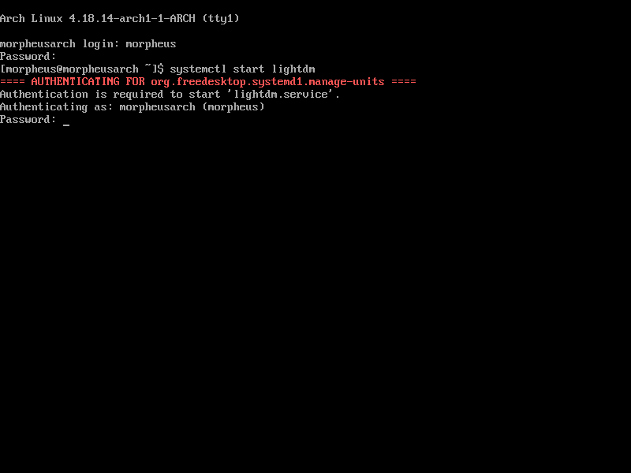

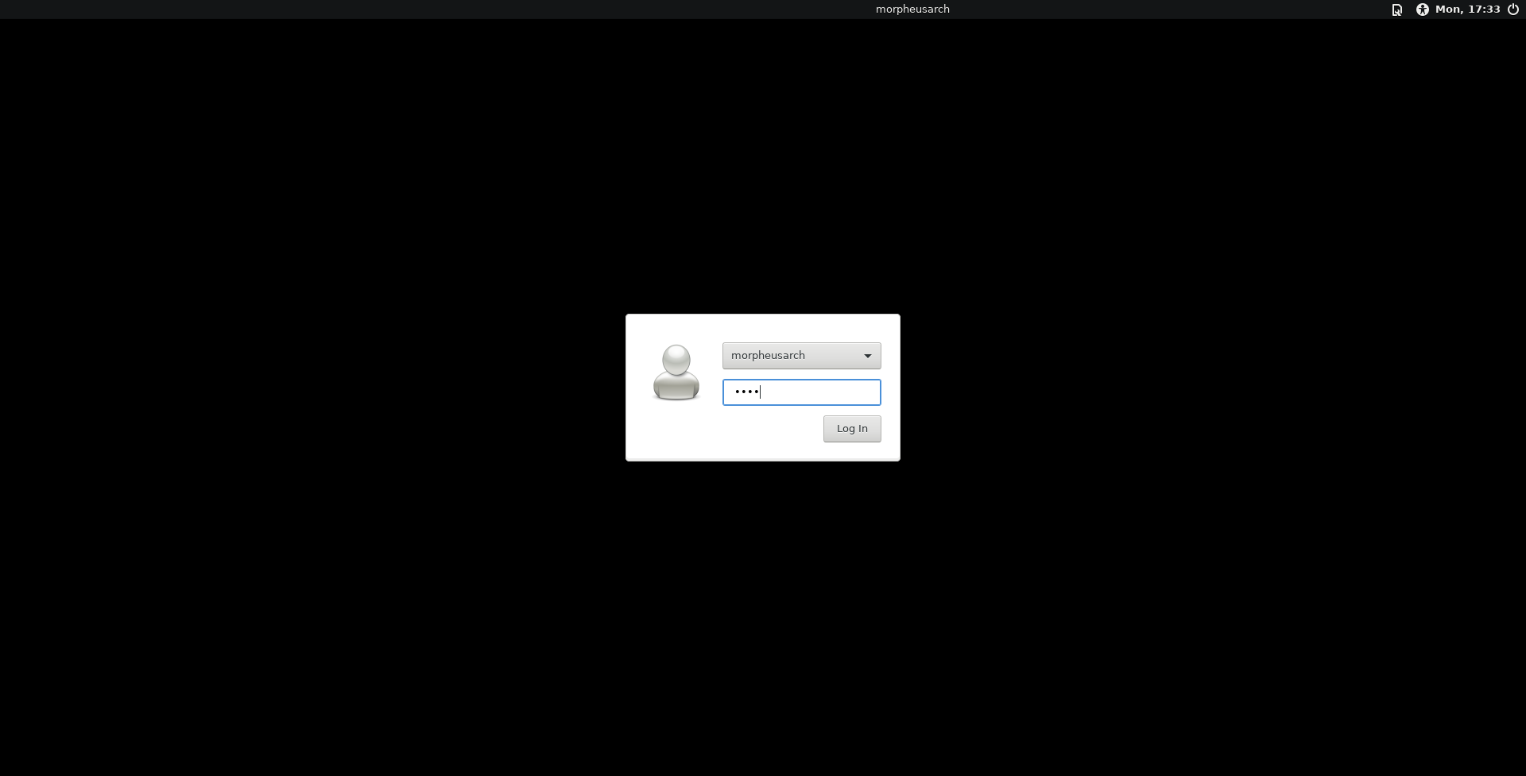

# Create a bootable USB

The recommended way is with the use of the dd command some tools exist for creating bootable flash drives but they are neither recommended nor officially supported.

sudo dd bs=4M if=MorpheusArch.iso of=/dev/sdX

# if is always before of

Failure to do so WILL result in the loss of data.

Remember to replace <MorpheusArch> with the current release of MorpheusArch and

Also remember to replace /dev/sdX with your flash drive. You can find your flash drive with use of the command:

lsblk

# Select the USB as the boot media

This varies from device to device. You need to enter the boot order in the BIOS of the system you are booting into.

LinDiag
LinDiag the Linux diagnostic software is included on version 2018.3 to launch it open a terminal and enter the command:
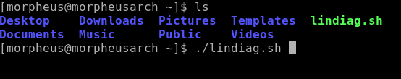
Use the su command to switch to root entering arch as the root password. And then run the script with the command ./lindiag.sh

Further documentation

https://github.com/MorpheusArch/LinDiag

https://www.cgsecurity.org/wiki/PhotoRec

https://www.technibble.com/guide-using-ddrescue-recover-data/

