Computer Network Assignment 2 report
1 Introduction
This is a assignment report about the second programming assignment of the computer networking. For this report, I will show the picture of the executing progress of peer.py and I will explain the result. You need to know that the executing environment is Python 3.13.2. You also need to know that the input.txt need to be allocated in the same page with peer.py . Strictly Speaking, you mustn’t change the config.json.

2 Detail Part of the code

Task 1.1: Listener and Packet Receiver
listener
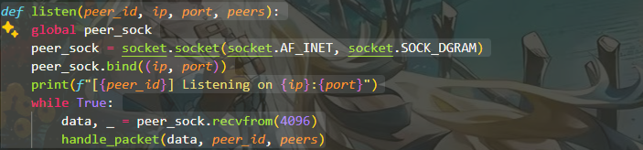
The listen(peer_id, ip, port, peers) function in Python sets up a UDP server for a peer-to-peer network. It creates a socket with socket.AF_INET and socket.SOCK_DGRAM, binds it to the specified IP and port, and listens for incoming packets. Using a 4096-byte buffer, it continuously receives data via recvfrom and passes it to handle_packet for processing. It also logs the listening status with the peer's ID, IP, and port, serving as a key component for packet reception in a distributed file transfer system.
handle_packet
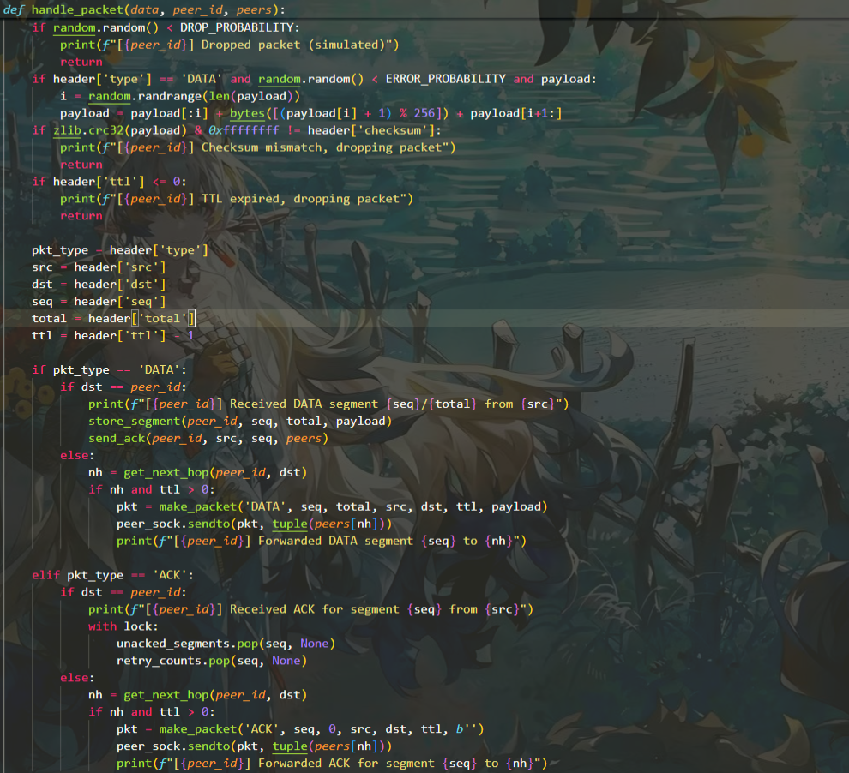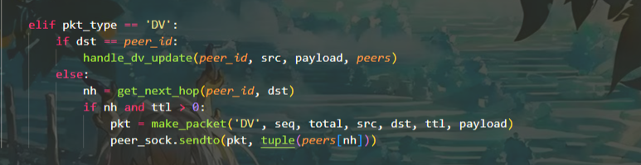

The handle_packet(data, peer_id, peers) function in Python processes incoming UDP packets in a peer-to-peer network. It parses the packet into header and payload, simulates packet loss with DROP_PROBABILITY, and introduces errors with ERROR_PROBABILITY. It verifies the checksum and TTL, dropping invalid packets. Based on the packet type—DATA, ACK, or DV—it either stores data segments, updates acknowledgment states, or handles routing updates, forwarding packets as needed. This function ensures reliable data handling and routing in the network.

Task 1.2: File Transmission
send_file
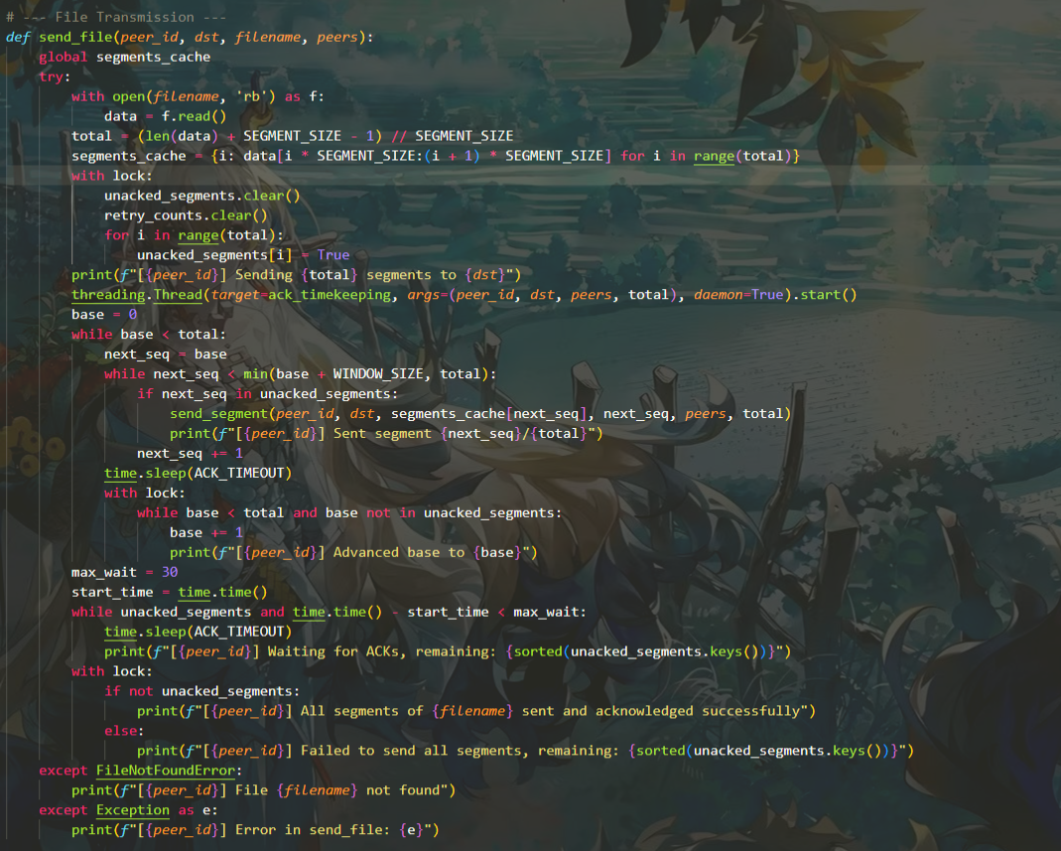
The send_file(peer_id, dst, filename, peers) function in Python facilitates reliable file transmission in a peer-to-peer network. It reads the file in binary mode, divides it into segments based on SEGMENT_SIZE, and caches them globally. Using a sliding window of size WINDOW_SIZE, it sends segments, tracks unacknowledged ones with unacked_segments, and advances the window upon receiving ACKs. A separate thread handles retransmissions via ack_timekeeping. After a 30-second wait, it confirms success or failure, logging the process, and handles errors like file not found, ensuring robust file delivery.

send_segment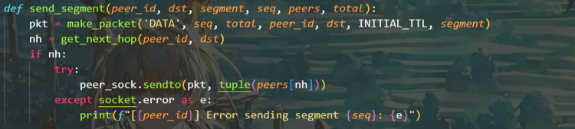

The send_segment(peer_id, dst, segment, seq, peers, total) function in Python handles sending a single data segment in a peer-to-peer network. It constructs a DATA packet using make_packet with the segment, sequence number, and total segments, setting an initial TTL. The function determines the next hop using get_next_hop, then sends the packet to that peer via peer_sock.sendto. If a socket error occurs, it logs the error with the peer ID and segment number, ensuring robust error handling during transmission.

Task 1.3: Segment Retransmission
ack_timekeeping
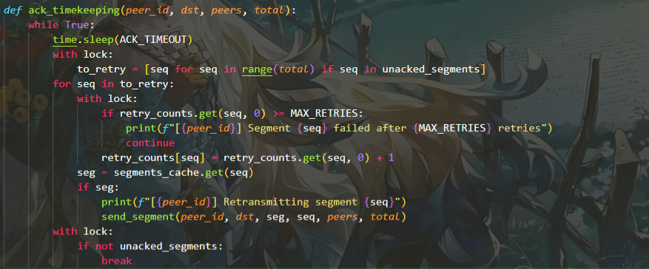
The ack_timekeeping(peer_id, dst, peers, total) function in Python manages acknowledgment timeouts and retransmissions in a peer-to-peer network. Running in a loop, it pauses for ACK_TIMEOUT seconds, then checks unacked_segments for unacknowledged segments. For each, it increments the retry count, retransmitting the segment via send_segment if below MAX_RETRIES, or logs a failure if exceeded. The loop terminates when all segments are acknowledged, ensuring reliable delivery with proper timeout handling.

Task 1.4: Segment Reception, Reassembly, and ACK

send_ack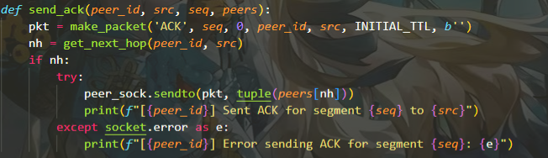
The send_ack(peer_id, src, seq, peers) function in Python sends an acknowledgment (ACK) packet in a peer-to-peer network. It constructs an ACK packet using make_packet with the sequence number, zero total segments, and an empty payload, setting an initial TTL. The function determines the next hop with get_next_hop and attempts to send the packet via peer_sock.sendto. Upon success, it logs the sent ACK; if a socket error occurs, it logs the error with the peer ID and sequence number, ensuring reliable acknowledgment transmission.

store_segment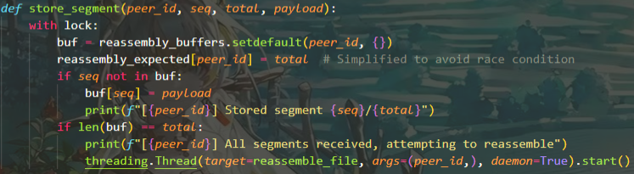
The store_segment(peer_id, seq, total, payload) function in Python manages segment storage for file reassembly in a peer-to-peer network. Under a thread-safe lock, it accesses the reassembly_buffers for the peer_id, setting the expected segment count in reassembly_expected. If the segment seq is not in the buffer, it stores the payload and logs the action. When all segments (len(buf) == total) are received, it logs the completion and starts a new thread to run reassemble_file, ensuring safe and asynchronous file reassembly.

reassemble_file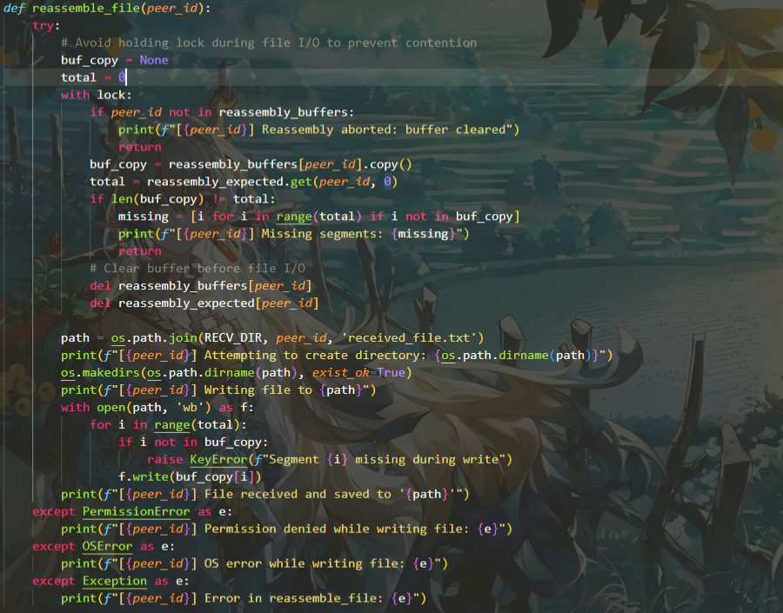
The reassemble_file(peer_id) function in Python reassembles file segments in a peer-to-peer network. It safely copies the reassembly_buffers under a lock, checks for missing segments, and clears the buffer to avoid contention. The function creates a directory at RECV_DIR/peer_id and writes segments to received_file.txt in binary mode. It logs the process and handles errors like PermissionError or OSError, ensuring robust file reassembly and storage.

TASK 2: Distance Vector (DV)-based routing algorithm
broadcast_dv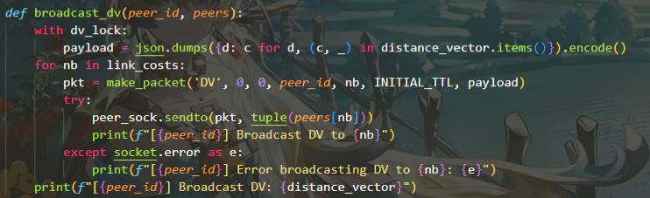
The broadcast_dv(peer_id, peers) function in Python manages the broadcasting of distance vector (DV) updates in a peer-to-peer network. Under a dv_lock, it serializes the distance_vector into a JSON payload. For each neighbor in link_costs, it creates a DV packet using make_packet with an initial TTL and sends it via peer_sock.sendto. The function logs successful broadcasts or socket errors for each neighbor, then outputs the updated distance_vector, ensuring dynamic routing updates across peers.

handle_dv_update
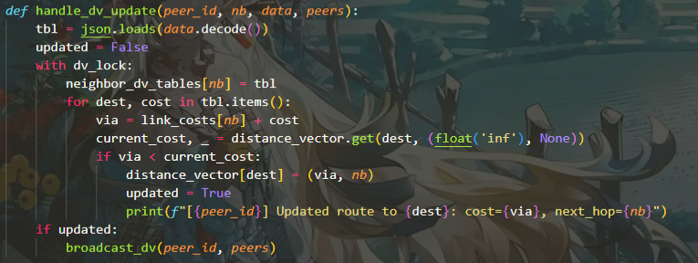

The handle_dv_update(peer_id, nb, data, peers) function in Python processes distance vector (DV) updates in a peer-to-peer network. It decodes the received data into a table, then under dv_lock, updates neighbor_dv_tables and checks each destination's cost. If a shorter path via the neighbor is found, it updates distance_vector with the new cost and next hop, logging the change. If updates occur, it triggers a broadcast_dv to propagate the changes, ensuring efficient routing optimization.

cost_update_thread
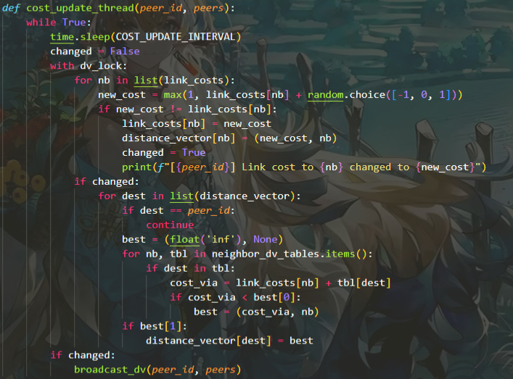
The cost_update_thread(peer_id, peers) function in Python periodically updates link costs in a peer-to-peer network. Every COST_UPDATE_INTERVAL, it adjusts costs in link_costs by adding a random value (-1, 0, or 1), ensuring a minimum of 1, under dv_lock. If changes occur, it updates distance_vector for neighbors, recalculates optimal routes for other destinations using neighbor_dv_tables, and triggers broadcast_dv to share updates, maintaining dynamic routing efficiency.

get_next_hop
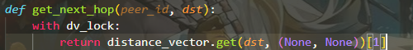
The get_next_hop(peer_id, dst) function in Python determines the next hop for a destination in a peer-to-peer network. Under dv_lock, it retrieves the next hop from the distance_vector dictionary using the destination dst, defaulting to (None, None) if not found. It returns the second element (index 1) of the tuple, representing the next hop peer, ensuring thread-safe and efficient routing decisions.

route_print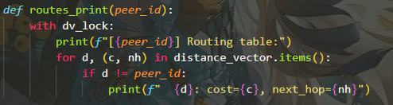
The routes_print(peer_id) function in Python displays the routing table for a peer in a peer-to-peer network. Under dv_lock, it prints a header with the peer's ID, then iterates over distance_vector.
3 Test
About the result in terminal
In Peer4, I try to display the route, then use the command of send Peer5 input.txt, then it display like this below
PS D:\CS305 Computer network\Assignment2> python3 peer.py --id Peer4
[Peer4] Starting...
[Peer4] Listening on 127.0.0.4:5004
[Peer4] > routes
[Peer4] Routing table:
Peer1: cost=inf, next_hop=None
Peer2: cost=4, next_hop=Peer2
Peer3: cost=1, next_hop=Peer3
Peer5: cost=2, next_hop=Peer5
[Peer4] > send Peer5 input.txt
[Peer4] Sending 18 segments to Peer5
[Peer4] Sent segment 0/18
[Peer4] Sent segment 1/18
[Peer4] Received ACK for segment 0 from Peer5
[Peer4] Sent segment 2/18
[Peer4] Received ACK for segment 1 from Peer5
[Peer4] Sent segment 3/18
[Peer4] Received ACK for segment 2 from Peer5
[Peer4] Retransmitting segment 3
[Peer4] Retransmitting segment 4
[Peer4] Retransmitting segment 5
[Peer4] Retransmitting segment 6
[Peer4] Received ACK for segment 3 from Peer5
[Peer4] Advanced base to 1
[Peer4] Advanced base to 2
[Peer4] Advanced base to 3
[Peer4] Retransmitting segment 7
[Peer4] Received ACK for segment 4 from Peer5
[Peer4] Sent segment 3/18
[Peer4] Retransmitting segment 8
[Peer4] Received ACK for segment 5 from Peer5
[Peer4] Sent segment 5/18
[Peer4] Retransmitting segment 9
[Peer4] Received ACK for segment 6 from Peer5
[Peer4] Received ACK for segment 3 from Peer5
[Peer4] Retransmitting segment 10
[Peer4] Received ACK for segment 7 from Peer5
[Peer4] Retransmitting segment 11
[Peer4] Received ACK for segment 5 from Peer5
[Peer4] Retransmitting segment 12
[Peer4] Sent segment 6/18
[Peer4] Received ACK for segment 8 from Peer5
[Peer4] Retransmitting segment 13
[Peer4] Received ACK for segment 6 from Peer5
[Peer4] Retransmitting segment 14
[Peer4] Retransmitting segment 15
[Peer4] Retransmitting segment 16
[Peer4] Received ACK for segment 10 from Peer5
[Peer4] Retransmitting segment 17
[Peer4] Received ACK for segment 11 from Peer5
[Peer4] Received ACK for segment 12 from Peer5
[Peer4] Received ACK for segment 13 from Peer5
[Peer4] Received ACK for segment 14 from Peer5
[Peer4] Received ACK for segment 15 from Peer5
[Peer4] Received ACK for segment 16 from Peer5
[Peer4] Received ACK for segment 17 from Peer5
[Peer4] Advanced base to 4
[Peer4] Advanced base to 5
[Peer4] Advanced base to 6
[Peer4] Advanced base to 7
[Peer4] Advanced base to 8
[Peer4] Advanced base to 9
[Peer4] Sent segment 9/18
[Peer4] Retransmitting segment 9
[Peer4] Received ACK for segment 9 from Peer5
[Peer4] Received ACK for segment 9 from Peer5
[Peer4] Advanced base to 10
[Peer4] Advanced base to 11
[Peer4] Advanced base to 12
[Peer4] Advanced base to 13
[Peer4] Advanced base to 14
[Peer4] Advanced base to 15
[Peer4] Advanced base to 16
[Peer4] Advanced base to 17
[Peer4] Advanced base to 18
[Peer4] All segments of input.txt sent and acknowledged successfully
[Peer4] > [Peer4] Updated route to Peer1: cost=6, next_hop=Peer2
[Peer4] Broadcast DV to Peer2
[Peer4] Broadcast DV to Peer3
[Peer4] Broadcast DV to Peer5
[Peer4] Broadcast DV: {'Peer1': (6, 'Peer2'), 'Peer2': (4, 'Peer2'), 'Peer3': (1, 'Peer3'), 'Peer4': (0, 'Peer4'), 'Peer5': (2, 'Peer5')}
[Peer4] Updated route to Peer1: cost=4, next_hop=Peer3
[Peer4] Updated route to Peer2: cost=2, next_hop=Peer3
[Peer4] Broadcast DV to Peer2
[Peer4] Broadcast DV to Peer3
[Peer4] Broadcast DV to Peer5
[Peer4] Broadcast DV: {'Peer1': (4, 'Peer3'), 'Peer2': (2, 'Peer3'), 'Peer3': (1, 'Peer3'), 'Peer4': (0, 'Peer4'), 'Peer5': (2, 'Peer5')}
[Peer4] Dropped packet (simulated)
[Peer4] Link cost to Peer3 changed to 2
[Peer4] Link cost to Peer5 changed to 1
[Peer4] Broadcast DV to Peer2
[Peer4] Broadcast DV to Peer3
[Peer4] Broadcast DV to Peer5
[Peer4] Broadcast DV: {'Peer1': (5, 'Peer3'), 'Peer2': (3, 'Peer3'), 'Peer3': (2, 'Peer3'), 'Peer4': (0, 'Peer4'), 'Peer5': (1, 'Peer5')}
The log shows Peer4 initiating a successful file transfer of input.txt (18 segments) to Peer5, with retransmissions handling packet loss. The DV routing table updates dynamically, adjusting costs (e.g., Peer1 from 6 to 4 via Peer3) and broadcasting changes. Simulated packet drops and cost updates (Peer3 to 2, Peer5 to 1) demonstrate robust network adaptability.
Meanwhile, the Peer5 display like this below.
[Peer5] Received DATA segment 0/18 from Peer4
[Peer5] Stored segment 0/18
[Peer5] Sent ACK for segment 0 to Peer4
[Peer5] Received DATA segment 1/18 from Peer4
[Peer5] Stored segment 1/18
[Peer5] Sent ACK for segment 1 to Peer4
[Peer5] Received DATA segment 2/18 from Peer4
[Peer5] Stored segment 2/18
[Peer5] Sent ACK for segment 2 to Peer4
[Peer5] Checksum mismatch, dropping packet
[Peer5] Received DATA segment 3/18 from Peer4
[Peer5] Stored segment 3/18
[Peer5] Sent ACK for segment 3 to Peer4
[Peer5] Received DATA segment 4/18 from Peer4
[Peer5] Stored segment 4/18
[Peer5] Sent ACK for segment 4 to Peer4
[Peer5] Received DATA segment 5/18 from Peer4
[Peer5] Stored segment 5/18
[Peer5] Sent ACK for segment 5 to Peer4
[Peer5] Received DATA segment 6/18 from Peer4
[Peer5] Stored segment 6/18
[Peer5] Sent ACK for segment 6 to Peer4
[Peer5] Received DATA segment 3/18 from Peer4
[Peer5] Sent ACK for segment 3 to Peer4
[Peer5] Received DATA segment 7/18 from Peer4
[Peer5] Stored segment 7/18
[Peer5] Sent ACK for segment 7 to Peer4
[Peer5] Received DATA segment 5/18 from Peer4
[Peer5] Sent ACK for segment 5 to Peer4
[Peer5] Received DATA segment 8/18 from Peer4
[Peer5] Stored segment 8/18
[Peer5] Sent ACK for segment 8 to Peer4
[Peer5] Received DATA segment 6/18 from Peer4
[Peer5] Sent ACK for segment 6 to Peer4
[Peer5] Dropped packet (simulated)
[Peer5] Received DATA segment 10/18 from Peer4
[Peer5] Stored segment 10/18
[Peer5] Sent ACK for segment 10 to Peer4
[Peer5] Received DATA segment 11/18 from Peer4
[Peer5] Stored segment 11/18
[Peer5] Sent ACK for segment 11 to Peer4
[Peer5] Received DATA segment 12/18 from Peer4
[Peer5] Stored segment 12/18
[Peer5] Sent ACK for segment 12 to Peer4
[Peer5] Received DATA segment 13/18 from Peer4
[Peer5] Stored segment 13/18
[Peer5] Sent ACK for segment 13 to Peer4
[Peer5] Received DATA segment 14/18 from Peer4
[Peer5] Stored segment 14/18
[Peer5] Sent ACK for segment 14 to Peer4
[Peer5] Received DATA segment 15/18 from Peer4
[Peer5] Stored segment 15/18
[Peer5] Sent ACK for segment 15 to Peer4
[Peer5] Received DATA segment 16/18 from Peer4
[Peer5] Stored segment 16/18
[Peer5] Sent ACK for segment 16 to Peer4
[Peer5] Received DATA segment 17/18 from Peer4
[Peer5] Stored segment 17/18
[Peer5] Sent ACK for segment 17 to Peer4
[Peer5] Received DATA segment 9/18 from Peer4
[Peer5] Stored segment 9/18
[Peer5] All segments received, attempting to reassemble
[Peer5] Attempting to create directory: files\Peer5
[Peer5] Sent ACK for segment 9 to Peer4
[Peer5] Received DATA segment 9/18 from Peer4
[Peer5] Stored segment 9/18
[Peer5] Sent ACK for segment 9 to Peer4
[Peer5] Writing file to files\Peer5\received_file.txt
[Peer5] File received and saved to 'files\Peer5\received_file.txt'
[Peer5] Updated route to Peer1: cost=8, next_hop=Peer4
[Peer5] Updated route to Peer2: cost=6, next_hop=Peer4
[Peer5] Updated route to Peer3: cost=3, next_hop=Peer4
[Peer5] Broadcast DV to Peer3
[Peer5] Broadcast DV to Peer4
[Peer5] Broadcast DV: {'Peer1': (8, 'Peer4'), 'Peer2': (6, 'Peer4'), 'Peer3': (3, 'Peer4'), 'Peer4': (2, 'Peer4'), 'Peer5': (0, 'Peer5')}
[Peer5] Updated route to Peer1: cost=6, next_hop=Peer4
[Peer5] Updated route to Peer2: cost=4, next_hop=Peer4
[Peer5] Broadcast DV to Peer3
[Peer5] Broadcast DV to Peer4
[Peer5] Broadcast DV: {'Peer1': (6, 'Peer4'), 'Peer2': (4, 'Peer4'), 'Peer3': (3, 'Peer4'), 'Peer4': (2, 'Peer4'), 'Peer5': (0, 'Peer5')}
[Peer5] Link cost to Peer4 changed to 1
[Peer5] Broadcast DV to Peer3
[Peer5] Broadcast DV to Peer4
[Peer5] Broadcast DV: {'Peer1': (6, 'Peer4'), 'Peer2': (4, 'Peer4'), 'Peer3': (3, 'Peer4'), 'Peer4': (1, 'Peer4'), 'Peer5': (0, 'Peer5')}
[Peer5] Link cost to Peer3 changed to 4
[Peer5] Broadcast DV to Peer3
[Peer5] Broadcast DV to Peer4
[Peer5] Broadcast DV: {'Peer1': (6, 'Peer4'), 'Peer2': (5, 'Peer4'), 'Peer3': (3, 'Peer4'), 'Peer4': (1, 'Peer4'), 'Peer5': (0, 'Peer5')}
The log shows Peer5 receiving all 18 segments of input.txt from Peer4, handling a checksum mismatch and simulated drop, and successfully reassembling the file into received_file.txt. DV routing updates adjust costs (e.g., Peer4 to 1), with broadcasts reflecting dynamic changes, ensuring network adaptability.
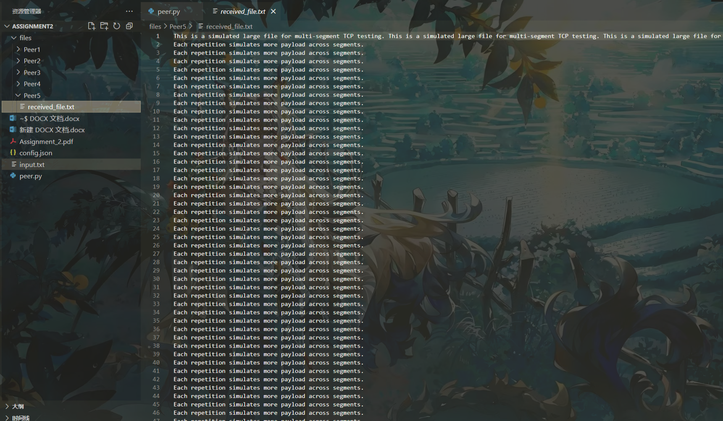
Above is the builders of the code, from this, we can see the received file has been perfectly done, which means the test for ‘send’ command is succeeded.

Then I test the routes command in Peer1, it display like below
[Peer1] Broadcast DV: {'Peer1': (0, 'Peer1'), 'Peer2': (2, 'Peer2'), 'Peer3': (3, 'Peer3'), 'Peer4': (4, 'Peer3'), 'Peer5': (5, 'Peer3')}
[Peer1] > routes
[Peer1] Routing table:
Peer2: cost=2, next_hop=Peer2
Peer3: cost=3, next_hop=Peer3
Peer4: cost=4, next_hop=Peer3
Peer5: cost=5, next_hop=Peer3
From above, we can see the routes can correctly display the routing table and it is fit with broadcast_dv. It’s succeed.
4 Conclusion
This project successfully implemented a reliable UDP-based file transfer system with a Distance Vector (DV) routing protocol for the second Computer Networking assignment. The system, built using peer.py, enabled robust file transmission between peers, as demonstrated by Peer4 sending input.txt (18 segments) to Peer5. Despite challenges like packet drops and checksum mismatches, the sliding window mechanism (size 4) and retransmission logic (up to 8 retries) ensured all segments were delivered, with Peer5 reassembling the file into received_file.txt. The DV protocol dynamically updated routing tables by using Bellman-Ford equation, adapting to link cost changes (e.g., Peer4 to Peer5 cost reduced to 1), enhancing network efficiency. Key functions like send_file, handle_packet, and reassemble_file worked cohesively to manage transmission, error handling, and file reassembly. Adjustments to DROP_PROBABILITY (0.05) and MAX_RETRIES improved reliability, while thread-safe operations prevented contention during reassembly. This project deepened my understanding of reliable transport over unreliable protocols and distributed routing, meeting all assignment criteria and laying a strong foundation for further exploration in networked systems. The implementation's success underscores the importance of error handling and dynamic adaptation in peer-to-peer networks.

