**CHAPTER 2: FUNCTIONAL SPECIFICATION REPORT**

**2.1. Data Requirements**

**2.1.1. Forms**

**2.1.1.1 List of Forms**

|  |  |  |  |
| --- | --- | --- | --- |
| *NO.* | *NAME* | *DESCRIPTION* | *USER* |
| *1* | ***Price Quotation*** | *This form contains the quoted order with the price, the schedule for measurement, and the terms of payment.* | *Management / Customer* |
| *2* | ***Purchase Order*** | *This report contains the list of orders of the customer, total amount, their terms and the date of the PO.* | *Management / Customer* |
| *3* | ***Measurement Form*** | *This form contains the details about the customer, his/her measurements and the job workers’ details. It also includes the tutorial and tips in taking measurements (if taken by nonprofessional).* | *Receptionist / Tailor /*  *Customer* |
| *4* | ***Delivery Form*** | *This form contains the customer/company name, the list of all the employees and the garments made for each.* | *Management / Runner / Customer* |
| *5* | ***Official Receipt*** | *This report contains the payee, the amount in full payment, the service(s) acquired and the date the OR was issued.* | *Management / Customer* |
| *6* | ***Billing Invoice*** | *This report contains the payee, the amount for down payment, the service(s) acquired and the date issued.* | *Management /*  *Customer* |
| *7* | ***Statement of Account*** | *This report contains the customer/company name, the date the orders were delivered, the order details and the total amount to be paid.* | *Management / Customer* |
| *8* | ***Delivery Receipt*** | *This report contains garments ordered, the date delivered as well as the total amount as proof of payment.* | *Management / Customer* |
| *9* | ***Contract of Agreement*** | *This report contains the garment / uniform package the customer ordered, total per garment depending on the quantity, overall amount, and schedule of work, terms of payment and the conditions of the contract. It also includes names and signatures of both parties’ representatives as well as the witnesses’.* | *Management / Customer* |
| *10* | *Acknowledgement Receipt* | *This report contains the amount received by the business from the customer as a form of verification.* | *Management / Customer* |

**2.1.1.3 Data Dictionary of Forms**

|  |  |  |  |
| --- | --- | --- | --- |
| FORM NAME : Price Quotation  FORM DESCRIPTION: *This form contains the quoted order with the price, the*  *schedule for measurement, and the terms of payment.* | | | |
| DATA ELEMENT | **DESCRIPTION** | **DATA TYPE** | **SAMPLE DATA** |
| Name | Name of the Customer | VarChar | Jacqueline Pablo |
| Company | Name of Company | VarChar | KServico |
| Address | Company Address | VarChar | Brgy. Socorro, Cubao |
| Garments | Garments to be ordered | VarChar | Pants |
| Quantity | Quantity per garment | VarChar | Two (2) |
| Unit Price | Price per piece | VarChar | P400 |
| Amount | Quantity times unit price | VarChar | P800 |
| Total | Total per package | VarChar | P4900 |

|  |  |  |  |
| --- | --- | --- | --- |
| FORM NAME : Purchase Order  FORM DESCRIPTION: *This report contains the list of orders of the customer,*  *total amount, their terms and the date of the PO.* | | | |
| DATA ELEMENT | **DESCRIPTION** | **DATA TYPE** | **SAMPLE DATA** |
| Company Name | Name of Purchaser / Company | VarChar | Bayer Philippines |
| Company Address | Address of the Purchaser | VarChar | Calamba, Laguna |
| Client Name | Name of Client | VarChar | Fashion Collection by Teresita Enrile |
| Client Address | Address of the Client | VarChar | Makati-Rizal Village |
| PO Number | Purchase Order Number | VarChar | 12345 |
| Date | Date of the PO | DateTime | 09/10/13 |
| PO Contact Person | Contact Person regarding the PO | VarChar | Grace Marie |
| PO Contact Details | Contact Details of the PO Contact Person | VarChar | 09123456789 |
| Item No | Item Code of the Order | VarChar | 0030 |
| Quantity | Number of sets | VarChar | 3 |
| Item Description | Description of the orders | VarChar | Female Uniforms |
| Price | Price per set | VarChar | P4375 |
| Value | Amount per set times quantity | VarChar | P17500 |
| Total | Overall Total | VarChar | P345625 |
| Consignee | Receiver of the delivery per order | VarChar | Accounting Department |
| Terms of Payment | How the order is to be paid | VarChar | Cash on Delivery |
| Representative | Authorized Representative of the Purchaser | VarChar | Dominic Zapanta |

|  |  |  |  |
| --- | --- | --- | --- |
| FORM NAME : Measurement Form  FORM DESCRIPTION: *This form contains the details about the customer,*  *his/her measurements and the job workers’ details.* | | | |
| DATA ELEMENT | **DESCRIPTION** | **DATA TYPE** | **SAMPLE DATA** |
| Name | Name of the Employee | VarChar | Haru Esteban |
| Company | Name of Company | VarChar | M |
| Department | Employees’ department | VarChar | Human Resource |
| Officer | If the employee to be measured is an officer | VarChar | Yes |
| Staff | If the employee to be measured is a staff | VarChar | No |
| i.e. Shoulder | Measurements to be taken | VarChar | 18 in |
| Remarks | Remarks about the job to be done | VarChar | Put little allowance |
| Cutter | Name of the Cutter assigned | VarChar | Anna |
| Sewer | Name of the sewer assigned | VarChar | Kelly |
| QC | Quality Control | VarChar | Natalya |
| Reviser | Reviser assigned | VarChar | Jazz |
| Date of Measurement | Date the measurement is taken | DateTime | 03/05/15 |
| Measurement taken by: | Name of the person who took the measurement | VarChar | Fara |

|  |  |  |  |
| --- | --- | --- | --- |
| FORM NAME: Delivery Form  FORM DESCRIPTION: *This form contains the customer/company name, the*  *list of all the employees and the garments made for each.* | | | |
| DATA ELEMENT | **DESCRIPTION** | **DATA TYPE** | **SAMPLE DATA** |
| To | Name of Customer/Company | VarChar | KServico |
| Name of Employee | List of names of employees | VarChar | Joaquin Antonio |
| Blouse | Quantity per person | VarChar | 1 |
| Pants | Quantity per person | VarChar | 1 |
| Dress | Quantity per person | VarChar | 1 |
| Received by | Receiver of the delivery | VarChar | Owen Santos |

|  |  |  |  |
| --- | --- | --- | --- |
| FORM NAME : Official Receipt  FORM DESCRIPTION: *This report contains the payee, the amount in full*  *payment, the service(s) acquired and the date the OR*  *was issued.* | | | |
| DATA ELEMENT | **DESCRIPTION** | **DATA TYPE** | **SAMPLE DATA** |
| Name | Name of the Customer/Company | VarChar | KServico |
| Address | Address of the Customer/Company | VarChar | Brgy. Socorro, Cubao |
| Date | Current Date | DateTime | 2/23/2013 |
| Amount | Total amount paid | VarChar | P55000 |
| Articles | Garments ordered | VarChar | Uniform |
| Cashier | Authorized Representative | VarChar | Grace Sales |

|  |  |  |  |
| --- | --- | --- | --- |
| FORM NAM : Billing Invoice  FORM DESCRIPTION: *This report contains the payee, the amount for down*  *payment, the service(s) acquired and the date issued.* | | | |
| DATA ELEMENT | **DESCRIPTION** | **DATA TYPE** | **SAMPLE DATA** |
| To | Name of the Customer/Company | VarChar | KServico |
| Address | Address of the Customer/Company | VarChar | Brgy. Socorro, Cubao |
| Date | Current Date | DateTime | 2/23/2013 |
| Quantity | No. of Order | VarChar | 2 |
| Articles | Garments ordered | VarChar | Blouse |
| Unit Price | Price per piece | VarChar | P350 |
| Amount | Quantity times the unit price | VarChar | P700 |
| Total | Total amount to be paid | VarChar | P2500 |

|  |  |  |  |
| --- | --- | --- | --- |
| FORM NAME: Statement of Account  FORM DESCRIPTION: *This report contains the customer/company name, the*  *date the orders were delivered, the order details and the*  *total amount to be paid.* | | | |
| DATA ELEMENT | **DESCRIPTION** | **DATA TYPE** | **SAMPLE DATA** |
| Name | Name of the Customer/Representative | VarChar | Jamila Matias |
| Position | Position of the Representative | VarChar | HR |
| Company | Name of the Company | VarChar | KServico |
| Address | Company Address | VarChar | Brgy. Socorro, Cubao |
| Account | Name of Account | VarChar | Kservico |
| Date | Due Date | DateTime | 4/25/15 |
| Quantity | No. of Order per garment | VarChar | 2 |
| Description | Kind of Garments | VarChar | Dress |
| Unit Price | Price per piece | VarChar | P350 |
| Total | Quantity times the unit price | VarChar | P700 |
| Total Amount Due | Total amount to be paid | VarChar | P2500 |

|  |  |  |  |
| --- | --- | --- | --- |
| FORM NAME : Delivery Receipt  FORM DESCRIPTION: *This report contains garments ordered, the date*  *Delivered as well as the total amount as proof of payment.* | | | |
| DATA ELEMENT | **DESCRIPTION** | **DATA TYPE** | **SAMPLE DATA** |
| Amount | Amount Paid | VarChar | Forty five thousand pesos (45000) |
| Name | Name of Customer / Company | VarChar | KServico |
| Representative | Checked and certified by the authorized representative of the business | VarChar | Manu Rios |

|  |  |  |  |
| --- | --- | --- | --- |
| FORM NAME : Contract of Agreement  FORM DESCRIPTION: *This report contains the garment / uniform package the*  *customer ordered, total per garment depending on the quantity, overall*  *amount, and schedule of work, terms of payment and the conditions of*  *the contract. It also includes names and signatures of both parties’*  *representatives as well as the witnesses’.* | | | |
| DATA ELEMENT | **DESCRIPTION** | **DATA TYPE** | **SAMPLE DATA** |
| Date | Current Date | DateTime | 2/23/2013 |
| Name | Name of the Customer/Company | VarChar | KServico |
| Subject | Order Description | VarChar | Supply of Female Uniforms |
| Garment | Garment Description | VarChar | Blouse |
| Quantity | Number of pieces | VarChar | 2 |
| Unit Price | Price per piece | VarChar | P350 |
| Amount | Quantity times the unit price | VarChar | P700 |
| Total | Total amount to be paid | VarChar | P2500 |
| Terms of Payment | How the order will be paid | VarChar | 50% Downpayment |
| Customer / Company Representative | Authorized representative of the Company | VarChar | Anton dela Vega |
| Business Representative | Authorized representative of the business | VarChar | Reid Alleje |
| Witness | Witness of the contract signing | VarChar | Kai Montezor |

|  |  |  |  |
| --- | --- | --- | --- |
| FORM NAME : Acknowledgement Receipt  FORM DESCRIPTION: *This report contains the amount received by the*  *business from the customer as a form of verification.* | | | |
| DATA ELEMENT | **DESCRIPTION** | **DATA TYPE** | **SAMPLE DATA** |
| Amount | Amount Paid | VarChar | Forty five thousand pesos (45000) |
| Name | Name of Customer / Company | VarChar | KServico |
| Receiver | Received by a representative from the business | VarChar | Grace Sales |

**2.1.2. Reports**

**2.1.2.1 List of Reports**

|  |  |  |  |
| --- | --- | --- | --- |
| *NO.* | *NAME* | *DESCRIPTION* | *USER* |
| *1* | ***Billing Report*** | *This report contains all the billing information of the orders for a specific period of time.* | *Management* |
| *2* | ***Account Receivables*** | *This contains all the receivables held by the business against its customers for goods supplied and/or services rendered in execution of the customer's order.* | *Management* |
| *3* | ***Job Order Report*** | *Contains all the job orders the business received for a specific period of time.* | *Management* |
| *4* | ***Delivery Report*** | *Contains all the delivery status and detailed delivery information about the job orders.* | *Management* |
| *5* | *Sales Report* | *Contains summarized information of the business’ sales* | *Management* |

**2.1.2.2 Layout of Reports**

**Billing Report**

|  |  |  |  |  |  |  |  |  |
| --- | --- | --- | --- | --- | --- | --- | --- | --- |
| **Period: From [Date] to [Date]** | | | | | | | | |
| **Receipt No** | **Order No** | **Customer/**  **Company** | **Billing Date** | **Total Amount** | **Amount Received** | **Balance** | **Accepted by** | **Time Stamp** |
|  |  |  |  |  |  |  |  |  |
|  |  |  |  |  |  |  |  |  |
| **Prepared by: [Name]** | | | | | | | | |

**Account Receivables**

|  |  |  |  |  |  |  |  |  |
| --- | --- | --- | --- | --- | --- | --- | --- | --- |
| **Period: From [Date] to [Date]** | | | | | | | | |
| **Order No** | **Order Date** | **Customer/**  **Company** | **Amount** | **Amount Received** | **Date Received** | **Outstanding**  **balance** | **Accepted by** | **Time Stamp** |
|  |  |  |  |  |  |  |  |  |
| **Prepared by: [Name]** | | | | | | | | |

**Job Order Report**

|  |  |  |  |  |  |  |  |  |
| --- | --- | --- | --- | --- | --- | --- | --- | --- |
| **Period: From [Date] to [Date]** | | | | | | | | |
| **Order No** | **Customer/**  **Company** | **Order Date** | **Payment**  **Terms** | **Gross Amount** | **Tax** | **Net Amount** | **Accepted by** | **Time Stamp** |
|  |  |  |  |  |  |  |  |  |
| **Prepared by: [Name]** | | | | | | | | |

**Delivery Report**

|  |  |  |  |  |  |  |  |  |  |
| --- | --- | --- | --- | --- | --- | --- | --- | --- | --- |
| **Period: From [Date] to [Date]** | | | | | | | | | |
| **Order No** | **Order Date** | **Delivery Date** | **Customer/**  **Company** | **Total Pieces** | **Pre Delivered** | **Delivery Pieces** | **Balance Pieces** | **Accepted by** | **Time Stamp** |
|  |  |  |  |  |  |  |  |  |  |
| **Prepared by: [Name]** | | | | | | | | | |

**Sales Report**

|  |  |  |  |  |  |  |  |  |  |
| --- | --- | --- | --- | --- | --- | --- | --- | --- | --- |
| **Period: From [Date] to [Date]** | | | | | | | | | |
| **Order No** | **Order Date** | **Customer/ Company** | **Gross Amount** | **Tax** | **Net Amount** | **Paid** | **Balance** | **Accepted by** | **Time Stamp** |
|  |  |  |  |  |  |  |  |  |  |
| **Prepared by: [Name]** | | | | | | | | | |

**2.1.2.3 Data Dictionary of Reports**

|  |  |  |  |  |
| --- | --- | --- | --- | --- |
| FORM NAME : Billing Report  FORM DESCRIPTION:  *This report contains all the billing information of the*  *orders for a specific period of time.* | | | | |
| DATA ELEMENT | **DESCRIPTION** | **DATA TYPE** | **SAMPLE DATA** |
| Period | Period of time the report is from | DateTime | 2014-09-29  2014-12-29 |
| Receipt No | Receipt number | VarChar | 01234 |
| Order No | Order number | VarChar | ORDER00372 |
| Customer/Company | Name of Customer | VarChar | Jacky Sales |
| Billing Date | Date the order was billed | DateTime | 2014-10-21 |
| Total Amount | Total amount | VarChar | 650,000 |
| Amount Received | Amount paid | VarChar | 325,000 |
| Balance | Remaining balance | VarChar | 325,000 |
| Accepted by | Employee that accepted the payment | VarChar | Lito Binas |
| Time Stamp | Date and time the payment was received | DateTime | 2014-10-22  02:35 pm |

|  |  |  |  |
| --- | --- | --- | --- |
| FORM NAME : Accounts Receivable  FORM DESCRIPTION: *This contains all the receivables held by the business*  *against its customers for goods supplied and/or services rendered*  *in execution of the customer's order.* | | | |
| DATA ELEMENT | **DESCRIPTION** | **DATA TYPE** | **SAMPLE DATA** |
| Period | Period of time the report is from | DateTime | 2014-09-29  2014-12-29 |
| Order No | Order number | VarChar | ORDER00372 |
| Order Date | Date of the order | DateTime | 2014-11-27 |
| Customer | Name of Customer | VarChar | Johanna Abatay |
| Amount | Total amount | VarChar | 343,400 |
| Amount Received | Amount paid | VarChar | 175,000 |
| Date Received | Date of payment | DateTime | 2014-11-23 |
| Outstanding Balance | Remaining balance | VarChar | 168,400 |
| Accepted by | Employee that accepted the payment | VarChar | Lito Binas |
| Timestamp | Date and time the payment was received | DateTime | 2014-10-22  02:35 pm |

|  |  |  |  |
| --- | --- | --- | --- |
| FORM NAME : Job Order Report  FORM DESCRIPTION: *Contains all the job orders the business received for a*  *specific period of time.* | | | |
| DATA ELEMENT | **DESCRIPTION** | **DATA TYPE** | **SAMPLE DATA** |
| Period | Period of time the report is from | DateTime | 2014-09-29  2014-12-29 |
| Order No | Order number | VarChar | ORDER00372 |
| Customer | Name of customer | VarChar | Johanna Abatay |
| Order Date | Date of the order | DateTime | 2014-11-27 |
| Payment Terms | Terms of payment | VarChar | Cheque |
| Gross Amount | Total amount without tax | VarChar | 340,000 |
| Tax | Tax amount | VarChar | 3,400 |
| Net Amount | Total amount with tax | VarChar | 343,400 |
| Accepted by | Employee that accepted the order | VarChar | Lito Binas |
| Timestamp | Date and time the order was received | DateTime | 2014-10-22  02:35 pm |

|  |  |  |  |
| --- | --- | --- | --- |
| FORM NAME : Delivery Report  FORM DESCRIPTION: *Contains all the delivery status and detailed delivery*  *information about the job orders.* | | | |
| DATA ELEMENT | **DESCRIPTION** | **DATA TYPE** | **SAMPLE DATA** |
| Period | Period of time the report is from | DateTime | 2014-09-29  2014-12-29 |
| Order No | Order number | VarChar | ORDER00372 |
| Order Date | Date of the order | DateTime | 2014-11-27 |
| Delivery Date | Date of the order delivered | DateTime | 2014-12-27 |
| Customer/Company | Name of customer | VarChar | Johanna Abatay |
| Total Pieces | Total number of ordered pieces | VarChar | 12 |
| Pre Delivered | Date the order was first delivered | DateTime | 2014-12-08 |
| Delivery Pieces | Number of pieces delivered | VarChar | 5 |
| Balance Pieces | Remaining pieces undelivered | VarChar | 7 |
| Accepted by | Customer/Representative that accepted the delivery | VarChar | Lito Binas |
| Timestamp | Date and time the delivery was received | DateTime | 2014-10-22  02:35 pm |

|  |  |  |  |
| --- | --- | --- | --- |
| FORM NAME : Sales Report  FORM DESCRIPTION: *Contains summarized information of the business’ sales* | | | |
| DATA ELEMENT | **DESCRIPTION** | **DATA TYPE** | **SAMPLE DATA** |
| Period | Period of time the report is from | DateTime | 2014-09-29  2014-12-29 |
| Order No | Order number | VarChar | ORDER00372 |
| Order Date | Date of the order | DateTime | 2014-11-27 |
| Customer/Company | Name of Customer | VarChar | Johanna Abatay |
| Gross Amount | Total amount without tax | VarChar | 340,000 |
| Tax | Tax amount | VarChar | 3,400 |
| Net Amount | Total amount with tax | VarChar | 343,400 |
| Paid | Amount paid | VarChar | 175,000 |
| Balance | Remaining balance | VarChar | 168,400 |
| Accepted by | Employee that accepted/confirmed the payment | VarChar | Lito Binas |
| Timestamp | Date and time the payment was received | DateTime | 2014-10-22  02:35 pm |

**2.1.3. Logical Data Structures**

### 2.1.3.1 Entity Relationship Diagram

<See attached file>

**2.2. Policies and Procedures**

**2.2.1 Procedures**

**2.2.1.1 Context Diagram**

<See attached file>

### 2.2.1.2 Level 1 Data Flow Diagram

<See attached file>

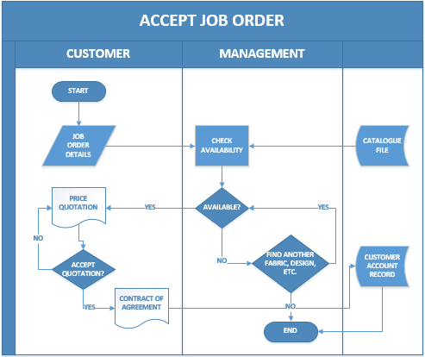**2.2.1.3 Process Flow Diagram**

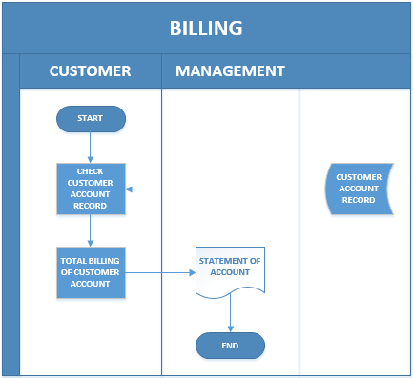

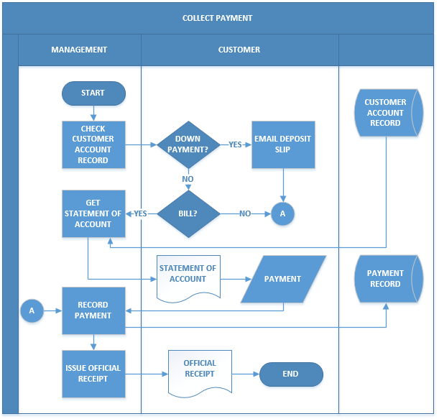

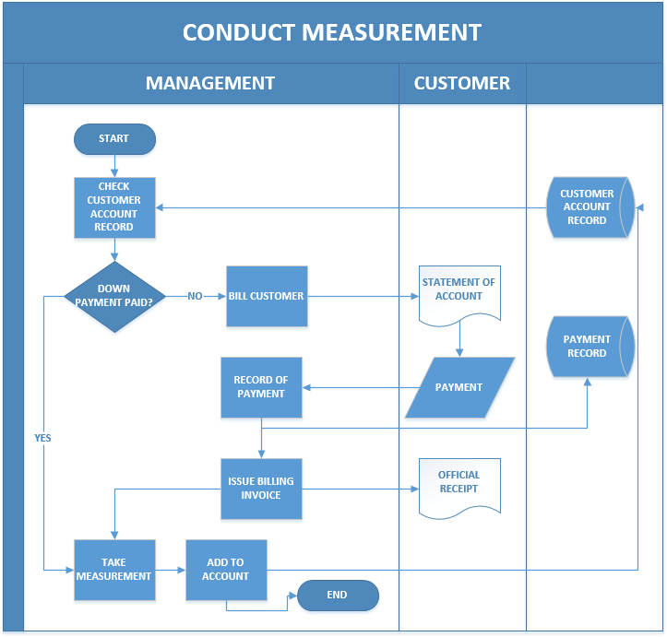

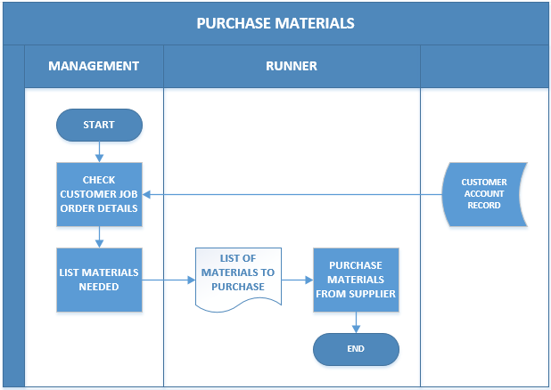

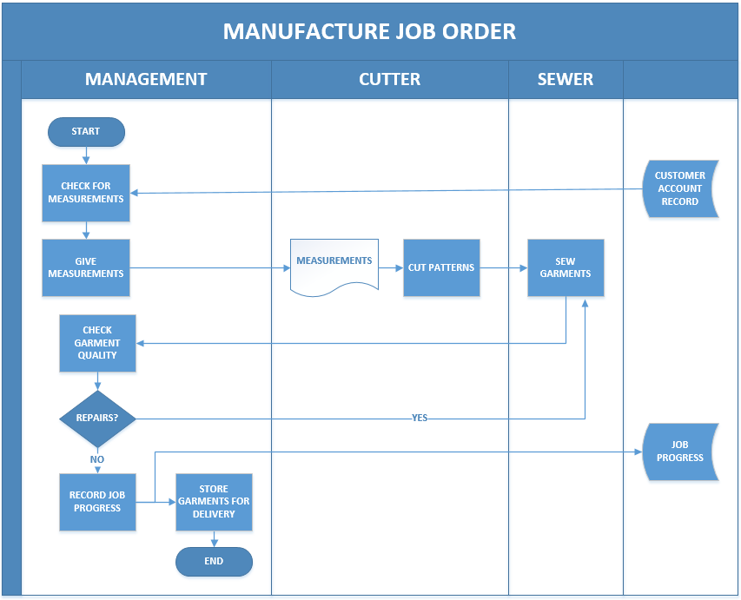

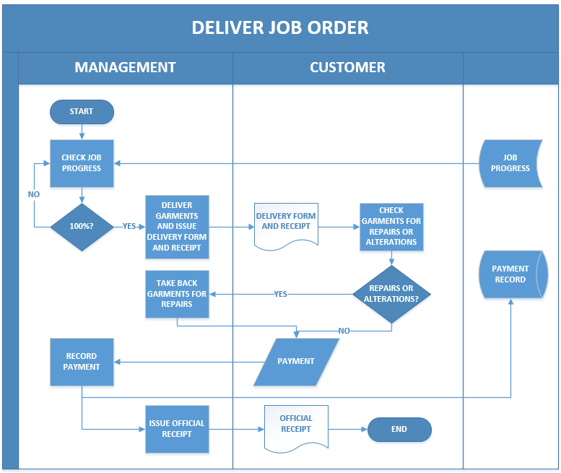

**2.2. PROBLEM ANALYSIS**

**2.2.1. Fishbone Diagram**

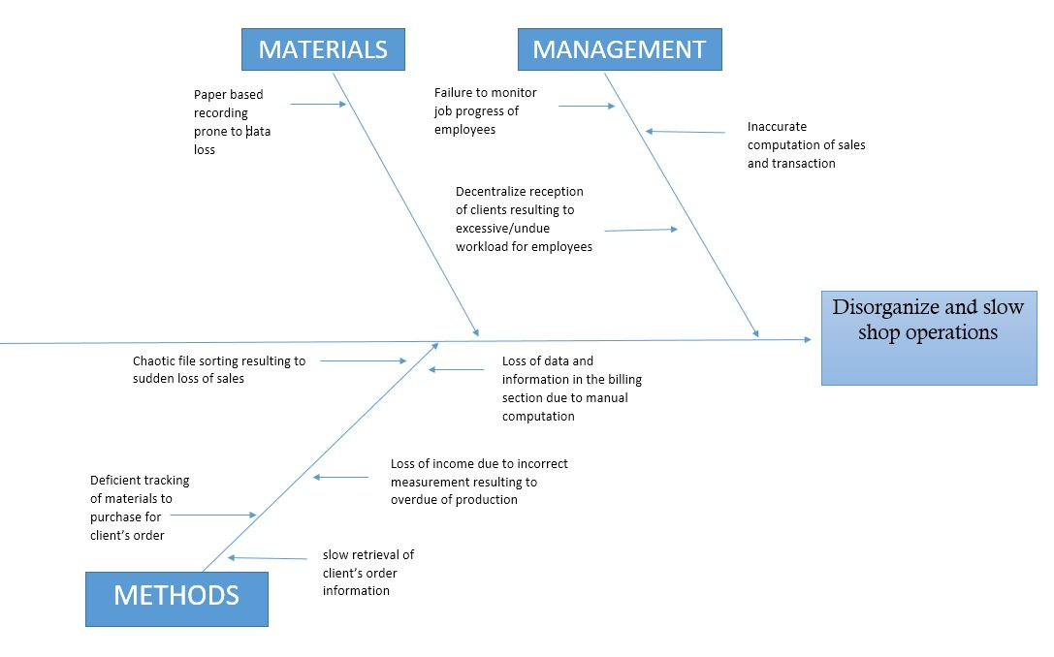

**2.2.2 Problem Requirements**

|  |  |
| --- | --- |
| Problem | Requirements |
| Disorganize and slow shop operations | * To automate the paper-based system of the shop into a modern computerized system that will enhance data retrieval, storage and security. * To smooth the progress of tracking and recording of job orders. * To create a system that will organize the records of the customers especially the multinational companies. * To build a database that will handle substantial files and multiple data that the shop needs to record. * To lessen the time in generating reports |

**2.2.3 Conclusions and Recommendations**

**2.2.3.1 Conclusion**

Based on observation and thorough analysis, inaccurate data entry, chaotic file sorting, slow retrieval of client’s job orders details, decentralize reception of client, and wrong computation of sales and balance poses as the main problem of the shop. They are also using logbooks and columnar books to record transactions which is prone to data lost. They do not have a backup data that will help them optimize the operations of the shop via minimizing the time in data retrieving, recording and updating. The proponents conclude that the propose system will be of great help to eradicate most of the problems of the business firm.

**2.2.3.2 Recommendation**

The Web Based Tailoring Management System is proposed to meet up the needs of the organization specially the tailoring business owners to provide an accurate data to its clients, monitor its sales properly and transparency to their business transactions. It is recommended to use this kind of modern system to provide a centralized, transparent, effective and modern system to the clients. This will enable the firm to expand its capabilities in handling customer inquiries as well as in optimizing internal job processes.