QUICK GUIDE

PGADMIN & POSTGRES INSTALL

Contents

DOWNLOADING PGADMIN 1

Connecting to AWS 1

DOWNLOADING POSTGRES 1

Connecting to localhost 1

LOADING YOUR OWN DATA 1

ERRORS! 1

**PostgreSQL** (pronounced "post-gress-Q-L") is an open source relational database management system ( DBMS ) developed by a worldwide team of volunteers.**PostgreSQL** is not controlled by any corporation or other private entity and the source code is available free of charge.

**pgAdmin** open source administration development platform for PostGreSQL

Postgres is how and where your data is stored, PgAdmin is a Viewer into Postgres to maintain the database or retrieve data.

# DOWNLOADING PGADMIN

Pgadmin4 is a viewer into the databases. The product can be buggy at times. You may need to reboot the program or even your device. Having a lot of programs running on your device will decrease performance.

After Pgadmin4 is loaded we will connect to AWS and then to our own servers.

Download the latest version of pgAdmin for your device. <https://www.pgadmin.org/download/>

The download is typically an executable file. .exe or mac .dmg it is also going to be the largest file.

Once you have downloaded pgAdmin you are ready to connect the SQL Editor to AWS

# Connecting to AWS

1. Open Pgadmin
2. Locate the Browser pane
3. Right click on the Server Icon
4. Choose Create
5. Click on Server

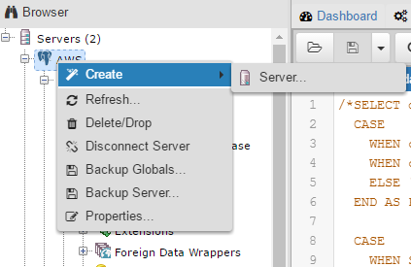

1. Give your connection to AWS a name, recommendation….AWS

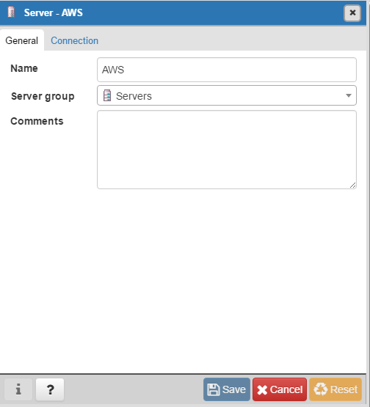

1. Then click on the Connections tab.
2. In the connection tab fill in the following.

Host name/address: Analyticsga.cuwj8wuu6wbh.us-west-2.rds.amazonaws.com

Port: 5432

Maintenance: postgres

User name: analytics_student

Your password for AWS is analyticsga

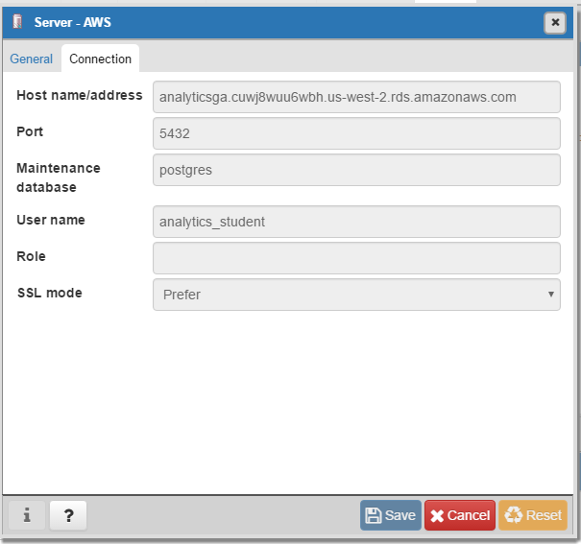

1. Save your connection and explore AWS. See if you can Navigate through the Browser panfind tables for Iowa liquor sales.

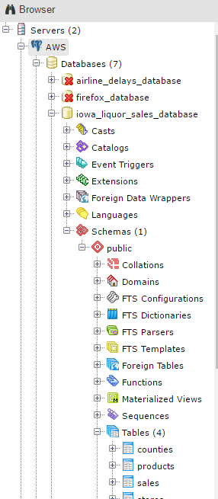

# DOWNLOADING POSTGRES

This will be your own local relational database management server(RDBMS)

<https://www.postgresql.org/>

You will be asked to Create a password. Write this password down. you will need it to connect to your database.

When asked what applications you would like installed, check all except Registration required add-ons. Also you may have some already installed, ie Postgres will already be installed.

We won’t need these add ons for class but you may want them as you further your understanding of data and databases.

*this snippet may look different from yours.

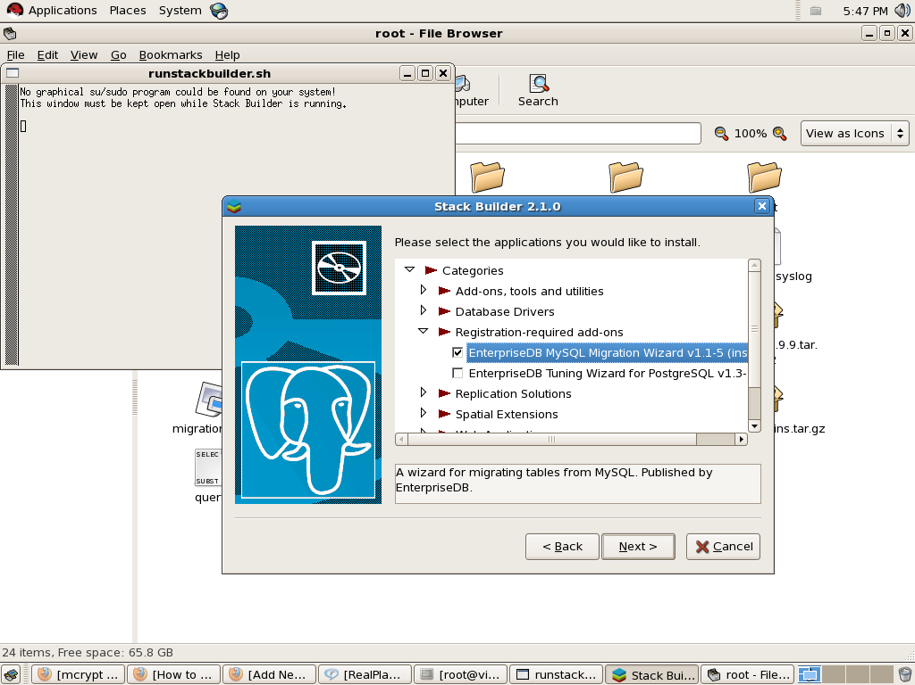

# Connecting to localhost

Once your all installed you are ready to connect to your database using pgAdmin

Open pgAdmin4

Create a new server connection

Name your connection whatever you like.

Here are the properties for your connection.

Remember the Password you created? You will need that now.

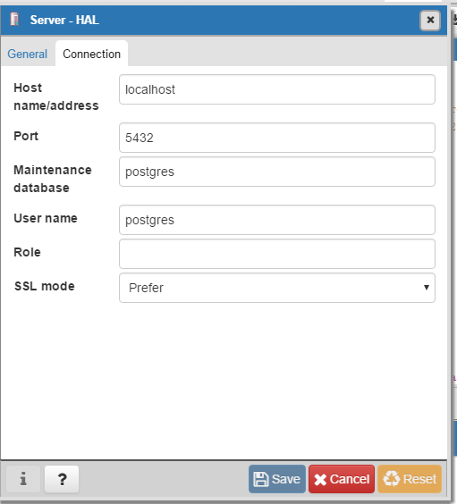

# LOADING YOUR OWN DATA

If we have time we will do this in class. This is just a quick guide)

Once you have created your connection. Navigate around your database. Currently there is no data loaded.

You will need to load data

Here is an example of how to load data into a table.

The dataset I will be using is a sample from titianic.csv

You can find this data set on my github or in any google search for titanic.csv

1. Once you have a data set that you want you will need to first open the SQL Editor within PgAdmin.
2. Right Click on you’re the Server you created. It should be an icon in your Browser pane.
3. Click on create Database
4. Name your database and save
5. Navigate to schemas in your new database
6. Right click on public
7. Choose Query tool.

Here is sample syntax of creating and loading tables into your database.

Here is the sample syntax.

CREATE TABLE public.titanic

(

passengerid integer,

survived integer,

pclass integer,

name character(225) ,

sex character(30),

age numeric,

sibsp integer,

parch integer,

ticket character(30),

fare money,

cabin character(15),

embarked character(1)

)

Finally you are ready to load your data into the new table.

Here is sample syntax using COPY and FROM to load data into the new table.

You will need to change this to your own address. Mac users will need to have their address of the file from GET INFO

COPY titanic FROM 'C:\Users\Matthew\Desktop\DataScience\titanic.csv' DELIMITER ',' CSV HEADER;

# ERRORS!

If you get permissions errors first check to make sure you have the file selected and not just the folder. Then try this method.

· Right click the folder containing the data file(s) that permission was denied to and then click **Properties**.

· In the Folder's Properties window, select the **Security** tab.

· Click the **Edit** button.

· In the "Permissions for the folder" window that opened, click the **Add...** button.

· Type Everyone into the "Enter the object names to select" text area box.

· Click **OK** and the window will close.

· Verify that the default **Read & Execute** permissions were set to **Allow** via the check checkbox in the previous window.

· Click **OK** and the window will close.

· Click the **Apply** button in the Folder Properties window.

Now you can run the SQL COPY statement that needs to access those files.

· Once done, return to the Folder's Properties window.

· Click the **Edit** button.

· Select the Everyone entry in the "Group or user names:" field.

· Click the **Remove** button.

· Click **OK** on the remaining open windows.

The permissions have now been returned to what they were.

MAC USERS -FINDING FILE ADDRESS

This one depends there are few methods you can try. If these do not work you may need to troubleshoot outside of class.

Method 1

1. Click on the file or folder you want the path for  
2. Click on ‘Finder’ in the menu bar  
3. ‘Services’  
4. ‘TextEdit’  
5. ‘New Window containing Selection’

Method 2

Try dragging file into browser window

Method 3

1. Click and hold the file.
2. While you still have it selected, do Command+Space to show the Spotlight menu.
3. Drag the file into the Spotlight field and release.
4. The file’s pathway is in Spotlight’s search field.

Method 4

