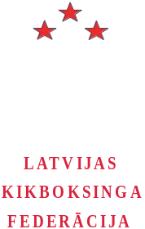 | Latvian Kickboxing Federation  Brīvības gatve 197, kor. 36, kab. 202,  Rīga LV-1039, Latvija  Tālr. + 371 67272181  Fakss + 371 67233877  Internets: http://www.budo.lv  E-pasts: budo@dza.lv  Reģistrācijas Nr.40008027906  IBAN LV43BATR0051J01521300  A/S “Baltic Trust Bank”, SWIFT BATRLV2X

“Latvia Open 2008”

12-th Latvian international kickboxing championship
(full-contact, low-kick)

Date | 7th – 9th of March, 2008
Organizers | Latvian Kickboxing Federation in cooperation with the Sport Department of the Ministry of Education and Science of LR  Brivibas gatve 197/36 – 202, Riga LV-1039, Latvia  Phone +371 67272181, Fax +371 67233877 e-mail: budo@dza.lv
Place | Sport complex of National Armed Forces  Krustabaznīcas 9, Riga, Latvia
Registration and weightening | 7th of March 16:00 – 19:00 in the office of the «BUDO Centre»  Brīvības gatve 197 / 36 – 202, Riga, Latvia
Drawing | 7th of March 19:30 - 20:30 in the office of the «BUDO Centre»
Seminar for judges | 7th of March 19:30 - 20:30 in the office of the «BUDO Centre»
Programme | - 8th of March 10:00 - 15:00 and 16:00 - 20:00 (preliminary fights)  - 9th of March 10:00 - 16:00 (finals and awardings, for the 1st place after 3 won  fights seniors are to be granted with the title “Sport Master of Latvia, black belt”)  at 10:00 championship opening ceremony  at 16:00 the banquet for official representatives, judges and coaches
Disciplines and regulations (WAKO) | Full-contact / Low-kick  Juniors (male) 1990 – 1992 (3 rounds х 2 min)  -54 kg, -57 kg, -60 kg, -63,5 kg, -67 kg, -71 kg, -75 kg, -81 kg, -86 kg, -91 kg, +91 kg  Seniors (male) 1989 and older (3 rounds х 2 min)  -54 kg, -57 kg, -60 kg, -63,5 kg, -67 kg, -71 kg, -75 kg, -81 kg, -86 kg, -91 kg, +91 kg  Women pairs to be agreed in advance !  Juniors 1990 – 1992 (3 rounds x 2 min)  Seniors 1989 and older (3 rounds x 2 min)  Full-contact / Low-kick  -52 kg, - 56 kg, -60 kg, -65 kg, -70 kg, +70 kg

- “Latvia Open 2008” is the official championship for 2008.
- All applications for participation in the championship must be submitted before 29th of February, 2008. Participation of sport teams, that did not apply in time, is not guaranteed. Applications can be submitted by fax
+ 371 67233877 or by e-mail budo@dza.lv
- Each contestant must have a valid identity document (with photo) and a medical certificate, legalised by a doctor and dated not earlier then the 18th of February, 2008.
All contestants, who do not have a medical certificate, will not be allowed to compete !
- Each team is itself responsible for all expenses carried by the team (starting fee, accommodation, transportation, food, etc…).

- On preliminary agreement with the organizing committee, judges from counties-participants are welcome.
- Starting fee is 15 EUR per fighter per discipline.
- All contestants must have their own protective gear and uniform according to WAKO rules (http://www.wakoweb.com)
- During the registration all international teams must submit to the organizing committee their national flag.
- The organizing committee is offering assistance in accommodation. Applications for accommodation must be submitted before 10th of February by fax + 371 67233877 or e-mail budo@dza.lv Payment for accommodation should be done during the registration.
Teams, that do not submit application for accommodation in time, are themselves responsible for their accommodation.
- If you need a Latvian entry visa, Latvian Kickboxing federation can provide you with an official invitation letter. Please forward to the organizing committee before 10th of February or earlier fax or e-mail with the following information:
- surname and name (as it is written in the passport)
- date and place (city, region, country) of birth
- nationality / citizenship
- address of permanent residence (home address)

Please get in touch in advance with the nearest Latvian embassy or consulate in your home country for more information about visa requirement. All consular expences shall be covered by the applicants. Invitation fee is 20,00 LVL plus 3,00 LVL per each person mentioned in the invitation. Fee for the invitation letter must be paid to the federation bank account in advance. In case the above mentioned information is not submitted in time, the organizing committee does not guarantee arrangement of the invitation letter in time. The host organisation is not responsible for issue of the entry visa to Latvia. Invitation letter does not give an automatic right to entry Latvia, each applicant must apply for an entry visa at the nearest Latvian embassy.

Confirmed by LKF Executive Council
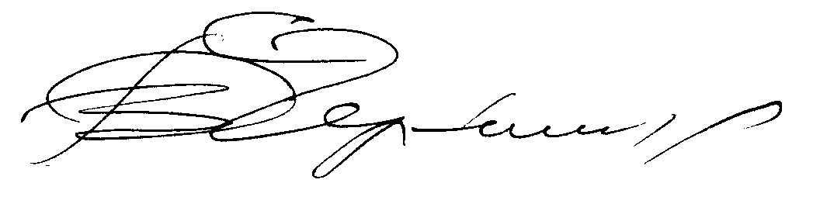
1st of December, 2007

V. Chernigov
LKF president
Application form for participation in «Latvia Open 2008»

Name of the federation, club, etc…
Address
Phone nr.
Fax nr.
E-mail address
Internet address
President or director (name, surname)
Head of the delegation (name, surname) and officials (judges, referees, etc.)
The list of the delegation
№ | Name, Surname | Date of birth |  | Discipline | Weight category | Nr. of fights/ wins |  | The best result
1
2
3
4
5
6
7
8
9
10
11
12
13
14
15
16
17
18
19
20
21
22
23
24
25
26
27
28
29
30

FC (full-contact), LK (low-kick)

_______________________________________________________
(name, surname, signature of the official)
(stamp)

