User Manual

Year: 2019 Semester: Fall Team: 10

Project:Gesture Controlled Remote for Smart Home

Creation Date: Nov 15,2019 Last Modified: Nov 15, 2019

Author: Xi Wu Email: wu999@purdue.edu

Assignment Evaluation:

|  |  |  |  |  |
| --- | --- | --- | --- | --- |
| **Item** | **Score (0-5)** | **Weight** | **Points** | **Notes** |
| **Assignment-Specific Items** | | | | |
| **Product Description** | 5 | x1 | 5 |  |
| **Product Illustration** | 4.5 | x2 | 9 |  |
| **Setup Instructions** | 4.5 | x3 | 13.5 |  |
| **Usage Instructions** | 5 | x3 | 15 |  |
| **Troubleshooting Instructions** | 5 | x3 | 15 |  |
| **Writing-Specific Items** | | | | |
| **Spelling and Grammar** | 4.5 | x2 | 9 |  |
| **Formatting and Citations** | 5 | x1 | 5 |  |
| **Figures and Graphs** | 5 | x2 | 10 |  |
| **Technical Writing Style** | 5 | x3 | 15 |  |
| **Total Score** | 96.5 | | |  |

5: Excellent 4: Good 3: Acceptable 2: Poor 1: Very Poor 0: Not attempted

Comments:

*Comments from the grader will be inserted here.*

Good work. Please have a look at the comments.

1. Product Description

Do you feel lazy to leave your bed to turn off the light? Have Google or Alexa don’t understand your instruction? Turning on, off home electronics such as lights, TV, and AC, these are mundane tasks that are unavoidable in everyday life. However, people always find it inconvenient to walk around the house just to push a couple buttons. For people who have trouble walking or moving around, these tasks could even be rather difficult to achieve.

We came out a solution. This device “Gesture Controlled Remote” can solve your problem by simply waving your hand and it will complete the task for you.

1. Product Illustrations

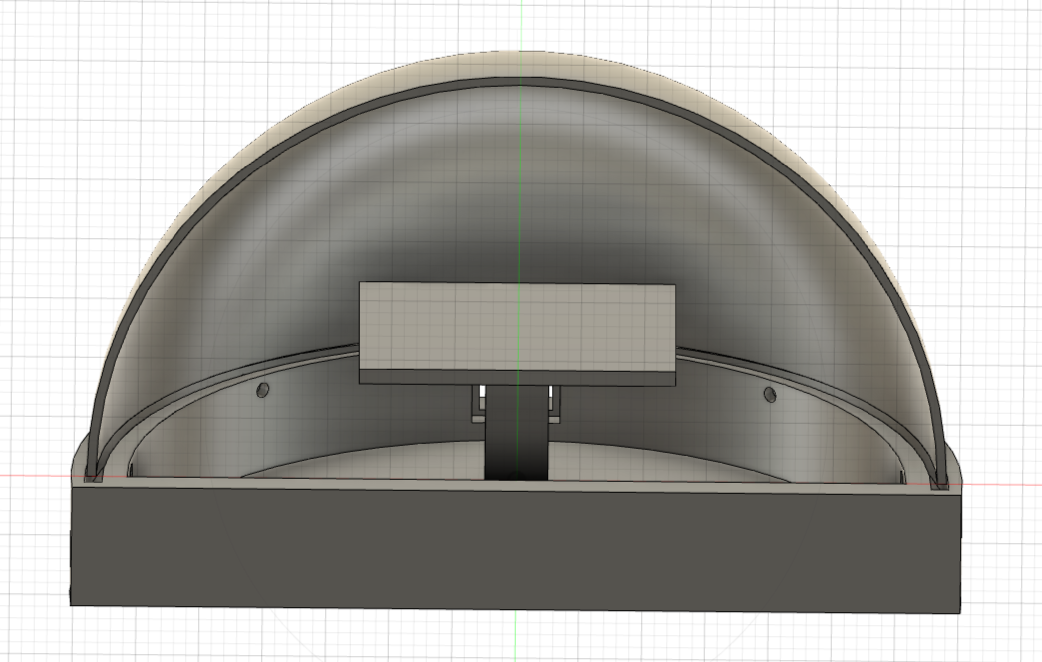

Figure 1. Front view of product

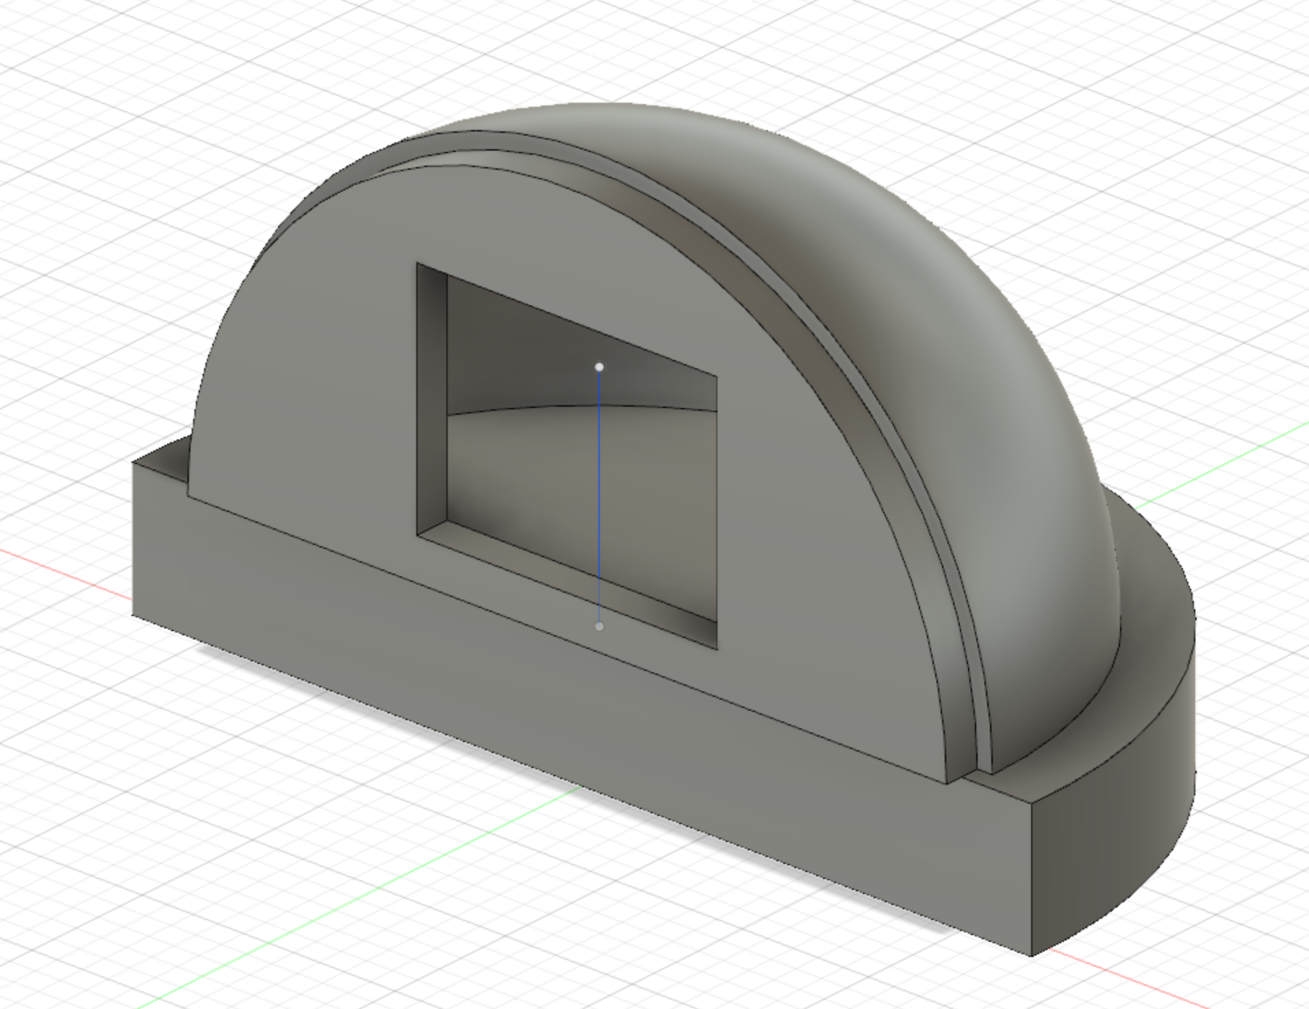

Figure 2. Side view of product

As one can see from the images, the product is in a half-dome shape. In the front would be where the sensors and LCD display are located. To interact with the product, the user simply needs to gesture in front of the device, and the LCD would display the current status of the device.

Although not shown in the first image, the front of the device would consist of a sheet of plastic with cutout space for the LCD and potentially the sensor module as well.

1. Setup Instructions
2. Insert the 3.6V rechargeable battery included in the package into the battery holder.
3. Turn on the power switch of the gesture-controlled smart home device.
4. Wait for the device to connect to WIFI.
5. Start using gestures to control the slave devices, repeat step 4 if you wish to add another device.
6. Select the device you would like to control on the home page.
7. Since each device has different functions, follow the instructions on the LCD display to control your device.
8. The LCD screen should display status of each slave device and battery usage.
9. Usage Instructions

General Usage:

1. Sensor is mounted on the front side of the device. Wave to it within 20 cm to make sure the accuracy of the gesture detection.
2. The LCD display will show the home page every time the device wakes up.
3. Follow the gesture instructions listed on the selected device page to control the slave device.
4. For battery’s health, please recharge the batteries when it is 20% and unplug the charger once it is fully charged.
5. Please keep the device on the dry area.
6. Once you have done controlling the slave devices, please turn off the gesture-controlled smart home device.
7. Troubleshooting Instructions

|  |  |
| --- | --- |
| **Potential Problem** | **Potential Solution** |
| Device is not turning on. | The device needs to be charged.  Replace a new micro-usb charger |
| The device has frozen | Push the power button to restart. |
| The device doesn’t recognize your instructions. | The lighting and distances will affect the performance of the device. Please check the user manual to learn more about the constraint. |
| The device doesn’t react the way you expect. | Contact the customer service for more information |

Customer Support: 1-765-432-0123. From 9 am to 5 pm Monday~Friday

Customer email: TEAM10@purdue.edu