Electrical Overview

Year: ___2019___ Semester: __Fall______ Team: __10___ Project:______Gesture-Control Smart Home Remote_______________________

Creation Date: _____SEP 12, 2019________________Last Modified: SEP 14, 2019

Author: _______Xi Wu______________ Email: _____wu999@purdue.edu_______

Assignment Evaluation:

|  |  |  |  |  |
| --- | --- | --- | --- | --- |
| **Item** | **Score (0-5)** | **Weight** | **Points** | **Notes** |
| **Assignment-Specific Items** | | | | |
| **Electrical Overview** | 5 | x3 | 15 | Good |
| **Electrical Considerations** | 4.5 | x3 | 13.5 | Add more reasoning/ citations. |
| **Interface Considerations** | 5 | x3 | 15 | Good |
| **System Block Diagram** | 4.5 | x3 | 13.5 | Minor detail |
| **Writing-Specific Items** | | | | |
| **Spelling and Grammar** | 4.5 | x2 | 9 |  |
| **Formatting and Citations** | 5 | x1 | 5 |  |
| **Figures and Graphs** | 5 | x2 | 10 |  |
| **Technical Writing Style** | 4.5 | x3 | 13.5 |  |
| **Total Score** | 94.5 | | |  |

5: Excellent 4: Good 3: Acceptable 2: Poor 1: Very Poor 0: Not attempted

General Comments:

*Relevant overall comments about the paper will be included here*

1.0 Electrical Overview

*In your functional specification, your team described the desired/expected functionality of your design. In this section, describe the implementation of that functionality from a hardware perspective. What TYPES of chips, sensors, devices, etc. do you expect to use? (note: these are broad categories, and not specific parts. Don’t provide part numbers here; simply describe the categories of parts (e.g. 16-bit microcontroller, pressure sensor, SD card, etc.) What data is being collected and transmitted by the various devices in your system? What software computations and algorithms are being performed in your design? (e.g. “Our DSP will be used to perform a 16-point FFT while the microcontroller will be used for general computing”) That information should be included here.*

The computation component consists of a 32-bit microcontroller. It will be in charge of managing the peripherals of the device and the interface between the different components. For gesture reading, we will be utilizing the gesture sensor. The gesture sensor will store the sensed gesture to its own register, and the microcontroller will use I2C to fetch the gesture reading result from the gesture sensor. WiFi module transmits data between the microcontroller to the linked devices, and the device status is displayed on the LCD screen. The power supply of our device will be a rechargeable battery since our design is going to be portable.

2.0 Electrical Considerations

2.1 Operating Voltage

The operating voltage of the design will be at 3.3V.

The microcontroller (STM32F407), sensor (APDS-9960), and the WiFi module (ESP-8266) we have chosen all recommend an operating voltage around 3.3V. The LCD (Adafruit TFT 320x480 3.5” Touchscreen) has a wider range of operating voltage, which lies between 3 to 5V. We have tested 3.3V operations for the LCD since all other components work at that voltage, and the performance is acceptable. The LCD is able to display all the information provided.

Therefore, we have chosen 18650 as the rechargeable battery. When it is fully charged, the battery reaches a high at 4.2V, then it discharges quickly to a stable 3.6 to 3.7 Volts. By using a voltage regulator with a dropoff voltage of 0.3V and a fixed output of 3.3V, we could stably output 3.3V to the entire device as long as the battery is charged.

2.2 Operating Frequency

The operating frequency is at 40KHz for the device. The main constraint we have is the LCD. Since the display reports the status to the user and is the most time-consuming component in the design, we would like to minimize the delay and prevent the user from noticing the flickering and other effects when updating the status. At 40KHz the LCD is able to operate without too much of a delay.

2.3 Power Supply

The power to our design will be supplied by the 18650 IC protected battery with a capacity of 3100mAh and operating at 3.7V, 5A at max. We will have a voltage regulator on our board to limit the voltage supplied to the components at 3.3V.

|  |  |
| --- | --- |
| Devices | Max current |
| Microcontroller[1] | 150 mA |
| Sensor[2] | 0.25mA |
| LCD[3] | 100mA |
| WiFi Module[4] | 12mA |
| Battery status IC[5] | 26uA |
| Total | 262.27mA |

3.0 Interface Considerations

The three main interfaces will be using are SPI, I2C, and UART.

UART will be used for transmitting and receiving data between ESP8266 and STM32F4, this is due to being a common protocol for bi-directional communication and the maximum size of the ESP8266 UART buffer can be 128 bytes long, which will be enough for a complete command to be sent.

For I2C, the data size is 10 bits, and the rate is 100kHz. I2C will be used for IC chip to send battery status and for the sensor(APDS-9960) to send the gesture information to STM32F4.

For the SPI, we will have a read/write speed of 24 MHz, and we will be using 16-bit packet size. SPI will be used for the display of the current status.

Since the IFTTT portion of the project is purely software through WIFI connection, we do not need to consider it when choosing the firmware interfaces.

4.0 Sources Cited:

[1]Datasheet(2019). STM32F407 Reference Manual. Available:<https://www.st.com/content/ccc/resource/technical/document/reference_manual/3d/6d/5a/66/b4/99/40/d4/DM00031020.pdf/files/DM00031020.pdf/jcr:content/translations/en.DM00031020.pdf>

[2]AvaGo.(2019) APDS-9960. Available: <https://cdn.sparkfun.com/assets/learn_tutorials/3/2/1/Avago-APDS-9960-datasheet.pdf>

[3]Adafruit.com(2019)3.5” TFT 320*480 + Touchscreen Breakout Board.Available:<https://www.adafruit.com/product/2050>

[4]ON Semiconductor. (2019) Battery Fuel Gauge IC(LC709203F).

Available:<https://www.onsemi.cn/PowerSolutions/document/ANDLC709203F-D.PDF>

Appendix 1: System Block Diagram

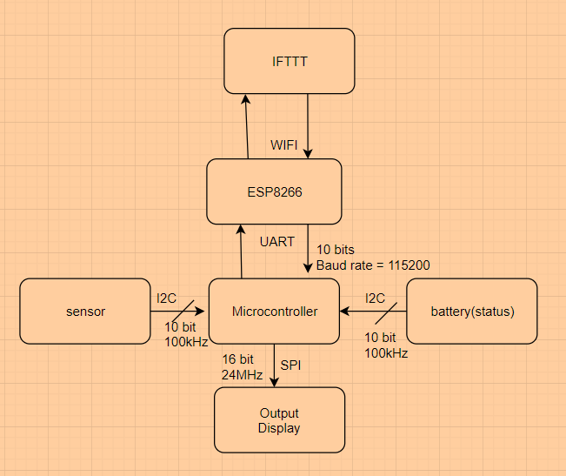

Figure 1, System Block Diagram