The UK’s Prime Minister is Expected to Announce the Recognition of a Palestinian State


The UK’s Prime Minister Keir Starmer is set to Announce Recognition of a Palestinian state after Israeli Leadership Failed to Meet Several Conditions Including agreeing to a Ceasefire.
Source: BBC
More on Page 2

______________________________________________________

New Mexico Becomes the first U.S. State to Offer Free universal Child Care to all Families, the Governor said this will save families an average of $12,000 USD per child, every year.

Source: 7KPLC
More on Page 2

______________________________________________________

UN Says Earths Ozone Layer is Healing Thanks to International Action.

Source: FRANCE24
More on Page 2

______________________________________________________

Source: APNews
More on Page 3

Nvidia to invest $5 billion in struggling rival Intel
1

The UK’s Prime Minister is Expected to Announce the Recognition of a Palestinian State
In July the Prime Minister Keir Starmer demanded that the Israeli Leadership meet several conditions Including a Ceasefire in the Gaza Strip.
The Israeli Leadership ruled this out since the start of the war.

Following this the PM announced they would shift their position regarding the conflict and recognise the Palestinian State, the PM’s move got criticised by the Israeli Government and far right Conservatives as a “Reward for Terror”.

Source: BBC
https://www.bbc.com/news/articles/ce800enrglzo

New Mexico Becomes the first U.S. State to Offer Free universal Child Care to all Families
According to New Mexico Governor Michelle Grisham after Nov. 1. they will lift the eligibility requirements from the state’s child care programme.
The Governor called this initiative “Groundbreaking”.

The Governor said this will save an Average of $12,000 USD per child every year.

Source: 7KPLC
https://www.kplctv.com/2025/09/09/new-mexico-becomes-first-us-state-offer-free-universal-child-care-all-families-it-can-be-done/

UN Says Earths Ozone Layer is Healing Thanks to International Action.
According to a report from the UN's World Meteorological Organization the Ozone Layer will be fully healed by mid-century thanks to international agreements like the Montreal Protocol.


Source: FRANCE24
https://www.france24.com/en/environment/20250916-un-says-ozone-layer-is-healing-hole-could-disappear-within-decades
2

Nvidia to invest $5 billion in struggling rival Intel
Nvidia, announced that it’s investing $5 billion in Intel and will collaborate with the struggling company.

Nvidia CEO Jensen Huang called it “a fusion of two world-class platforms” that combines Intel’s strength in making CPUs, that power most laptops, with Nvidia’s focus on the specialized graphics chips that are critical for artificial intelligence.

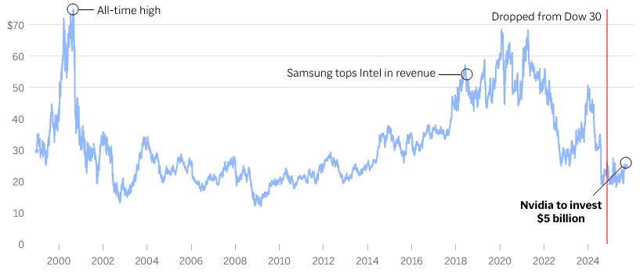
Source: APNews
https://apnews.com/article/nvida-intel-chips-investment-73c307d2f6ceccd6854d6666775358f3

DeCorpo Tip #1: Alternative to Microsoft Office
If you ever need to create a Presentation, a Text Document or a Math Sheet you might know that the Microsoft Suite is almost always the Best option, and its old competitor OpenOffice is pretty much dead.
Luckily LibreOffice Exists a full Office Suite with Regular Updates and a large community that can help you on the Forums.

Go visit https://www.libreoffice.org/ and give it a spin!

3

Video Game Review #1: Lethal Company
---{ Graphics }---
☑ Beautiful
The Graphics in Lethal Company are a Beatieful Mix of Retro Style Graphics and Modern Effects such as Volumetric Fog, the Game renders at a very low Resolution wich makes it very performant.
---{ Gameplay }---
☑ Very good
The Gameplay Involves repeating a very “simple” task over and over again, its almost like being a REPO* man cough cough. Of course it gets wildly spiced up when a Monster kills all of your friends and you’re running for your life to the ship with 20 seconds left before the Autopilot leaves you behind.
*There is a Game Called R.E.P.O wich is Inspired by Lethal Company and Involves very Similar Gameplay
---{ Audio }---
☑ Eargasm
The Sound design is brilliant, every ambient sound is super scary, the monsters sound real and the music is amazing aswell, this paired with the Brilliant voice chat makes it genuinly nice to listen to.
---{ PC Requirements }---
☑ Potato
Due to the ridicously low render resolution this game should run on any computer, even a work laptop.
---{ Game Size }---
☑ Old Fashioned
The game is a Measly 1.4GB
---{ Difficulty }---
☑ Easy to learn / Hard to master
The Controls are easy to grasp but being good and consistently reaching your quota requires a lot of skill.
The hardest part for many (not for me, I’m a programmer. Checkmate) is using the ships terminal where you need to manually type all the commands like a 80s computer, and besides a “help” command you’re on your own.

4
---{ Grind }---
☑ Average grind level
You can grind to get better gear and unlock more expensive locations but you really don’t have to.
---{ Story }---
☑ Some lore
The Game has small amounts of Lore in the form of Environmental Storytelling and notes you can find but they serve mostly as a substitute to learn about enemy behaviour.
---{ Game Time }---
☑ To infinity and beyond
You can play this game Indefinitly, there is no finishing this game and if you get bored you’ll come back a few weeks later, trust me.
---{ Price }---
☑ Worth the price
For just 10 EUR this game is Definitly Worth every penny!
---{ Bugs }---
☑ Minor bugs
There is Minor bugs, especially the ragdolled corpses are a little buggy but the game is pretty polished overall.
---{ 10 / 10 }---
Overall the game gets a solid 10/10 and is seriously impressive for just one developer.

5

