Using ettbc: Emulating a Target Trial for Breast Cancer Screening
Douglas Ezra Morrison
2026-10-02

1 Background
This article demonstrates how to use the {ettbc} package to emulate a target trial for breast cancer screening using the clone-censor-reweight methodology. The methods are based on the study by García-Albéniz et al. (2020), who estimated the effect of continuing annual screening mammography on breast cancer mortality in Medicare beneficiaries aged 70–84 years.

1.1 The Target Trial
The study aimed to answer: Does continuing annual screening mammography (compared with stopping) reduce breast cancer mortality in older women?
Because a randomised trial of this question is unlikely to be conducted, the target trial was emulated using Medicare claims data. The key methodological challenge is confounding by indication: women who continue screening tend to be healthier and more health-conscious than those who stop.

1.2 The Clone-Censor-Reweight Approach
The clone-censor-reweight method handles time-varying treatment and censoring in three steps (Hernán and Robins 2016):
- Clone: Each participant is replicated into two copies — one assigned to the STOPBASE arm (stop screening at study entry) and one to the CONTINUE arm (continue annual screening).
- Censor: Clones are censored in their assigned arm when they deviate from the protocol:
  - STOPBASE: censored at the first screening mammogram received after the initial grace period.
  - CONTINUE: censored when more than 14 months pass without any mammogram.
- Reweight: Inverse probability weights (IPW) are constructed to account for the informative censoring introduced in step 2.
The {ettbc} package implements the first two steps with clone_censor() and provides a helper function expand_to_long() to prepare the dataset for the IPW outcome analysis.

2 Example Data
The package ships with three synthetic datasets that mimic the structure of the original study data (but contain entirely simulated values).
# One row per participant
head(cohort)
#> id age start_month end_month death_month bc_death bc_month
#> 1 1 81 26 108 NA 0 NA
#> 2 2 81 33 108 NA 0 NA
#> 3 3 76 28 108 NA 0 NA
#> 4 4 75 1 108 NA 0 NA
#> 5 5 77 17 108 NA 0 NA
#> 6 6 70 40 108 NA 0 NA
# One row per screening mammogram event
head(screening_mammograms)
#> id month
#> 1 1 16
#> 2 1 38
#> 3 1 50
#> 4 1 63
#> 5 1 77
#> 6 1 88
# One row per diagnostic mammogram event
head(diagnostic_mammograms)
#> id month
#> 1 98 46
#> 2 4 55
#> 3 84 95
#> 4 68 60
#> 5 77 70
#> 6 93 35
Months are numbered consecutively from 1 (January 2000) to 108 (December 2008). Participants enter the study between months 1 and 60.
hist(
cohort$start_month,
breaks = 20,
main = "Study Entry Month",
xlab = "Month (1 = January 2000)",
col = "steelblue",
border = "white"
)
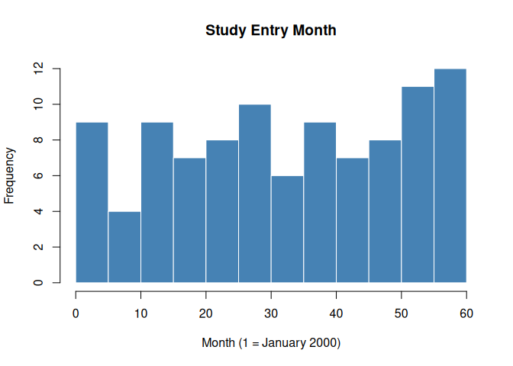
Figure 1: Distribution of study entry months in the simulated cohort.

3 Step 1: Clone and Censor
clone_censor() takes the cohort and mammography event datasets and returns a data frame with two rows per participant — one for each arm.
cloned <- clone_censor(
cohort,
screening_mammograms,
diagnostic_mammograms
)
nrow(cloned) # should be 2 × nrow(cohort)
#> [1] 200
head(cloned[, c("id", "arm", "start_month", "end_month",
"censor_month", "fup", "died", "bc_died")])
#> id arm start_month end_month censor_month fup died bc_died
#> 1 1 STOPBASE 26 38 38 13 0 0
#> 2 2 STOPBASE 33 45 45 13 0 0
#> 3 3 STOPBASE 28 42 42 15 0 0
#> 4 4 STOPBASE 1 12 12 12 0 0
#> 5 5 STOPBASE 17 28 28 12 0 0
#> 6 6 STOPBASE 40 52 52 13 0 0
The key new columns are:
- arm: trial arm ("STOPBASE" or "CONTINUE")
- end_month: final observed month (minimum of death, administrative censoring, and protocol censoring)
- censor_month: month of protocol deviation censoring (NA if not censored for protocol non-adherence)
- fup: follow-up time in months
- died: overall mortality indicator (1 if death caused end of follow-up)
- bc_died: breast cancer mortality indicator

3.1 Censoring Patterns by Arm
Because participants in STOPBASE are censored when they get a screening mammogram, annual screeners are censored early in that arm. Conversely, participants in CONTINUE are censored when they go too long without a mammogram, so non-adherers are censored early.
par(mfrow = c(1, 2))
stopbase <- cloned[cloned$arm == "STOPBASE", ]
continue <- cloned[cloned$arm == "CONTINUE", ]
hist(stopbase$fup,
breaks = 20, main = "STOPBASE",
xlab = "Follow-up (months)", col = "#E05C4B", border = "white",
xlim = c(0, 110)
)
hist(continue$fup,
breaks = 20, main = "CONTINUE",
xlab = "Follow-up (months)", col = "#4B8FE0", border = "white",
xlim = c(0, 110)
)
par(mfrow = c(1, 1))
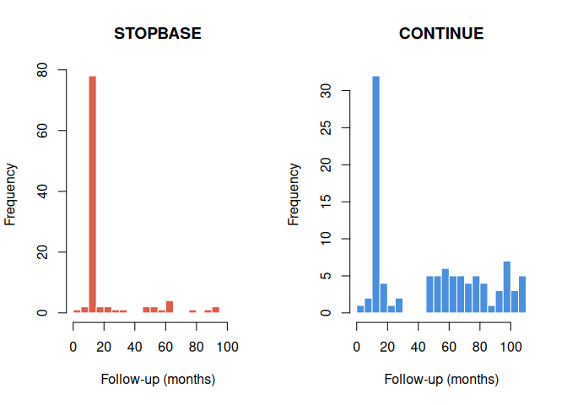
Figure 2: Follow-up time by arm and censoring type.
# Percentage censored for protocol non-adherence in each arm
prop_censored <- tapply(
!is.na(cloned$censor_month),
cloned$arm,
mean
)
round(prop_censored * 100, 1)
#> CONTINUE STOPBASE
#> 34 90
As expected, most STOPBASE clones are censored (those who continued getting annual mammograms), while only a minority of CONTINUE clones are censored (those who stopped getting mammograms).

4 Step 2: Expand to Long Format
expand_to_long() converts the cloned dataset to one row per participant-arm-month. This format is required for the discrete-time survival models used to estimate the outcome.
long_data <- expand_to_long(cloned)
nrow(long_data) # total person-arm-months
#> [1] 7052
head(long_data)
#> id arm month month2 dead_t1 bc_dead_t1 bc_long
#> 1 1 STOPBASE 26 0 0 0 0
#> 2 1 STOPBASE 27 1 0 0 0
#> 3 1 STOPBASE 28 2 0 0 0
#> 4 1 STOPBASE 29 3 0 0 0
#> 5 1 STOPBASE 30 4 0 0 0
#> 6 1 STOPBASE 31 5 0 0 0
The key columns in the long dataset are:
- month: calendar month (1–108)
- month2: months since study entry (0-indexed)
- dead_t1: death in the next interval: 1 = yes, 0 = no, NA = censored
- bc_dead_t1: breast cancer death in the next interval
- bc_long: breast cancer diagnosis flag at this month
# Total events in the long dataset
table(long_data$dead_t1, useNA = "ifany")
#>
#> 0 1 <NA>
#> 6852 19 181

4.1 Verifying the Long Format
A simple check: the number of observed deaths in the long dataset should equal the number of died == 1 rows in the cloned dataset.
# Deaths in cloned dataset
sum(cloned$died)
#> [1] 19
# Rows with dead_t1 = 1 in long dataset
sum(long_data$dead_t1 == 1L, na.rm = TRUE)
#> [1] 19

5 Step 3: Descriptive Analysis
Before fitting weighted outcome models, it is useful to describe the data and examine crude survival by arm.
We first define a small helper that summarises one arm’s long dataset into a crude cumulative mortality curve. For each month since study entry it counts the deaths, then accumulates them and divides by the number of clones at risk at entry.
crude_cumulative_mortality <- function(arm_long) {
months <- 0:max(arm_long$month2)
deaths <- vapply(
months,
function(t) sum(arm_long$dead_t1[arm_long$month2 == t] == 1L, na.rm = TRUE),
numeric(1)
)
n_risk <- vapply(
months,
function(t) sum(arm_long$month2 == t),
numeric(1)
)
data.frame(
month2 = months,
cum_mort = cumsum(deaths) / max(n_risk, 1L)
)
}
With the computation factored out, plotting the two arms is a short loop over the helper.
arms <- c("STOPBASE", "CONTINUE")
cols <- c("#E05C4B", "#4B8FE0")
plot(NA,
xlim = c(0, 70), ylim = c(0, 0.15),
xlab = "Months since study entry",
ylab = "Cumulative mortality (crude)",
main = "Crude cumulative mortality by arm"
)
for (j in seq_along(arms)) {
curve <- crude_cumulative_mortality(long_data[long_data$arm == arms[j], ])
lines(curve$month2, curve$cum_mort, col = cols[j], lwd = 2)
}
legend("topleft",
legend = arms, col = cols, lwd = 2, bty = "n"
)
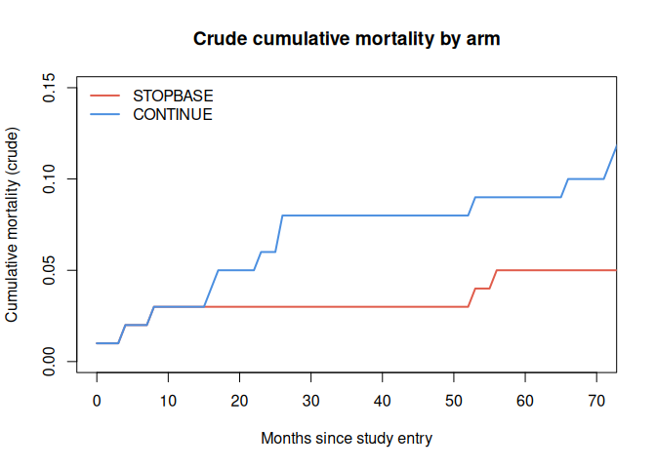
Figure 3: Empirical cumulative mortality by arm (crude, without IPW). Under the null, the two arms should be similar because clones are derived from the same participants.
 Note
The crude curves above do not account for the informative censoring introduced by the clone-censor step. The rest of this article applies inverse probability weights (IPW) to correct for the different censoring mechanisms in each arm, then fits the weighted outcome model and bootstraps a confidence interval. See García-Albéniz et al. (2020) for the full analysis on the real cohort.

6 A Larger Simulated Cohort
The 100-participant dataset above is convenient for showing the data structure, but it is too small to fit a stable weighted outcome model: with so few deaths the screening-propensity model separates and the resulting weights are erratic. For the weighted analysis we simulate a larger cohort with simulate_screening_cohort(), which returns the same three linked tables.
The simulation builds in no screening effect on mortality, so the honest expectation is a null result: the two arms should look alike, and the weighted contrast should sit near no difference. What the rest of the article demonstrates is that the machinery runs end to end and recovers that null, not a substantive estimate; a real reproduction needs the Medicare cohort and the paper’s full covariate set.
sim <- simulate_screening_cohort(n = 1000, max_month = 108, seed = 7)
cloned_l <- clone_censor(
sim$cohort, sim$screening_mammograms, sim$diagnostic_mammograms
)
long_l <- expand_to_long(cloned_l)
long_l <- augment_long_covariates(
long_l, sim$screening_mammograms, sim$diagnostic_mammograms
)
nrow(long_l) # person-arm-months
#> [1] 73469

7 Step 4: Inverse Probability Weights
fit_screening_propensity() fits the pooled logistic model for the probability of a screening mammogram at each eligible month (the SAS cann17b denominator), and compute_ipw_weights() turns those probabilities into stabilized per-arm weights, truncated at the 99th percentile within each arm.
propensity <- fit_screening_propensity(long_l)
weighted <- compute_ipw_weights(propensity$data, pred_prob_col = "p_scrmammo")
# Stabilized, truncated weights are centered near 1 in both arms
round(t(sapply(split(weighted$wp99, weighted$arm), summary)), 2)
#> Min. 1st Qu. Median Mean 3rd Qu. Max.
#> CONTINUE 0 1 1.33 2.10 2.17 15.35
#> STOPBASE 1 1 1.00 5.07 10.15 37.88

8 Step 5: Weighted Outcome Model
fit_outcome_hr() fits the IP-weighted pooled logistic outcome model, with follow-up time entered through a restricted cubic spline and an arm-by-time interaction. The reported odds ratio approximates the hazard ratio for the STOPBASE arm relative to CONTINUE.
hr <- fit_outcome_hr(
weighted,
weight_col = "wp99",
outcome_col = "dead_t1"
)
round(c(OR = hr$or, hr$or_ci), 3)
#> OR 2.5 % 97.5 %
#> 0.976 0.669 1.422
As expected under a simulation with no built-in effect, the odds ratio sits near 1 and its confidence interval covers the null.

9 Step 6: Standardized Survival Curves
predict_survival_ipw() applies g-computation to the weighted model, averaging the predicted survival over the cohort to produce a marginal survival curve for each arm.
surv <- predict_survival_ipw(
weighted,
weight_col = "wp99",
outcome_col = "dead_t1"
)
plot(NA,
xlim = c(0, 72), ylim = c(0.8, 1),
xlab = "Months since study entry",
ylab = "Survival probability",
main = "IP-weighted survival by arm"
)
lines(surv$month, surv$s_continue, col = "#4B8FE0", lwd = 2)
lines(surv$month, surv$s_stopbase, col = "#E05C4B", lwd = 2)
legend("bottomleft",
legend = c("CONTINUE", "STOPBASE"),
col = c("#4B8FE0", "#E05C4B"), lwd = 2, bty = "n"
)
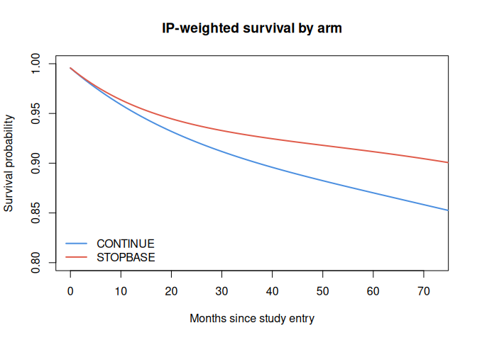
Figure 4: IP-weighted marginal survival by arm. The arms track each other closely, consistent with the null effect built into the simulation.

10 Step 7: Bootstrap Confidence Intervals
bootstrap_ci() resamples participants, recomputes the weights and survival curves on each resample, and returns percentile confidence intervals for the month-by-month survival difference between arms. The number of resamples is kept small here so the article renders quickly; a real analysis uses several hundred.
boot <- bootstrap_ci(
propensity$data,
pred_prob_col = "p_scrmammo",
outcome_col = "dead_t1",
max_month = 72,
n_boot = 50,
seed = 1
)
plot(NA,
xlim = c(0, 72), ylim = range(c(boot$diff_lo, boot$diff_hi), na.rm = TRUE),
xlab = "Months since study entry",
ylab = "Survival difference (CONTINUE - STOPBASE)",
main = "Bootstrap survival difference with 95% CI"
)
abline(h = 0, col = "grey60", lty = 2)
polygon(
c(boot$month, rev(boot$month)),
c(boot$diff_lo, rev(boot$diff_hi)),
col = "#4B8FE022", border = NA
)
lines(boot$month, boot$diff, col = "#222222", lwd = 2)
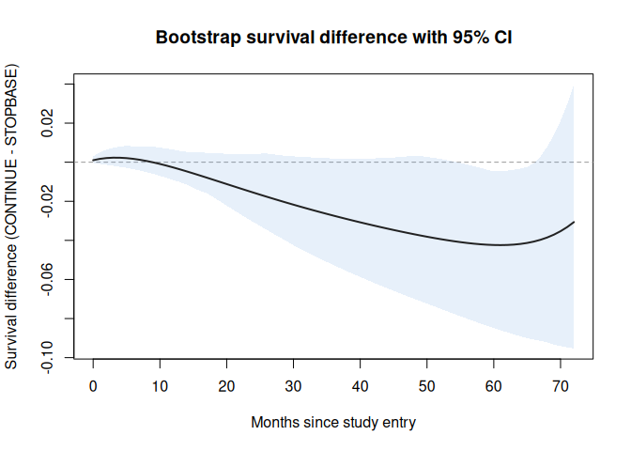
Figure 5: Bootstrap survival difference (CONTINUE minus STOPBASE) with a 95 percent percentile confidence band. The band covers zero throughout, the expected null.

11 Summary
The {ettbc} package implements the full clone-censor-reweight pipeline:
Table 1: Core ettbc functions
Function | Input | Output
simulate_screening_cohort() | cohort size | three linked synthetic tables
clone_censor() | cohort + mammogram events | two rows per participant
expand_to_long() | cloned dataset | one row per participant-arm-month
augment_long_covariates() | long dataset + events | time-varying screening covariates
fit_screening_propensity() | augmented long dataset | screening probabilities
compute_ipw_weights() | long dataset + probabilities | stabilized IPW weights
fit_outcome_hr() | weighted long dataset | arm hazard ratio
predict_survival_ipw() | weighted long dataset | marginal survival curves
bootstrap_ci() | long dataset + probabilities | survival difference with CI

Run on the synthetic cohort, the pipeline recovers the null effect the simulation was built with. Pointed at a real Medicare cohort with the paper’s full covariate set, the same functions reproduce the substantive analysis of García-Albéniz et al. (2020).
The {ettbc} package provides two core functions for the clone-censor step of target trial emulation:
Table 2: Core ettbc functions
Function | Input | Output
clone_censor() | cohort + mammogram events | two rows per participant
expand_to_long() | cloned dataset | one row per participant-arm-month

After running these steps, the long dataset can be used with standard weighted logistic or pooled logistic regression to estimate the intention-to-treat effect of each screening strategy.

12 References
García-Albéniz, Xabier, Hajime Uno, Deepak L Bhatt, Patrick H McArdle, Marshall M Joffe, and Miguel A Hernán. 2020. “Continuation of Annual Screening Mammography and Breast Cancer Mortality in Women Older Than 70 Years: A Prospective Observational Study.” Annals of Internal Medicine 172 (6): 381–89. https://doi.org/10.7326/M18-1199.
Hernán, Miguel A, and James M Robins. 2016. “Using Big Data to Emulate a Target Trial When a Randomized Trial Is Not Available.” American Journal of Epidemiology 183 (8): 758–64. https://doi.org/10.1093/aje/kwv254.

