$L^{p}$ Spaces
Last modified: 2026-10-29 20:01:11 (PDT)

1 $L^{p}$ spaces
Definition 1 ($L^{p}$ norm ($p$-norm of a function)) Let $(S,S,μ)$ be a measure space. For any real number $p≥1$, the $L^{p}$ norm of a measurable function $f:S→R$ is:
​f​p=def​S​​f​p dμ​1/p.
Example 1 (The $L^{1}$ and $L^{2}$ norms of $x↦x$ on the unit interval) Let $S=[0,1]$ with the Lebesgue measure $μ$, and let $f(x)=x$. By Definition 1,
$$\begin{aligned}​∥f∥​_{1}&=\int_{0}^{1}{x} dx \\ &=\frac{1}{2},\end{aligned}$$
and
$$\begin{aligned}​∥f∥​_{2}&=​\left(\int_{0}^{1}{x^{2}} dx\right)​^{1/2} \\ &=​\left(\frac{1}{3}\right)​^{1/2}.\end{aligned}$$

R
lpna_x_pf <- seq(0, 1, length.out = 201)
lpna_p1_pf <- tibble::tibble(
x = lpna_x_pf, y = lpna_x_pf, panel = "p = 1: area = 1/2"
)
lpna_sq_pf <- lpna_x_pf^2
lpna_p2_pf <- tibble::tibble(
x = lpna_x_pf, y = lpna_sq_pf, panel = "p = 2: area = 1/3"
)
lpna_curves_pf <- dplyr::bind_rows(lpna_p1_pf, lpna_p2_pf)
lpna_aes_pf <- ggplot2::aes(x, y)
ggplot2::ggplot(lpna_curves_pf, lpna_aes_pf) +
ggplot2::geom_area(fill = "#0072B2", alpha = 0.3) +
ggplot2::geom_line(colour = "#0072B2") +
ggplot2::facet_wrap(ggplot2::vars(panel)) +
ggplot2::labs(x = "x", y = "|f(x)|^p")
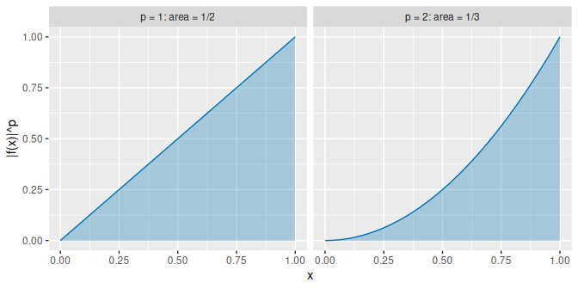

Python
import matplotlib.pyplot as plt
import numpy as np
lpna_x_pf = np.linspace(0, 1, 201)
fig, axes = plt.subplots(1, 2, figsize=(7, 3.5), sharey=True,
layout="constrained")
for ax, p, title in zip(axes, [1, 2], ["p = 1: area = 1/2", "p = 2: area = 1/3"]):
ax.fill_between(lpna_x_pf, lpna_x_pf**p, color="#0072B2", alpha=0.3)
ax.plot(lpna_x_pf, lpna_x_pf**p, color="#0072B2")
ax.set_title(title)
ax.set_xlabel("x")
axes[0].set_ylabel("|f(x)|^p")
plt.show()
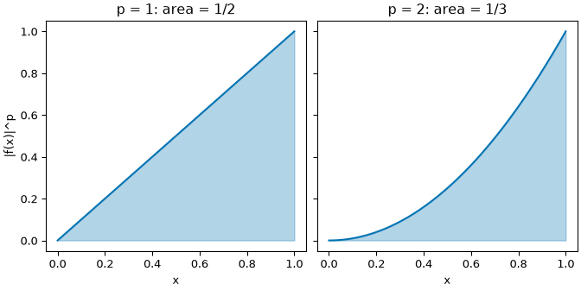
Figure 1: The area under $​\left|f\right|​^{p}$ for $f(x)=x$ on $[0,1]$ in Example 1. The area is $​∥f∥​_{p}^{p}$: $1/2$ for $p=1$ and $1/3$ for $p=2$, so $​∥f∥​_{2}=\sqrt{1/3}$.
Definition 2 ($L^{p}$ space ($L^{p}(S,S,μ)$)) Let $(S,S,μ)$ be a measure space. Let $p≥1$ be a real number. The $L^{p}$ space $L^{p}(S,S,μ)$ is the set of all measurable functions $f:S→R$ whose $L^{p}$ norm is less than $∞$: $​∥f∥​_{p}<∞$.
Example 2 (An $L^{1}$ function not in $L^{2}$) Consider the interval $(0,1)$ with the Borel $σ$-algebra (Definition 3 in Sigma-Algebras) and Lebesgue measure $μ$ (Definition 6 in Measures and Probability Measures). Define $f:(0,1)→R$ by $f(x)=x^{−1/2}$.
- For $p=1$:
$$\begin{aligned}​∥f∥​_{1}&=\int_{0}^{1}{x^{−1/2}} dx \\ &=​\left[2x^{1/2}\right]​_{0}^{1} \\ &=2 \\ &<∞,\end{aligned}$$
- so $f∈L^{1}((0,1),μ)$.
- For $p=2$:
$$\begin{aligned}​\left|f(x)\right|​^{2}&=​\left(x^{−1/2}\right)​^{2} \\ &=\frac{1}{x}.\end{aligned}$$
- The integral is:
$$\begin{aligned}\int_{0}^{1}{\frac{1}{x}} dx&=\lim_{ε→0^{+}}​\left[lnx\right]​_{ε}^{1} \\ &=\lim_{ε→0^{+}}(−lnε) \\ &=∞.\end{aligned}$$
- So $​∥f∥​_{2}=∞$, so $f∉L^{2}((0,1),μ)$.
This shows that $L^{2}⊂L^{1}$ on sets of finite measure: a larger $p$ imposes stricter requirements near singularities.

R
lpss_x_pf <- seq(0.01, 1, length.out = 400)
lpss_root_pf <- lpss_x_pf^(-1 / 2)
lpss_p1_pf <- tibble::tibble(
x = lpss_x_pf, y = lpss_root_pf, panel = "p = 1: area = 2"
)
lpss_inv_pf <- 1 / lpss_x_pf
lpss_p2_pf <- tibble::tibble(
x = lpss_x_pf, y = lpss_inv_pf, panel = "p = 2: area = infinity"
)
lpss_curves_pf <- dplyr::bind_rows(lpss_p1_pf, lpss_p2_pf)
lpss_aes_pf <- ggplot2::aes(x, y, fill = panel, colour = panel)
lpss_colours_pf <- c("#0072B2", "#D55E00")
lpss_ylim_pf <- c(0, 10)
ggplot2::ggplot(lpss_curves_pf, lpss_aes_pf) +
ggplot2::geom_area(alpha = 0.3, colour = NA) +
ggplot2::geom_line() +
ggplot2::facet_wrap(ggplot2::vars(panel)) +
ggplot2::scale_fill_manual(values = lpss_colours_pf) +
ggplot2::scale_colour_manual(values = lpss_colours_pf) +
ggplot2::coord_cartesian(ylim = lpss_ylim_pf) +
ggplot2::guides(fill = "none", colour = "none") +
ggplot2::labs(x = "x", y = "|f(x)|^p")
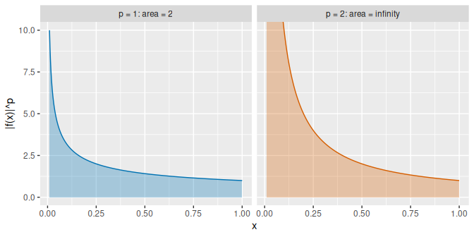

Python
import matplotlib.pyplot as plt
import numpy as np
lpss_x_pf = np.linspace(0.01, 1, 400)
lpss_curves_pf = [
("p = 1: area = 2", lpss_x_pf ** (-1 / 2), "#0072B2"),
("p = 2: area = infinity", 1 / lpss_x_pf, "#D55E00"),
]
fig, axes = plt.subplots(1, 2, figsize=(7, 3.5), sharey=True,
layout="constrained")
for ax, (title, y, colour) in zip(axes, lpss_curves_pf):
ax.fill_between(lpss_x_pf, y, color=colour, alpha=0.3)
ax.plot(lpss_x_pf, y, color=colour)
ax.set_title(title)
ax.set_xlabel("x")
ax.set_ylim(0, 10)
#> <matplotlib.collections.FillBetweenPolyCollection object at 0x7f58feef6490>
#> [<matplotlib.lines.Line2D object at 0x7f58feef65d0>]
#> Text(0.5, 1.0, 'p = 1: area = 2')
#> Text(0.5, 0, 'x')
#> (0.0, 10.0)
#> <matplotlib.collections.FillBetweenPolyCollection object at 0x7f58feef6710>
#> [<matplotlib.lines.Line2D object at 0x7f58feef6850>]
#> Text(0.5, 1.0, 'p = 2: area = infinity')
#> Text(0.5, 0, 'x')
#> (0.0, 10.0)
axes[0].set_ylabel("|f(x)|^p")
plt.show()
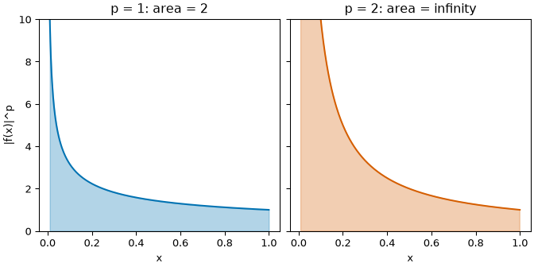
Figure 2: The area under $​\left|f\right|​^{p}$ for $f(x)=x^{−1/2}$ on $(0,1)$ in Example 2. The curve for $p=1$ has area $2$, so $f∈L^{1}$. The curve for $p=2$ keeps climbing toward $x=0$ and its area is $∞$, so $f∉L^{2}$. The plots cut the curves off at $10$.
Definition 3 (Equal almost everywhere ($f=g$ $μ$-a.e.)) Let $(S,S,μ)$ be a measure space. Let $f,g:S→R$ be measurable. The functions $f$ and $g$ are equal almost everywhere, written $f=g$ $μ$-a.e., if $f(s)=g(s)$ holds almost everywhere.
Example 3 (A function that differs from $0$ at one point) Let $S=R$ with the Lebesgue measure $μ$. Let $f(s)=1$ if $s=0$, and $f(s)=0$ otherwise. The set $​\left\{s:f(s)≠0\right\}​=​\left\{0\right\}​$ has measure zero, so $f=0$ almost everywhere by Definition 3.
Definition 4 ($L^{p}$ space ($L^{p}(S,S,μ)$, $L^{p}(μ)$)) Let $(S,S,μ)$ be a measure space. Let $p≥1$ be a real number. For each $f$ in the $L^{p}$ space, let $[f]$ be the set of all functions in $L^{p}(S,S,μ)$ that are equal almost everywhere to $f$. The $L^{p}$ space $L^{p}(S,S,μ)$ (or simply $L^{p}(μ)$) is the set of all such sets $[f]$, with the norm $​∥[f]∥​_{p}\overset{\text{def}}{=}​∥f∥​_{p}$ ($L^{p}$ norm).
Example 4 (The zero element of $L^{p}$) Let $f$ be the function in Example 3, which is $1$ at $s=0$ and $0$ elsewhere. Then $f=0$ almost everywhere, so $[f]=[0]$. Also $​∥f∥​_{p}=0$ although $f≠0$, so $​∥f∥​_{p}=0$ can hold for a nonzero element of $L^{p}$; on $L^{p}(μ)$, $​∥[f]∥​_{p}=0$ only for $[f]=[0]$, as a norm requires.
Definition 5 (Essential supremum norm ($L^{∞}$ norm)) Let $(S,S,μ)$ be a measure space. The essential supremum norm (or $L^{∞}$ norm) of a measurable function $f:S→R$ is:
$$​∥f∥​_{∞}\overset{\text{def}}{=}inf​\left\{C≥0:μ(​\left\{s∈S:​\left|f(s)\right|​>C\right\}​)=0\right\}​.$$
Example 5 (The essential supremum norm ignores a null set) Let $S=[0,1]$ with the Lebesgue measure $μ$. Let $f(s)=5$ if $s=0$ and $f(s)=s$ otherwise. Then $\sup_{s}​\left|f(s)\right|​=5$. For $C≥1$, the set $​\left\{s:​\left|f(s)\right|​>C\right\}​$ is empty or $​\left\{0\right\}​$, so it has measure zero, and for $C<1$ it has positive measure. By Definition 5, $​∥f∥​_{∞}=1$.

R
esn_x_pf <- seq(0, 1, length.out = 101)
esn_line_pf <- tibble::tibble(x = esn_x_pf, y = esn_x_pf)
esn_open_pf <- tibble::tibble(x = 0, y = 0)
esn_spike_pf <- tibble::tibble(x = 0, y = 5)
esn_aes_pf <- ggplot2::aes(x, y)
ggplot2::ggplot(esn_line_pf, esn_aes_pf) +
ggplot2::geom_line(colour = "#0072B2") +
ggplot2::geom_point(data = esn_open_pf, shape = 1, size = 3) +
ggplot2::geom_point(data = esn_spike_pf, colour = "#D55E00", size = 3) +
ggplot2::geom_hline(yintercept = 1, linetype = "dashed") +
ggplot2::labs(x = "s", y = "f(s)")
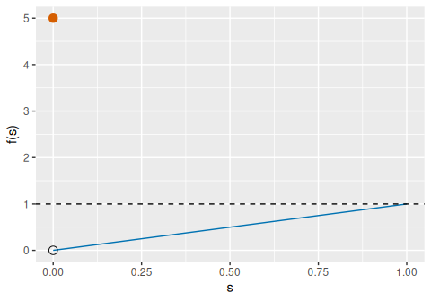

Python
import matplotlib.pyplot as plt
import numpy as np
esn_x_pf = np.linspace(0, 1, 101)
fig, ax = plt.subplots(figsize=(5, 3.5), layout="constrained")
ax.plot(esn_x_pf, esn_x_pf, color="#0072B2")
ax.plot(0, 0, marker="o", markerfacecolor="white", color="black")
ax.plot(0, 5, marker="o", color="#D55E00")
ax.axhline(1, linestyle="dashed", color="black")
ax.set_xlabel("s")
ax.set_ylabel("f(s)")
plt.show()
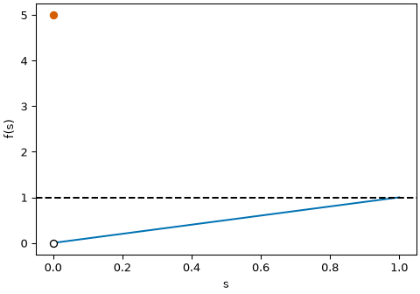
Figure 3: The function in Example 5: $f(s)=s$ except $f(0)=5$. The supremum is $5$, reached only at the single point $s=0$, which has measure zero, so the essential supremum norm is the dashed height $1$.
Definition 6 ($L^{∞}$ space ($L^{∞}(S,S,μ)$)) Let $(S,S,μ)$ be a measure space. The $L^{∞}$ space $L^{∞}(S,S,μ)$ is the set of all measurable functions $f:S→R$ whose essential supremum norm is less than $∞$: $​∥f∥​_{∞}<∞$.
Example 6 (Bounded and unbounded functions) Let $S=(0,1)$ with the Lebesgue measure $μ$. The function $f(s)=s$ has $​∥f∥​_{∞}=1<∞$, so $f∈L^{∞}(S,S,μ)$ by Definition 6. The function $g(s)=1/s$ exceeds every $C$ on the set $(0,1/C)$ of positive measure, so $​∥g∥​_{∞}=∞$ and $g∉L^{∞}(S,S,μ)$.
Definition 7 ($L^{∞}$ space ($L^{∞}(S,S,μ)$, $L^{∞}(μ)$)) Let $(S,S,μ)$ be a measure space. For each $f$ in the $L^{∞}$ space, let $[f]$ be the set of all functions in $L^{∞}(S,S,μ)$ that are equal almost everywhere to $f$. The $L^{∞}$ space $L^{∞}(S,S,μ)$ (or simply $L^{∞}(μ)$) is the set of all such sets $[f]$, with the norm $​∥[f]∥​_{∞}\overset{\text{def}}{=}​∥f∥​_{∞}$ (essential supremum norm).
Example 7 (Bounded functions equal almost everywhere) Let $f$ be the function in Example 5 and $h(s)=s$ on $[0,1]$. Then $f=h$ almost everywhere (Definition 3), so $[f]=[h]$ in $L^{∞}(μ)$, and $​∥[f]∥​_{∞}=​∥h∥​_{∞}=1$.
Theorem 1 (Holder’s inequality) Let $(S,S,μ)$ be a measure space, and let $p,q∈[1,∞]$ be conjugate exponents satisfying $\frac{1}{p}+\frac{1}{q}=1$ (with the convention that $q=∞$ when $p=1$, and $q=1$ when $p=∞$). If $f∈L^{p}(μ)$ and $g∈L^{q}(μ)$ (Definition 4), then their product $fg$ is absolutely integrable ($fg∈L^{1}(μ)$) and satisfies:
​fg​1=S​​fg​ dμ≤​f​p ​g​q.
When
$$\begin{aligned}p&=q \\ &=2,\end{aligned}$$
this inequality is the Cauchy-Schwarz inequality for integrals.
Theorem 2 (Minkowski’s inequality ($L^{p}$ triangle inequality)) Let $(S,S,μ)$ be a measure space and let $1≤p≤∞$. For any functions $f,g∈L^{p}(μ)$ (Definition 4), their sum $f+g$ is in $L^{p}(μ)$ and satisfies:
$$​∥f+g∥​_{p}≤​∥f∥​_{p}+​∥g∥​_{p}.$$
Together with absolute homogeneity $​∥cf∥​_{p}=​\left|c\right|​ ​∥f∥​_{p}$ and definiteness, Minkowski’s inequality establishes that $L^{p}(μ)$ satisfies all axioms of a normed vector space.
Example 8 (Applying Holder’s inequality to finite sums and expectations)
- Finite vectors (Cauchy-Schwarz and taxicab bounds): Equipping a finite set with the counting measure, Holder’s inequality for conjugate exponents $p,q$ gives:
$$\sum_{i=1}^{n}{​}\left|x_{i}y_{i}\right|​≤​\left(\sum_{i=1}^{n}{​}\left|x_{i}\right|​^{p}\right)​^{1/p}​\left(\sum_{i=1}^{n}{​}\left|y_{i}\right|​^{q}\right)​^{1/q}.$$
- Setting $p=1$, $q=∞$ gives $\sum_{i=1}^n\mathopen{}\left|x_i y_i\right|\mathclose{} \le \mathopen{}\left\lVert\mathord{\smash[b]{\underset{\raise.3ex\hbox{$\scriptstyle\sim$}}{x}}\vphantom{x}}\right\rVert\mathclose{}_1\,\mathopen{}\left\lVert\mathord{\smash[b]{\underset{\raise.3ex\hbox{$\scriptstyle\sim$}}{y}}\vphantom{y}}\right\rVert\mathclose{}_\infty$. Setting
$$\begin{aligned}p&=q \\ &=2\end{aligned}$$
- gives the standard vector Cauchy-Schwarz inequality.
- Covariance bound for random variables: On a probability space with measure $P$ (Definition 12 in Measures and Probability Measures), taking
$$\begin{aligned}p&=q \\ &=2\end{aligned}$$
- gives $E​\left[​\left|XY\right|​\right]​≤\sqrt{E​\left[X^{2}\right]​} \sqrt{E​\left[Y^{2}\right]​}$, guaranteeing that the covariance between any two square-integrable random variables is finite.
Remark 1 ($L^{p}$ spaces and norms in probability and machine learning). In probability, statistics, and machine learning, $L^{p}$ spaces structure the geometry of random variables, estimators, and loss functions:
- Random variables, moments, and inclusion of $L^{p}$ spaces: When $μ=P$ is a probability measure (Definition 12 in Measures and Probability Measures) with total measure $P​\left(S\right)​=1$, an $L^{p}$ function is a random variable $X$ with finite $p$-th moment:
$$​∥X∥​_{p}=​\left(E​\left[​\left|X\right|​^{p}\right]​\right)​^{1/p}.$$
- By Jensen’s inequality, if $1≤p≤q≤∞$, then $​∥X∥​_{p}≤​∥X∥​_{q}$, so $L^{q}(P)⊆L^{p}(P)$. For instance, every random variable with finite variance ($X∈L^{2}$) has finite expectation ($X∈L^{1}$).
- The unique Hilbert space $L^{2}$ and conditional expectation: Among all $L^{p}$ spaces, only $L^{2}(μ)$ is an inner product space, equipped with the inner product ​f,g​=defS​fg dμ (all other $L^{p}$ spaces fail the parallelogram law). The completeness of $L^{2}$ makes it a Hilbert space. In regression, the conditional expectation $E​\left[Y∣X\right]​$ is the orthogonal projection of $Y∈L^{2}$ onto the closed subspace of $L^{2}$ functions measurable with respect to $X$, minimizing the population mean squared error (pMSE) $​∥Y−g(X)∥​_{2}^{2}$.
- Loss functions, estimation, and robustness: The choice of $p$ in $L^{p}$ norms defines loss functions for optimization and regression:
  - $L^{2}$ loss (population mean squared error (pMSE), or sample mean squared error (sMSE) on a sample): penalizes large errors quadratically, yielding the conditional mean; sensitive to outliers.
  - $L^{1}$ loss (population mean absolute error (pMAE), or sample mean absolute error (sMAE) on a sample): penalizes errors linearly, yielding the conditional median; robust to heavy tails and outliers.
  - $L^{∞}$ loss (Chebyshev criterion): minimizes the worst-case maximum error across all instances.

