Measurable Functions and Integrals
Last modified: 2026-10-31 06:43:52 (PDT)

1 Measurable functions and integrals
Definition 1 (Measurable function) Let $(S,S)$ be a measurable space. A function $f:S→R$ is measurable (with respect to $S$) [1] if, for every real number $c$, the set of elements where $f$ is at most $c$ is measurable:
$$​\left\{s∈S:f(s)≤c\right\}​∈S$$
Remark 1 (Measurable functions in general). Other sources define a function $f:S→T$ between measurable spaces $(S,S)$ and $(T,T)$ to be measurable when $​\left\{s∈S:f(s)∈B\right\}​∈S$ for every $B∈T$. For $T=R$ with the Borel $σ$-algebra, that definition is equivalent to Definition 1. For example, with $B=(−∞,c]$, the general definition requires $​\left\{s∈S:f(s)≤c\right\}​∈S$, which is the condition in Definition 1.
Example 1 (Measurable and not measurable) On the die rolls $D$, take the $σ$-algebra $S=​\left\{∅,​\left\{2,4,6\right\}​,​\left\{1,3,5\right\}​,D\right\}​$ of Example 1 in Sigma-Algebras.
- Let $f(x)=1$ for even $x$ and $f(x)=0$ for odd $x$. The set $​\left\{x∈D:f(x)≤c\right\}​$ is $∅$ when $c<0$, $​\left\{1,3,5\right\}​$ when $0≤c<1$, and $D$ when $c≥1$. All three are in $S$, so $f$ is measurable.
- Let $g(x)=x$. Then $​\left\{x∈D:g(x)≤1\right\}​=​\left\{1\right\}​$, which is not in $S$, so $g$ is not measurable.
With the $σ$-algebra of all subsets of $D$ instead, every set $​\left\{x∈D:g(x)≤c\right\}​$ is a subset of $D$, so every function $D→R$, including $g$, is measurable.
Definition 2 (Integral of a non-negative function) Let $(S,S,μ)$ be a measure space, and let $f:S→[0,∞)$ be measurable. The integral of $f$ with respect to $μ$ is [2]
S​f dμ=defsup​i=1n​infs∈Aif(s)​μ(Ai)​
where the supremum is over all ways of writing $S$ as the union of finitely many nonempty pairwise disjoint sets $A_{1},…,A_{n}$ in $S$, and each $\inf_{s∈A_{i}}f(s)$ is the infimum of the values of $f$ on $A_{i}$. In the sums, $0⋅∞\overset{\text{def}}{=}0$, and $x⋅∞\overset{\text{def}}{=}∞$ for $x>0$; the supremum is $∞$ if some sum is $∞$. The integral is also written S​f(s) dμ(s).
[3, Sec. 15]
Remark 2 (Each sum is a lower estimate). Each sum in Definition 2 splits $S$ into pieces and weights each piece $A_{i}$ by the smallest value $f$ approaches on it, so each sum is at most the integral. For Lebesgue measure on a closed interval $[a,b]$ and a function $f≥0$ that has a Riemann integral on $[a,b]$, the two integrals agree: [a,b]​f dλ=abf(x) dx [2].
Example 2 (Integrals with respect to counting measure) Let $μ$ be the counting measure on the die rolls $D$, and let $g:D→[0,∞)$. Every function on $D$ is measurable (Example 1).
The integral is the sum of the values. For any split of $D$ into nonempty pairwise disjoint sets $A_{1},…,A_{n}$:
i=1n​infx∈Aig(x)​μ(Ai)&=i=1nx∈Ai​infy∈Aig(y)&&(μ(Ai) counts the elements of Ai)&≤i=1nx∈Ai​g(x)&&(an infimum is at most each value)&=x∈D​g(x)&&(each x∈D is in exactly one Ai)
The split into the six single points $​\left\{1\right\}​,…,​\left\{6\right\}​$ gives exactly x∈D​g(x), so the supremum is D​g dμ=x∈D​g(x). For example, with $g(x)=x$,
D​g dμ&=1+2+⋯+6&=21.
An infinite integral. For the counting measure $μ$ on $N$ and the constant function $h(n)=1$, the split with one set, $A_{1}=N$, gives the sum
$$\begin{aligned}1⋅μ(N)&=1⋅∞ \\ &=∞,\end{aligned}$$
so N​h dμ=∞.
Remark 3 (A function in terms of its positive and negative parts). For a function $f:S→R$, with the positive part and negative part, $f=f^{+}−f^{−}$ and $​\left|f\right|​=f^{+}+f^{−}$. ($f^{+}$, $f^{−}$, and $​\left|f\right|​$ are measurable when $f$ is [3], Theorem 13.3.)
Definition 3 (Integral of a real-valued function) Let $(S,S,μ)$ be a measure space, and let $f:S→R$ be measurable. Let $f^{+}$ and $f^{−}$ be the positive part and negative part of $f$. The integral of $f$ with respect to $μ$ is
S​f dμ=defS​f+ dμ−S​f− dμ,
using Definition 2 for each term, when at least one of the two terms is finite; otherwise, the integral of $f$ is undefined.
[3, Sec. 15]
Example 3 (An integral with positive and negative parts) For the counting measure $μ$ on the die rolls $D$, let $f(x)=x−3$. Its values at $1,…,6$ are $−2,−1,0,1,2,3$, so:
- $f^{+}$ has values $0,0,0,1,2,3$, and D​f+ dμ=6 by Example 2;
- $f^{−}$ has values $2,1,0,0,0,0$, and D​f− dμ=3;
D​f dμ&=6−3&=3,
- which is also
x∈D​(x−3)&=21−18&=3.

R
pnp_rolls_pf <- 1:6
pnp_f_pf <- pnp_rolls_pf - 3
pnp_plus_pf <- pmax(pnp_f_pf, 0)
pnp_minus_pf <- pmax(-pnp_f_pf, 0)
pnp_f_tbl_pf <- tibble::tibble(
x = pnp_rolls_pf, value = pnp_f_pf, panel = "f (sum = 3)"
)
pnp_plus_tbl_pf <- tibble::tibble(
x = pnp_rolls_pf, value = pnp_plus_pf, panel = "f+ (sum = 6)"
)
pnp_minus_tbl_pf <- tibble::tibble(
x = pnp_rolls_pf, value = pnp_minus_pf, panel = "f- (sum = 3)"
)
pnp_bars_pf <- dplyr::bind_rows(pnp_f_tbl_pf, pnp_plus_tbl_pf, pnp_minus_tbl_pf)
pnp_aes_pf <- ggplot2::aes(x, value, fill = panel)
pnp_colours_pf <- c("#0072B2", "#009E73", "#D55E00")
ggplot2::ggplot(pnp_bars_pf, pnp_aes_pf) +
ggplot2::geom_col() +
ggplot2::facet_wrap(ggplot2::vars(panel)) +
ggplot2::scale_fill_manual(values = pnp_colours_pf) +
ggplot2::scale_x_continuous(breaks = pnp_rolls_pf) +
ggplot2::guides(fill = "none") +
ggplot2::labs(x = "Die roll x", y = "Value")
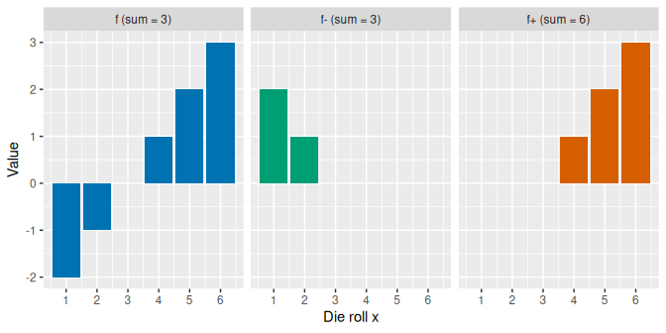

Python
import matplotlib.pyplot as plt
import numpy as np
pnp_rolls_pf = np.arange(1, 7)
pnp_f_pf = pnp_rolls_pf - 3
pnp_panels_pf = [
("f (sum = 3)", pnp_f_pf, "#0072B2"),
("f+ (sum = 6)", np.maximum(pnp_f_pf, 0), "#009E73"),
("f- (sum = 3)", np.maximum(-pnp_f_pf, 0), "#D55E00"),
]
fig, axes = plt.subplots(1, 3, figsize=(7, 3.5), sharey=True,
layout="constrained")
for ax, (title, values, colour) in zip(axes, pnp_panels_pf):
ax.bar(pnp_rolls_pf, values, color=colour)
ax.set_title(title)
ax.set_xlabel("Die roll x")
axes[0].set_ylabel("Value")
plt.show()
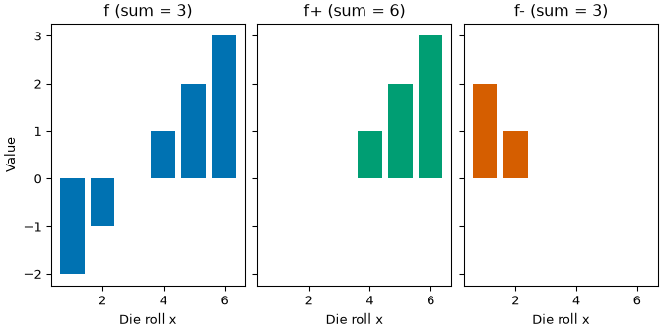
Figure 1: Let $D$ be the die rolls of Example 3. The plot shows the function $f(x)=x−3$ on $D$, its positive part, and its negative part. With the counting measure, each integral is the sum of the bar heights, and $6−3=3$ is the integral of $f$.
Definition 4 (Absolutely integrable function, integrable function) Let $(S,S,μ)$ be a measure space. A measurable function $f:S→R$ is absolutely integrable with respect to $μ$ (often just called integrable) if the integral of its absolute value is finite:
S​​f​ dμ<∞
The property itself is called absolute integrability.
Remark 4 (An absolutely integrable function has a finite integral). If $f$ is absolutely integrable, then S​f+ dμ and S​f− dμ are both finite, because $f^{+}≤​\left|f\right|​$ and $f^{−}≤​\left|f\right|​$, so each sum in Definition 2 for $f^{+}$ or $f^{−}$ is at most the matching sum for $​\left|f\right|​$. So S​f dμ (Definition 3) is a real number.
Example 4 (Absolutely integrable and not)
- For the counting measure on the die rolls $D$, $f(x)=x−3$ (Example 3) is absolutely integrable:
D​​f​ dμ&=2+1+0+1+2+3&=9&<∞
- by Example 2.
- For the counting measure on $N$, the constant function $h(n)=1$ is not absolutely integrable, because
N​​h​ dμ&=N​h dμ&=∞
- (Example 2).
[1] Wikipedia contributors, “Measurable function — Wikipedia, the free encyclopedia.” 2026. Available: https://en.wikipedia.org/wiki/Measurable_function
[2] Wikipedia contributors, “Lebesgue integration — Wikipedia, the free encyclopedia.” 2026. Available: https://en.wikipedia.org/wiki/Lebesgue_integration
[3] P. Billingsley, Probability and measure, 3rd ed. in Wiley series in probability and mathematical statistics. New York: Wiley, 1995.

