Quarto Manuscript Template
Your Name
Last modified: 2026-10-08 21:57:43 (UTC)
Abstract
This is a template for creating manuscripts with Quarto. Replace this abstract with your own summary of the work: the research question, methods, key findings, and conclusions. Aim for 150–250 words for most journals.

Introduction
This is a Quarto manuscript template. The manuscript is available in multiple formats:
- HTML: An interactive web version with table of contents and linked cross-references
- PDF: A print-ready document suitable for journal submission
- DOCX: A Microsoft Word document for collaborators who prefer tracked changes
- JATS XML: A structured format required by some journals and preprint servers
Cite references with @citationkey (Author 2024) or in parentheses (Author and Coauthor 2024).

Background
Add background and motivation here. Cross-reference sections with @sec-methods (renders as Section 2).

Methods
Describe your study design, data sources, and analysis approach here.

Data
You can include inline R code: the square root of 2 is 1.4142.

Analysis
Code chunks execute and embed results:
Supplementary analyses live in a separate notebook (notebooks/supplementary-analysis.qmd) and are embedded in the HTML output automatically.

Results
Present your findings here. Reference figures with @fig-example (Figure 1) and tables with @tbl-summary (Table 1).
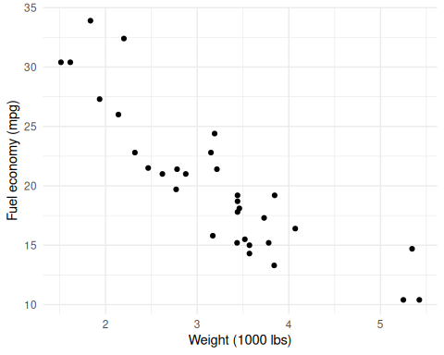
Figure 1: Fuel economy vs. weight for 32 cars.
_{Source: Article Notebook}

Discussion
Interpret your results, address limitations, and describe implications.

Conclusion
Summarize the key findings and their significance.

References
Author, Example. 2024. Example Book Title. Example Publisher. https://doi.org/10.1007/978-3-319-24277-4.
Author, Example, and Another Coauthor. 2024. “Example Article Title.” Example Journal 10 (1): 1–10. https://doi.org/10.1038/nature12373.
This sentence tests the PR preview and will not be merged.

