Getting Started
library(qnp)

1 Introduction
This vignette provides an introduction to the {qnp} package, which provides helpers for including plots in Quarto notes.

2 Basic Usage
interactive_plot() makes a ggplot interactive in HTML output and leaves it unchanged in other output formats. The alt argument gives a text alternative for screen readers:
library(ggplot2)
p <- ggplot(mtcars, aes(wt, mpg)) +
geom_point()
interactive_plot(
plot = p,
alt = "Scatterplot of fuel economy versus car weight"
)
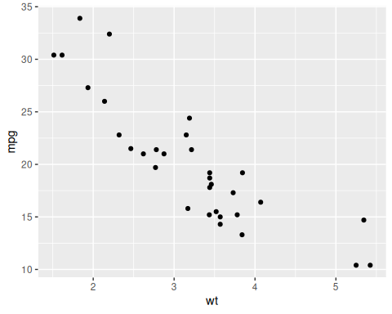

3 Next Steps
For more information, see the package documentation.

