Quarto Vignette Example
library(qnp)

1 Introduction
This vignette demonstrates how to use Quarto (.qmd) files as vignettes in R packages. Quarto is the next-generation version of R Markdown, offering enhanced features and better integration with multiple programming languages.

2 Why Use Quarto?
Quarto offers several advantages over traditional R Markdown:
- Enhanced features: Better support for cross-references, callouts, and other advanced formatting
- Multiple engines: Works with R, Python, Julia, and Observable
- Modern syntax: Cleaner YAML and chunk options using #| syntax
- Better publishing: Improved website and book publishing capabilities

3 Basic Example
Here’s a basic example using the package:
# Create some sample data
sample_data <- c(1, 2, 3, 4, 5, 10, 15, 20)
# Plot it, interactively in HTML output
p <- ggplot2::ggplot(
data.frame(index = seq_along(sample_data), value = sample_data),
ggplot2::aes(index, value)
) +
ggplot2::geom_point()
interactive_plot(
plot = p,
alt = "Scatterplot of the sample values by index"
)
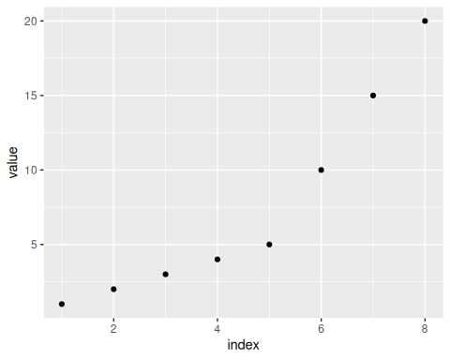

4 Quarto Features

4.1 Callouts
 Note
This is a callout block that highlights important information.

 Tip
Quarto supports multiple types of callouts: note, tip, warning, important, and caution.

4.2 Code Chunks with Modern Syntax
You can use the modern #| syntax for chunk options:
# Create a simple plot
plot(sample_data,
main = "Sample Data",
xlab = "Index",
ylab = "Value",
pch = 19,
col = "steelblue")

Figure 1: Example plot showing data distribution

5 Theorem Environments
Quarto supports theorem and proof environments that integrate with the callouty-theorem extension to render as styled callout blocks.
Definition (Sample Mean)
Definition 1 (Sample Mean) The sample mean of observations $x_{1},x_{2},…,x_{n}$ is:
$$\overset{‾}{x}=\frac{1}{n}\sum_{i=1}^{n}{x_{i}}$$

Theorem (Unbiasedness of the Sample Mean)
Theorem 1 (Unbiasedness of the Sample Mean) The sample mean $\overset{‾}{x}$ is an unbiased estimator of the population mean $μ$:
$$E[\overset{‾}{x}]=μ$$

Proof
Proof. By linearity of expectation:
$$E[\overset{‾}{x}]=E​\left[\frac{1}{n}\sum_{i=1}^{n}{x_{i}}\right]=\frac{1}{n}\sum_{i=1}^{n}{E}[x_{i}]=\frac{1}{n}⋅nμ=μ. ▫$$

Example (Computing the Sample Mean)
Example 1 (Computing the Sample Mean) For the data $\{1,2,3,4,5\}$:
$$\overset{‾}{x}=\frac{1+2+3+4+5}{5}=3$$

6 Equations
Quarto has excellent support for mathematical equations using LaTeX syntax:
Inline equation: $E=mc^{2}$
Display equation:
$$\overset{‾}{x}=\frac{1}{n}\sum_{i=1}^{n}{x_{i}}$$

7 Tables
Table 1: Comparison of R Markdown and Quarto
Feature | R Markdown | Quarto
YAML | Standard | Enhanced
Chunks | {r, option=value} | #| option: value
Publishing | Good | Excellent
Cross-refs | Limited | Native

8 Summary
Quarto vignettes provide a modern, feature-rich way to document R packages. They integrate seamlessly with documentation systems and offer enhanced capabilities for technical documentation.

9 References
For more information, see:
- Quarto Documentation
- Using Quarto with R
- R Core Team (2024)
- Morrison-Lab (2024)
Morrison-Lab. 2024. Qnp: Quarto Notes Plots. https://github.com/Morrison-Lab/qnp.
R Core Team. 2024. R: A Language and Environment for Statistical Computing. R Foundation for Statistical Computing. https://www.R-project.org/.

