Plotting a Binary Outcome
Last modified: 2026-10-19 01:39:01 (PDT)

0.1 Why a scatterplot fails
An outcome that takes only the values 0 and 1 puts every point of a scatterplot on one of two horizontal stripes. Dots on the same stripe overlap wherever the feature takes similar values, so the plot hides how many observations there are. Two plots avoid this: a rug and a pair of histograms.
The examples use the Western Collaborative Group Study, which followed 3154 middle-aged men for coronary heart disease (Rosenman et al. 1975). In data/wcgs.csv, the outcome chd is 1 for a man with an incident case and 0 for a man without one. The feature is his body mass index, bmi. Each plot also shows the line fitted to chd by least squares on bmi.

R
wcgs <- read.csv("data/wcgs.csv")
fit_bmi <- lm(chd ~ bmi, data = wcgs)

Python
import numpy as np
import pandas as pd
wcgs = pd.read_csv("data/wcgs.csv")
slope, intercept = np.polyfit(wcgs["bmi"], wcgs["chd"], 1)
fitted_bmi = intercept + slope * wcgs["bmi"]

0.2 A rug
Example 1 (A rug of the WCGS outcome) A rug draws one tick per observation along an axis. Draw the men with chd $=0$ along the bottom edge and the men with chd $=1$ along the top edge. Transparent ticks darken where many observations share nearly the same bmi.

R
library(ggplot2)
ggplot(wcgs, aes(bmi, chd)) +
geom_rug(data = subset(wcgs, chd == 0), sides = "b", alpha = 0.3) +
geom_rug(data = subset(wcgs, chd == 1), sides = "t", alpha = 0.3) +
geom_hline(yintercept = c(0, 1), linetype = "dashed") +
geom_smooth(method = "lm", se = FALSE) +
labs(x = "Body mass index (bmi)", y = "Fitted chd")
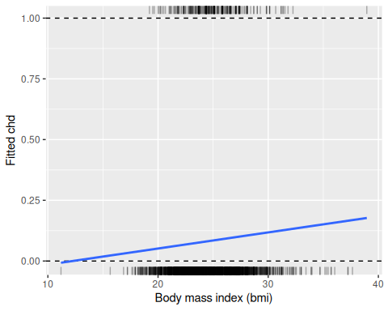
Fitted line of chd on bmi in the WCGS data, with a rug of the men with chd = 1 along the top and chd = 0 along the bottom.

Python
import matplotlib.pyplot as plt
fig, ax = plt.subplots()
for chd, side in [(0, 0.0), (1, 1.0)]:
bmi_chd = wcgs.loc[wcgs["chd"] == chd, "bmi"]
ax.plot(bmi_chd, [side] * len(bmi_chd), "|", color="gray", alpha=0.3)
ax.axhline(0, linestyle="--", color="black")
ax.axhline(1, linestyle="--", color="black")
ax.plot(wcgs["bmi"], fitted_bmi)
ax.set_xlabel("Body mass index (bmi)")
ax.set_ylabel("Fitted chd")
plt.show()

Fitted line of chd on bmi in the WCGS data, with a rug of the men with chd = 1 along the top and chd = 0 along the bottom.

0.3 Two histograms
Example 2 (Two histograms of the WCGS feature) A histogram of bmi for the men with chd $=0$ stands on the line $y=0$. A histogram for the men with chd $=1$ hangs down from the line $y=1$. Each histogram is scaled so its tallest bar is $0.3$ high, because there are far fewer cases than non-cases and the raw counts would hide the smaller group. The heights then show each group’s shape, not how many men it holds.

R
breaks <- seq(floor(min(wcgs$bmi)), ceiling(max(wcgs$bmi)), by = 1)
bars <- function(data, chd_value) {
counts <- hist(data$bmi[data$chd == chd_value], breaks = breaks,
plot = FALSE)$counts
data.frame(xmin = head(breaks, -1), xmax = tail(breaks, -1),
height = 0.3 * counts / max(counts))
}
bars0 <- bars(wcgs, 0)
bars1 <- bars(wcgs, 1)
ggplot(wcgs, aes(bmi, chd)) +
geom_rect(data = bars0,
aes(xmin = xmin, xmax = xmax, ymin = 0, ymax = height),
inherit.aes = FALSE, alpha = 0.4) +
geom_rect(data = bars1,
aes(xmin = xmin, xmax = xmax, ymin = 1 - height, ymax = 1),
inherit.aes = FALSE, alpha = 0.4) +
geom_smooth(method = "lm", se = FALSE) +
labs(x = "Body mass index (bmi)", y = "Fitted chd")
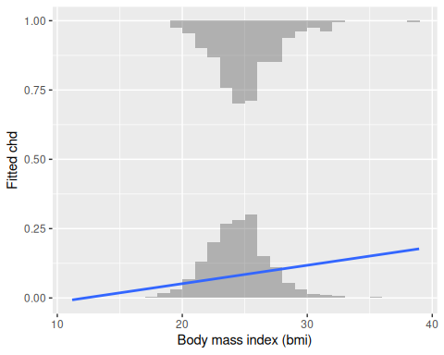
The same line, with a histogram of bmi for the men with chd = 0 standing on the line y = 0 and one for the men with chd = 1 hanging from the line y = 1. Each histogram is scaled so its tallest bar is 0.3 high.

Python
breaks = np.arange(np.floor(wcgs["bmi"].min()), np.ceil(wcgs["bmi"].max()) + 1)
fig, ax = plt.subplots()
for chd, base, sign in [(0, 0.0, 1), (1, 1.0, -1)]:
counts, _ = np.histogram(wcgs.loc[wcgs["chd"] == chd, "bmi"], bins=breaks)
ax.bar(breaks[:-1], sign * 0.3 * counts / counts.max(), width=1,
bottom=base, align="edge", alpha=0.4)
#> <BarContainer object of 28 artists>
#> <BarContainer object of 28 artists>
ax.plot(wcgs["bmi"], fitted_bmi)
#> [<matplotlib.lines.Line2D object at 0x7f01ab844690>]
ax.set_xlabel("Body mass index (bmi)")
#> Text(0.5, 0, 'Body mass index (bmi)')
ax.set_ylabel("Fitted chd")
#> Text(0, 0.5, 'Fitted chd')
plt.show()

The same line, with a histogram of bmi for the men with chd = 0 standing on the line y = 0 and one for the men with chd = 1 hanging from the line y = 1. Each histogram is scaled so its tallest bar is 0.3 high.

References
Rosenman, Ray H, Richard J Brand, C David Jenkins, Meyer Friedman, Reuben Straus, and Moses Wurm. 1975. “Coronary Heart Disease in the Western Collaborative Group Study: Final Follow-up Experience of 8 1/2 Years.” JAMA 233 (8): 872–77. https://doi.org/10.1001/jama.1975.03260080034016.

