MKOB4 User Guide
Version 4.1
(This document is under construction. It has a long way to go!)

Introduction
MKOB4 is an application for practicing landline telegraphy using American Morse. It can be used locally, or over the Internet when connected to a Wire on a MorseKOB Server.

MKOB4 is a cross-platform successor to the popular MorseKOB 2.5 application by Les Kerr. However, MKOB4 has been written completely from scratch in Python, to allow it to run on any platform that supports Python TK GUI applications. Les Kerr initiated the development and was joined by Patrik Dirks and Ed Silky. The team moved the project to GitHub and it is now available as complete source for the public. Although its functionality, and many of the user actions, are similar to MorseKOB 2.5, it is not identical, and it is not intended to be.

This document describes the functionality and user actions of the MKOB4 application, and does not compare MKOB4 to MorseKOB 2.5.

…

Main Screen
The main user interface looks like this on Windows:

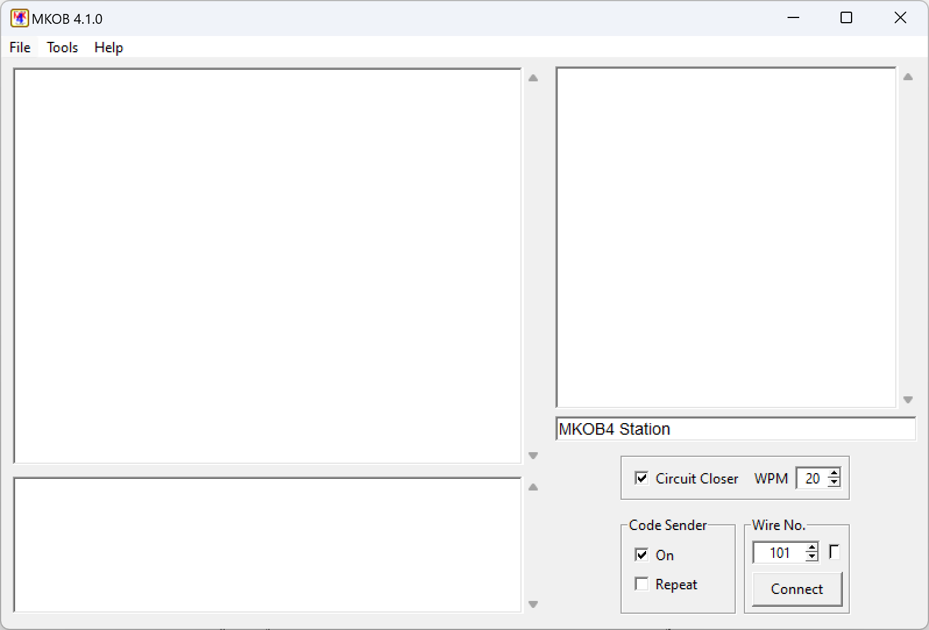

<< Detail the sections of the UI >>

File Menu
<< Detail the menu items >>

Tools Menu

Show Packets
When connected to a Wire this will display information about the packets of information sent to the wire and received from the wire.

This is intended primarily for program debugging, but the information can be educational as well.

Key Timing Graph…
The Key Timing Graph gives a visual representation of the key press and release durations of entered or received code.

The graph can be used for:
- practice and improvement of your keying
- tuning a auto/bug key
- adjusting the WPM setting for better decoding of received code
- more?

Explanation of the graph:

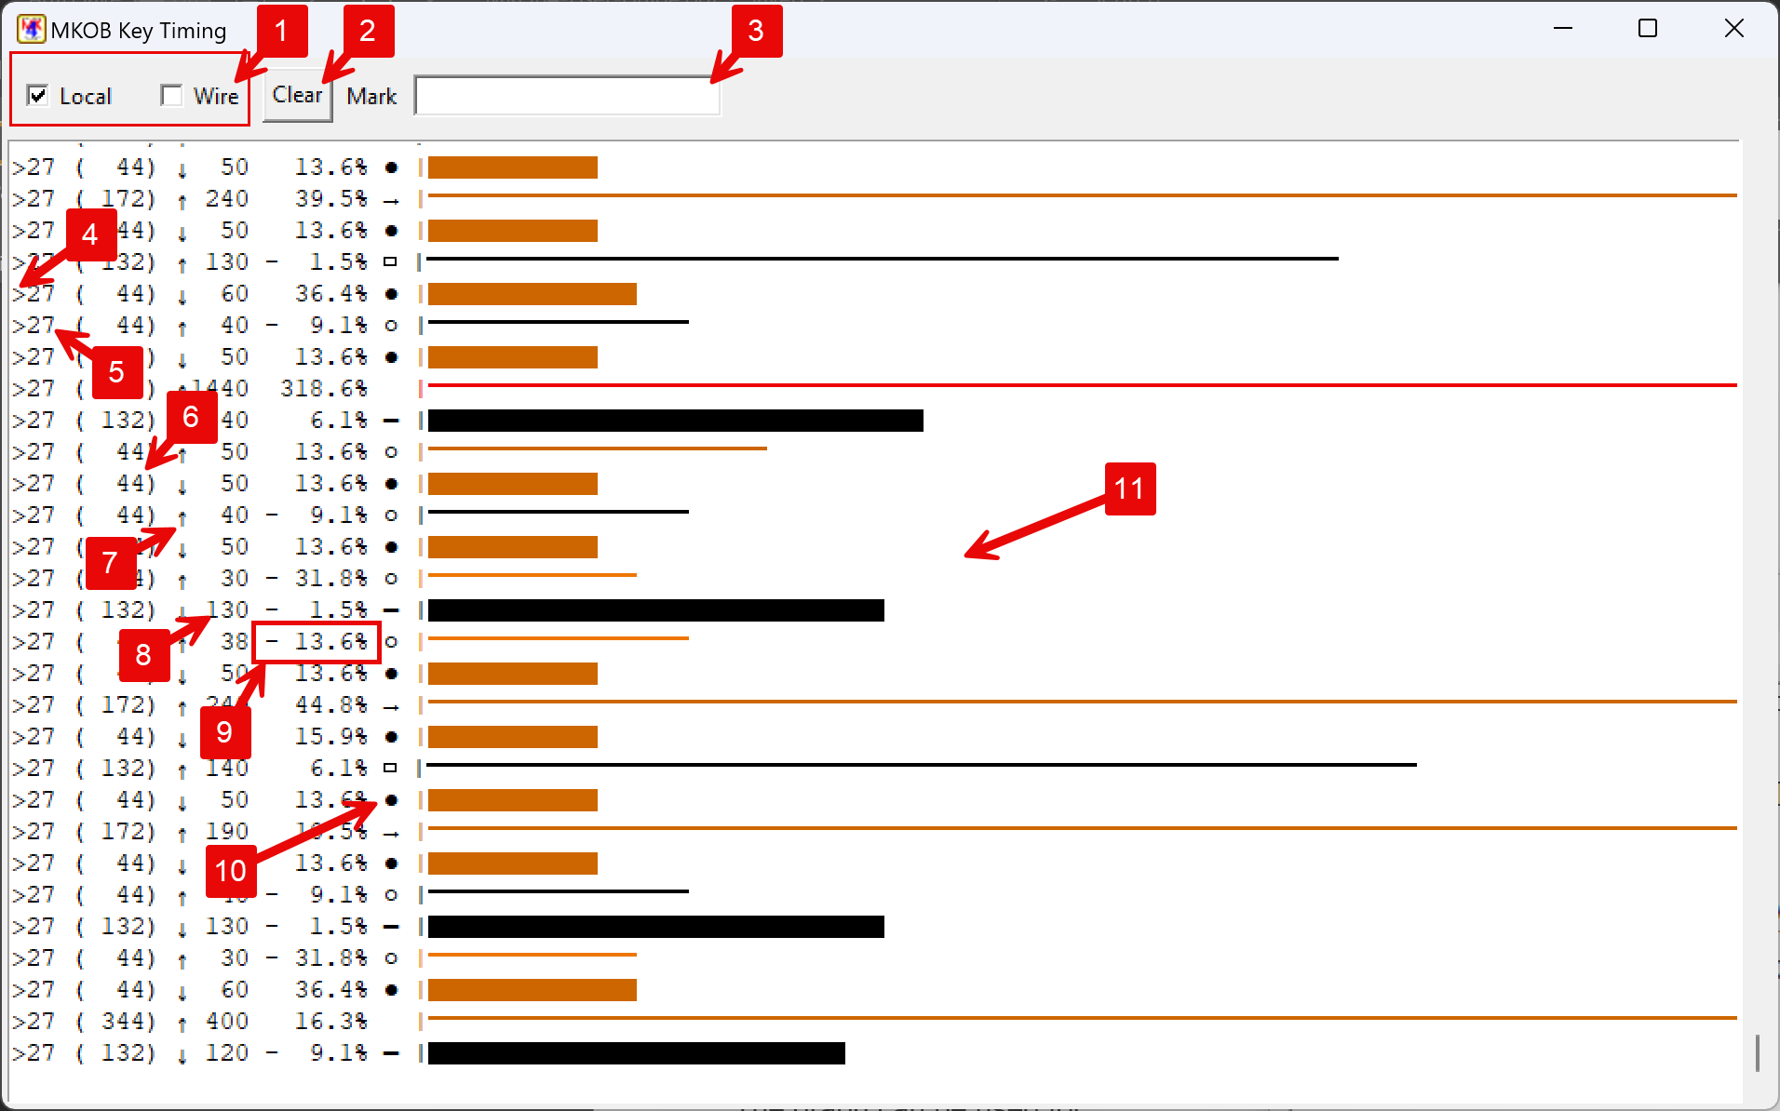

- Select whether key timing from ‘Local’ and/or ‘Wire’ sources are graphed.
- Clear the contents of the graph.
- Enter text to mark the graph. A line of text is inserted into the graph by typing in the field and pressing the Enter/Return key.
- Indicates the source of the key action:
  - ‘>’ Local
  - ‘<’ Wire
- WPM setting being used for comparisons/calculations.
- Expected duration in milliseconds (1000 = 1 second)
- Key action:
  - ↓ Key down
  - ↑ Key up
- Measured duration in milliseconds (1000 = 1 second)
- Error percentage compared to expected. A negative value indicates that the measured duration was shorter than that expected, a positive value indicates that it is longer.
- Indication of what element this duration is closest to, given the WPM setting:
  - ‘●’ Dot
  - ‘▬’ Dash
  - ‘L’ Long ‘L’ dash
  - ‘0’ Extra-long ‘0’ dash
  - ‘○’ Element space (the space between character elements)
  - ‘▭’ Intra-character space (space within the Morse characters: C, O, R, Y, Z, &)
  - ‘ ‘ Space between characters
  - ‘→’ Space between words
- Graphical representation of the duration of the key action:
  - Length is based on the key action duration.
  - Key down actions use a wide bar.
  - Key up actions use a thin line.
  - The color is based on the duration error:
    - Black: Less than ±10%
    - Lighter brown: -10% or more (negative error – too short)
    - Darker brown: +10% or more (positive error – too long)
    - Red: The value was too large to fit within the graph maximum

Local sources include a connected key, text entered in the Code Sender entry box, and recordings being played using the File:Play… function. Wire source is code received from a connected wire.

It is important to understand that the graph is not decoding Morse. It is selecting the expected element based on the duration of the key action, given the configured code speed (WPM). Therefore, it is possible to get a sequence of elements that do not represent a valid Morse character. For example, you might get a sequence of: ●▭●▭● (which isn’t a valid character) if you were attempting to key an ‘S’ and your element spacing was slightly too long. You can monitor the Reader window in the main window to see what the Morse Reader/Decoder recognized your code as.

