MKOB4 User Guide
Version 4.3

Introduction
MKOB4 is an application for practicing landline telegraphy using American Morse. It can be used locally, or over the Internet when connected to a Wire on a KOBServer hub.

MKOB4 is a cross-platform successor to the popular MorseKOB 2.5 application by Les Kerr.

MKOB4 has been written completely from scratch in Python, to allow it to run on any platform that supports Python TK GUI applications. Although its functionality, and many of the user actions, are similar to MorseKOB 2.5, it is not identical, and it is not intended to be.

This document describes the functionality and user actions of the MKOB4 application and, typically, does not compare MKOB4 to MorseKOB 2.5. Knowledge of the MorseKOB 2.5 application is not assumed or required.

PyKOB
MKOB uses the PyKOB modules. PyKOB consists of a number of modules that provide different aspects of handling code, the physical key and sounder, internet connection to a KOBServer instance, system audio to simulate a sounder or provide tone, configuration and logging capabilities, and more. When updating MKOB, it is advisable to get the latest (associated) release of PyKOB as well.

Utilities
The PyKOB package also includes a number of utility applications. The README file included in the package contains a short description of each of the utility applications.

MRT (Morse Receive & Transmit - Marty)
MRT is a command-line/terminal application that is somewhat similar to MKOB, though it is completely text based, allowing it to be run via a remote terminal connection to a system, or even automatically in the background (headless). It uses the same pykob configurations as MKOB (and the utility applications). In addition, it has a few options that allow it to support displays and similar applications.

There is a separate document that describes MRT and its options.

Closed Circuit (Loop) Telegraphy
Even if you are very familiar with Landline Telegraphy, it is suggested that you at least read through the section Circuit and Key Closer and MKOB’s Virtual Closer to get the best results and experience using MKOB.

This section provides a very brief description of Landline, Closed Circuit, Telegraphy, that is important for the effective, and enjoyable, use of the MKOB application.

One of the primary features of MKOB (and the PyKOB modules and MRT) is support for interfacing to a physical ‘closed’/’loop’ telegraph circuit and simulating the operation of a loop telegraph circuit locally and connected to a KOBServer hub via the internet.

This simulates the operation of Landline-Telegraphy and a closed-loop circuit as used by virtually every railroad, Western Union, and many other communication services in the United States, and in fact, North America and beyond, when telegraphy was THE means of communication. In fact, for railroads, that lasted well into the 1960’s (and in some areas, even into the 70’s).

Describing closed loop, landline, telegraphy is not the focus of this document. There are a number of sources available online or at the library that describe it. However, there is one aspect of closed loop, landline, telegraphy that is critical to understand for successful use of MKOB (and MRT and some of the other utilities), and for connecting to a KOBServer and communicating with others – that is the aspect of the circuit being open or closed, and use of the Closer on the key.

Telegraph Key Closer
Landline telegraphy relies on a connection between each and every station in the network. Again, it is beyond the scope/intention of this document to describe how this was achieved, but you can think of it (in concept anyway) like the lighting wiring in your house. Power goes through the wall switches in the room (sometimes multiple for 3/multi-way switches) and is connected to the lights. When all the switches are closed the lights are on. If any of the switches are open the lights are off.

In the telegraph line the operators in each office/station have a telegraph key that is wired into the circuit. If the key is opened, the power to the circuit is cut and all the sounders in the circuit are de-energized (producing the distinctive ‘clack’ sound). When all the operator’s keys are closed, the power to the circuit is restored and all the sounders are energized (producing the distinctive ‘click’ sound). To communicate, all the operators at the offices/stations in the circuit/loop line keep their keys closed except for the one that wants to send a message. That operator Opens their key and then starts sending the message by actuating the key (pressing and releasing it).

A telegraph key designed for landline telegraphy includes a part referred to as The Closer. Keys designed for radio often do not include a Closer.

Below are pictures of a landline telegraph straight key and a ‘bug’ keyer showing the Closer.

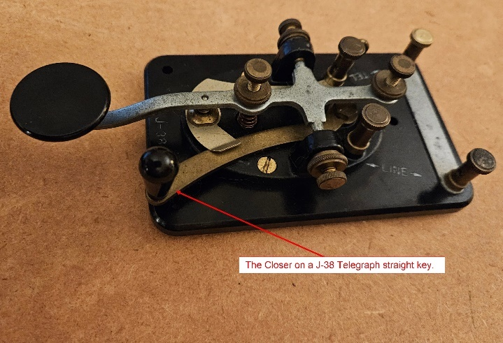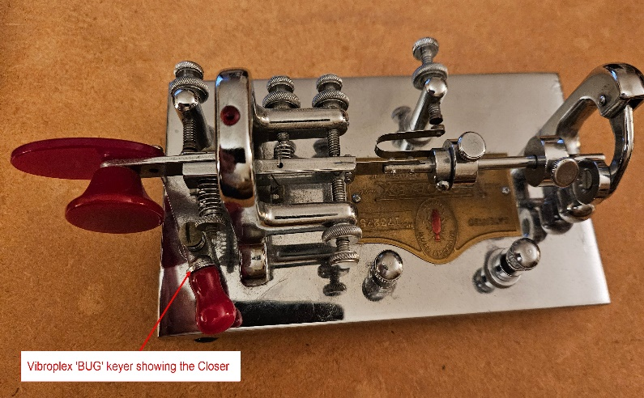

The flow for communicating using landline telegraphy is:
- Use the Closer on the key to keep your key closed when you are not sending (all other operators do the same).
- When you are ready to send, listen for a pause in activity, then open the Closer on your key.
- This (opening your key) will cause all sounders in the circuit to de-energize – producing the distinctive ‘clack’.
- Send your message. This will cause all sounders in the circuit to ‘follow’ your key (energizing and de-energizing as your key is closed and opened).
- When you finish sending your message, close your key. That will energize the circuit causing all the sounders to produce the distinctive ‘click’.
- This process repeats, for each operator that sends a message.

Circuit and Key Closer and MKOB’s Virtual Closer
(Important for using MKOB)

MKOB tracks the open/closed state of the key attached to the interface and will show its state in the Key Closed checkbox in the interface. In addition to following the state of the physical key, MKOB implements a Virtual Closer.

Typically, the state of the Virtual Closer will be the same as the physical key’s Closer. However, if the physical key does not have a closer (for example, when using a key designed for radio), or there isn’t a physical key attached, the MKOB’s Virtual Closer can be used to control the open/closed state of the circuit – allowing code to be sent to a wire from the key (that doesn’t have a closer) or from the Keyboard Sender.

In addition, the Virtual Closer can actually be used to override the state of the physical key. Allowing code to be sent from the Keyboard Sender (including the Keyer keys) even if the physical key is closed.

Understanding the functionality and use of the Virtual Closer in MKOB is important to the successful (and enjoyable) operation of the application and communicating on wires with others in the best simulation of a true landline telegraph circuit using the world-wide connectivity afforded by the internet. Could Morse and Vail have ever envisioned this?!

Comparison to MorseKOB 2.5
This is the one place where the operation of MKOB will be compared to that of MorseKOB 2.5. If you do not have experience with MorseKOB 2.5 you can skip the rest of this section.

MorseKOB 2.5 doesn’t track the state of the physical key’s closer in its interface. It treats its keyboard sender, its system (computer) audio sounder, and its Circuit Closer checkbox as a ‘separate circuit’ that is connected is series with the connected physical key and sounder (loop) and the KOBServer wire (circuit) that others are also connected into.

The operation of the Virtual Closer in MKOB was designed to allow the use of a physical key and sounder, with occasional use of the Keyboard Sender without requiring interaction with the MKOB user interface. The circuit is opened and closed using the physical key’s closer and (when needed) text can be entered using the keyboard, then you can go directly back to the physical key to continue sending. When you are done, you close the key’s closer, and you are ready to receive code from the other operators connected to the wire.

If you don’t have a physical key and/or sounder connected, that’s fine. Just use the Virtual Closer, the Keyboard Sender, and the System sound.

Functionality

Main Screen
The main MKOB user interface looks like this on Windows:

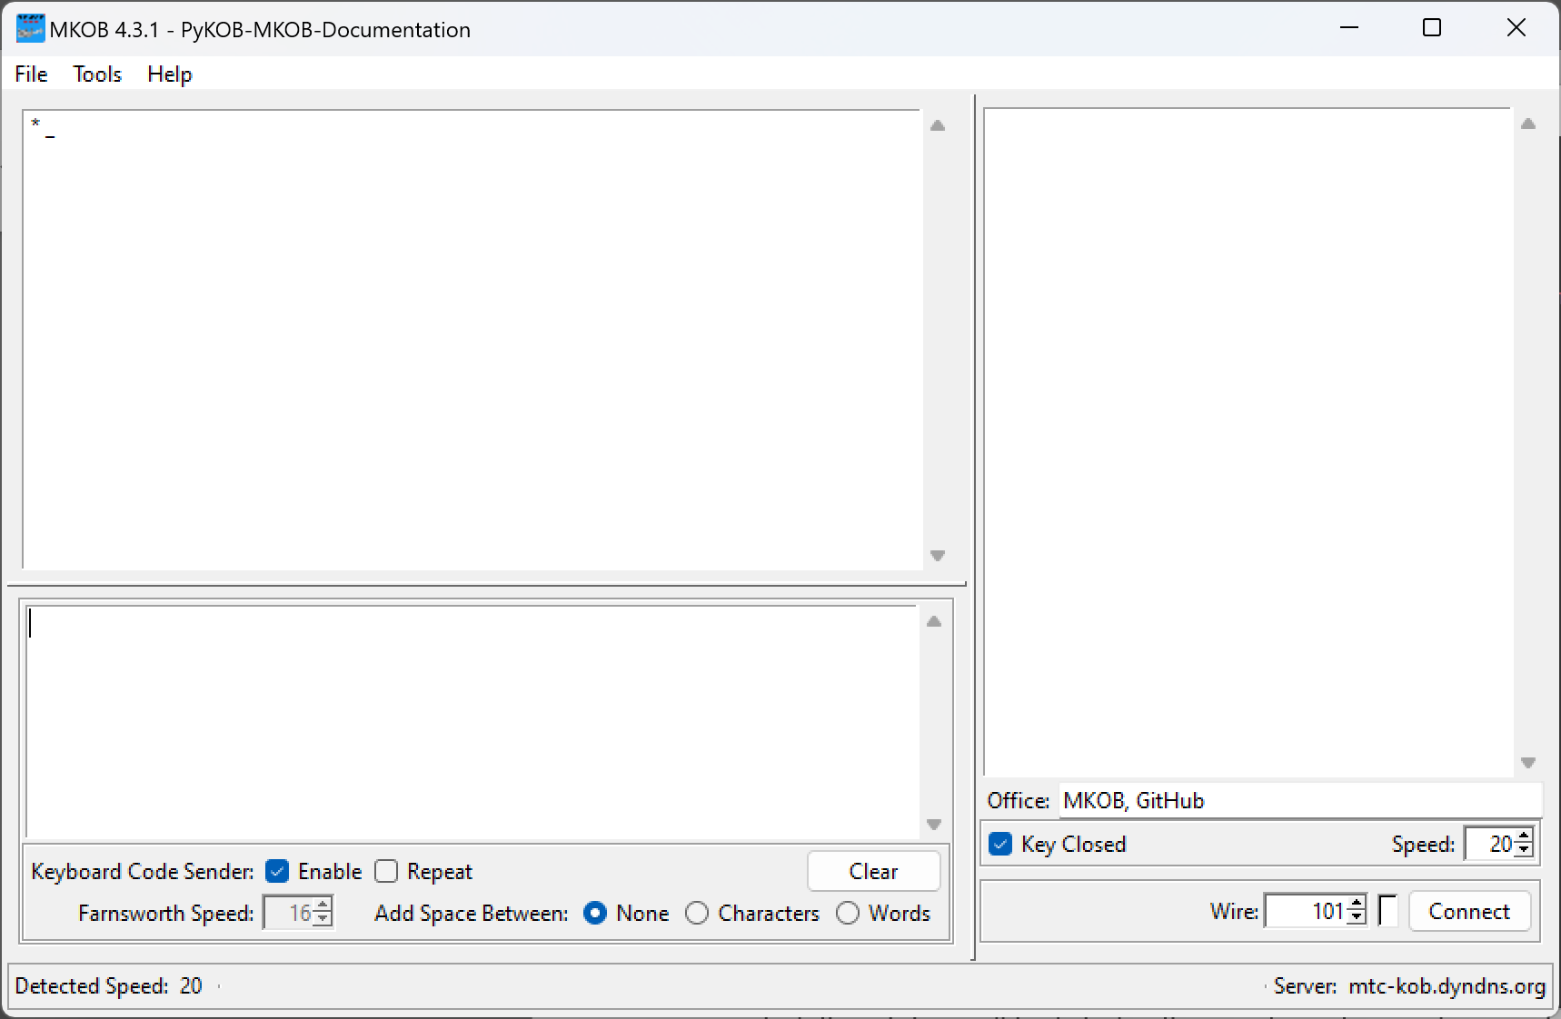

The interface looks similar on Mac and Linux.

Detailed descriptions of the sections and controls are in separate sections. This is an overview.

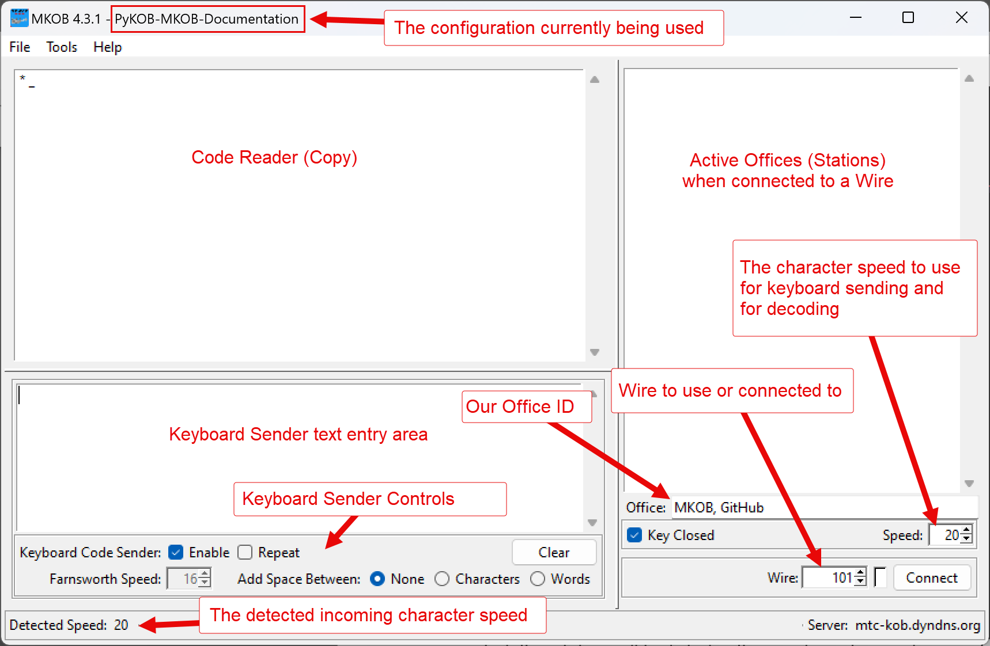

Code Reader (Copy)
Copied (decoded) code is displayed in this window. Code is copied from the local key and from stations on the wire when connected. The name of the sending station is displayed at the beginning of a new line when the sender changes. The Reader window is also occasionally used to display information from the MKOB application to the user.

Active Offices (Stations)
Offices that are currently connected to the wire are listed in this window. When not connected, this station will be listed in this window when code is sent from it.

The order of the offices and the formatting used can be helpful when connected to a chat-type wire with a number of offices connected. The offices are listed as follows:
- The top/first office is the current sender.
- After the current sender (and a line), other offices/stations that you have not received code from will be listed in order of how long they have been connected (as observed by this station), starting with the most recent. These are indented.
- After the indented list, stations that you have received code from are listed from the least recently received from to the most recently received from (the last sender).
This ordering can help if you are the current sender and you are trying to decide who to turn the wire over to next. It is important to realize that the order is based on activity seen since you connected. The wire traffic doesn’t contain history information, and therefore it is possible that an office listed near the top and indented, has actually sent some information before you connected to the wire. However, it can still be helpful, especially if you have been connected to the wire for a while.

Keyboard Sender
Text entered in this window, either from the keyboard or loaded from a file, will be coded at the current character/text speed when the Keyboard Code Sender (Enable) checkbox is checked, and the key is open (either the physical key or the virtual key by unchecking the Key Closed checkbox). The Repeat checkbox will cause the sender to repeat when it reaches the end of the text.

Office (Station) Name
Text entry field used to enter/display the name of this office/station. The office/station name is used when you connect to a wire on a KOBServer. The Office/Station name can also be set in the Preferences dialog.

Key Closed (checkbox)
Indicates the state of the physical and/or virtual key, open/closed. It can be used to control the state of the circuit, overriding the physical key, if one is being used.

Speed
This is the character speed used for sending from the Keyboard Sender and ‘Keyer’ keys (Shift-Left and Shift-Right when the Keyboard Sender is enabled), and for decoding (copying) incoming code. See the section in Preferences about character speed, text speed, and spacing, for information on how to use Farnsworth.

File Menu
The file menu contains four sections.

Section 1
Operations that apply to the Keyboard Sender.

New
Clears the Keyboard Sender window. This is retained from earlier versions for compatibility. It does the same as the Clear button in the Keyboard Sender area or the F12 hotkey.

Open…
Allows selecting a text file. The contents of the text file are copied into the Keyboard Sender window. Within the text, two special characters are recognized to allow the (virtual) key to be opened and closed.
- ‘~’ Opens the virtual key.
- ‘+’ Closes the virtual key.

Section 2
Operations that control session recording and playback.

Session recording and playback provides a great way of practicing your ability to copy hand-keyed code (listening to distinctive ‘fists’, as it is referred to). Recording a ‘Wire 11’ (or other ‘live’) session, and them playing it back, allows you to hear the code as it was sent. Refer to the Record & Playback section for more information.

Record
Start recording the current session. The recording uses an automatically generated file name. The recording can be played using File:Play… or using the Play.py command line utility.

End Recording
End recording of the current session.

Play…
Allows selecting a PyKOB recording file (.pkrec or .json file). The selected recording file will start playing. Refer to the Record & Playback section for more information about controlling playback.

Section 3
Operations pertaining to application preferences (configuration).

Preferences…
Opens the Preferences dialog to allow setting preference/configuration options. Refer to the Preferences section for more information.

Load…
Allows selecting a configuration file that is then loaded and used as the current configuration.

Save
Saves the current configuration. This saves to the configuration that is currently in use (named configuration file or the global configuration).

Save As…
Saves the current configuration to a named configuration file. The file can be an existing configuration file or a new configuration file. This will not save to the global configuration.

Load Global
Load the global configuration and make it the current configuration.

Save Global
Save the current configuration as the global configuration.

Section 4

Exit
Exit MKOB4.

Tools Menu

Show Packets
When connected to a Wire this will display information about the packets of information sent to the wire and received from the wire.

This is intended primarily for program debugging, but the information can be educational as well.

Key Timing Graph…
Open the Key Timing Graph.

The Key Timing Graph gives a visual representation of the key press and release durations of entered or received code.

Refer to the separate Key Timing Graph section for more information.

Help Menu

Active Wires
Opens a separate window that displays the currently active wires on the KOBServer. The list can be used to select a wire to connect to (single click) and to connect (double click). If already connected, it will switch the wire.

Keyboard Shortcuts
Opens a separate window that displays the keyboard shortcuts available in MKOB4.

About
Lists version information for MKOB4, PyKOB, and some of the primary modules used.

Preferences
All of the application preferences (also referred to as the configuration) can be set using the Preferences Dialog accessed using the File:Preferences… menu. They can also be listed and set using the Configure.py command line utility. Some of the configuration can also be set using the operational controls in the interface.

The Preferences dialog contains three tabs that help organize the application settings.

Base
Application hardware configuration.

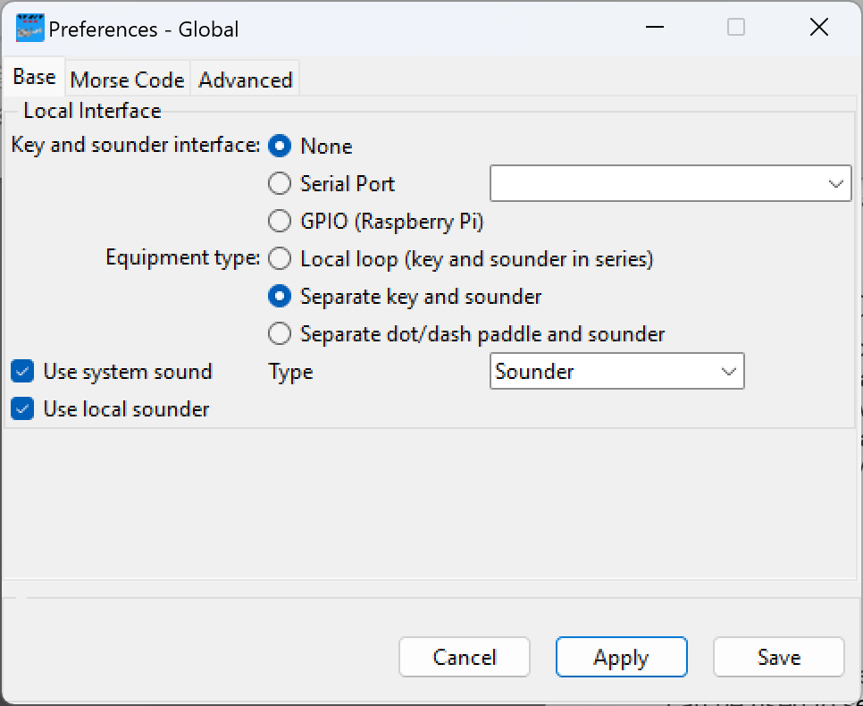

Local Interface
Specifies the interface to a physical key and sounder.

- Key and sounder interface:
  - None – No interface is to be used
  - Serial Port – A serial interface to either a key, a sounder, or a KOB, is used. The drop-down menu contains a list of serial devices found.
  - GPIO (Raspberry Pi) – The GPIO on a Raspberry Pi is used to interface to a key, a sounder, or a KOB.
- Equipment type:
  - Local loop (key and sounder in series) – This is often considered ‘the traditional configuration’, as it is how actual telegraph stations were set up. This requires a special loop interface in order to be able to detect the key as well as drive the sounder with them connected in series. This is how a KOB (Key on Board) is wired.
  - Separate key and sounder – This should be used when the interface connects to the key and sounder individually. It should also be used, if only a key or only a sounder is being used. For example, when using a physical key and the system (computer) sound.
  - Separate dot/dash paddle and sounder – This is currently under development. It will be used when a dot/dash (keyer) device is used along with a sounder or tone output. The Keyboard Sender does provide ‘keyer’ functionality using the Shift-Left and Shift-Right keys.
- Use system sound:
This checkbox enables the use of the system sound to simulate a sounder or provide a tone.
- Type: drop-down selection of
  - Sounder – Provide a simulated sounder (‘click’ (down), ‘clack’ (up))
  - Tone – Use a radio-style tone (on/off)
- Use local sounder:
This checkbox enables the use of the local sounder (when one is connected). Disabling the local sounder can be helpful when one wants to practice without disturbing others. The system sound can be used with headphones while still being able to use the physical key. This even works with most loop interfaces and a KOB.

Morse Code
Controls the Keyboard Sender sending and Code Reader decoding.

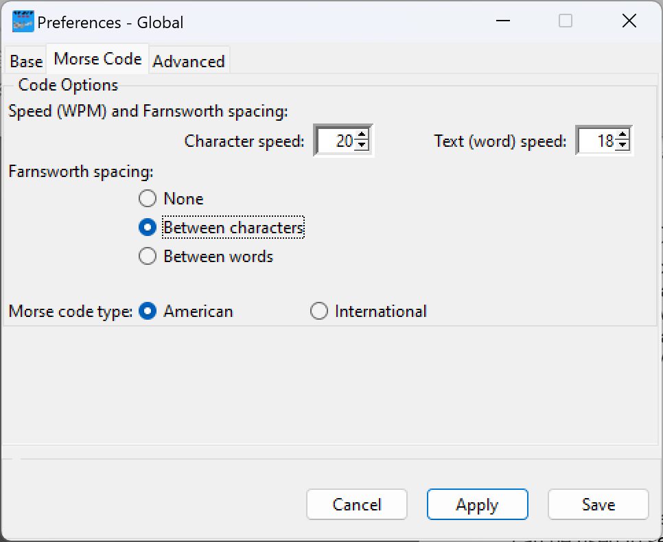

- Speed (WPM) and Farnsworth spacing:
The Farnsworth Method is a technique to aid in learning to copy code. Using the technique, characters are sent at a faster speed than the overall speed of the text. This can help you by listening to characters at the speed you wish to achieve, while making it somewhat easier to copy the full content, as it is being delivered at a lower speed.

- Character speed: The speed the characters will be sent and decoded at
- Text (word) speed: The speed the overall text will be delivered at
The text speed will always be less than or equal to the character speed.

- Farnsworth spacing:
Controls where space (additional time) will be added to effectively slow down the overall speed of the delivered text.

- None – No additional space will be added. Selecting this will disable the Text (word) speed selector, as the overall speed will be the character speed.
- Between characters – Space, as needed, will be inserted between each character sent.
- Between words – Space, as needed, will be only be inserted between words. Words themselves, will be delivered at the full character speed.

The speeds and spacing option can be set in the main application interface.

- Morse code type:
  - American – Use American (Landline) Morse when sending from the Keyboard or decoding in the Reader.
  - International – Use International (Continental) code when sending from the Keyboard or decoding in the Reader.

Advanced
Controls other aspects of the application that are less frequently changed.

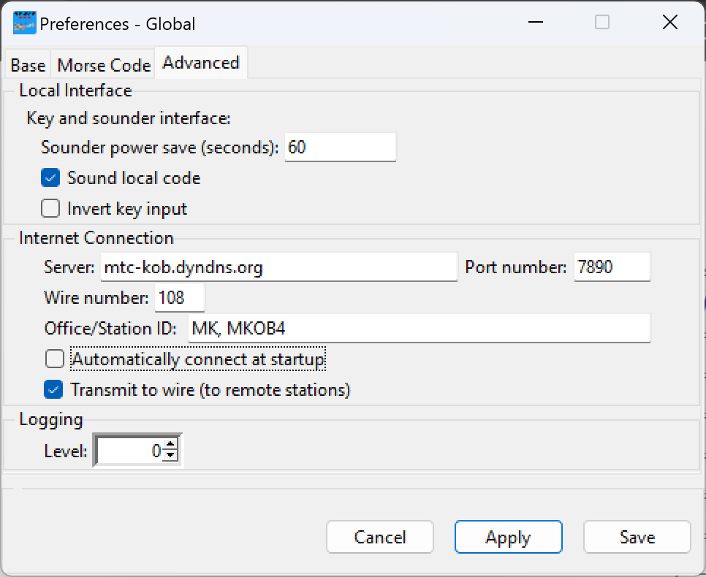

Local Interface
Additional control of the local, physical, interface.

- Key and sounder interface:
  - Sounder power save (seconds) -
Since a closed-loop telegraph has the sounder energized whenever it is idle, this feature allows power to be saved and the risk of fire to be reduced, by de-energizing the sounder after a period of no activity. When the specified number of seconds elapses with no activity of the sounder, the sounder will be powered off. Any activity, whether received from a connected wire or initiated on the local key or Keyboard Sender, will re-energize the sounder and normal operation will continue.
A value of zero (0) disables this functionality.
- Sound local code:
This enables/disables the sounding of code keyed locally, from either the physical key or from the Keyboard Sender.
- Invert key input:
This inverts the state of the key. Some interfaces, most notably the modem interface, present the key state at the opposite level of what is considered ‘normal’, and this option allows their use.

Internet Connection
Configuration for connecting to a KOBServer and wire.

- Server: The hostname or IP address of the KOBServer
- Port number: The port to use for connecting to the KOBServer
If the Server or Port (or both) are cleared, the application will use the default KOBServer at mtc-kob.dyndns.org and port 7890.
Wire number: The wire number to connect to on the KOBServer
The Wire number can be set in the main application interface.
- Office/Station ID: The Office ID used when connecting to the KOBServer Wire
For an individual, this is typically a two-letter designator that identifies your office/station, followed by some brief space or comma separated information that may be interesting to others. For example, your initials, your location, etc. When selecting a designator, it is good practice to observe the active wires for a while and do your best to select something not being used by someone else.
For a feed of some type, this is a description of the feed, including a designator identifying who is providing it. If you are interested in providing a feed, please contact the MTC to get a Wire allocated, and be added to the wire plan.
- Automatically connect at startup: This causes MKOB to connect to the configured wire as soon as it is started, without requiring the Connect button to be pressed.
- Transmit to wire (to remote stations):
Transmit keyed code from either the physical key or the Keyboard Sender to the KOBServer wire (when connected). Sending to the wire is typically what is desired, but this option can be used as a safeguard to keep you from accidentally sending code when you are practicing.

Logging
Configuration for controlling the amount of logging sent to the console.

- Level: The desired level of logging information
Information is logged at four (4) main levels:

Error – This is information that represents a serious error in the application operation. This generally means that some aspect of the application is not functioning and might even result in the application terminating.
This is Level -3 (minus 3)

Warn – This is information about something that might cause, or by causing, the application to not operate as intended/desired.
This is Level -2 (minus 2)

Info – This is information about the operation, configuration, or other aspect of the application or environment that might be interesting or helpful.
This is Level -1 (minus 1)

Debug – Debugging information is actually provided at a number of levels and it intended to help in troubleshooting problems in the operation of the application.
This is Level 1+ (1 and greater)

The Level value for this configuration setting is used to control what is logged:
0 – Log Error, Warn, and Info level information. Do not log any Debug information.
-1 – Log Error and Warn level information. Do not log Info or Debug information.
-2 – Log Error level information. Do not log Warn, Info or Debug information.
-3 – Do not log any information (completely silent).
1 (and greater) – Log Error, Warn, and Info level information, as well as Debug information designated as Level-X, where X is equal to or less than the value specified. The higher the number, the more debugging information that will be logged.

Cancel, Apply, Save
The buttons at the bottom allow you to:

- Cancel – Close the Preferences dialog without making any changes to the active configuration (even if changes have been made within the dialog).
- Apply – Apply changes that have been made to the active configuration, but do not save them. This is often used when making temporary changes, or when you want to save a new configuration based on the active/current configuration. To do that, refer to the additional information below.
- Save – Apply changes that have been made to the active configuration and save the changes out to the current configuration (a named configuration file or the global configuration).

Creating a New Configuration or Updating an Existing Configuration
Using the Preferences dialog and the File menu, new named configurations can be created or an existing configuration can be updated. The steps are:

- Start with an existing configuration. Do this by loading a configuration file or the global configuration using the File menu.
- Use the Preferences dialog to make any changes desired.
- Use Apply (not Save) to close the dialog.
- Use the File:Save As… to save a named configuration file, or…
- Use the File:Save Global to save to the global configuration.

The Configure.py command line utility can also read from one configuration, make changes, and save to a different configuration. Use the `--help` command line option of the Configure utility to see information about its operation.

Starting MKOB with a Specific Configuration (and multiple instances)
MKOB provides command line options that allow starting with a specific configuration. The option can be used to create desktop shortcuts or scripts that run MKOB in a specific way.

Multiple instances of MKOB can be running at the same time using different configurations to connect to different servers, different wires, or use different connected equipment.

This is done with a single installation of MKOB (PyKOB). There is no need to install MKOB (PyKOB) multiple times.

The command line option of interest is:
- --config config-file
The config-file is the path to a configuration file to be used.

Without this command line option, MKOB uses the global configuration.

If you intend to run multiple instances, and you are using a physical key/sounder. You will need to make sure that you specify different Serial Port values for each instance (if you have multiple interfaces connected) or specify None for the additional instances. If you don’t do this, MKOB will still function, but you will receive an error dialog when the additional instances start, letting you know that the interface is busy/not available.

Typical Configurations
Here are recommendations for Preference/Configuration settings for some typical (different) combinations of equipment.

Of course, these are not all the possibilities, but these are some of the most common.

Physical KOB (Key on Board) device connected using a ‘loop’ interface:
- Select the serial port used to connect the interface.
- Select ‘Local loop’ as the equipment type.
- Uncheck ‘Use system sound’.

Physical Key & Sounder connected through the interface, but not wired in series:
- Select the serial port used to connect the interface.
- Select ‘Separate key and sounder’ as the equipment type.
- Uncheck ‘Use system sound’.

Physical Key connected to the DSR line of a serial port (no sounder):
- Select the serial port used to connect the interface.
- Select ‘Separate key and sounder’ as the equipment type.
- Uncheck ‘Use local sounder’.
- Check ‘Use system sound’ to provide the synthesized sounder.
- (optionally select ‘Tone’ rather than ‘Sounder’)

Physical Sounder connected through an interface to the RTS line of a serial port (no key):
- Select the serial port used to connect the interface.
- Select ‘Separate key and sounder’ as the equipment type.
- Uncheck ‘Use system sound’.

No Physical Equipment:
- Select ‘None’ for ‘Key and sounder interface’.
- Uncheck ‘Use local sounder’.
- Check ‘Use system sound’ to provide the synthesized sounder.
- (optionally select ‘Tone’ rather than ‘Sounder’)

Physical KOB connected using a ‘loop’ interface – with ‘private’ practice:
Using most of the available Loop interfaces and a KOB, MKOB allows you to disable the sounder, use the system sound (allowing you to use headphones), and still be able to key using the physical key on the KOB! This allows you to practice your physical keying without disturbing others in your house, even though your equipment is a Loop and KOB!!!

- Select the serial port used to connect the interface.
- Select ‘Local loop’ as the equipment type.
- Uncheck ‘Use local sounder’.
- Check ‘Use system sound’.

Plug in your headphones/earbuds and start keying. No excuse now!

Key Timing Graph
The Key Timing graph can be used for:
- Practice and improvement of your keying.
- Tuning an auto/bug key.
- Adjusting the Speed setting for better decoding of received code.
- more?

Explanation of the graph:

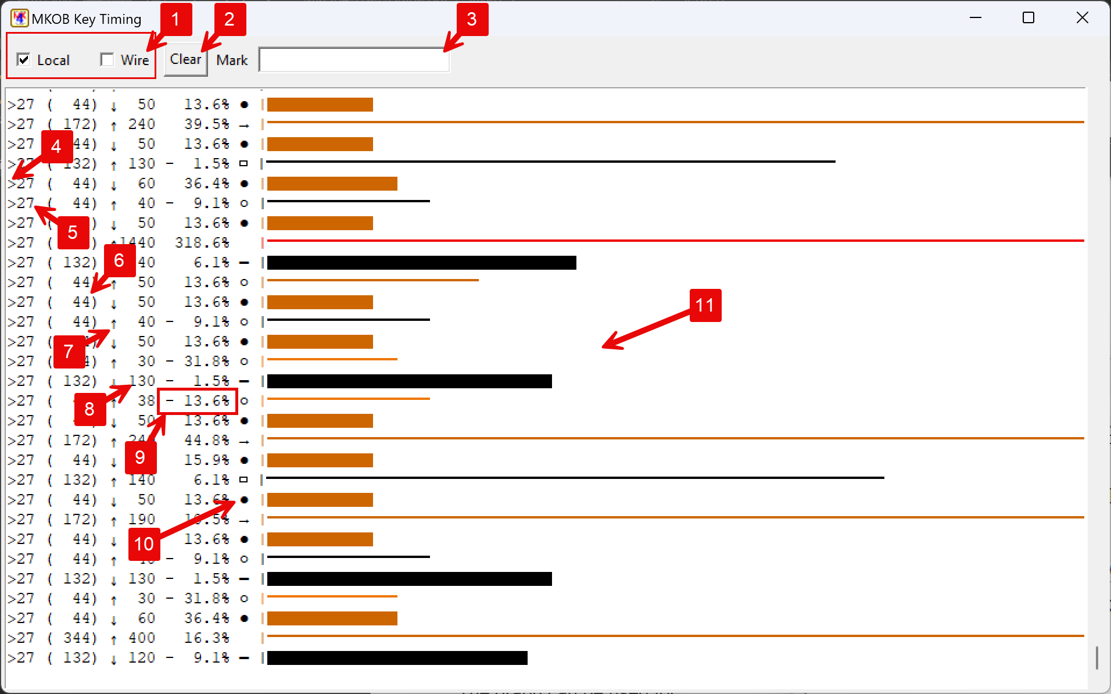

- Select whether key timing from ‘Local’ and/or ‘Wire’ sources are graphed.
- Clear the contents of the graph.
- Enter text to mark the graph. A line of text is inserted into the graph by typing in the field and pressing the Enter/Return key.
- Indicates the source of the key action:
  - ‘>’ Local
  - ‘<’ Wire
- Speed (WPM) setting being used for comparisons/calculations.
- Expected duration in milliseconds (1000 = 1 second)
- Key action:
  - ↓ Key down
  - ↑ Key up
- Measured duration in milliseconds (1000 = 1 second)
- Error percentage compared to expected. A negative value indicates that the measured duration was shorter than expected, a positive value indicates that it is longer.
- Indication of what element this duration is closest to, given the Speed (WPM) setting:
  - ‘●’ Dit (dot)
  - ‘▬’ Dah (dash)
  - ‘L’ Long ‘L’ dash
  - ‘0’ Extra-long ‘0’ dash
  - ‘○’ Element space (the space between character elements)
  - ‘▭’ Intra-character space (space within the Morse characters: C, O, R, Y, Z, &)
  - ‘ ‘ Space between characters
  - ‘→’ Space between words
- Graphical representation of the duration of the key action:
  - Length is based on the key action duration.
  - Key down actions use a wide bar.
  - Key up actions use a thin line.
  - The color is based on the duration error:
    - Black: Less than ±10%
    - Lighter brown: -10% or more (negative error – too short)
    - Darker brown: +10% or more (positive error – too long)
    - Red: The value was too large to fit within the graph maximum

Local sources include a connected key, text entered in the Keyboard Sender window, and recordings being played using the File:Play… function. Wire source is code received from a connected wire.

It is important to understand that the graph is not decoding Morse. It is selecting the expected element based on the duration of the key action, given the configured code speed (WPM). Therefore, it is possible to get a sequence of elements that do not represent a valid Morse character. For example, you might get a sequence of: ●▭●▭● (dit, intra-char-space, dit, intra-char-space, dit - which isn’t a valid character) if you were attempting to key an ‘S’ and your element spacing was slightly too long. You can monitor the Reader window in the main window to see what the Morse Reader/Decoder recognized your code as.

Record & Playback
MKOB allows you to record and play back sessions recorded in the PyKOB timing&info format (PyKOB JSON file with a .pkrec extension).

This does not simply record the text, but the actual key press/release timings used to track the physical operation of the key. In addition, the actual date/time of the activity is available and can be displayed. The office/station name of the sender is included. The result is that during playback, the actual experience of the session is reproduced.

PyKOB recordings have been used to archive code from Instructograph tapes, Dial-Up session audio recordings, Morse Day celebrations, and day-to-day sessions with other Landline Telegraphy enthusiasts. You can listen to a PyKOB recording of Instructograph Tape 5 on Wire 135 on the public KOBServer (mtc-kob.dyndns.org). That PyKOB recording is included in the ‘learn’ folder in the MKOB/PyKOB installation. In addition, a recording of a live Morse-Day session is included (mkob_learn\Morse Day.pkrec). It is a good recording to use to try out the playback capabilities described in this section and to practice your ability to copy actual, hand-sent, code.

Record
You can start recording a session using the File:Record menu entry. That will start recording the current session using an automatically generated file name (based on the current date and time). The name of the file will be presented in a dialog box and displayed in the MKOB status bar.

Once the recording is started, all code activity (local and from the connected wire) will be recorded.

The recording can be stopped using the File:End Recording menu entry or when MKOB is closed.

Play Recording
A recording is loaded to play using the File:Play… menu entry. The menu entry opens a file selection dialog that is used to select a .pkrec (or a recording .json file). When a recording file is selected, MKOB will start reproducing the session. That includes listing the Offices/Stations that were involved in the session, reproducing the code (as it was sent), and cycling the Offices window through the active senders.

(Currently, only offices/stations that sent code are included in the recording. Including all offices, and displaying them as they join and drop, is planned as an enhancement.)

Playback
MKOB plays the recording at actual speed. The Play utility (part of the PyKOB package) allows adjusting the playback speed as a +/- percentage of actual speed.

MKOB compresses long periods of ‘dead’/idle space (silence) down to five (5) seconds of reproduced idle time. The Play utility allows adjusting the period of idle time that is reproduced (allowing for exact reproduction of the recorded session).

Recording playback is treated like local keying, except that it will not send to a wire. If MKOB is currently connected to a wire, it will disconnect before playing a recording. Connecting is disabled while a recording is playing. This is done to avoid the recording being misconstrued by others as a live session. To provide a recording on a live wire, you can use the Feed utility (part of the PyKOB package). That allows you to provide a feed sourced from a recording, but it identifies the feed as the source rather than the individual offices that contributed to the recording. This is how Wire-134 is sourced from the recording of Instructograph Tape 5.

Playback Control
During playback, keyboard keys can be used to pause, move, and stop playback.

Stop Playback
While playing back – Ctrl-S will stop playback.

Pause/Resume Playback
Ctrl-P will pause current playback, and resume paused playback.

Move Back 15 Seconds
Ctrl-H will move back 15 seconds.

It is important to realize that MKOB does not put any indication of this movement into the Reader (Code Decoder) window.

Move Forward 15 Seconds
Ctrl-L will move forward 15 seconds.

It is important to realize that MKOB does not put any indication of this movement into the Reader (Code Decoder) window.

Move to Start of Current Sender
Ctrl-J will move the playback back to the beginning of the code sent by the current sender.

It is important to realize that MKOB does not put any indication of this movement into the Reader (Code Decoder) window.

Move to the End of the Current Sender
Ctrl-K will move the playback forward to the end of the code sent by the current sender.

It is important to realize that MKOB does not put any indication of this movement into the Reader (Code Decoder) window.

Moving to the Previous Sender
There isn’t a control to move to the previous sender. However, the combination of:
- Ctrl-J – Move to the Start of the Current Sender
- Ctrl-H – Move back 15 Seconds
- Ctrl-J – Move to the Start of the Current Sender
Will typically do it. This will move to the start of the current sender, then move back 15 seconds (which should be back into the previous sender), then move to the start of that sender.
(File an enhancement issue if that doesn’t work for you 😊)

