*Heaven’s Light is Our Guide*

**Rajshahi University of Engineering & Technology**

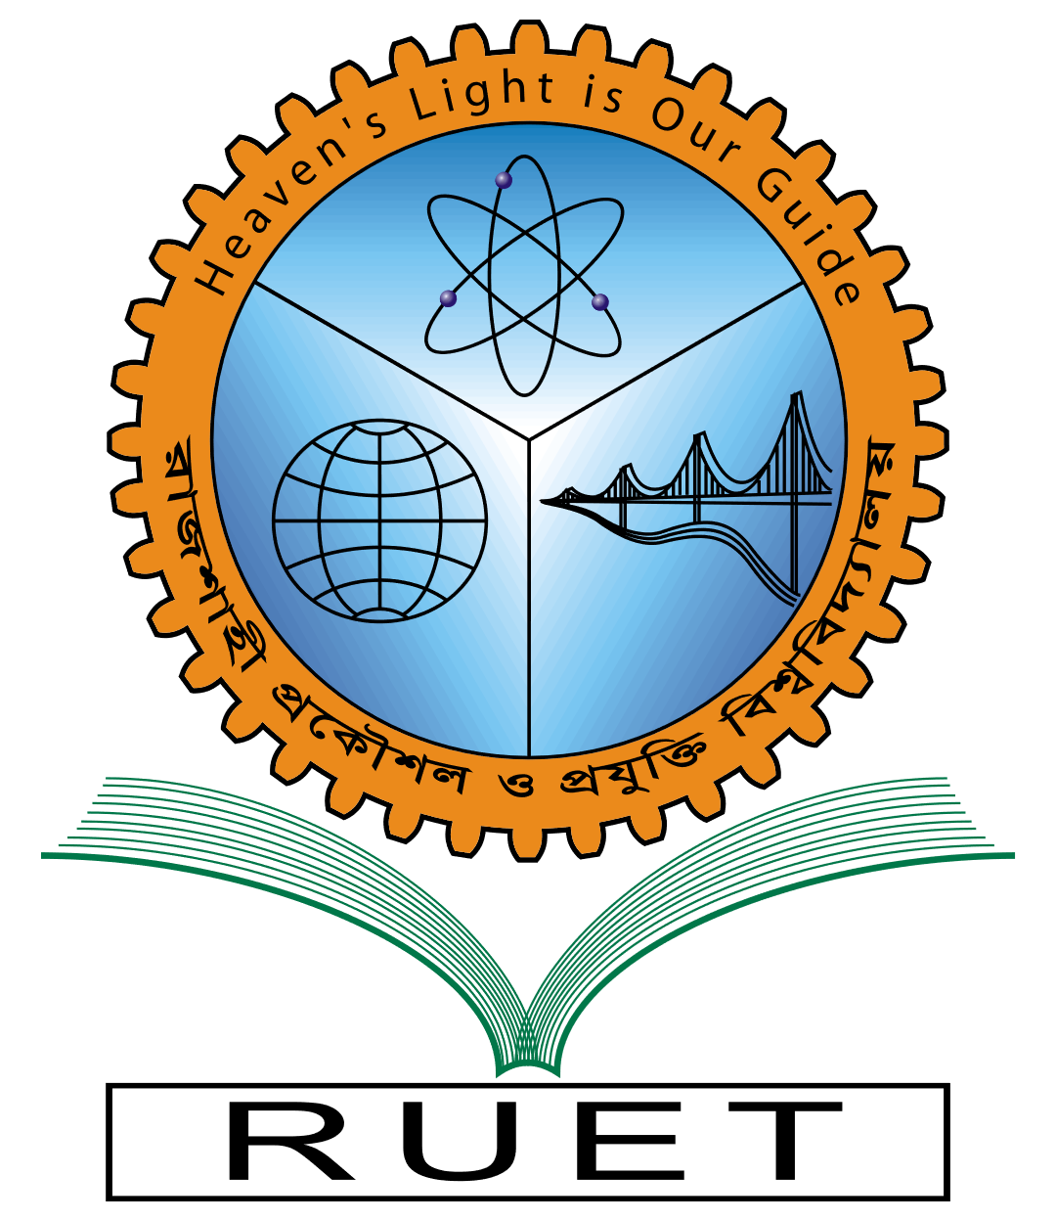

Department of Electrical & Computer Engineering

**System Analysis**

**of**

**Technical Training Center(TTC), Rajshahi**

**Course No:** ECE 3118

**Course Title:** Software Engineering & Information System Design Sessional

**Submitted By:**

**Submitted To :**

Rakibul Hassan

Assistant Professor

Dept. of ECE,RUET

1. Name: Safal Kumar Biswas

Roll: 1810056

1. Name: Israt Zahan

Roll:1810057

1. Name: Ahmad Nafi

Roll:1810058

4.Name:M.Morsedur Rahman

Roll:1810059

5. Name: Mahdi Hasan

Roll:1810060