A/B Testing and Hypothesis Testing
  - Comparing Session Duration for UI_A and UI_B
Name: ____________________ Student ID: ____________________
Course: ___________________ Section: _______________________

1. Objective and hypotheses
Compare population mean session duration between the two mobile-app interfaces. The target metric is session_duration_seconds, measured in seconds. All differences are defined as UI_B minus UI_A. Retain every observation without transformations.
$H₀: μB − μA = 0 H₁: μB − μA ≠ 0 α = 0.05 (two-sided)$

2. Data exploration
The supplied CSV contains 10,000 session records and 9 columns (10,001 records including the header). The first ten rows appear in Appendix A.
CSV column | Description | Type
user_id | Session identifier | Integer
ui_version | Interface shown: UI_A or UI_B | String
timestamp | Session date and time; loaded as text | Date/time text
session_duration_  seconds | Session length; target metric, seconds | Float
pages_visited | Pages/screens viewed | Integer
clicks | Total interactions | Integer
errors_encountered | Errors or bugs experienced | Integer
conversion | Desired action completed: 1=yes, 0=no | Binary
bounce | Left without interaction: 1=yes, 0=no | Binary
Column names above preserve CSV capitalization. The assignment capitalizes four headers differently; the analysis uses the actual CSV names.

2.1 Data quality and descriptive statistics
Data-quality checks: missing cells = 0; duplicate rows = 0; duplicate user ids = 0; unexpected ui labels = 0; non numeric or nonfinite durations = 0; nonpositive durations = 0.
Every column has zero missing values. No records were removed, imputed, or transformed. Distinct session IDs do not demonstrate independent users or observations.
Statistic | UI_A | UI_B
Sample size | 5,013 | 4,987
Mean (seconds) | 99.6631 | 126.2585
Sample SD (seconds) | 71.5636 | 83.6444
Minimum (seconds) | 1.6100 | 2.2500
25th percentile (seconds) | 47.6700 | 65.7350
Median (seconds) | 81.8100 | 109.1500
75th percentile (seconds) | 133.5300 | 167.3500
Maximum (seconds) | 525.9500 | 666.5100
Sample SD uses ddof=1; quartiles use linear interpolation. SD describes variation among individual durations. Standard error describes uncertainty in an estimated mean (SD/√n under independence). These quantities are not interchangeable.
The assignment preview lists SDs of 68.45 and 71.23 seconds, whereas the CSV yields 71.5636 and 83.6444. Counts and rounded means match. All calculations use the CSV.

3. Normality assessment
Group | n | Skewness¹ | Shapiro W | p-value
UI_A | 5013 | 1.367327 | 0.895352 | 5.031549e-50
UI_B | 4987 | 1.368853 | 0.906892 | 5.703987e-48
¹ Sample skewness uses bias=False. Shapiro H₀: normal distribution; H₁: non-normal. Both p-values are below 0.05, supporting rejection. A large p-value would not prove normality.

3.1 Histograms of individual durations
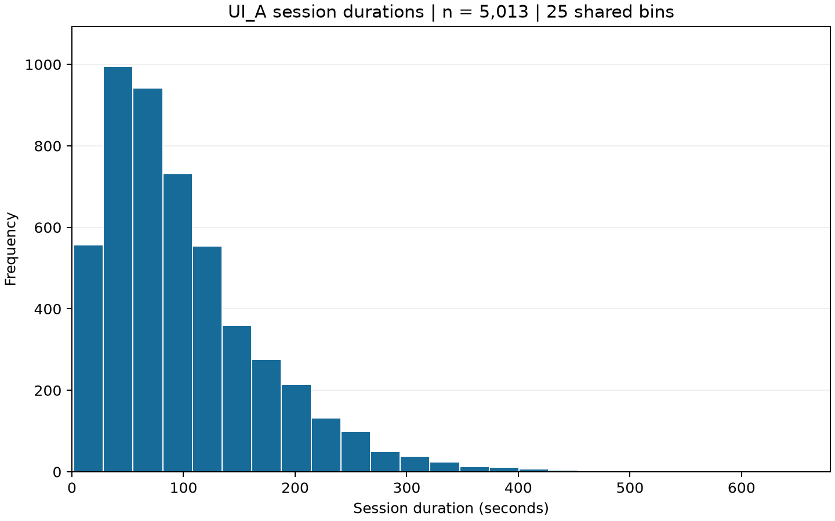
Figure 1. UI_A: 25 bins; a clear right tail and asymmetric concentration at shorter durations.
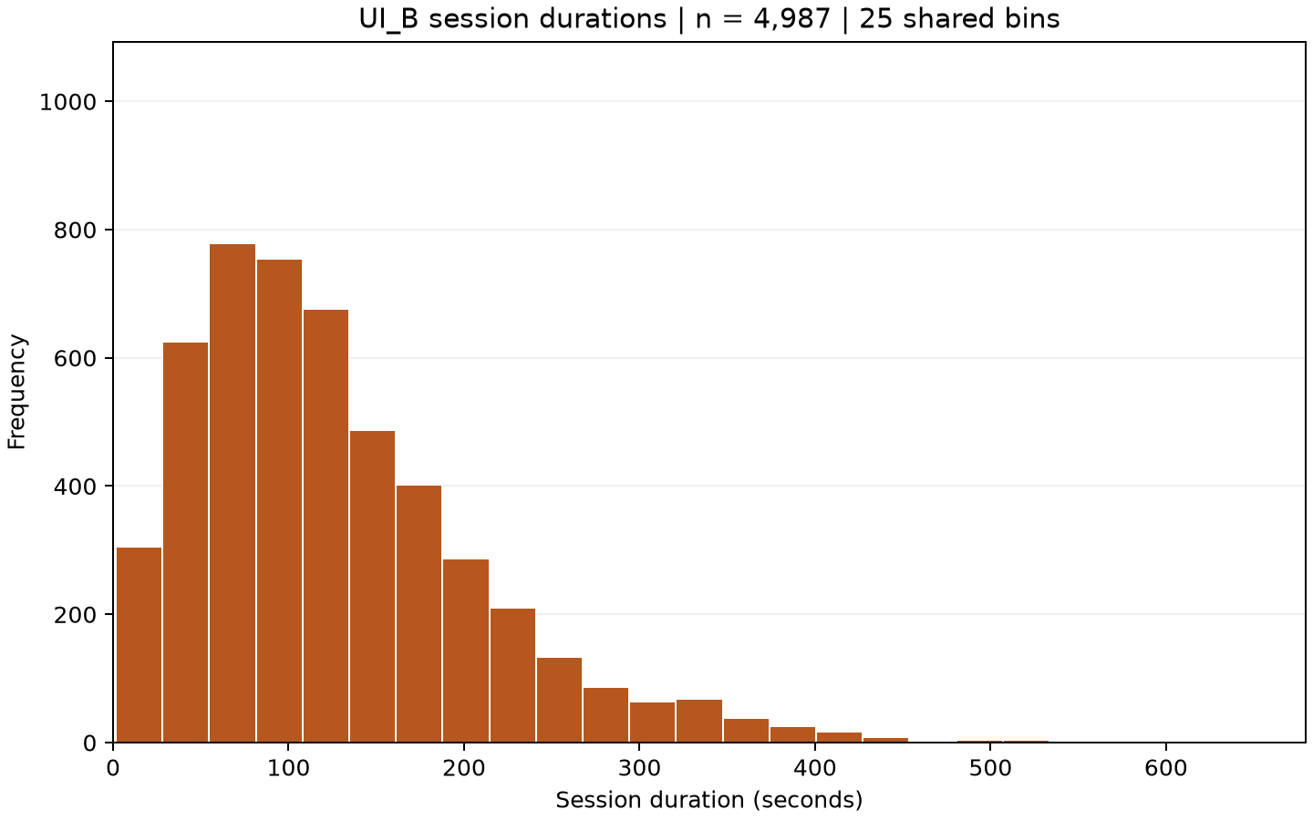
Figure 2. UI_B: the same 25 bin boundaries and axis limits. The distribution is right-skewed and extends farther to the right.
Both are unimodal but not symmetric bell shapes. All observations, including extreme durations, remain visible in the full-range plots.

3.2 Normal Q-Q plots and inference
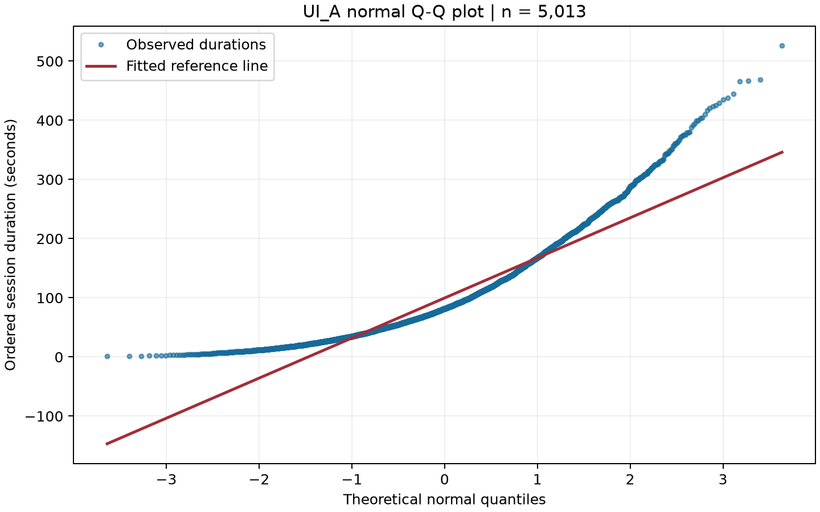
Figure 3. UI_A normal probability plot (scipy.stats.probplot), with its fitted reference line.
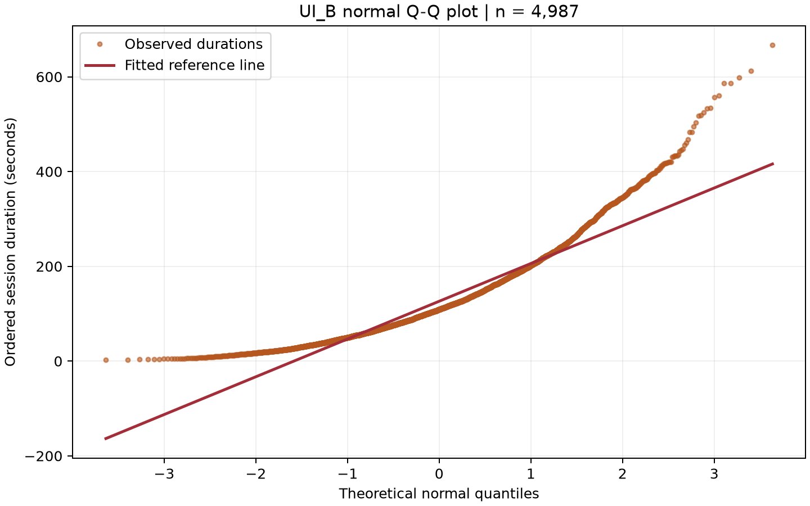
Figure 4. UI_B normal probability plot, with its fitted reference line. Both show systematic curvature and large upper-tail departures.
The lower tails lie above the fitted lines, central portions tend below them, and upper tails rise sharply above them. Positive skewness corroborates these departures.

3.3 Normality limitations and assumptions
UI_A uses all 5,013 observations. SciPy issued the following warning; no subsampling was performed:
UserWarning: scipy.stats.shapiro: For N > 5000, computed p-value may not be accurate. Current N is 5013.
For more than 5,000 observations, SciPy documents that W remains accurate but the p-value may not. Treat its precise magnitude cautiously. UI_B has 4,987 observations and did not trigger this warning. Large samples make normality tests sensitive, but the observed curvature and skewness also show substantial non-normality [1].
The distribution of individual durations is not the sampling distribution of a mean. Under independence and finite population variances, large samples support approximate mean inference even with non-normal raw data. Independence is assumed from the assignment scenario; unique IDs do not establish it. Large samples do not repair dependence or biased sampling. Welch addresses unequal variances, not raw-data normality.

4. Variance assessment and Welch test
Median-centered Levene (Brown-Forsythe) gives statistic 65.919294, p = 5.25152025e-16. It is robust to departures from normality, especially skewness [2]. The assignment rule selects Welch because p < 0.05. A non-significant result would not prove equal variances; preliminary variance-based selection is data-dependent and can affect overall error properties.
Let mA, mB be sample means; sA, sB sample SDs; and nA, nB sample sizes. Define vA = sA²/nA and vB = sB²/nB.
$SE = √(vB + vA); t = (mB − mA)/SE$
$df = (vB + vA)² / [vB²/(nB − 1) + vA²/(nA − 1)]$
$p = 2 × t.sf(|t|, df)$
$CI₉₅ = (mB − mA) ± t.ppf(0.975, df) × SE$
vB = 83.64436110²/4987 = 1.4029234298; vA = 71.56361982²/5013 = 1.0216141396.
SE = √(1.4029234298 + 1.0216141396) = 1.55709267 seconds. t = (126.25848606 − 99.66307401)/1.55709267 = 17.08017297.
df = (1.40292343 + 1.02161414)² / [1.40292343²/4986 + 1.02161414²/5012] = 9748.82914022.

4.1 Test results and interpretation
Welch result: UI_B minus UI_A | Value
Mean difference (seconds) | 26.59541206
Standard error (seconds) | 1.55709267
t-statistic | 17.08017297
Degrees of freedom | 9748.82914022
Two-sided p-value | 1.79827227e-64
95% CI (seconds) | [23.54318756, 29.64763655]
Decision at α = 0.05 | Reject H0
CI = 26.59541206 ± 1.96020735 × 1.55709267 = [23.54318756, 29.64763655] seconds.
Reject H₀. UI_B has a higher estimated mean duration by 26.5954 seconds. The confidence interval excludes zero. The p-value describes tail extremeness under H₀ and the model; it is not the probability that H₀ is true. Statistical significance does not by itself establish business value.
The raw-data SciPy test uses UI_B first, UI_A second, equal_var=False, and a two-sided alternative [3]. Independent summary-statistic formulas agree with SciPy, including its confidence interval. Tiny p-values were checked with relative tolerance 1e-10, absolute tolerance zero, and positivity assertions; the script and notebook also agree.

5. Required normal-model probability scenarios
$XA \sim Normal(mA, sA²); XB \sim Normal(mB, sB²)$
mA = 99.66307401, sA = 71.56361982; mB = 126.25848606, sB = 83.64436110 seconds. Use individual-session SDs, not standard errors. All displayed substitutions are rounded only for readability.
These are the normal-model approximations required by the assignment. Both raw distributions are right-skewed and non-normal; large samples do not make individual durations normal. The requested model is not truncated, even though it allows negative theoretical durations. Empirical comparisons are reported separately.

5.1 Worked probability answers

(a) P(XA > mB)
A UI_A session exceeds the UI_B sample mean.
zlower = (126.25848606 − 99.66307401) / 71.56361982 = 0.37163313.
1 − Φ(z) = norm.sf(0.37163313) = 0.35508301 = 35.5083%.
Under this model, about 35.51% of individual UI_A sessions satisfy the event.
UI_B’s full-precision sample mean is a fixed threshold here. This is not P(XA > XB).

(b) P(XA < 80)
A UI_A session lasts less than 80 seconds.
zupper = (80.00000000 − 99.66307401) / 71.56361982 = -0.27476355.
Φ(z) = norm.cdf(-0.27476355) = 0.39174895 = 39.1749%.
Under this model, about 39.17% of individual UI_A sessions satisfy the event.

(c) P(XB > 150)
A UI_B session lasts more than 150 seconds.
zlower = (150.00000000 − 126.25848606) / 83.64436110 = 0.28383879.
1 − Φ(z) = norm.sf(0.28383879) = 0.38826696 = 38.8267%.
Under this model, about 38.83% of individual UI_B sessions satisfy the event.

(d) P(80 < XA < 120)
A UI_A session lasts strictly between 80 and 120 seconds.
zlower = (80.00000000 − 99.66307401) / 71.56361982 = -0.27476355.
zupper = (120.00000000 − 99.66307401) / 71.56361982 = 0.28417967.
Φ(zupper) − Φ(zlower) = Φ(0.28417967) − Φ(-0.27476355) = 0.22011470 = 22.0115%.
Under this model, about 22.01% of individual UI_A sessions satisfy the event.

5.2 Supplementary empirical comparison
Observed proportions use the matching group denominator, strict inequalities, and the full-precision UI_B mean for (a). These sample proportions supplement, rather than replace, the required normal-model answers.
Event | Count / n | Observed proportion | Observed % | Model %
P(XA > mB) | 1405/5013 | 0.280271 | 28.0271 | 35.5083
P(XA < 80) | 2448/5013 | 0.488330 | 48.8330 | 39.1749
P(XB > 150) | 1542/4987 | 0.309204 | 30.9204 | 38.8267
P(80 < XA < 120) | 1057/5013 | 0.210852 | 21.0852 | 22.0115
The normal approximation differs from the empirical distribution: right skew changes the allocation of mass around the thresholds and in the tails. Empirical rates describe this sample, not exact population probabilities. The strongest mismatches occur in (a), (b), and (c).

6. Business impact and conclusion
$Absolute difference = mB − mA$
= 126.25848606 − 99.66307401 = 26.59541206 seconds.
$Relative increase (\%) = 100 × (mB − mA)/mA$
= 100 × (126.25848606 − 99.66307401) / 99.66307401 = 26.685322%.
This is a relative percentage increase in mean session duration, not a change in percentage points. The verified Welch result is statistically significant (p = 1.79827227e-64); its 95% interval for UI_B minus UI_A is [23.543188, 29.647637] seconds.
If longer engagement is the business objective, UI_B is a candidate for adoption, conditional on practical value, costs, and checks of relevant outcomes. Longer sessions alone do not prove better usability, satisfaction, conversion, or revenue; they may also reflect friction. The evidence establishes a difference in mean duration under the stated assumptions, not a universal improvement in user experience.

7. Reproducibility and sources
Supplied sources: A_B_Testing_Hypothesis_Testing_Assignment.docx and ui_ab_testing_data.csv. Original files remain unchanged. Numeric tables and substitutions in this report are loaded from the verified analysis outputs; figures are the previously inspected exports.
From the project folder, follow README.md to use the Python 3.13.1 .venv and requirements.txt. Run the analysis script, then the full notebook in a fresh project kernel. Finally run the report builder. The accompanying notebook and script retain full code; this report presents methods and findings.
.\.venv\Scripts\python.exe scripts\analyze_ab_testing.py
.\.venv\Scripts\python.exe scripts\execute_notebook.py
.\.venv\Scripts\python.exe scripts\build_report.py
Saved analysis sources: descriptive_statistics.csv, normality_assessment.csv, variance_test.csv, t_test_results.csv, probability_scenarios.csv, and business_impact.csv in results/. Full precision is retained in those files; only reported displays are rounded. Tiny p-values use scientific notation.
Checks include normal-probability z-score versus direct loc/scale calculations, strict empirical counts and group denominators, probability bounds, and script/notebook/manual-formula agreement. Report generation checks key values against the source CSV and saved results without replacing them.

Documentation consulted
[1] SciPy documentation. Shapiro-Wilk: sample-size warning.
https://docs.scipy.org/doc/scipy/reference/generated/scipy.stats.shapiro.html
[2] SciPy documentation. Levene: median-centered variance assessment.
https://docs.scipy.org/doc/scipy/reference/generated/scipy.stats.levene.html
[3] SciPy documentation. Independent t-test: Welch and confidence interval.
https://docs.scipy.org/doc/scipy/reference/generated/scipy.stats.ttest_ind.html
[4] SciPy documentation. Probability plots: normal quantiles and fitted line.
https://docs.scipy.org/doc/scipy/reference/generated/scipy.stats.probplot.html
The normal Q-Q visualizations use scipy.stats.probplot with normal quantiles and a fitted reference line [4]. No external datasets or invented references are used.

Appendix A. First ten CSV records
All nine columns are shown in their original row order. Short display headers are mapped below to the exact CSV names; all durations are in seconds.
user_id | UI | timestamp | Duration  (seconds) | Pages | Clicks | Errors | Conversion | Bounce
1 | UI_A | 15-01-24 2:46 | 50.43 | 2 | 5 | 1 | 0 | 0
2 | UI_B | 20-01-24 23:28 | 8.71 | 9 | 6 | 0 | 0 | 0
3 | UI_A | 04-01-24 19:54 | 88.4 | 4 | 4 | 0 | 0 | 0
4 | UI_A | 20-01-24 22:06 | 91.6 | 3 | 4 | 0 | 1 | 0
5 | UI_A | 27-01-24 5:12 | 240.79 | 3 | 3 | 1 | 0 | 0
6 | UI_B | 20-01-24 20:59 | 138.44 | 3 | 3 | 0 | 0 | 1
7 | UI_A | 11-01-24 6:35 | 54.03 | 4 | 8 | 1 | 0 | 0
8 | UI_A | 10-01-24 1:37 | 17.28 | 3 | 7 | 0 | 0 | 0
9 | UI_A | 03-01-24 20:41 | 76.78 | 3 | 8 | 0 | 0 | 1
10 | UI_B | 29-01-24 22:09 | 141.43 | 4 | 4 | 1 | 0 | 0
UI = ui_version; Duration = session_duration_seconds; Pages = pages_visited; Clicks = clicks; Errors = errors_encountered; Conversion = conversion; Bounce = bounce. user_id and timestamp retain their original names.
The timestamp is displayed exactly as loaded. Conversion and bounce are binary indicators defined in Section 2. Their business outcomes were not analyzed in this assignment.

