PPMS
Production Planning & Monitoring System
User Manual
Step-by-step guides, tips and recommendations for every screen

MODULES | F200 – KD1 · F200 – KD2 · F100 – KD2
COVERS | Viewers, Operators, Planners and Master Admins
EDITION | 07 October 2026

About this manual
This manual explains how to use PPMS, chapter by chapter, in the same order as the screen. Every topic says who can use it and which module it applies to, explains what it does, and then gives numbered steps. Where it helps, you will also find these boxes:
Tips
• Handy extra information and shortcuts.

Recommended
• How we recommend using the feature — good practice from daily use.

Caution
• Something to watch out for, such as an action that cannot be undone.

The same manual is built into PPMS: open the menu (☰) → Help & User Manual, where it can be searched and filtered to your role. For a quick visual introduction, choose ☰ → Guided tour. Screens are shown in the Light theme.

Quick reference

What each role can do
Action | Viewer | Operator | Planner | Master Admin
View every screen, filter and the charts | ✓ | ✓ | ✓ | ✓
Export reports (with the "Can export" permission) | ✓ | ✓ | ✓ | ✓
Record actual start and completion dates | — | ✓ | ✓ | ✓
Comments, delay reasons and X-ray results | — | ✓ | ✓ | ✓
Report and update production issues | — | ✓ | ✓ | ✓
Unit Codes and plan versions | — | ✓ | ✓ | ✓
Edit the Gantt: move, resize, add, delete blocks | — | — | ✓ | ✓
Reorder route, hide or delete processes | — | — | ✓ | ✓
Manage Processes, lead times, no-work days | — | — | ✓ | ✓
User Management, Audit Log, Active Users | — | — | — | ✓

Task statuses
Status | Meaning
Completed | Finished on or before the planned end date.
Late Completion | Finished, but after the planned end date.
In Progress | Started (actual start recorded) and not finished yet.
Overdue | Not started and already past the planned end date.
Planned | Not started yet and not yet due.

Keyboard shortcuts
Keys | What it does
Esc | Close a dialog, menu, the manual or the guided tour
Ctrl + Enter | Save the issue you are writing
← / → | Previous / next issue in the issue details · Back / next in the guided tour
F5 | Reload the page
Ctrl + Shift + R | Hard reload — use if the page looks out of date

Contents
Right-click here and choose "Update Field" to build the table of contents.

01 Getting Started
Sign in, find your way around the screen and learn what your role allows. New users should start here — or take the guided tour from the menu (☰).
In this chapter: Your first 10 minutes · The guided tour · Signing in · User roles and what they can do · The top bar · Modules: KD1, F200-KD2 and F100-KD2 · Filtering the page

Your first 10 minutes
Who can use it: Everyone | Applies to: All modules

A short checklist that gets a new user productive straight away.
STEP BY STEP
1 | Sign in with the email and password the administrator gave you, then change the password from your name (top right) → Change password.
2 | Open the menu (☰) → Guided tour. It walks you around every part of the screen in about two minutes.
3 | Check the module and plan version at the top (for example F200 – KD2 · KD2 Battalion 1). Everything on the page belongs to that plan.
4 | Use the Filters panel to narrow the page to the battalion, vehicle or units you are responsible for.
5 | Read the Executive Summary and the Delivery card — they tell you where production stands and when delivery is expected.
6 | Scroll to the part of the page you work in: the Schedule (planners), the Plan Table (recording actual dates) or Production Issues.
7 | Bookmark the PPMS link and keep this manual one click away: ☰ → Help & User Manual.

Recommended
• Pick a colour theme that is comfortable for long sessions — Light is best for printing screenshots, Dark for the shop floor.
• Ask the PPMS Assistant (chat bubble, bottom left) whenever you are unsure — it knows this manual.

See also: The guided tour · User roles and what they can do · Filtering the page · Executive Summary

The guided tour
Who can use it: Everyone | Applies to: All modules

An interactive walk-through that highlights each part of the screen and explains what it does. Start it any time from the menu (☰) → Guided tour.
The tour moves the page for you and spotlights one area at a time — the top bar, filters, summary, schedule, progress matrix, analytics, plan table, issues and the assistant. It only shows the parts that exist for your role and module.
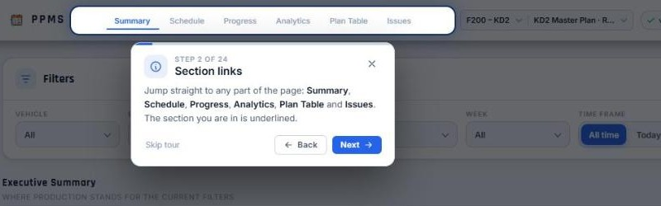
Figure 1 — The guided tour
STEP BY STEP
1 | Open the menu (☰) at the top right and choose Guided tour.
2 | Read the card next to the highlighted area and press Next (or the → key) to continue.
3 | Press Back (←) to go back a step, or Skip tour (Esc) to stop at any time.
4 | Start it again whenever you like — nothing on the page is changed by the tour.

Tips
• New users are offered the tour once, the first time they open PPMS.

See also: Your first 10 minutes · Help & User Manual

Signing in
Who can use it: Everyone | Applies to: All modules

PPMS (Production Planning & Monitoring System) opens on the sign-in page. Use the email and password given to you by the system administrator.
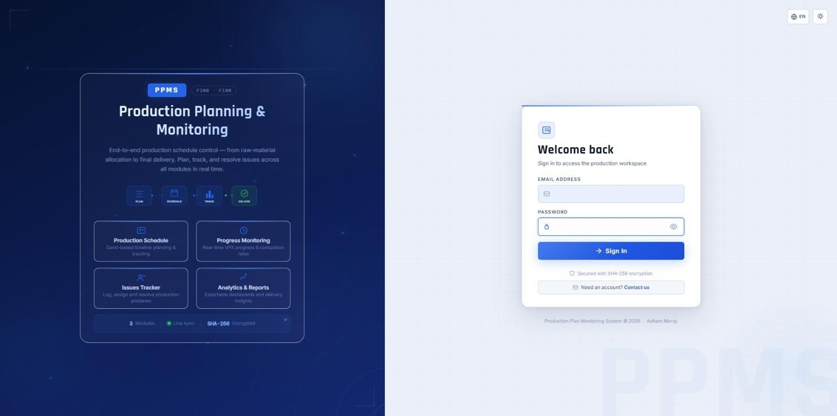
Figure 2 — Signing in
STEP BY STEP
1 | Open the PPMS link in your browser (Chrome or Edge recommended).
2 | If you prefer Korean or Arabic, click the globe button (EN) at the top right and choose 한국어 or العربية — the sign-in page and PPMS switch language.
3 | Enter your email and password, then press Sign In.
4 | If your account has access to more than one module, PPMS opens the module you used last.

Tips
• If you see "Your account has been deactivated", contact the administrator.
• The sun / moon button next to the globe changes the colour theme.
• You stay signed in while the browser tab is open. Opening PPMS again while still signed in is recorded in the Audit Log as "Opened PPMS — still signed in".

Caution
• Never share your password. Every change you make is recorded in the Audit Log under your name.

See also: Changing your password · User roles and what they can do · Language — English, Korean, Arabic

User roles and what they can do
Who can use it: Everyone | Applies to: All modules

Every account has one role. The role decides which buttons you see — buttons you can't use are simply hidden.
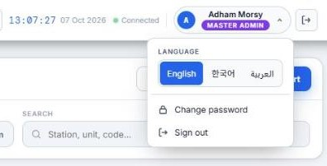
Figure 3 — User roles and what they can do
STEP BY STEP
1 | Viewer — can see every screen, filter, and (if allowed) export reports. Cannot change data.
2 | Operator — everything a Viewer can do, plus record actual start and completion dates, comments, delay reasons, X-ray results and production issues.
3 | Planner — everything an Operator can do, plus edit the plan itself: move and resize Gantt blocks, add plan blocks, hide or delete processes, manage processes, lead times and plan versions.
4 | Master Admin — everything, plus User Management, the Audit Log and Active Users.

Tips
• Exporting reports is a separate permission ("Can export") set per user in User Management.
• Your role is shown under your name at the top right. If an admin changes it, PPMS updates while you are signed in.

See also: User Management

The top bar
Who can use it: Everyone | Applies to: All modules

The top bar is always visible. It holds the section links, the module and plan version switch, the version number, notifications, language, theme, the menu and your account.
Figure 4 — The top bar
STEP BY STEP
1 | Section links — Summary, Schedule, Progress, Analytics, Plan Table and Issues — scroll the page to that section; the current one is underlined.
2 | Module switch — choose F200 – KD1, F200 – KD2 or F100 – KD2. The page reloads for that module.
3 | Plan version switch — choose which active version of the plan you are looking at.
4 | Version number (e.g. ✓ v158) — the PPMS version you are running. It blinks orange when a newer version is available.
5 | Bell — notifications about new comments, new or updated issues, and plan changes.
6 | People icon (Master Admin) — who is online now, live (see Active Users).
7 | Globe (EN / 한 / ع) — the interface language: English, Korean or Arabic.
8 | Sun / moon icon — choose a colour theme.
9 | Menu (☰) — Help & User Manual, Guided tour, and — depending on your role — Audit Log, Unit Codes, User Management, Manage Processes and Manage Plan Versions.
10 | Your name — change your password or sign out. The green dot next to the clock shows the live connection.

Tips
• Hover any button or icon for a short description — PPMS shows it in a small card.

See also: Modules: KD1, F200-KD2 and F100-KD2 · Keeping PPMS up to date · Notifications · Colour themes · Language — English, Korean, Arabic

Modules: KD1, F200-KD2 and F100-KD2
Who can use it: Everyone | Applies to: All modules

PPMS holds three separate plans. Each module has its own plan, versions, units and issues.
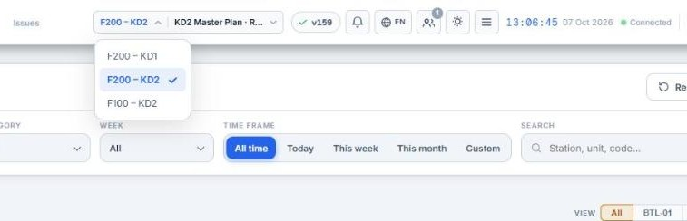
Figure 5 — Modules: KD1, F200-KD2 and F100-KD2
STEP BY STEP
1 | KD1 — the assembly plan (per vehicle and station).
2 | F200-KD2 — K9, K10 and K11 production per battalion and unit, from Sub weldment through final test.
3 | F100-KD2 — gun and vehicle parts per battalion, with manufacturers (HAS, DOOWON).
4 | Switch module from the module switch in the top bar. Your access to each module is set by the administrator.

Tips
• Notifications from other modules still reach you; clicking one switches module automatically.

Filtering the page
Who can use it: Everyone | Applies to: All modules

The Filters panel at the top narrows every section of the page at once: the Executive Summary, schedule, progress, charts and plan table.
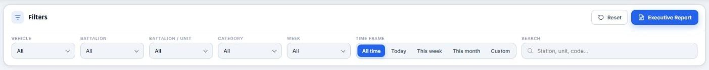
Figure 6 — Filtering the page
STEP BY STEP
1 | Pick one or more values in Vehicle, Battalion, Unit, Category or Week. Each list allows several ticks; a filter that is set turns blue.
2 | Choose a Time frame: All time, Today, This week, This month, or Custom (then pick From and To dates).
3 | Type in Search to find a station, unit or code.
4 | Every active filter appears as a chip next to the Filters title (for example "Vehicle: K9 ×"). Click × on a chip to remove that one filter.
5 | Press Reset to clear every filter at once.

Tips
• KD2 unit labels (M1, M2 …) repeat in every battalion. When several battalions are shown, the Unit list includes the battalion.
• The Plan Table and the Issues table also have their own filter icon in each column header.

Recommended
• Use "All time" when you look at the delivery date — a short time frame only sees part of each unit's route, so the forecast covers that part only.
• Filter by your battalion or units first thing in the morning; the choice stays while you work.

See also: Executive Summary · The Plan Table

02 Daily Workflows
Ready-made routines for each kind of user: what to do at the start of a shift, how a planner keeps the plan current, and how management reviews progress.
In this chapter: Operator: a typical shift · Planner: keeping the plan current · Management: reviewing progress · Working together on the same plan

Operator: a typical shift
Who can use it: Operator and above | Applies to: All modules

The routine that keeps PPMS accurate: record what happened on the floor the same day, and raise problems early.
STEP BY STEP
1 | Start of shift — filter to your battalion and units, then check the Overdue tile and the bell for new comments or issues.
2 | Open the Plan Table and record Actual Start for every station that began today.
3 | When a station finishes, record its Completion date (click the Completed On cell).
4 | Anything blocking work? Press Report Issue in Production Issues — title, category, priority and a short description is enough to start.
5 | Late vehicle? Add a delay reason in Vehicle Production Progress so management sees why.
6 | For X-ray stations, record each X-ray and repair cycle on the row's X-ray marker.
7 | End of shift — check nothing you worked on is left without dates, and reply to comments addressed to you.

Recommended
• Record dates the same day. The delivery forecast, the VPX and every report are only as good as the actual dates entered.
• Use comments for short notes on a task and Production Issues for real problems that need an owner and follow-up.

See also: Recording actual start and completion · Reporting an issue · Delay reasons · X-ray and repair tracking

Planner: keeping the plan current
Who can use it: Planner and Master Admin | Applies to: F200-KD2

A weekly routine for planners to keep the plan realistic and the delivery forecast trustworthy.
STEP BY STEP
1 | Open the Delivery card → Delivery Delay Analysis. Note the units furthest behind and the stations in "Where to act first".
2 | Review the Station Bottleneck and Planned vs Expected Finish charts in Analytics for trends.
3 | In the Schedule press Edit Gantt and reschedule what has really moved (use "This + everything after" to shift a unit's remaining route).
4 | Add any missing work with Add work; hide processes that don't apply to this plan version.
5 | Keep No-work days up to date for holidays and shutdowns.
6 | Before a big re-plan, create a new plan version so the previous one is kept for comparison.

Recommended
• Agree a weekly re-plan slot so operators know when dates may move.
• Give each new plan version a clear name that says why and when, e.g. "Revision 3 — after machining backlog, Oct 2026".
• When several planners edit at once, watch the "is editing this plan" badge and the Live edits panel.

Caution
• Edits change the plan version you are viewing for everyone immediately. Use Undo straight away if you move the wrong blocks.

See also: Editing the schedule · Delivery Delay Analysis · Plan versions · Working together on the same plan

Management: reviewing progress
Who can use it: Everyone | Applies to: All modules

Five minutes is enough to know where production stands and what needs a decision.
STEP BY STEP
1 | Look at the Executive Summary ring and tiles for overall progress.
2 | Check the Delivery card: planned vs expected delivery and the delay in working days.
3 | Click it to see which units are furthest behind and which stations are causing it.
4 | Scan the open Critical / High issues counter in Production Issues.
5 | Generate the Executive Report (PDF or Word) for meetings and email.

Recommended
• Use the same filters each week so figures are comparable from one review to the next.

See also: Executive Summary · Delivery Delay Analysis · Executive Report

Working together on the same plan
Who can use it: Everyone | Applies to: All modules

Several people can use and edit PPMS at the same time. Changes appear for everyone within a second or two, without reloading.
When another user changes the plan, PPMS fetches only the blocks that changed and updates your screen, with a message such as "Plan updated by Omar". Your own changes never show that message.
Planners see who else is editing ("Omar is editing this plan") and, while editing, the Live edits panel lists recent changes from everyone.
Tips
• A redraw waits until you finish dragging a bar, so a colleague's change never moves a block out from under your mouse.
• Parts of the page you are not looking at (for example the Plan Table while you work on the Gantt) catch up the moment you scroll to them.

Recommended
• Agree who edits which battalion or station when two planners re-plan at the same time.

See also: Editing the schedule · Notifications

03 Dashboard
The top of the page answers "where are we?": the Executive Summary, the delivery forecast and why it may be late, the station-by-station matrix and the analytics charts.
In this chapter: Executive Summary · Delivery Delay Analysis · How the delivery forecast and delays are calculated · Vehicle Production Progress (VPX) · Manufacturing Analytics (charts)

Executive Summary
Who can use it: Everyone | Applies to: All modules

The Executive Summary shows where production stands for the current filters. The label on the right (for example "F200 – KD2 — All data") says exactly what the numbers cover.
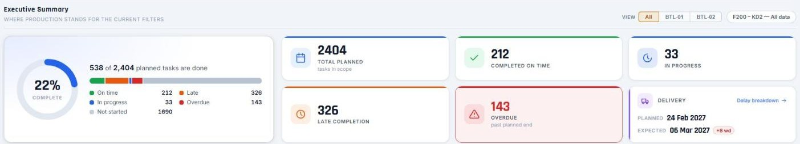
Figure 7 — Executive Summary
STEP BY STEP
1 | KD2: use the battalion tabs at the top of the summary — All, or one battalion — to scope the ring, the tiles and the Delivery card. Your choice is remembered.
2 | The ring shows the % of planned tasks that are done, with "X of Y planned tasks are done" beside it.
3 | The coloured bar splits every task into On time, Late, In progress, Overdue and Not started, with the count of each.
4 | The tiles show Total planned, Completed on time, In progress, Late completion and Overdue. Overdue turns red whenever something is past its planned end.
5 | The Delivery card shows the planned and forecast delivery dates and the delay in working days (wd). Click it for the Delivery Delay Analysis.

Tips
• Status rules: done on or before the planned end = Completed; done after it = Late Completion; started but not done = In Progress; not started and past the planned end = Overdue.

See also: Delivery Delay Analysis · How the delivery forecast and delays are calculated

Delivery Delay Analysis
Who can use it: Everyone | Applies to: All modules

Opened from the Delivery card, it explains why delivery may be late, which units are furthest behind and where to act first.
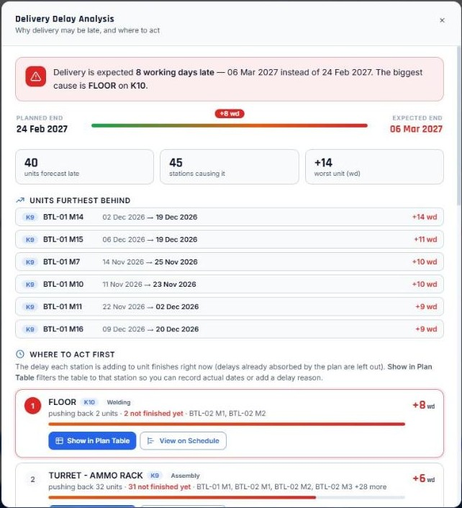
Figure 8 — Delivery Delay Analysis
STEP BY STEP
1 | Read the verdict at the top — for example "Delivery is expected 27 working days late — 19 Dec 2026 instead of 17 Nov 2026. The biggest cause is MACHINING 1ST/2ND on K9."
2 | The timeline shows planned end against expected end; the counters show how many units are forecast late, how many stations are causing it, and the worst unit.
3 | "Units furthest behind" lists each late unit with its planned and forecast finish.
4 | "Where to act first" ranks the stations adding the most delay to unit finishes right now. Each card shows how many units it is pushing back and how many of those blocks are not finished yet.
5 | Press Show in Plan Table to filter the table to that station — record actual dates or add delay reasons there. Press View on Schedule to see it on the Gantt.
6 | "All delays by category" lists every contributing station, grouped by category.
7 | To see everything again afterwards, remove the Search chip in the Filters panel.

Tips
• A station that was late long ago but whose delay the plan has since absorbed is not listed — only delay that still reaches a unit's finish counts.

Recommended
• Work the "Where to act first" list from the top: unfinished blocks at the top station recover the most days.

See also: How the delivery forecast and delays are calculated · Executive Summary · Delay reasons

How the delivery forecast and delays are calculated
Who can use it: Everyone | Applies to: F200-KD2

PPMS forecasts each unit's finish by following its process order from where it stands today. The same forecast drives the Delivery card, the Delivery Delay Analysis, the VPX Station Report, the Executive Report and the Analytics finish chart.
Each unit is walked through its stations in route order. Hull and Turret (K9) or Structure (K10/K11) are built in parallel; Assembly & Processing & Testing starts after all of them.
A finished station uses its actual completion date. An unfinished station starts no earlier than its planned start, the day after the station(s) before it finish, and today (or on its actual start if it has started), and takes its planned number of working days.
A unit's delay is its forecast finish compared with its planned finish. Expected delivery is the latest forecast unit finish. If a station was late but the plan had slack afterwards, that delay is absorbed and no longer counts.
STEP BY STEP
1 | Look at the Delivery card for the forecast delivery date and delay.
2 | Click it to see which units and stations drive it.
3 | Use the Plan Table "Delay" column for how late each individual block was — that is a separate, historical figure.

Tips
• Working days exclude Fridays.
• The forecast follows the filters. With "All time" and no category filter it sees each unit's whole route.

Caution
• An unfinished station whose planned dates have passed is forecast to start today with its full duration — record actual start dates so the forecast stays realistic.

See also: Delivery Delay Analysis · Recording actual start and completion · VPX Station Report

Vehicle Production Progress (VPX)
Who can use it: Everyone | Applies to: F200-KD2

A station-by-station matrix of every unit: planned against actual for each station, coloured by status. It shows one battalion at a time, because unit labels (M1, M2 …) repeat in every battalion.
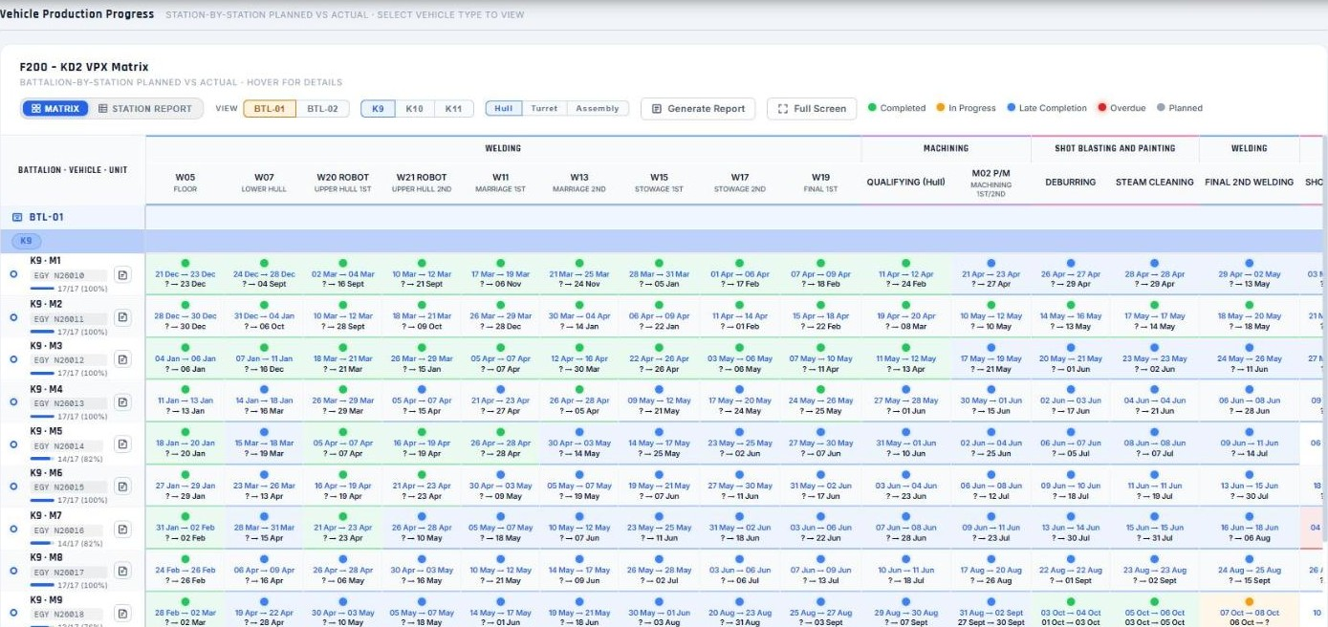
Figure 9 — Vehicle Production Progress (VPX)
STEP BY STEP
1 | Choose the battalion with the battalion tabs.
2 | Choose the vehicle type tab (K9, K10, K11) and the category tab (for example Hull, Turret, Assembly).
3 | Switch between Matrix and Station Report views. Station Report adds forecast dates and a Delay column for that component.
4 | Hover a cell for a card with the unit, planned and actual dates and status.
5 | Use Full Screen to see the whole matrix.
6 | Use Generate Report to export the VPX Station Report.

Tips
• In the Station Report, red cells are unfinished and past their planned end; they show the forecast finish date. Grey dates are forecasts.

See also: VPX Station Report · Delay reasons · How the delivery forecast and delays are calculated

Manufacturing Analytics (charts)
Who can use it: Everyone | Applies to: All modules

Charts that summarise the filtered plan, in three rows. Progress over time: Cumulative Progress, Weekly Throughput and Status Breakdown. Units & delivery: Unit Progress Ranking and Planned vs Expected Finish. Bottlenecks & issues: Station Bottleneck and Issues Trend. Each chart shows a one-line insight worked out from the data.
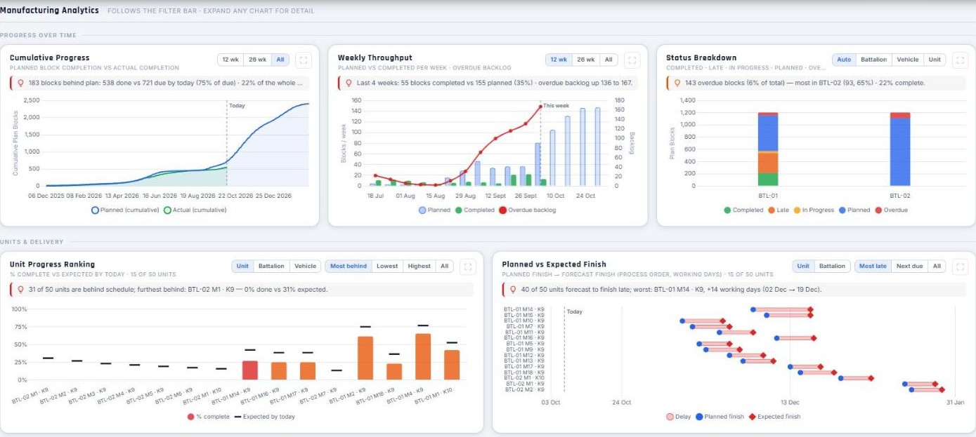
Figure 10 — Manufacturing Analytics (charts)
STEP BY STEP
1 | Scroll to Analytics or click Analytics in the top bar.
2 | Use the small buttons on each chart to change its range, grouping (unit, battalion, vehicle) or view — your choice is remembered.
3 | Read the insight line under each chart title for the key takeaway; hover the chart for exact values.
4 | Use the expand icon to open a chart full screen — the insight is shown in full there.

Tips
• All charts follow the filter bar except Issues Trend, which covers the whole module.
• Planned vs Expected Finish uses the delivery forecast; Station Bottleneck shows each station's own block lateness.
• Charts draw when you scroll to them, so the rest of the page stays fast.

See also: How the delivery forecast and delays are calculated · Executive Summary

04 Schedule (Gantt)
The plan on a calendar. Everyone can read it; planners change it directly on the chart.
In this chapter: Reading the Production Schedule · Editing the schedule · Reordering the route and hiding or deleting processes

Reading the Production Schedule
Who can use it: Everyone | Applies to: All modules

The Gantt chart shows the plan on a calendar. It opens in Process view: one lane per station, with a bar for each unit working at that station.
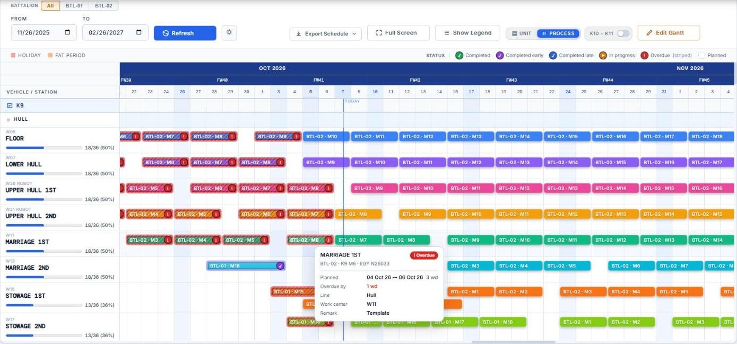
Figure 11 — Reading the Production Schedule
STEP BY STEP
1 | KD2: choose the battalion with the battalion chips above the chart — PPMS loads only that battalion, so the page stays fast. "Load all battalions" shows every battalion.
2 | Choose the date window with From and To, then press Refresh.
3 | Switch between Process view (one lane per station) and Unit view (one lane per unit) with the UNIT / PROCESS switch.
4 | Process view, K10 and K11: switch on "K10 + K11 together" to see both vehicles' blocks on the same station rows (K11 blocks have a white left edge).
5 | Unit view: each vehicle row is split into labelled line bands — Hull / Turret / Assembly for K9, Structure / Assembly for K10 and K11 — so each line reads as one sequence.
6 | Scroll sideways to move through time; the header shows weeks (FW) and days, Saturdays are shaded and TODAY is marked.
7 | Read the status badge on each block with the key above the chart: ✓ Completed, purple = completed early, blue = completed late, ▶ In progress, ! Overdue (red), plain = Planned.
8 | Hover a block for its card: status, unit, planned and actual dates with working days, delay or expected finish, line and work center.
9 | Use Full Screen for a larger view and Export Schedule to download it (Excel).

Tips
• Each process lane shows how many of its blocks are done, e.g. 13/18 (72%).
• The hover card's "Expected finish" uses the same process-order forecast as the Delivery card.

See also: Editing the schedule · Filtering the page · How the delivery forecast and delays are calculated

Editing the schedule
Who can use it: Planner and Master Admin | Applies to: F200-KD2

Planners change the plan directly on the Gantt chart. Every change is recorded in the Audit Log, and other users see "… is editing this plan".
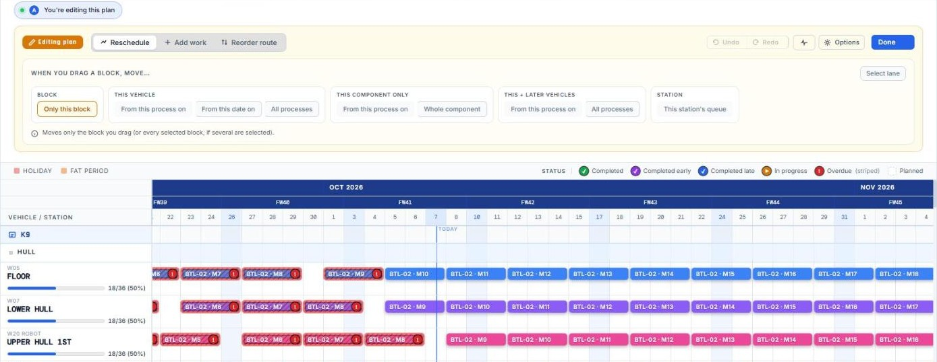
Figure 12 — Editing the schedule
STEP BY STEP
1 | Press Edit Gantt. The Editing bar appears above the chart with three tasks: Reschedule, Add work and Reorder route.
2 | Reschedule — drag a block to move it, or drag its left or right edge to change only its start or end date.
3 | Open "When you drag a block, move…" to choose what moves with it:
4 | • Block — Only this block (or every selected block).
5 | • This vehicle — From this process on (the rest of its line, then Assembly), From this date on (every block starting on or after it, all lines), or All processes.
6 | • This component only — From this process on, or the Whole component (Hull, Turret or Assembly) — nothing else moves.
7 | • This + later vehicles — From this process on, or All processes — the same move for this vehicle and every later vehicle of the same battalion and type.
8 | • Station — This station's queue: this block and every block after it at the same station, across all vehicles.
9 | Hover a block to show its checkbox (select it for group actions) and its ⋯ menu (Move up / down, Edit, Delete). "Select lane" adds a button on each row to select all of its blocks.
10 | Add work — place new plan blocks (see "Adding work to the plan"). Reorder route — change the station order or hide / delete processes.
11 | Use Undo / Redo to reverse a change. The live edit feed shows what you and others changed.
12 | The gear icon opens Options — Include Saturdays and No-work Days.
13 | Press Done to leave edit mode.

Tips
• Edits apply only to the plan version you are viewing.
• Moves skip no-work days and Fridays.
• Selected blocks keep their tick when the mouse moves away; press Delete selected in the selection strip to remove several at once.

Recommended
• When a unit slips, use This vehicle → From this process on — it moves its remaining route together and keeps the sequence intact.
• Use This component only when just one line (for example Hull) is late and the other line is on time.

Caution
• Deleting blocks removes their recorded progress too. Use Undo immediately if you delete by mistake.

See also: Reordering the route and hiding or deleting processes · Adding work to the plan · No-work days · Working together on the same plan

Reordering the route and hiding or deleting processes
Who can use it: Planner and Master Admin | Applies to: F200-KD2

In Process view, Reorder route changes the order of stations for this plan version and lets you hide or delete a process from it.
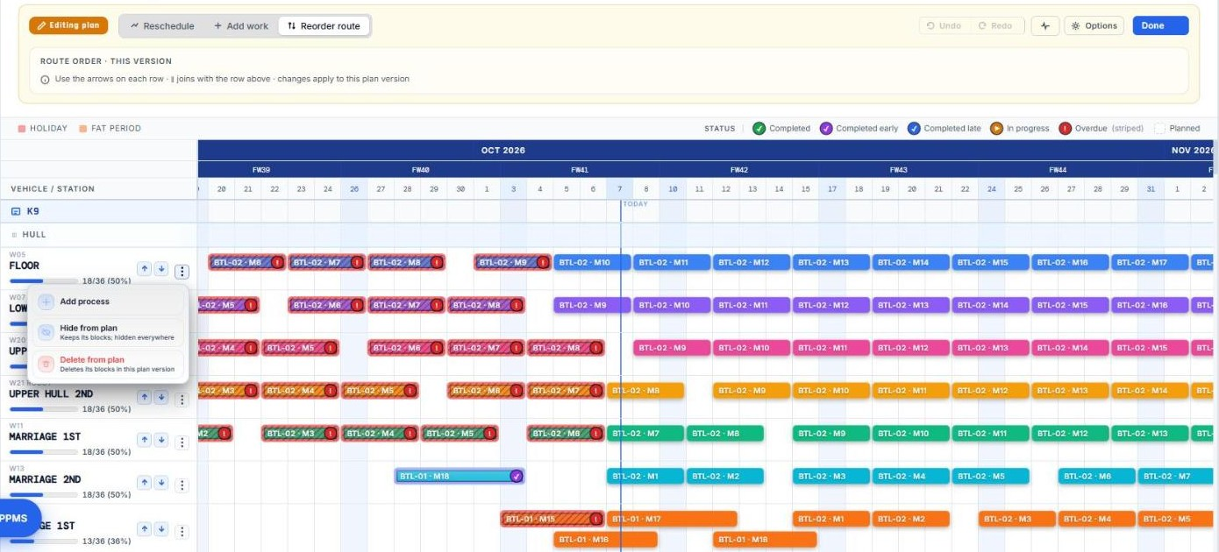
Figure 13 — Reordering the route and hiding or deleting processes
STEP BY STEP
1 | Press Edit Gantt, switch to Process view, and choose Reorder route.
2 | Use the ↑ ↓ arrows on a process to move it earlier or later within its track.
3 | Open the process's ⋯ menu for: Add process, Hide from plan / Show in plan, Delete from plan / Restore to plan.
4 | Hide from plan keeps the process and its blocks but removes them from the Gantt, VPX, Plan Table, summary, charts and exports. Show in plan brings them back.
5 | Delete from plan permanently deletes its blocks in this plan version (you are asked to confirm and told how many) and removes the process from the version. Restore to plan brings the empty process back.

Tips
• Hidden and deleted processes appear greyed (with a "Hidden" / "Deleted from plan" label) only in Reorder route mode.

Caution
• Delete from plan cannot be undone with Undo — the blocks and their progress are gone. Hide first if you are unsure.
• Hiding or deleting never changes the process catalog or other plan versions.

See also: Editing the schedule · Manage Processes and routes · Plan versions

05 Plan Table
Every planned task as a row. This is where the shop floor records what actually happened — start and completion dates, comments, delay reasons and X-ray results.
In this chapter: The Plan Table · Recording actual start and completion · Comments on a task · Delay reasons · X-ray and repair tracking · Uploading a plan file

The Plan Table
Who can use it: Everyone | Applies to: All modules

Every planned task as a row: vehicle, unit, station, code, week, planned start and end, actual start, completion date, status, delay and comments.
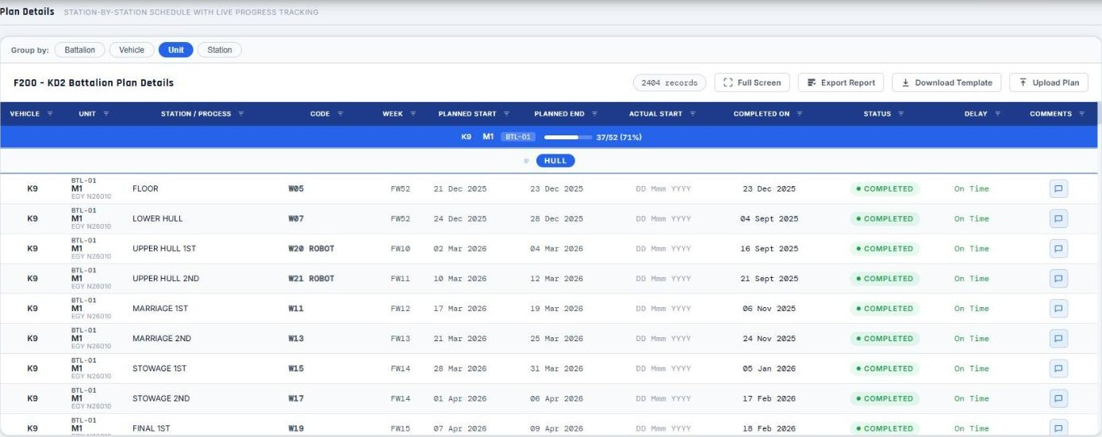
Figure 14 — The Plan Table
STEP BY STEP
1 | Choose how rows are grouped: Battalion, Vehicle, Unit or Station (KD2).
2 | Use the filter icon in any column header to tick the values you want; "Clear column filters" removes them.
3 | Scroll inside the table — rows load 150 at a time as you scroll, or press "show more" on the last row.
4 | Use Full Screen for a larger table and Export Report to download it.

Tips
• The header shows the total number of records even while only part of them is drawn.
• Delay shows how late that block is or was, in days; "+5d start" means it started 5 days late.

See also: Recording actual start and completion · Comments on a task · Export Report (plan data)

Recording actual start and completion
Who can use it: Operator and above | Applies to: All modules

Record when work on a station actually started and finished. Status, delay, the summary, the VPX and the delivery forecast all update automatically.
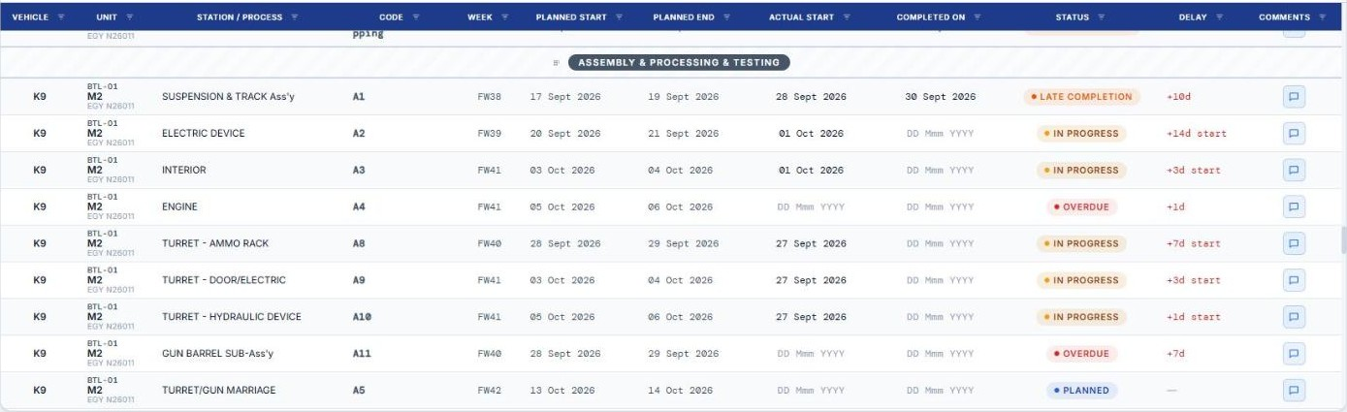
Figure 15 — Recording actual start and completion
STEP BY STEP
1 | Find the row in the Plan Table (use Search or the column filters).
2 | Click the Actual Start cell and pick the date.
3 | When the station is finished, click the Completed On cell and pick the completion date.
4 | To correct a date, click it again and change it, or use × to clear it.

Tips
• Status rules: completed on or before the planned end = Completed; after = Late Completion; started but not done = In Progress; not started after the planned end = Overdue.

Recommended
• Enter dates the same day. Missing actual start dates make the forecast assume work begins today.

Caution
• Double-check the year when picking dates — a wrong year can make a unit look months early or late.

See also: How the delivery forecast and delays are calculated · Operator: a typical shift

Comments on a task
Who can use it: Operator and above | Applies to: All modules

Anyone with write access can add comments to a task. Each comment shows who wrote it and when, and other users get a notification.
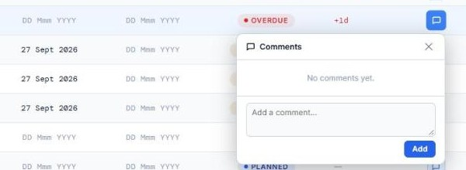
Figure 16 — Comments on a task
STEP BY STEP
1 | Click the comment icon in the Comments column (the number shows how many there are).
2 | Type your comment and press Add.
3 | Edit or delete your own comments with the pencil and bin icons.

Recommended
• Keep comments short and factual; raise a Production Issue for anything that needs an owner and a resolution.

See also: Reporting an issue · Notifications

Delay reasons
Who can use it: Operator and above | Applies to: F200-KD2

Record the main reason a vehicle is delayed. The reason appears in the VPX Station Report and the Executive Report, after the Delay column.
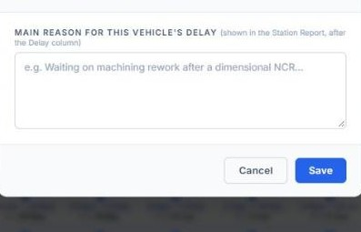
Figure 17 — Delay reasons
STEP BY STEP
1 | Go to Vehicle Production Progress and pick the vehicle (K9 / K10 / K11) and the category tab (for example Hull).
2 | Click the small note icon next to the unit.
3 | Describe the main reason (for example "Waiting on machining rework after a dimensional NCR") and press Save.

Tips
• A reason is kept per category tab.
• The vehicle must be registered in Unit Codes first.

Recommended
• Write the cause and the next action, e.g. "Bore out of tolerance — re-machining, due 12 Oct".

See also: Vehicle Production Progress (VPX) · Executive Report

X-ray and repair tracking
Who can use it: Operator and above | Applies to: F200-KD2

Stations marked "Requires X-ray" in Manage Processes show an X-ray marker. It tracks each X-ray and repair cycle until the weld passes QA.
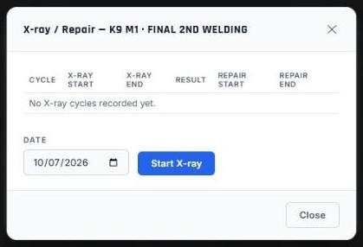
Figure 18 — X-ray and repair tracking
STEP BY STEP
1 | Click the X-ray marker on the row.
2 | Press Start X-ray when the part goes to X-ray.
3 | Record the result: No Issues — Pass, or Issues Found — Fail.
4 | After a fail, record the repair start and end; the part then returns for the next X-ray.
5 | When it passes, the marker shows QA Passed.

Tips
• Marker stages: X-ray → In X-ray → Repair Needed → In Repair → QA Passed.

See also: Manage Processes and routes

Uploading a plan file
Who can use it: Planner and Master Admin | Applies to: F200-KD2

Planners can load plan rows from a CSV or Excel file.
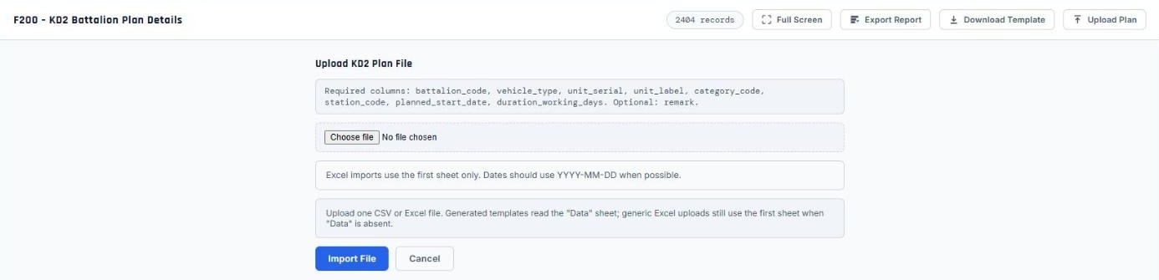
Figure 19 — Uploading a plan file
STEP BY STEP
1 | Press Download Template in the Plan Table header to get a file with the right columns.
2 | Fill it in: battalion_code, vehicle_type, unit_serial, unit_label, category_code, station_code, planned_start_date, duration_working_days (remark is optional).
3 | Press Upload Plan, choose the file, then press Import File and check the result message.

Tips
• Excel uploads read the "Data" sheet of the template (otherwise the first sheet). Use YYYY-MM-DD dates where possible.

Caution
• Rows go into the plan version you are viewing. Check the version switch before importing.

See also: Plan versions · Adding work to the plan

06 Production Issues
Report production problems, follow them up to resolution and produce issue reports.
In this chapter: The Production Issues list · Reporting an issue · Viewing and updating an issue · Issue drafts · Generating an issues report

The Production Issues list
Who can use it: Everyone | Applies to: All modules

All production problems reported in the current module, newest first, with counters for Open, In Progress, Resolved and open Critical/High issues.
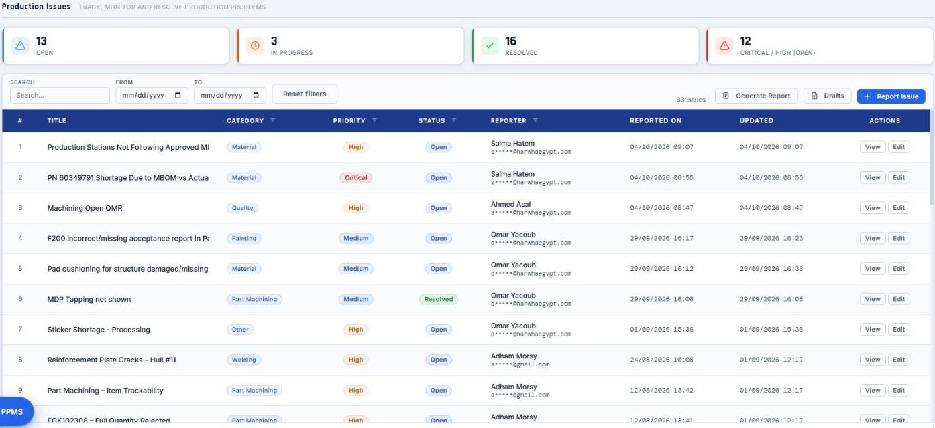
Figure 20 — The Production Issues list
STEP BY STEP
1 | Use Search and the From / To dates in the toolbar.
2 | Use the filter icon in the Category, Priority, Status and Reporter column headers.
3 | Active filters show as chips next to the issue count; click a chip's × to clear it.
4 | Press Load more at the bottom to see older issues.

See also: Reporting an issue · Generating an issues report

Reporting an issue
Who can use it: Operator and above | Applies to: All modules

Record a production problem so it can be followed up and included in reports.
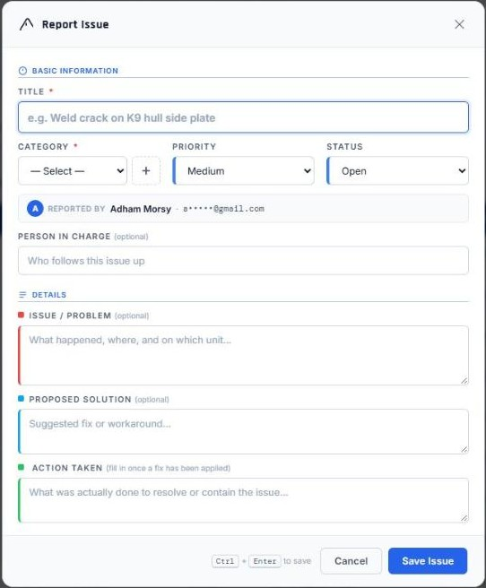
Figure 21 — Reporting an issue
STEP BY STEP
1 | Press Report Issue.
2 | Enter a Title and choose a Category (required). Set Priority and Status.
3 | Optionally name the Person In Charge.
4 | Describe the Issue / Problem, the Proposed Solution and, once fixed, the Action Taken.
5 | Press Save Issue (or Ctrl + Enter).

Tips
• To add a new category, press + next to Category, type the name and press Add.
• Your form is saved as a draft while you type — see Issue drafts.

Recommended
• Use a title that says what and where, e.g. "K9 BTL-01 M7 — turret ring bore out of tolerance".
• Set Critical / High only for issues that stop production — they are counted separately on the dashboard.

See also: Viewing and updating an issue · Issue drafts

Viewing and updating an issue
Who can use it: Everyone | Applies to: All modules

Click an issue title or View to see its details: progress (Reported → In Progress → Resolved → Closed), problem, solution, action taken, and who is responsible.
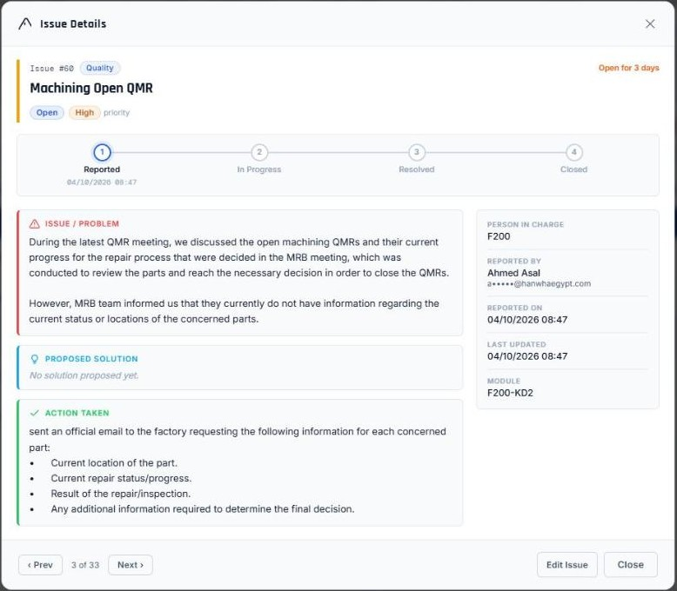
Figure 22 — Viewing and updating an issue
STEP BY STEP
1 | Click the issue title or View.
2 | Use Prev / Next (or the ← → keys) to move through the listed issues.
3 | The reporter or a Master Admin can press Edit Issue to update it, for example to change the status to Resolved and record the Action Taken.

Tips
• The resolved date is set when an issue first becomes Resolved or Closed and is kept on later edits.

Recommended
• Always fill in Action Taken when resolving — it is what management reads in the Status Report.

See also: Reporting an issue · Generating an issues report

Issue drafts
Who can use it: Operator and above | Applies to: All modules

An unfinished issue is saved to your account as you type, so you can finish it later on any device. Drafts are private until you report them.
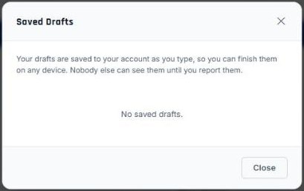
Figure 23 — Issue drafts
STEP BY STEP
1 | Press Drafts in the Issues toolbar (the badge shows how many you have).
2 | Press Resume to continue a draft, or Delete to discard it.

See also: Reporting an issue

Generating an issues report
Who can use it: Everyone | Applies to: All modules

Export issues to PDF, Excel or Word. Choose the report, pick which issues, then untick any you want to leave out.
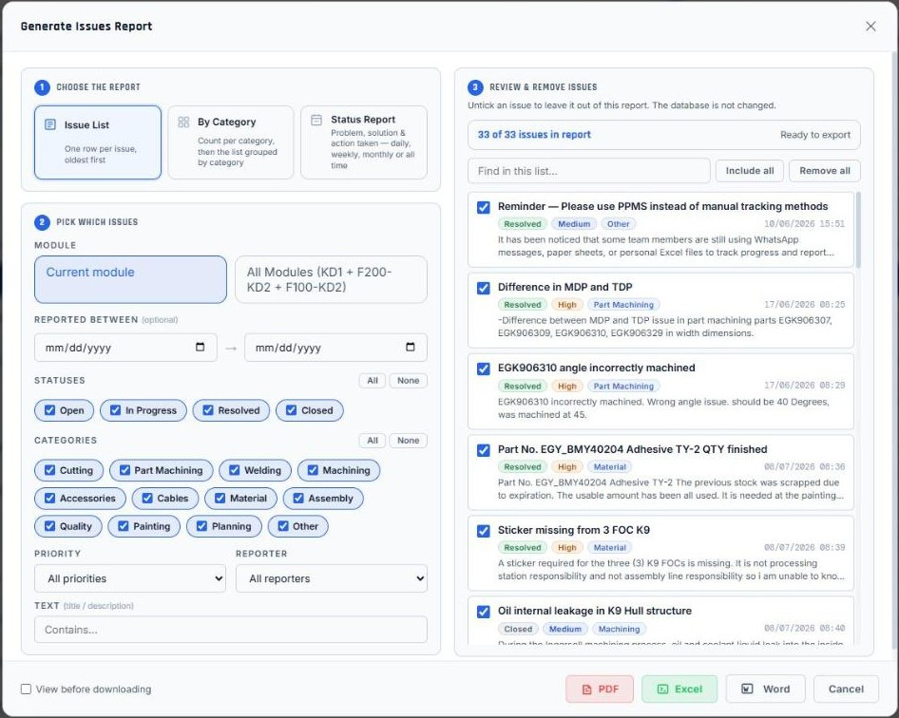
Figure 24 — Generating an issues report
STEP BY STEP
1 | Press Generate Report in the Issues toolbar.
2 | Step 1 — choose Issue List, By Category, or Status Report (Table or Written report layout).
3 | Step 2 — choose the module scope, period or dates, statuses, categories and other filters. The dialog starts with the Issues table's current filters.
4 | Step 3 — review the list on the right and untick issues to remove them from this report. The database is not changed.
5 | Press PDF, Excel or Word. Tick "View before downloading" to preview first.

Tips
• Status Report periods: Today, Last 7 days, This month, All time, or Custom dates (From / To).

See also: Executive Report

07 Reports & Exports
Every printable or shareable output: plan exports, the VPX Station Report and the Executive Report for management.
In this chapter: Export Report (plan data) · VPX Station Report · Executive Report

Export Report (plan data)
Who can use it: Everyone | Applies to: All modules

Export the plan as PDF, Excel or Word using its own copy of the filters, pre-filled from the filter bar.
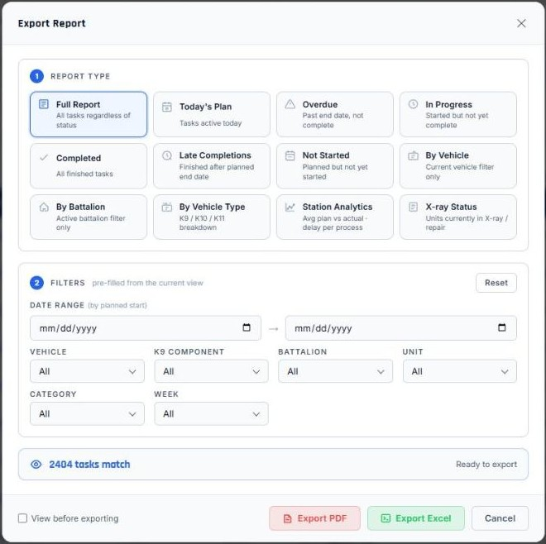
Figure 25 — Export Report (plan data)
STEP BY STEP
1 | Open Export Report in the Plan Table header.
2 | Adjust the report filters (vehicle, battalion, unit, category, week).
3 | Choose the format. Tick "View before exporting" to preview.

Tips
• Exporting requires the "Can export" permission.
• Exports always include every matching record, not only the rows drawn on screen.

See also: The Plan Table

VPX Station Report
Who can use it: Everyone | Applies to: F200-KD2

A station-by-station report of each vehicle with planned, actual and forecast dates, the forecast delay and the delay reason.
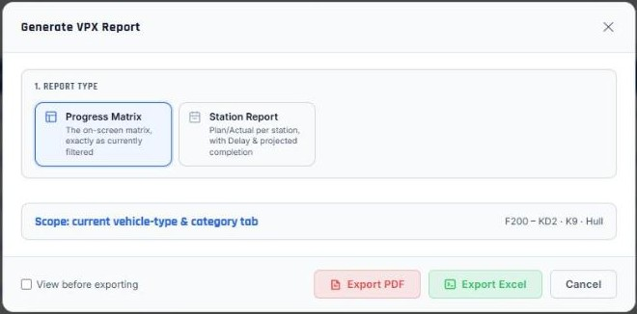
Figure 26 — VPX Station Report
STEP BY STEP
1 | In Vehicle Production Progress, press Generate Report.
2 | Choose the vehicles/segments and the format, then export.

Tips
• The Delay column is the component's forecast delay at its last station, following the process order.

See also: Vehicle Production Progress (VPX) · How the delivery forecast and delays are calculated · Delay reasons

Executive Report
Who can use it: Everyone | Applies to: F200-KD2

One print-friendly document for management: a cover summary (progress, status split and delivery forecast), the VPX Station Report, two pages of Production Insights and the all-time Production Issues Status Report.
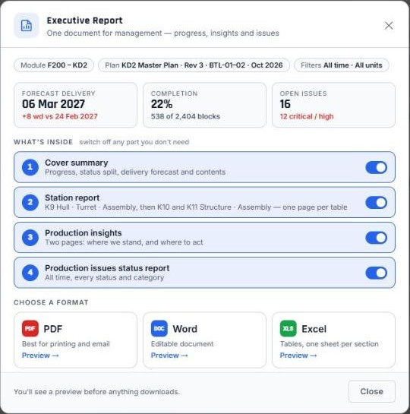
Figure 27 — Executive Report
STEP BY STEP
1 | Press Executive Report in the filter bar.
2 | Under "What's inside", switch off any part you don't need: Cover summary, Station report, Production insights (two pages — where we stand, and where to act) and Production issues status report.
3 | Choose a format: PDF (best for printing and email), Word (editable) or Excel (one sheet per section).
4 | Check the preview, then download.

Tips
• Each VPX table fits on one page; the colours are light so the report prints well.
• Production Insights use the same process-order forecast as the Delivery card and list the units furthest behind and the stations adding the most delay.

Recommended
• Generate it with "All time" and no category filter so the delivery forecast covers every unit's full route.

See also: VPX Station Report · Generating an issues report · Management: reviewing progress

08 KD2 Planning
How the F200-KD2 plan is built and maintained: adding work, processes and routes, lead times, no-work days, plan versions and unit codes.
In this chapter: Adding work to the plan · Manage Processes and routes · Lead times · No-work days · Plan versions · Unit Codes

Adding work to the plan
Who can use it: Planner and Master Admin | Applies to: F200-KD2

Add work to the live plan in three ways: click on the chart, fill in a form, or copy a planned unit's whole sequence to other units.
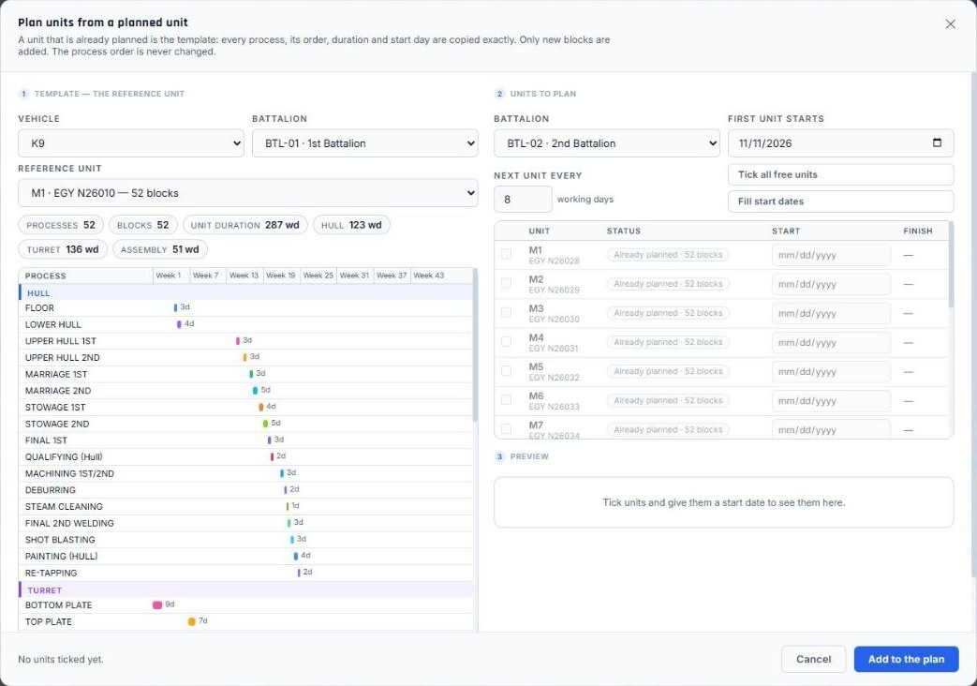
Figure 28 — Adding work to the plan
STEP BY STEP
1 | Press Edit Gantt, then choose Add work. Pick how: Click to place, Fill in a form, or Copy a planned unit.
2 | Click to place — pick a unit or station, then click a lane and date on the chart to drop the block there.
3 | Fill in a form — choose Battalion, Vehicle, Unit, Planned start, Process / Station and Duration (working days), then press Add to KD2 Plan.
4 | Copy a planned unit — choose a unit that is already planned as the template. Tick the units to plan (or "Tick all free units"), set the first unit's start and "Next unit every … working days" (or "Fill start dates"), check the preview, and press Add to the plan.

Tips
• Copy a planned unit copies every process, its order, duration and start day exactly; only new blocks are added and the process order never changes.
• Units that someone else planned in the meantime are left out and listed.
• A placed block appears for other users within a second or two. Undo removes a whole copied set at once.

See also: Editing the schedule · Lead times

Manage Processes and routes
Who can use it: Planner and Master Admin | Applies to: F200-KD2

Maintain the stations, process categories and route order for each vehicle type, including which stations require X-ray.
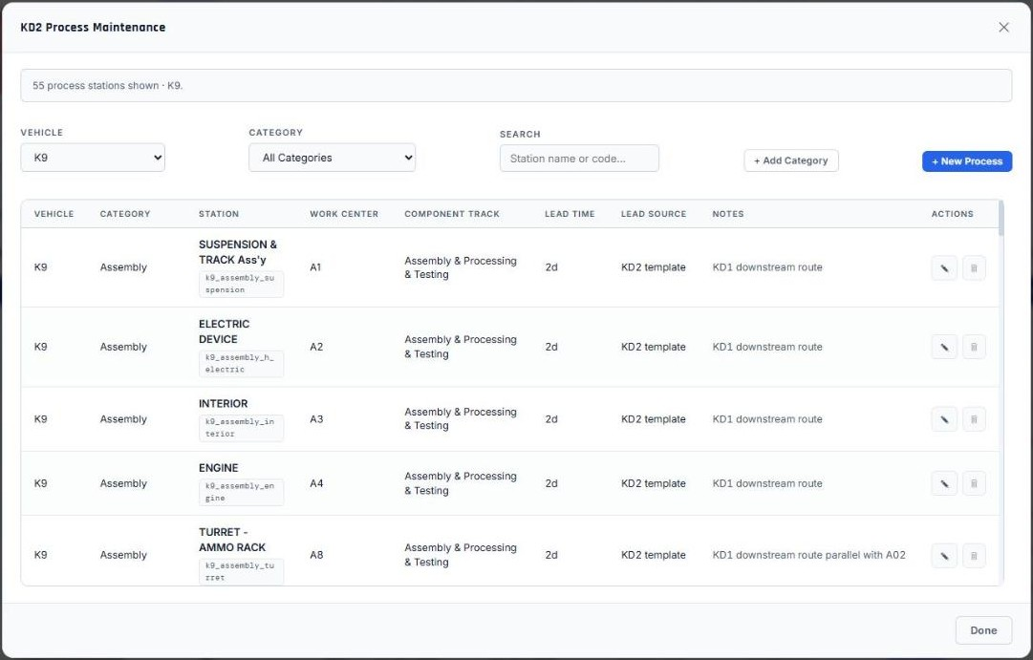
Figure 29 — Manage Processes and routes
STEP BY STEP
1 | Open the menu (☰) → Manage Processes.
2 | Add or edit a station, its category, sequence and whether it requires X-ray.
3 | Save. The Route / Process Flow view shows the resulting order.

Caution
• The process catalog is shared by every plan version. To leave a process out of one version only, use Hide or Delete in Reorder route instead.

See also: Reordering the route and hiding or deleting processes · Lead times · X-ray and repair tracking

Lead times
Who can use it: Planner and Master Admin | Applies to: F200-KD2

Each station has a default lead time (duration). It is used when blocks are placed or a plan is generated.
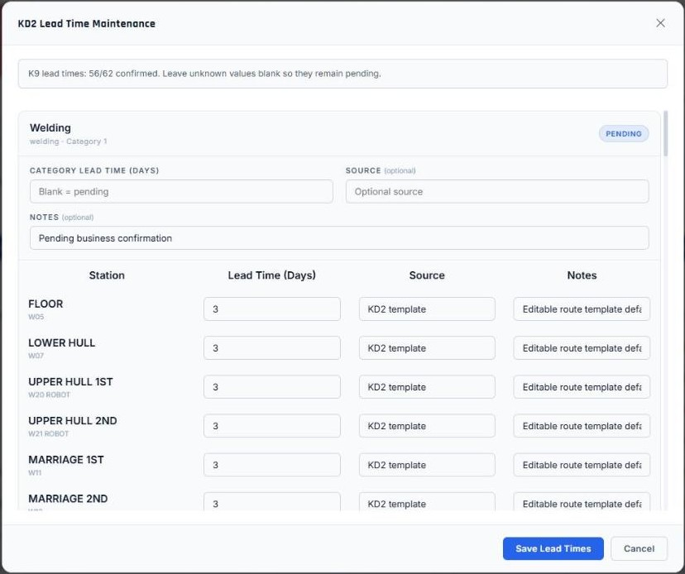
Figure 30 — Lead times
STEP BY STEP
1 | Open the menu (☰) → Manage Processes.
2 | Find the station; its Lead Time column shows the duration and where it came from (Lead Source).
3 | Press the pencil on that row to change it, then save.

Tips
• Changing a lead time does not move blocks already in the plan.

See also: Manage Processes and routes · Adding work to the plan

No-work days
Who can use it: Planner and Master Admin | Applies to: F200-KD2

Days on which no production is planned (holidays, shutdowns). Scheduling and moves skip them.
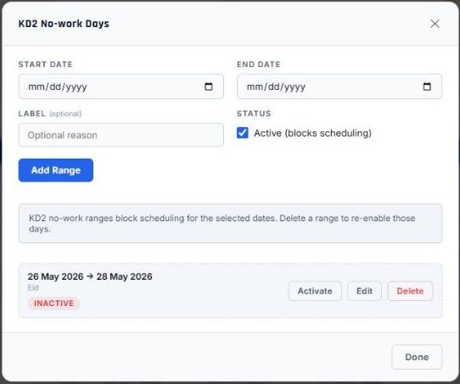
Figure 31 — No-work days
STEP BY STEP
1 | Press Edit Gantt, then the gear icon on the right of the Editing bar → No-work Days.
2 | Enter the Start and End dates and an optional label (for example "Eid"), keep Active ticked, and press Add Range.
3 | Existing ranges are listed below — Activate / deactivate, Edit or Delete them.

Recommended
• Enter the year's official holidays at the start of the year.

See also: Editing the schedule

Plan versions
Who can use it: Operator and above | Applies to: All modules

Keep several versions of a plan (for example a baseline and revisions). Every user opens an active version; archived versions are kept but cannot be opened until restored.
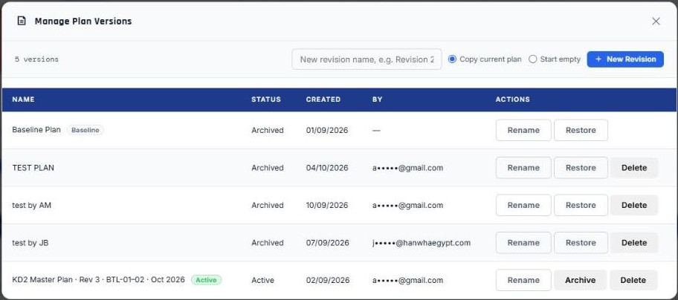
Figure 32 — Plan versions
STEP BY STEP
1 | Open the menu (☰) → Manage Plan Versions.
2 | Create a revision (a copy of the current plan, or empty), rename a version, or Set Active to make it the one you view.
3 | Archive a version you no longer use; Restore brings it back. Master Admins can delete revisions (never the baseline).
4 | Use the plan version switch in the top bar to move between active versions.

Tips
• If the version you are viewing is archived by someone else, PPMS reloads onto an active one.

Recommended
• Create a new revision before any large re-plan, and give it a name that says why and when.

Caution
• Deleting a version permanently deletes every plan row in it.

See also: Planner: keeping the plan current · Reordering the route and hiding or deleting processes

Unit Codes
Who can use it: Operator and above | Applies to: All modules

The register of units per battalion and vehicle type, with their serial numbers (for example BTL-01 K9 M2 = EGY N26029).
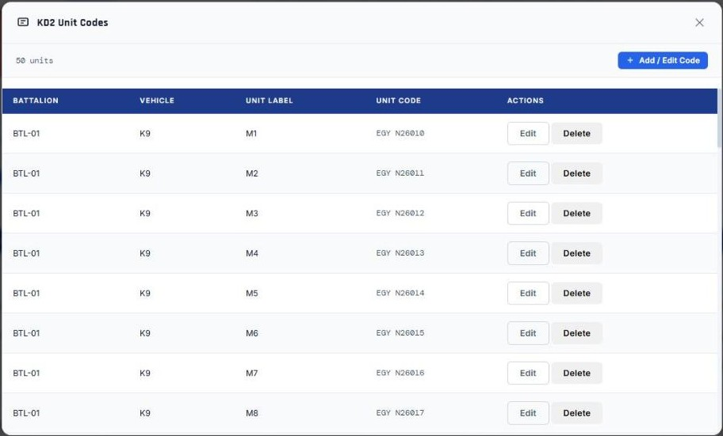
Figure 33 — Unit Codes
STEP BY STEP
1 | Open the menu (☰) → Unit Codes.
2 | Add a unit with battalion, vehicle, unit label and serial, or edit an existing one.

Tips
• Adding a unit that already exists shows a warning instead of overwriting it.

See also: Delay reasons

09 F100-KD2
The F100 module for gun and vehicle parts.
In this chapter: Working in F100-KD2

Working in F100-KD2
Who can use it: Everyone | Applies to: F100-KD2

F100-KD2 tracks gun parts and vehicle parts per battalion and manufacturer.
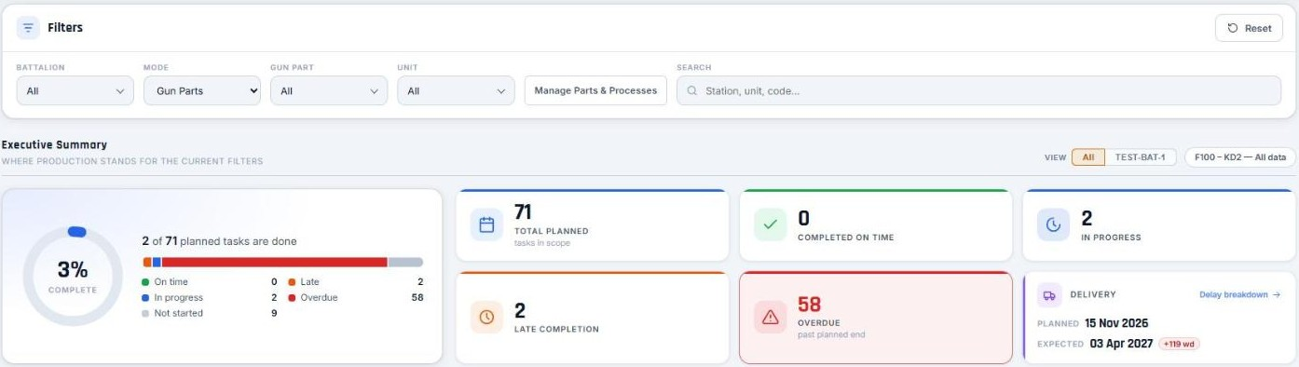
Figure 34 — Working in F100-KD2
STEP BY STEP
1 | Choose the Mode (gun parts or vehicle parts) in the filter bar.
2 | Filter by Battalion, Gun Part, Unit, Manufacturer and Vehicle type.
3 | Record actual start and completion dates, notes and comments in the table.
4 | Planners use Manage Parts & Processes to maintain parts and their process steps.

10 Administration
For Master Admins: accounts and permissions, the audit trail and who is online.
In this chapter: User Management · Audit Log · Active Users

User Management
Who can use it: Master Admin only | Applies to: All modules

Create and manage accounts: role, allowed modules, export permission and active status — with each person's last sign-in.
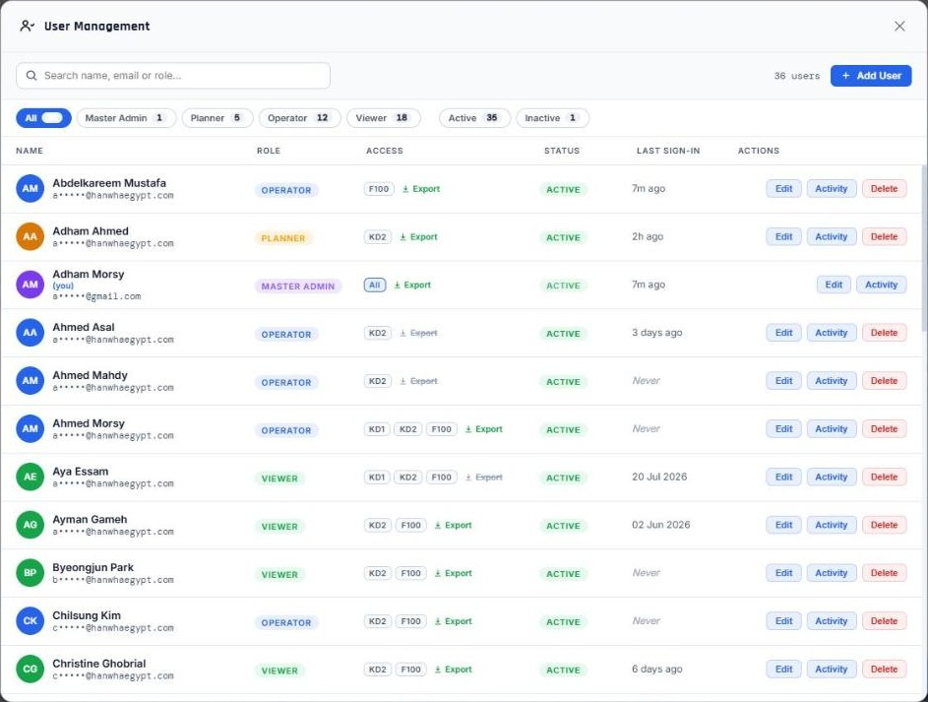
Figure 35 — User Management
STEP BY STEP
1 | Open the menu (☰) → User Management.
2 | Find people with the search box, or filter with the chips: a role (Master Admin, Planner, Operator, Viewer) or Active / Inactive. Each chip shows its count.
3 | Press Add User, or Edit on a row. The edit panel opens beside the list: name, email, role (with a short description of what it can do), module access, "Can export Excel & PDF reports", account status and password.
4 | Press Save User. PPMS checks the email (valid and not already used), the password (at least 6 characters) and that at least one module is ticked.
5 | Click a user's status (Active / Inactive) to activate or deactivate the account.
6 | Press Activity to open the Audit Log filtered to that person.

Tips
• Changes take effect for that user immediately, even while they are signed in.
• You cannot change your own role or status, or delete yourself, and the last active Master Admin cannot be removed, demoted or deactivated — so nobody gets locked out.

Recommended
• Give each person the lowest role that lets them do their job, and their own personal account — shared accounts hide who made a change.
• Deactivate rather than delete accounts of people who leave; their history stays readable.

See also: User roles and what they can do · Audit Log · Active Users

Audit Log
Who can use it: Master Admin only | Applies to: All modules

A plain-language record of everything that happens in PPMS: who did what, to which unit, station, user or issue, and what changed — with a View button that opens the thing in the system.
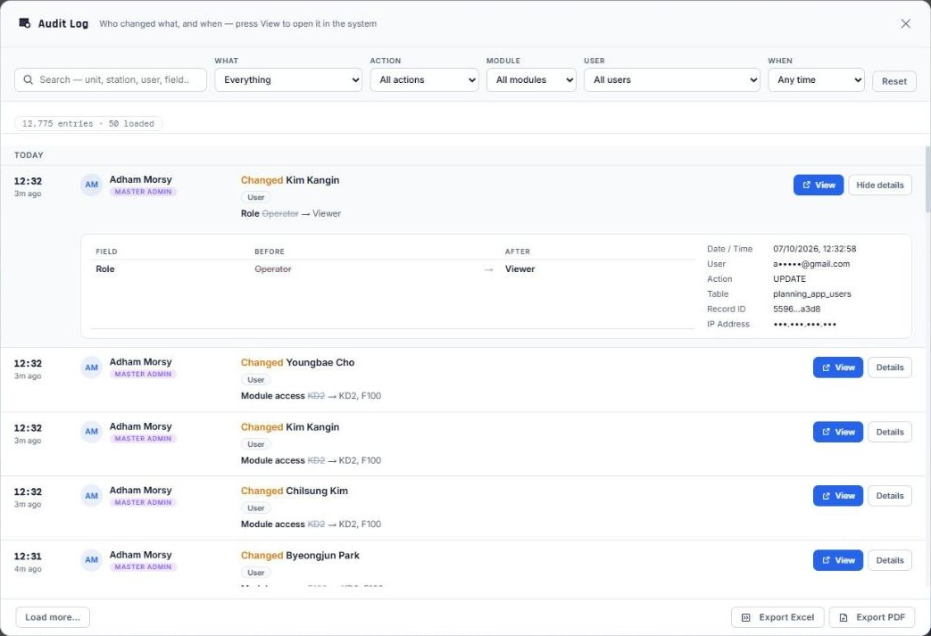
Figure 36 — Audit Log
STEP BY STEP
1 | Open the menu (☰) → Audit Log. Entries are grouped by day, newest first.
2 | Each entry reads like a sentence — for example "Changed BTL-01 K9 M2 · Hull - Floor — Planned start 03 Oct → 05 Oct" — with the person, their role, the module and the plan version.
3 | Filter by What (plan blocks, actual dates, issues, users, sign-ins, reports & exports …), Action, Module, User and When (today, last 7 / 30 days or custom dates). Use Search to find a unit, station, user or field on the loaded pages.
4 | Press View to go to the record: a plan block flashes on the Gantt, an issue opens, a user opens in User Management, a process opens in Manage Processes. PPMS switches module first if needed.
5 | Press Details for the full before / after table and the technical record (table, record id, IP address).
6 | Export to Excel or PDF — the export contains the same readable "What happened" and "Changes".

Tips
• Sign-ins are recorded, and so is opening PPMS again while still signed in, or coming back after 20 minutes or more away.
• Every report or file downloaded from PPMS (PDF, Excel, Word) is recorded as an export.

See also: User Management · Active Users

Active Users
Who can use it: Master Admin only | Applies to: All modules

The people icon in the top bar shows, live, who is using PPMS right now, what they are doing and where.
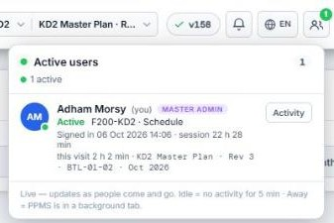
Figure 37 — Active Users
STEP BY STEP
1 | Click the people icon (the badge shows how many are online).
2 | Each person shows a status: Active, Editing the plan, Idle (no activity for 5 minutes) or Away (PPMS in a background tab).
3 | Below the name: where they are (module, section, and what they are editing), when they signed in and how long the session has lasted, and how long this visit has lasted.
4 | Press Activity for their Audit Log, or User to open them in User Management.

Tips
• The list updates by itself while it is open; people who close PPMS leave the list at once.
• A person tagged "older version" should load the latest version (the blinking version number) to show where they are and to record their exports.

See also: Working together on the same plan · Audit Log · User Management

11 Personal Settings
Make PPMS yours — themes, notifications, password, updates, the manual and the assistant.
In this chapter: Keeping PPMS up to date · Colour themes · Language — English, Korean, Arabic · Notifications · Changing your password · Help & User Manual · The PPMS Assistant

Keeping PPMS up to date
Who can use it: Everyone | Applies to: All modules

The version number in the top bar (for example ✓ v138) shows which PPMS version you are running. When a newer version is released it turns orange and blinks, e.g. v137 → v138.
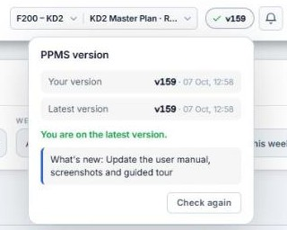
Figure 38 — Keeping PPMS up to date
STEP BY STEP
1 | Click the blinking version number.
2 | Read "What's new" to see what changed.
3 | Save any work in progress, then press Load latest version. The page reloads on the new version.

Tips
• PPMS checks for a new version every few minutes and whenever you return to the tab.
• If you have unsaved work (the Gantt in edit mode, an open form), PPMS warns you before reloading.

Recommended
• Update as soon as you see the blinking number so everyone works on the same version.

Colour themes
Who can use it: Everyone | Applies to: All modules

Choose how PPMS looks: Dark, Light, Nord, Dracula, Midnight, Catppuccin or Crimson Red. Your choice is remembered for your account on this device.
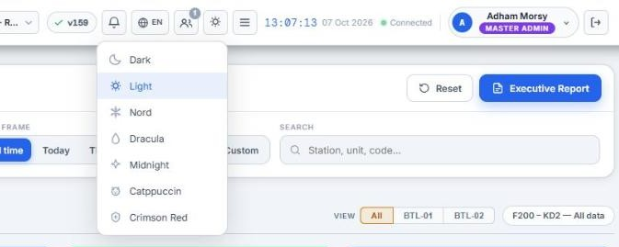
Figure 39 — Colour themes
STEP BY STEP
1 | Click the theme button in the top bar.
2 | Pick a theme from the list.

Language — English, Korean, Arabic
Who can use it: Everyone | Applies to: All modules

PPMS can be used in English, Korean (한국어) or Arabic (العربية). Your choice is remembered on this device and on your account.
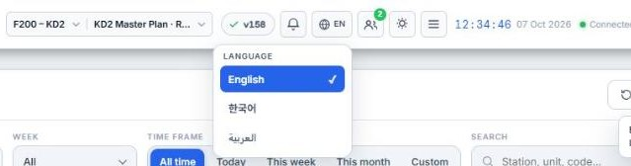
Figure 40 — Language — English, Korean, Arabic
STEP BY STEP
1 | Click the globe button in the top bar (it shows EN, 한 or ع) — or the same button on the sign-in page.
2 | Choose English, 한국어 or العربية. The page reloads in that language.

Tips
• Arabic switches the page to right-to-left. The Gantt timeline and the VPX matrix stay left-to-right, because time and process order run that way.
• Plan data — station, part and unit names, codes — is never translated. Exported reports (PDF, Excel, Word) stay in English.
• The Korean translation is a work in progress; suggestions are welcome.

See also: The top bar · Signing in

Notifications
Who can use it: Everyone | Applies to: All modules

The bell collects new comments, new and updated issues and plan changes, including from other modules. Master Admins also see sign-ins and report exports.
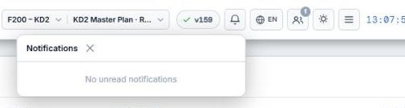
Figure 41 — Notifications
STEP BY STEP
1 | Click the bell to open the list.
2 | Click a notification to jump to the task or issue; PPMS switches module if needed.

See also: Comments on a task · Working together on the same plan · Audit Log

Changing your password
Who can use it: Everyone | Applies to: All modules

Change your own password at any time.
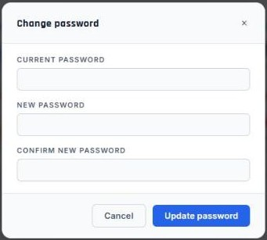
Figure 42 — Changing your password
STEP BY STEP
1 | Click your name at the top right → Change password.
2 | Enter your current password, then the new one twice, and press Update password.

Recommended
• Use at least 10 characters and don't reuse a password from another system.

Help & User Manual
Who can use it: Everyone | Applies to: All modules

This manual is built into PPMS. Open it any time from the menu (☰) → Help & User Manual.
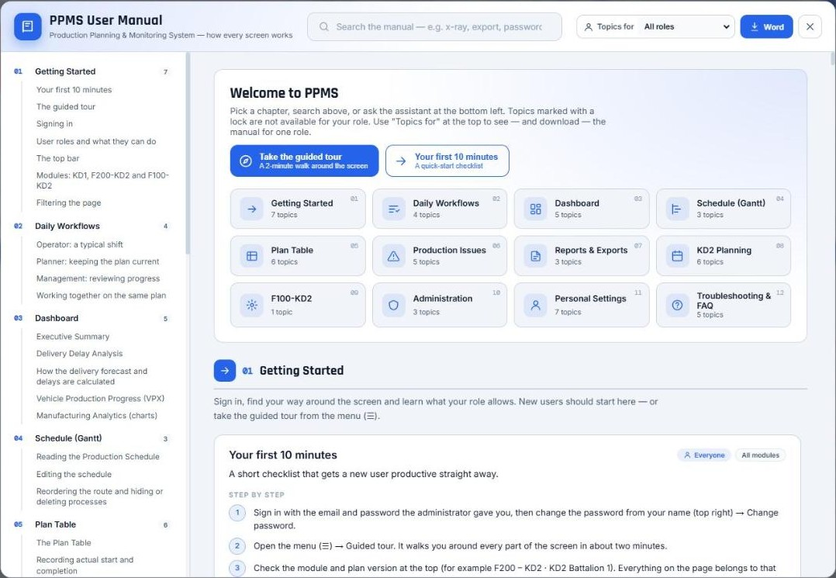
Figure 43 — Help & User Manual
STEP BY STEP
1 | Pick a chapter on the start screen or in the contents on the left.
2 | Type in the search box to find a topic (for example "x-ray" or "export").
3 | Choose a role in "Topics for" (All roles, Viewer, Operator, Planner or Master Admin) to see only the topics that role can use — your own role is marked "(you)". The choice is remembered.
4 | Press a topic's "Show me" button to go straight to that feature.
5 | Press Word to download the manual as a Word document for printing or email. It downloads the edition for the role chosen in "Topics for" — for example "Word · Operator" for an Operator's manual.

See also: The guided tour · The PPMS Assistant

The PPMS Assistant
Who can use it: Everyone | Applies to: All modules

The chat bubble at the bottom left answers questions about PPMS and can do things for you, such as opening a screen, applying filters or starting a report. Anything that would change data is shown to you first and only happens when you confirm.
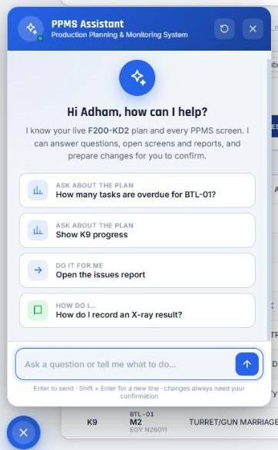
Figure 44 — The PPMS Assistant
STEP BY STEP
1 | Click the chat bubble at the bottom left.
2 | Type a question ("How many tasks are overdue for BTL-01 K9?", "How do I record an X-ray result?") or a request ("open the issues report").
3 | Use the suggested buttons, or confirm a proposed change.

See also: Help & User Manual

12 Troubleshooting & FAQ
Answers to the questions users ask most, and what to do when something doesn't look right.
In this chapter: Why does the Plan Table show a bigger delay than the Delivery card? · The page doesn't show my colleague's change · I can't find a button described in this manual · PPMS feels slow or the tab stops responding · I entered a wrong date

Why does the Plan Table show a bigger delay than the Delivery card?
Who can use it: Everyone | Applies to: F200-KD2

They measure different things. The Plan Table "Delay" is how late one block was. The Delivery card is how late the units are forecast to finish today.
Example: a station planned for February finished 62 working days late in May. The Plan Table keeps showing +62 for that block. But the stations after it were planned later, so the unit caught up — it no longer delays delivery, and the Delivery card doesn't count it.
See also: How the delivery forecast and delays are calculated

The page doesn't show my colleague's change
Who can use it: Everyone | Applies to: All modules

Live changes normally appear within a second or two.
STEP BY STEP
1 | Check the connection dot next to the clock is green ("Connected").
2 | Check you are on the same module and plan version as your colleague.
3 | Check your filters — the change may be outside them.
4 | If the version number is blinking, load the latest version.
5 | Still nothing? Reload the page (F5).

See also: Working together on the same plan · Keeping PPMS up to date

I can't find a button described in this manual
Who can use it: Everyone | Applies to: All modules

Buttons you are not allowed to use are hidden, and some features exist only in one module.
STEP BY STEP
1 | Check the role label on the topic ("Planner and Master Admin", etc.) against your role under your name.
2 | Check the module label (for example "F200-KD2") against the module switch in the top bar.
3 | Edit-mode controls on Gantt blocks appear only when you hover the block.
4 | Ask your administrator if you need more access.

See also: User roles and what they can do · Modules: KD1, F200-KD2 and F100-KD2

PPMS feels slow or the tab stops responding
Who can use it: Everyone | Applies to: All modules

PPMS is built to stay light, but a very busy browser can still struggle.
STEP BY STEP
1 | Make sure you are on the latest version (the version number isn't blinking).
2 | Close other heavy tabs and applications.
3 | Narrow the filters to what you need — fewer rows means faster pages.
4 | If the browser shows "This page is having a problem", press Reload; nothing you had saved is lost.

Recommended
• Use Chrome or Edge on a PC with at least 8 GB of memory for planning work.

See also: Filtering the page · Keeping PPMS up to date

I entered a wrong date
Who can use it: Operator and above | Applies to: All modules

Dates can be corrected at any time; every change is kept in the Audit Log.
STEP BY STEP
1 | Find the row in the Plan Table.
2 | Click the date and pick the correct one, or use × to clear it.
3 | Status, delay and the forecast update immediately.

See also: Recording actual start and completion

Glossary
The terms used in PPMS and in this manual.
Term | Meaning
Actual start / Completion date | The dates work really started and finished at a station, recorded in the Plan Table.
Battalion (BTL-01 …) | A delivery batch of vehicles. Unit labels (M1, M2 …) repeat in every battalion.
Block | One unit at one station on the Gantt — a planned start and end date.
Category | A group of stations, e.g. Welding, Machining, Assembly.
Delay (Plan Table) | How late that one block is or was: completion after the planned end, or still unfinished past it. A historical fact about the block.
Delivery forecast | The expected delivery date worked out by following each unit's process order from where it stands today (see "How the delivery forecast works").
Feeder lines | Hull and Turret (K9) or Structure (K10/K11) — built in parallel before the downstream Assembly & Processing & Testing line.
FW | Factory week number, shown in the Gantt header and the Week column.
Late Completion | Finished, but after the planned end date.
Lead time | A station's default duration in working days, used when blocks are placed or a plan is generated.
No-work day | A holiday or shutdown day; scheduling and moves skip it. Fridays are never working days.
Overdue | Not finished (and not started) and already past the planned end date.
Plan version | A copy of the plan, e.g. a baseline and later revisions. Only active versions can be opened.
Process view / Unit view | Gantt layouts: one lane per station, or one lane per unit.
Station / Process | One manufacturing step, e.g. LOWER HULL or QUALIFYING (Turret).
Unit code / Serial | The vehicle's registered identity, e.g. BTL-01 K9 M2 = EGY N26029.
VPX | Vehicle Production Progress — the station-by-station matrix of every unit.
wd | Working days — calendar days excluding Fridays (and no-work days where they apply).

