Algorithm PA1 Report
B07901069 電機二 劉奇聖
1. Running time table

2. Running time curves
(Assume the CPU time for “too long” is 60000 ms (1 min). For clearity, I take symmetrical log scale for input size and running time.)
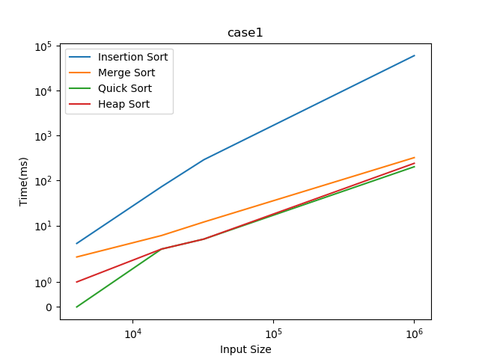
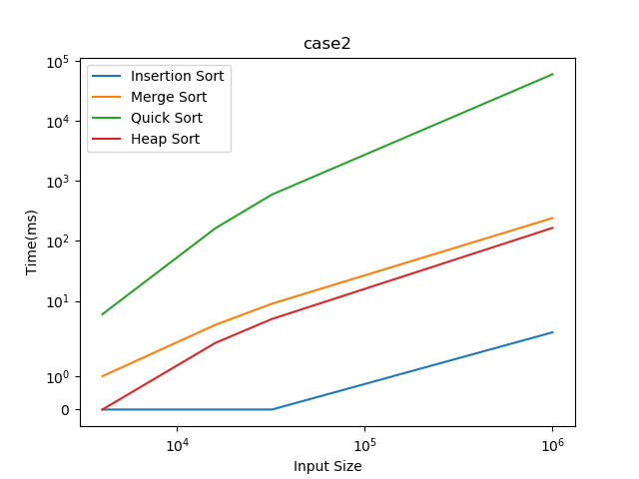

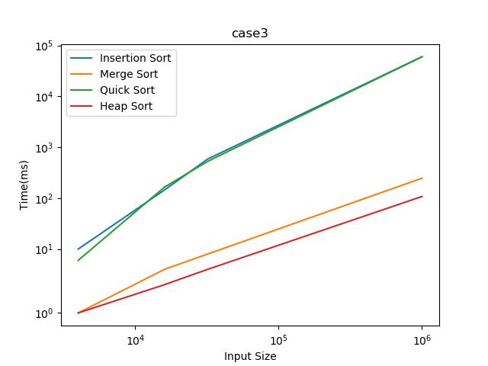

In case1(random order), insertion sort is the slowest, it is a direct result that insertion sort runs in O(n²) in average. And we can find that quick sort is the fastest among three O(n lg n) algorithms.

In case2(sorted order), insertion sort is the fastest because it is O(n) in this case. Quick sort is the slowest because it is the worst case, which is O(n²), for quick sort.

In case3(reversed sorted order), insertion sort and quick sort are all slow because they are O(n²).

