HW4 Report
B07901069 電機三 劉奇聖

Snapshots

a. RTL(Pass)

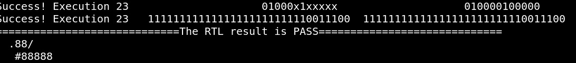
b. SYN(Pass)

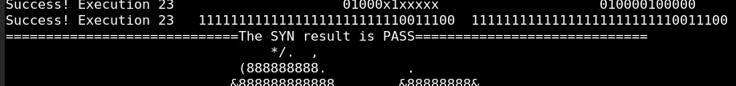
c. no latch
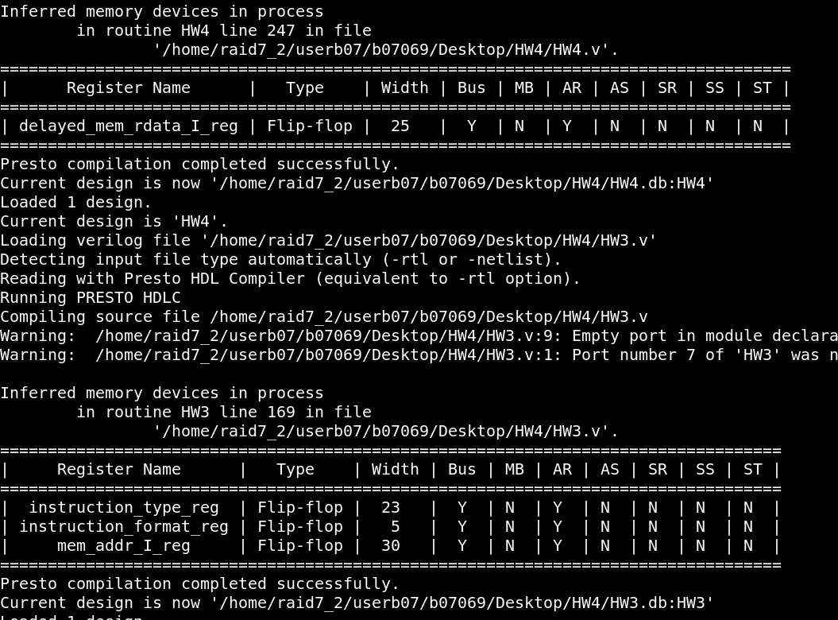

d. Timing report
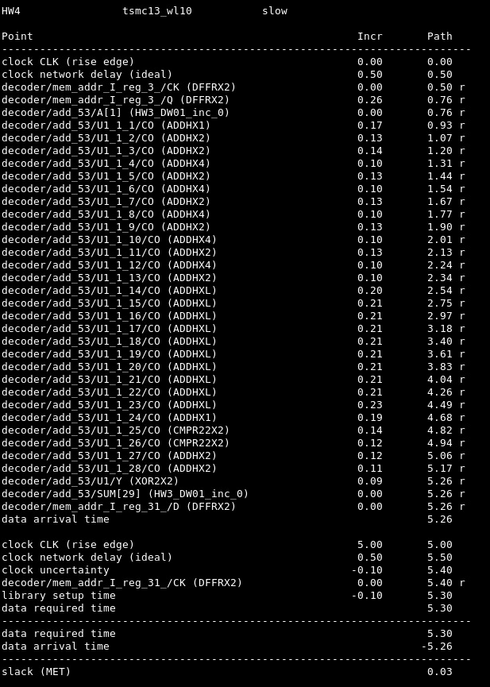

e. Area report

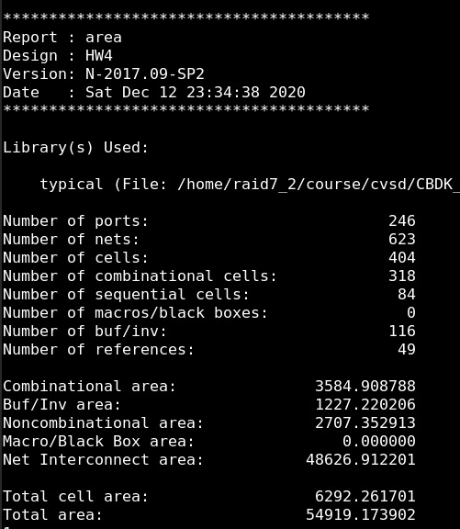
f. Cycle time

