Q1: A plot includes curve describing the relation of k and approximation error.
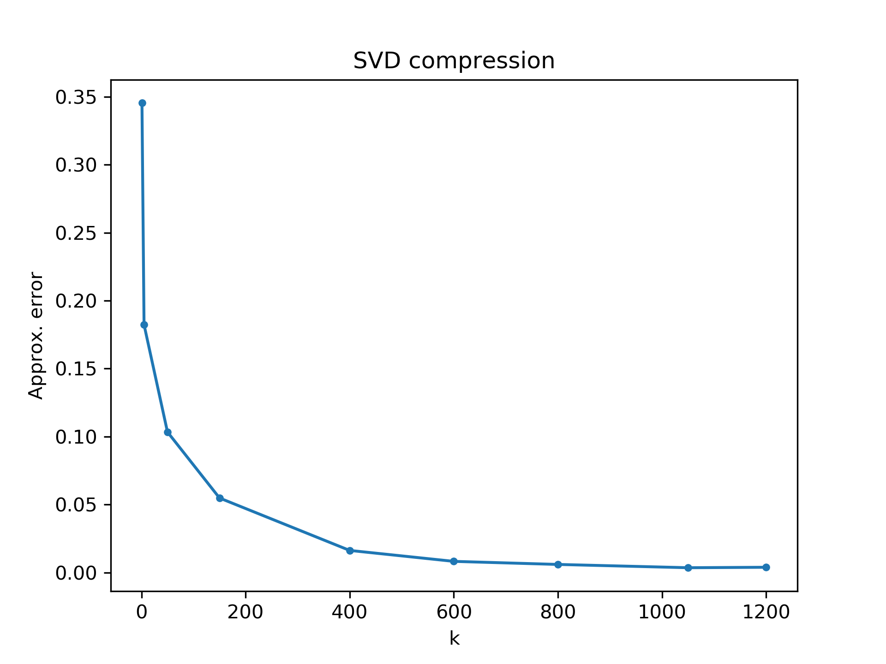
Q2: Analyze the rank of R channel of the provided image and explain how you analyze.
A2: The rank of R channel is approximately 467. By slowly increasing the value of k and compute the approximation error on R channel, the approximation error when k=467 is 0.009986, which is smaller than the specified threshold 0.01(1%). Therefore, the rank of R channel is about 467.

Q3: Plots in page 6 but on G channel.

Original G channel



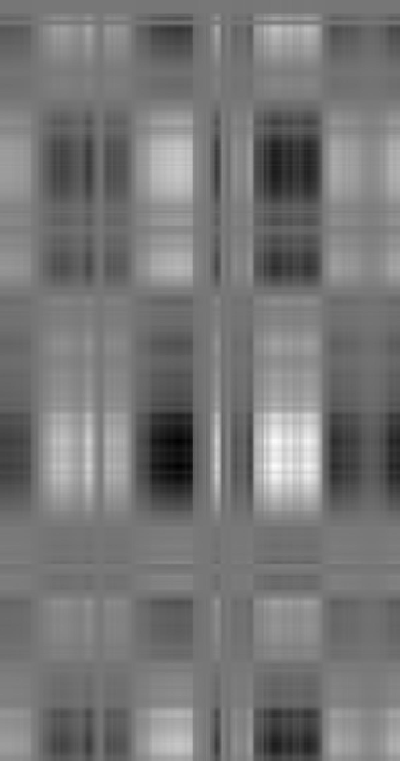
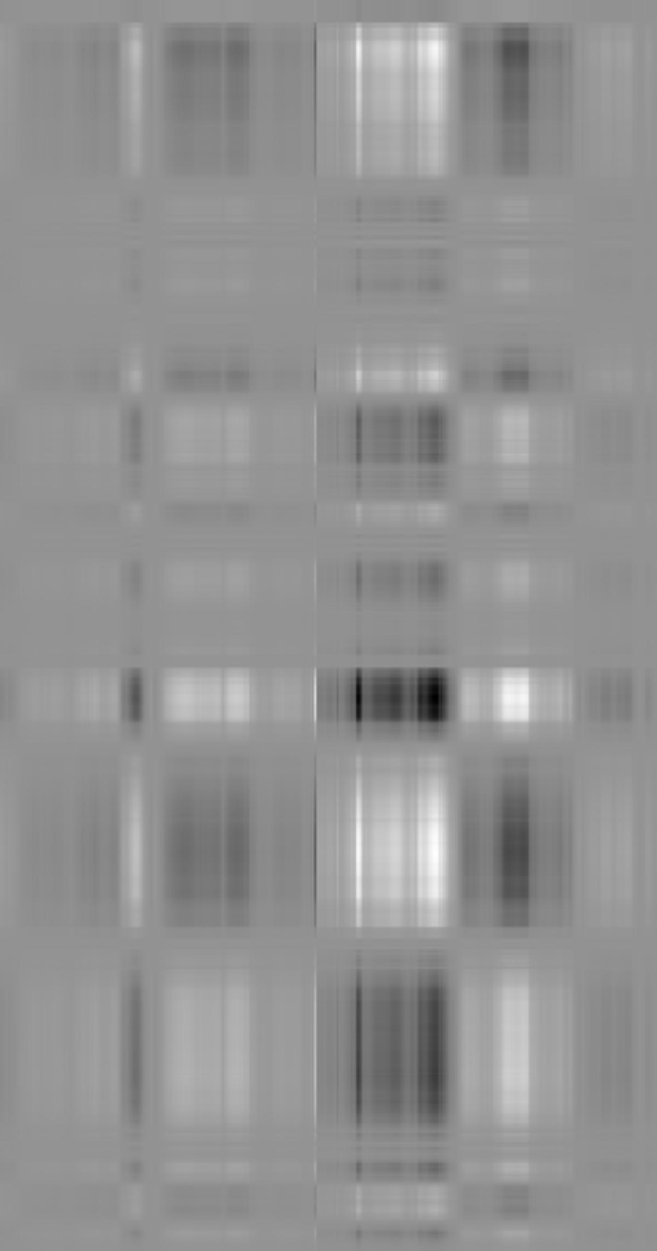

A1,G
A2,G
A3,G
A4,G
A5,G
+
+
+
=
+

