UNIVERSITY OF PENNSYLVANIA
DEPARTMENT OF ELECTRICAL ENGINEERING
ESE UNDERGRADUATE LABORATORY
ESE 205: Electrical Circuits and Systems I Laboratory
Object Tracking using PING Sensor, Servo Motor and Arduino Board

Goal: To measure distance using PING Sensor and track objects within the specified distance using Servo motor and
- display the distance measured on the 16X2 LCD Display
- use sound buzzer to indicate objects tracked
Parts Required
- Arduino Board
- USB Cable
- Wires
- LCD
- PING Sensor
- Servo Motor
- Sound Buzzer CX-0905

Procedure:
    - Connect the PING Sensor to the Arduino Board as shown in Figure 1
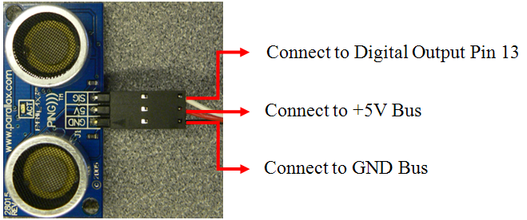

Figure 1: Connection of PING Sensor
    - Connect the Servo Motor to the Arduino Board as shown in Figure 2
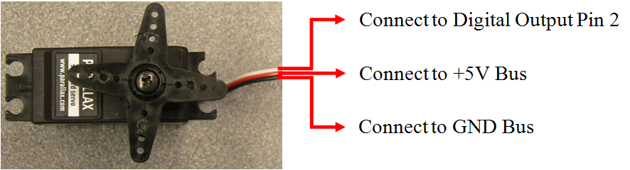

Figure 2: Connection of Servo Motor
    - Build the sound buzzer CX-0905 circuit as shown in Figure 3
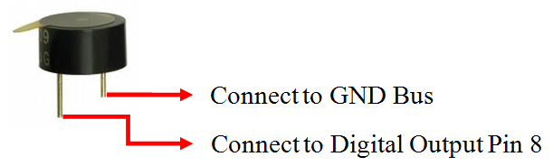

Figure 3: Sound Buzzer Circuit

    - Distance Display
Wire the 16X2 LCD display. For reference please see the Arduino OpAmp lab on the ESE 205 website, http://www.seas.upenn.edu/~ese205/Arduino%20Opamp_v7.doc
Note: The Pins 11, 12, 13 and 14 of the LCD Display are connected to the Digital I/O Pins 6, 5, 4 and 3 of the Arduino Board.
LCD | 1 | 2 | 3 | 4 | 5 | 6 | 7 | 8 | 9 | 10 | 11 | 12 | 13 | 14 | 15 | 16
Arduino Board | GND | +5V | GND | 12 | GND | 11 | - | - | - | - | 6 | 5 | 4 | 3 | +5V | GND

    - Compile and download the following working code to the Arduino Board using Arduino IDE
#include <Servo.h> // include the servo library
#include <LiquidCrystal.h> // include the library code:

Servo servoMotor; // creates an instance of the servo object to control a servo
LiquidCrystal lcd(12, 11, 6, 5, 4, 3); // initialize the library with the numbers of the interface pins

const int pingPin = 13; // Control pin for Ping Sensor
const int servoPin = 2; // Control pin for servo motor, may only be pin 9 or 10
const int speakerPin = 8; // Control pin for the Sound Buzzer

int moveServoLeft = 0; // variable to control the motion of the Servo Motor to the left
int moveServoRight = 0; // variable to control the motion of the Servo Motor to the right
int servoPosition = 0; // variable to control the position of the Servo Motor

void setup() {

// set up the LCD's number of rows and columns:
lcd.begin(16, 2);

// initial Display
lcd.setCursor(0,0);
lcd.print("Distance (inch.)");
lcd.setCursor(0,0);

servoMotor.attach(servoPin); // attaches the servo on pin 2 to the servo object
servoMotor.write(0); // set servo to intial position

moveServoLeft = 1; // intial motion of Servo is from 0 to 180 i.e left
}

void loop() {

// get Distance
long duration, inches, cm;

// to set speakerPin and servoPin mode to OUTPUT
pinMode(speakerPin, OUTPUT);
pinMode(servoPin, OUTPUT);

digitalWrite(speakerPin, LOW); // sound buzzer is defalut switched off

// The PING Sensor is triggered by a HIGH pulse of 2 or more microseconds.
// Give a short LOW pulse beforehand to ensure a clean HIGH pulse:
pinMode(pingPin, OUTPUT);
digitalWrite(pingPin, LOW);
delayMicroseconds(2);
digitalWrite(pingPin, HIGH);
delayMicroseconds(5);
digitalWrite(pingPin, LOW);

// The same pin is used to read the signal from the PING Sensor, a HIGH pulse whose duration is the time (in
// microseconds) from the sending of the ping to the reception of its echo off of an object.

pinMode(pingPin, INPUT);
duration = pulseIn(pingPin, HIGH);

// convert the time into a distance
inches = microsecondsToInches(duration);
cm = microsecondsToCentimeters(duration);

delay(200);
lcd.clear();
// set the cursor to column 0, line 1
// (note: line 1 is the second row, since counting begins with 0):
lcd.print("Distance (inch.)");
lcd.setCursor(0, 1);
lcd.print(inches);

// to enable tracking the Servo motor is rotated only if the distance of the objects are greater than or equal to 5”
if(inches >= 5) {
servoMotor.attach(servoPin);
servoMotor.write(servoPosition);
delay(20);
// to move right if the motor has reached 180 degrees
if(servoPosition == 180 && moveServoLeft == 1){
moveServoRight = 1;
moveServoLeft = 0;
}
// to move left if the motor has reached 0 degrees
if(servoPosition == 0 && moveServoRight == 1){
moveServoLeft = 1;
moveServoRight = 0;
}

// to move left from 0 degree to 180 degrees
if(moveServoLeft == 1 & servoPosition <= 160)
servoPosition = servoPosition + 20;
// to move right from 180 degrees to 0 degree
if(moveServoRight == 1 & servoPosition >= 0)
servoPosition = servoPosition - 20;
}

// to disable tracking the Servo motor is detached if the distance of the object is lesser than 5”
else {

servoMotor.detach();

for(int duration = 0; duration < 100; duration ++){
digitalWrite(speakerPin, HIGH);
delayMicroseconds(200);
digitalWrite(speakerPin, LOW);
delayMicroseconds(200);
}

}

}

long microsecondsToInches(long microseconds)
{
// According to Parallax's datasheet for the PING))), there are 73.746 microseconds per inch (i.e. sound travels at
// 1130 feet per second). This gives the distance travelled by the ping, outbound and return, so we divide by 2 to
// get the distance of the obstacle. See: http://www.parallax.com/dl/docs/prod/acc/28015-PING-v1.3.pdf

return microseconds / 74 / 2;
}

long microsecondsToCentimeters(long microseconds)
{
// The speed of sound is 340 m/s or 29 microseconds per centimeter. The ping travels out and back, so to find the
// distance of the object we take half of the distance travelled.

return microseconds / 29 / 2;
}
    - Questions:
- Give a brief (2-4 sentences) explanation of how the Servo Motor works.
- Display the distance measured in centimeters.
- How do you increase or decrease the speed at which the objects are scanned?
- Increase the tracking range (distance) of the setup to 10” or 25.4 cm.

    - Extra Credit:

Re-write the firmware to display the count of number of objects scanned in a minute. (10 points)

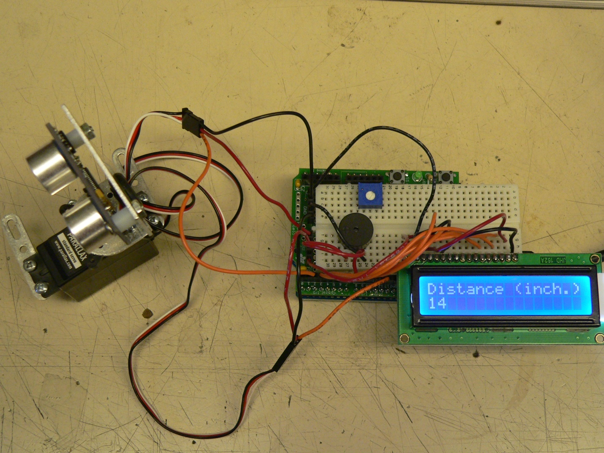 Figure 4: Tracking of objects using PING Sensor, Servo Motor and Arduino Board

