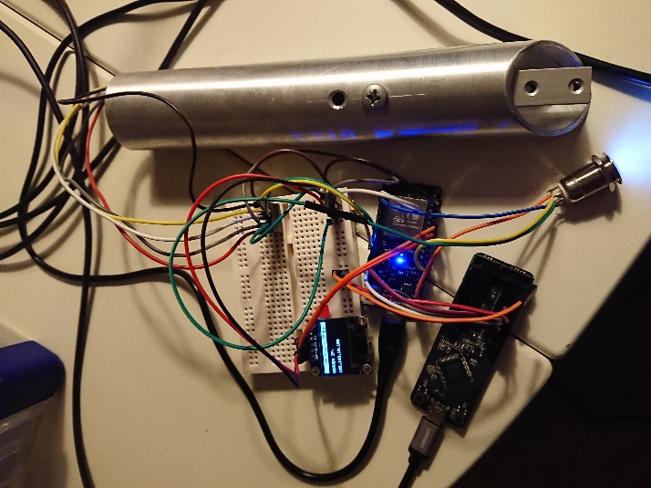

Table of Contents

**No table of contents entries found.**

# Introduction

This document describes the materials, components, and software to use in order to assemble the algometer, to be used in the pain research project.

This device is designed to provide wireless capability’s and connection to a redcap database to save the test data. The device itself host’s a webserver which presents the test procedure to be followed for this research project.

The main purpose is to capture pressure data, instruct the patient in the test to be executed, and deliver an easy way to produce consistent test results, by the means of streamlining the test cases.

# Assembly guide

## Prerequisite

## Software

### PlatformIO

This project was developed with the opensource software extension for Visual Studio Code, nemed PlatfomIO.

A descriptive guide on the installation process can be found following this link:

<https://docs.platformio.org/en/latest/ide/vscode.html#installation>

### GitHub project

The PlatformIO project-based firmware, running on the device, can be found following this link:

<https://github.com/MortenBrask/Pressure_Probe>

* Download the project to any desired location
* Open Visual Studio Code, PlatformIO should start with a welcome screen.
* 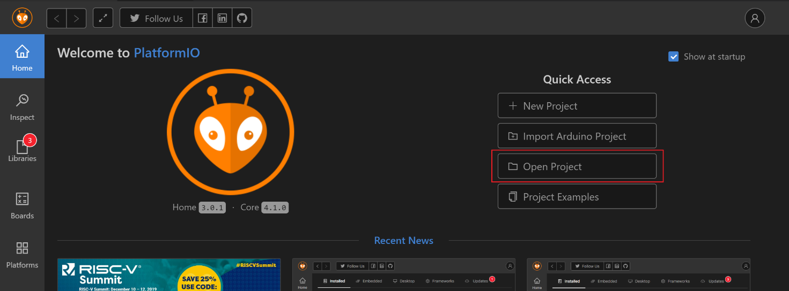Click ‘Open Project’ and navigate to the downloaded github project
* The navigator should now have the entire project listed

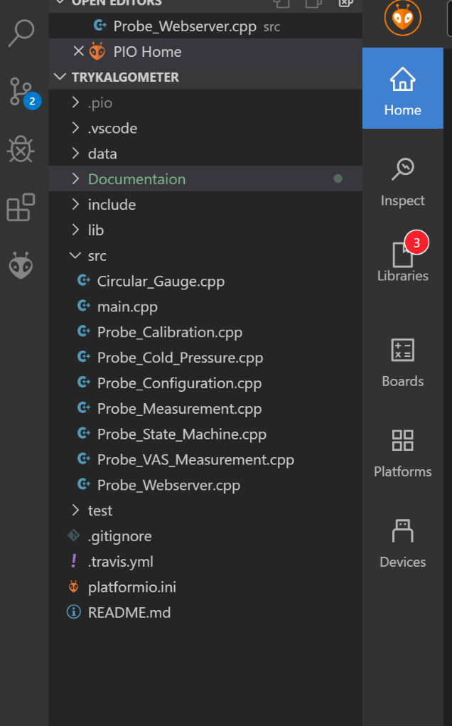

### Uploading the firmware

In order to flash the ESP32, connect the ESP32, and press the ‘Upload’ button which resides in the blue bottom taskbar of PlatformIO, and looks like an arrow pointing to the right.

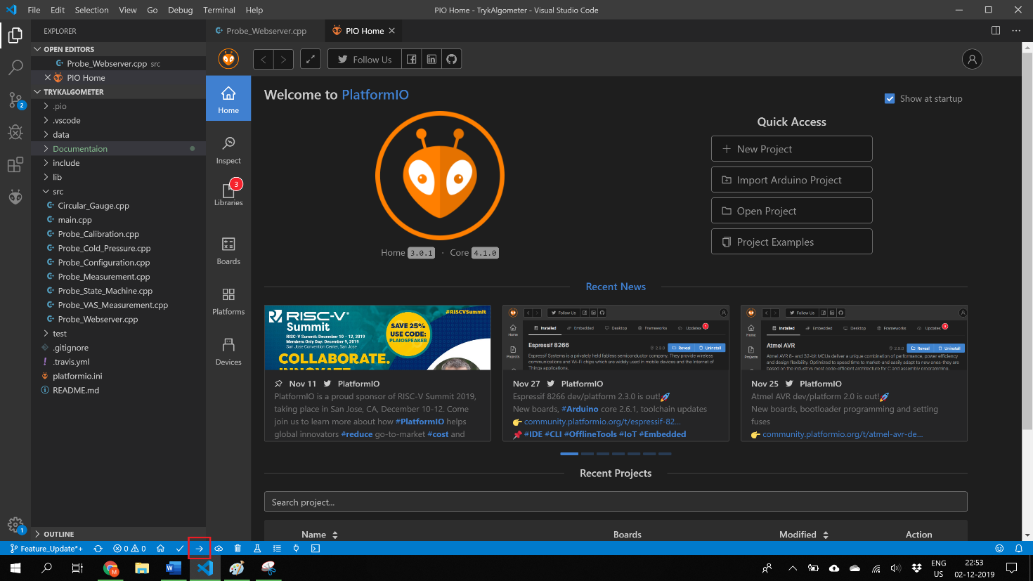

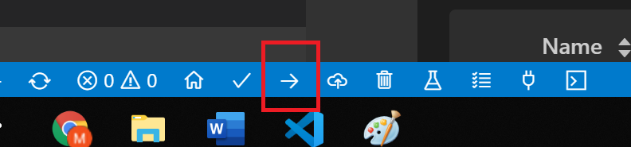

When the software is uploaded, the external files should be uploaded to the Flash Files System of the ESP32.

Press the ‘Run Tasks” button and select ‘Upload File System Image’ from the dropdown.

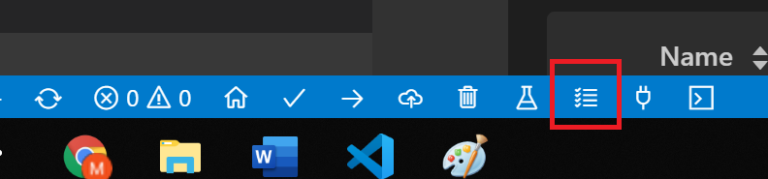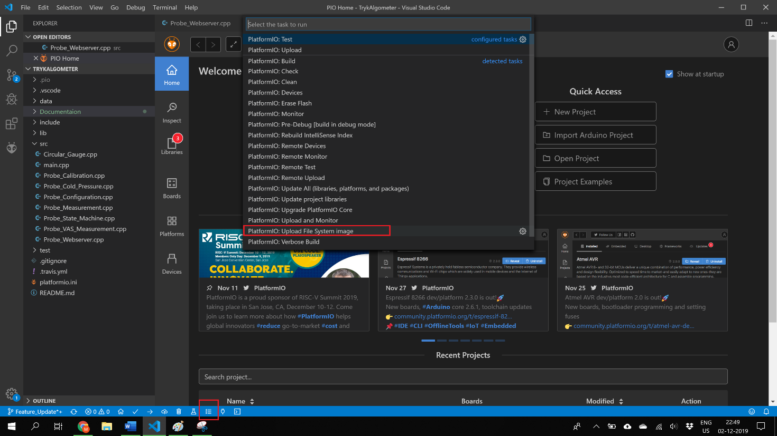

This will upload all the HTML, CSS, and various other files needed for the device to function properly.

## Hardware

### Tools

Various tools are needed in order to assemble a single unit, some of the tools may or may not be required or can be fulfilled by other means. The following lists the tools required for a smooth assembly:

* Soldering iron
* Solder
* Cable stripper
* Zip ties
* Crimp tool
* Shrink tube with solder
* Shrink tube min 19mm, or nonconducting tape
* 3D printer (4 printed parts is part of the build)
* Various screwdrivers with heads dependant on the screws chosen
* Nose pliers

### Components

Following is a complete list of the components used in the build, and links to the corresponding component:

|  |  |  |  |
| --- | --- | --- | --- |
| **1x Lolin D32, ESP32 development board** |  | **1x HX711, load cell amplifier** |  |
| **1x 10 Kg Load cell** |  | **1x 12mm LED Latching pushbutton** |  |
| **1x Adafruit micro USB panelmount** |  | **1x 0.96” OLED I2C display** |  |
| **8x 30cm Jumper Wire, Female to Female** |  | **2x 10cm Jumper Wire, Female to Female** |  |
| **2x 10cm Jumper Wire, Male to Male** |  | **1x M2 x min 4mm machine screw** |  |
| **1x M2 nut** |  | **1x M4 x 6mm** |  |
| **2x M4 x 16mm** |  | **4x Crimp Header Terminals** |  |
| **20x 90 degree Pin Header, 2.54mm** |  | **10x straight Pin Header, 2.54mm** |  |
| **1x 3.7V LiPo battery** |  |  |  |
|  |  |  |  |

### Component Links

* **1x Lolin D32, ESP32 development board** <https://www.aliexpress.com/item/32808551116.html?spm=2114.12010612.8148356.3.7de9667bvOHkMl>
* **1x HX711, load cell amplifier** <https://www.aliexpress.com/item/32848866947.html?spm=2114.12010615.8148356.1.686b48ac4pEAVO>
* **1x 10 Kg Load cell** <https://www.aliexpress.com/item/32949395083.html?spm=2114.12010615.8148356.1.2cad70eeDpNp8A>
* **1x 12mm LED Latching pushbutton** <https://www.aliexpress.com/item/32945377096.html?spm=a2g0s.9042311.0.0.362a4c4dVHYnRZ>
* **1x Adafruit micro USB panelmount** <https://www.adafruit.com/product/3258>
* **1x 0.96” OLED I2C display** <https://www.aliexpress.com/item/32902463963.html?spm=a2g0s.9042311.0.0.27424c4d3bTmO2>
* **8x 30cm Jumper Wire, Female to Female** <https://www.aliexpress.com/item/32962785036.html?spm=2114.12010615.8148356.1.71c7730c4DUeBp>
* **2x 10cm Jumper Wire, Female to Female** <https://www.aliexpress.com/item/32962785036.html?spm=2114.12010615.8148356.1.71c7730c4DUeBp>
* **2x 10cm Jumper Wire, Male to Male** <https://www.aliexpress.com/item/32962785036.html?spm=2114.12010615.8148356.1.71c7730c4DUeBp>
* **1x M2 x min 4mm machine screw** <https://uk.farnell.com/c/fasteners-mechanical/fasteners-fixings/screws-bolts/machine-screws?thread-size-metric=m2>
* **1x M2 nut** <https://uk.farnell.com/search?st=m2%20nut>
* **1x M4 x 6mm** <https://uk.farnell.com/w/c/fasteners-mechanical/fasteners-fixings/screws-bolts/machine-screws?st=m4%20screw&ost=M4%20screw>
* **2x M4 x 16mm** <https://uk.farnell.com/w/c/fasteners-mechanical/fasteners-fixings/screws-bolts/machine-screws?st=m4%20screw&ost=M4%20screw>
* **4x Crimp Header Terminals** <https://www.aliexpress.com/item/32960693762.html?spm=a2g0o.store_home.productList_8947779.pic_8>
* **20x 90 degree Pin Header, 2.54mm** <https://www.aliexpress.com/item/32856536650.html?gps-id=pcStoreJustForYou&scm=1007.23125.122752.0&scm_id=1007.23125.122752.0&scm-url=1007.23125.122752.0&pvid=bc8eea78-f8cd-41bf-bf3c-d4b60c50aaae&spm=a2g0o.store_home.smartJustForYou_99425223.1>
* **10x straight Pin Header, 2.54mm** <https://www.aliexpress.com/item/32856484890.html?gps-id=pcStoreJustForYou&scm=1007.23125.122752.0&scm_id=1007.23125.122752.0&scm-url=1007.23125.122752.0&pvid=bc8eea78-f8cd-41bf-bf3c-d4b60c50aaae&spm=a2g0o.store_home.smartJustForYou_99425223.2>
* **1x 3.7V LiPo battery** <https://www.aliexpress.com/item/32859283434.html?spm=a2g0o.productlist.0.0.11916044SDLtea&algo_pvid=a7087df0-ee0b-47a6-8cfb-b7ff3c001396&algo_expid=a7087df0-ee0b-47a6-8cfb-b7ff3c001396-6&btsid=db88c5c8-4212-46ec-958a-c3218b9c68ca&ws_ab_test=searchweb0_0,searchweb201602_1,searchweb201603_55>

## Assembly

### Lolin ESP32

Solder the 9 straight, and 9, 90 degree bend pins pin headers on the board starting from 3.3V and Ground