Privacy By Design (Lecture 1)

Definition:
- Privacy engineering is the discipline of applying engineering principles and processes to build privacy protections into systems, products, and services.
- Essential concept: Personal data are any information which is related to an identified or identifiable natural person. https://gdpr-info.eu/issues/personal-data/
- Sensitive data: Genetic, biometric and health data, personal data revealing racial and ethnic origin, political opinions, religious or ideological convictions or trade union membership.

Components of privacy engineering:
- Privacy requirements
- Risk assessments
- Privacy engineering and security objectives
- Risk management
- Privacy impact assessment

The seven principles
- Proactive rather than reactive (preventative, not remedial)
  - Privacy by design is about anticipating and preventing incidents rather than reacting when they occur
- Privacy by default (as the default setting)
  - Data protection should be the default so that individuals don't have to do anything to ensure their privacy
- Building privacy into the design
  - Data protection should be integrated into systems, policies, and processes already in the development phase
- Completely functional (full functionality, positive sum, not zero sum)
  - It should be possible to achieve maximum data protection in combination with other business goals - it's a question of getting both
- End-to-end security (full lifecycle protection)
  - Data protection must be present throughout the entire lifecycle from the moment data is collected until it is deleted
- Visibility and transparency
  - The organization must be open about how it protects personal data
- Respect for user privacy
  - Privacy by design is about putting the needs and rights of the individual at the center

Privacy enhancing techniques (Lecture 2,3,4)

Differential privacy
Formal definition:

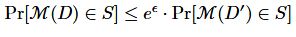
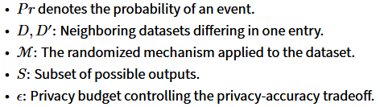
ε dictates how privacy preserving it is. If e.g. ε = 0.01, then e^0.01 = 1.01, which means the difference between the two datasets is so small that attackers wouldn’t be able to distinguish between the datasets. If e.g. ε = 10, then e^10 = 22000, then the two datasets are clearly distinguishable from one another.

Laplace mechanism - the noise is defined as:
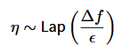
So for e.g. age it might be 100 for a summation query.

Gaussian mechanism:
Not as private due to δ risk - the probability of privacy failure. This allows you to have more accurate results while giving away some privacy, which when applied practically still has an extremely low chance of actually leaking data. Generally the larger the dataset, the lower you can set δ.

Composition theorems:
Privacy budget accumulates when multiple DP mechanisms are applied. Two approaches are:

Sequential composition: summation of privacy loss, loss grows linearly
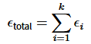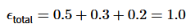

Advanced composition: accounts for failures. Privacy loss grows slower (sqrt(k)) (applicable to (ϵ,δ)-DP)
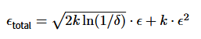
Each mechanism satisfies privacy
End result:

This further demonstrates the usefulness of (ϵ,δ)-DP.

Multiparty computation: a way for a group of people to get an answer to a question without any individual revealing their secrets.
- Example usage: two millionaires want to know who is richer without revealing exactly how much money they have.
- The Goal: Privacy (nobody learns the input) and Correctness (the result is accurate).

Garbled circuits: a specific method for MPC, usually between two parties (Alice and Bob). It transforms a logical computation (like an "AND" gate) into a "scrambled" version that can be evaluated without seeing the underlying data.

- How it works:
  - Garbling: Alice takes a logic circuit and "garbles" it by replacing 0s and 1s with random-looking cryptographic keys (tokens). She also encrypts the truth table of the gates.
  - Transfer: She sends the encrypted gates to Bob.
  - Oblivious Transfer: Bob gets the keys corresponding to his private input without Alice knowing which ones he picked.
  - Evaluation: Bob "decrypts" his way through the circuit. He gets a final result but never sees Alice’s bits or the intermediate steps.
Analogy: It’s like Alice giving Bob a series of locked boxes. Bob has some keys, and Alice gives him others via a "blindfolded" hand-off. Bob can unlock the final box to see the result, but he can't see what was inside the intermediate boxes.
Homomorphic encryption: allows you to perform mathematical calculations on encrypted data without ever decrypting it first.
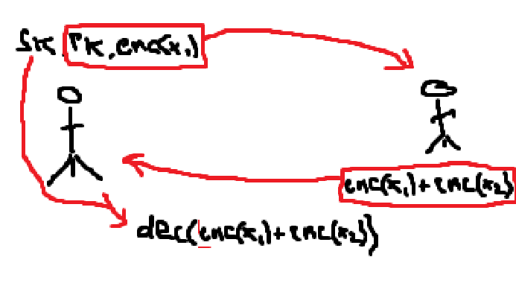
- Alice generates secret key and public key
- Alice encrypts x₁ and sends public key and enc(x₁) to Bob
- Bob does enc(x₁) + enc(x₂) and sends back to Alice
- Alice uses secret key to to decrypt (enc(x₁) + enc(x₂))
Shamir secret sharing: a way to "slice" the data. It is based on a simple geometric principle: it takes k points to define a polynomial of degree k−1.
How it works:
- To hide a secret (e.g., the number 10), you treat it as the y-intercept of a random line or curve.
- If you want a "2-out-of-3" scheme, you draw a random line passing through (0,10). You then give three different people different points on that line.
- Any two people can connect their dots to find the line and the intercept. One person alone has just a single dot and can’t know the slope—meaning the secret could be literally any number.
The Benefit: It is "Information-Theoretic Secure." Even a computer with infinite power cannot guess the secret because, mathematically, every possible secret is equally likely.
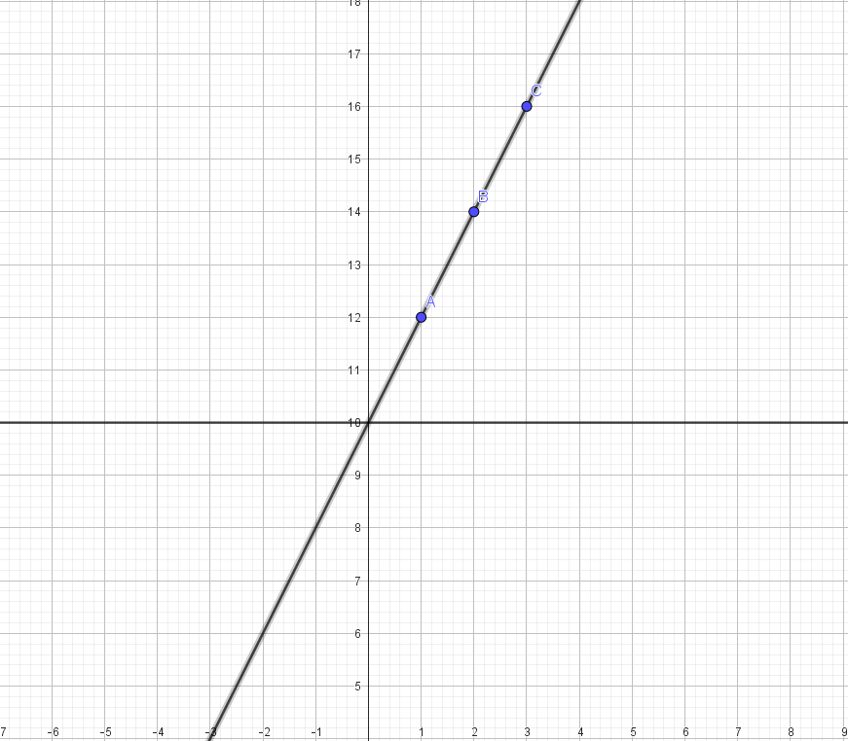

Beaver triples: a "cryptographic trick" to make multiplication fast.
- How it works:
  - Preparation: Before the real data is even known (the "Offline Phase"), a trusted source (or a slow protocol) generates a "triple" of random numbers (a,b,c) such that a×b=c. These are distributed as secret shares.
  - The Online Phase: When Alice and Bob need to multiply their actual secret inputs (x×y), they use the triple to "mask" their values.
  - Because the "heavy lifting" of the multiplication was done ahead of time with the random a and b, the actual computation becomes a simple matter of sharing two masked values and doing basic addition.
Example:
Value | Alice's Share (Party 1) | Bob's Share (Party 2) | Total (Hidden Value)
s | 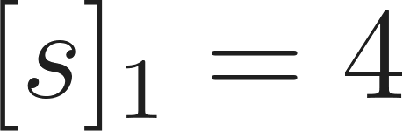 | 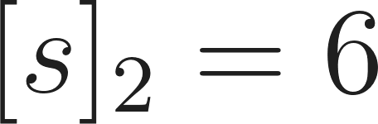 | 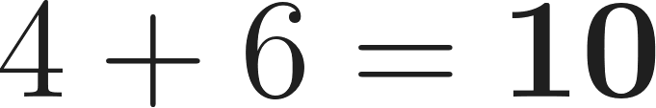
s' | 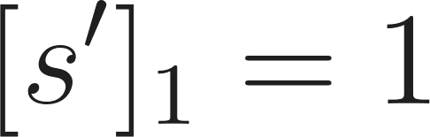 | 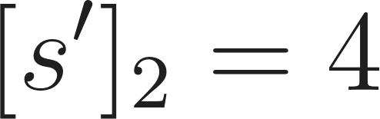 | 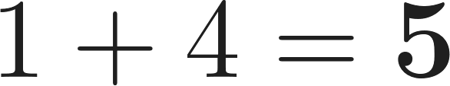
a | 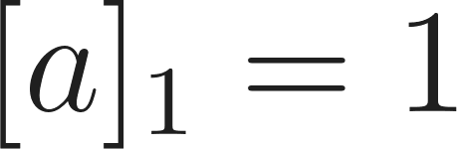 | 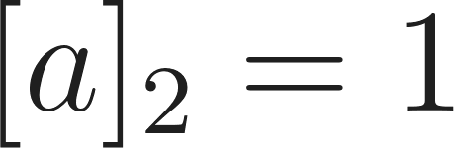 | 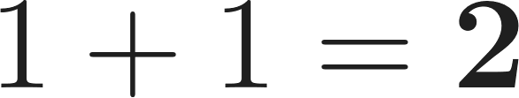
b | 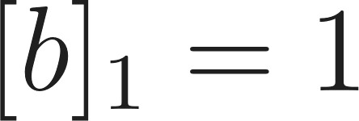 | 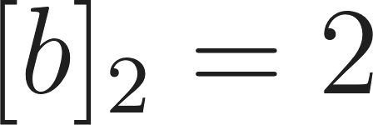 | 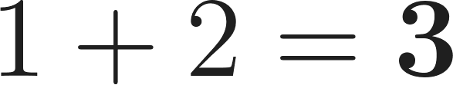
c | 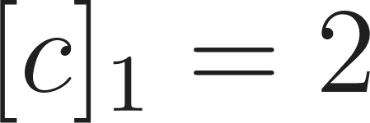 | 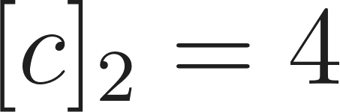 | 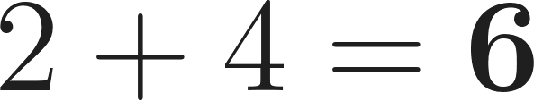
Alice computes:
Bob computes:
Alice and Bob exchange their shares of 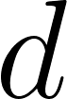 and 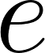 to reconstruct the real values.
They use the formula: .
Because and are now public numbers, Alice and Bob can multiply their private shares by these numbers.
Important: The term 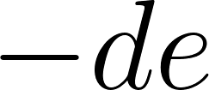 ($16$) is a public constant. In additive sharing, typically one party subtracts the constant so it isn't subtracted twice. Let's assign this task to Alice.
Alice's Calculation:
Bob's Calculation:
Alice holds the final share 2. Bob holds the final share 48.
Neither knows the other's number, but if they combine them:
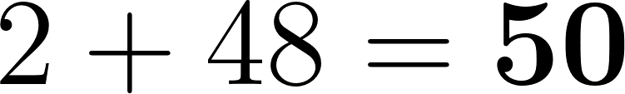

SPDZ: a state-of-the-art framework that combines the ideas above into a practical, "dishonest majority" protocol. This means it stays secure even if everyone in the room is a "bad actor" except for you.
- The Two Phases:
  - Offline Phase: Uses heavy cryptography (like Homomorphic Encryption) to produce a massive "pile" of Beaver Triples and other "pre-computed" data.
  - Online Phase: Uses those triples to perform the actual calculation at lightning speed.
- The "Secret Sauce" (MACs): SPDZ adds a Message Authentication Code (MAC) to every share. If a participant tries to lie about their share to mess up the result, the MAC check will fail at the end, and the protocol will "abort" rather than give a wrong answer.

Privacy preserving distributed computation (Lecture 5,6,7)
Adversary models:
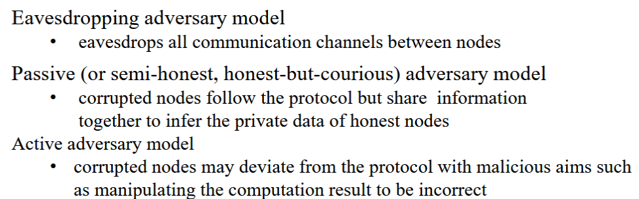

Privacy in machine learning (Lecture 8)

ML input memorization
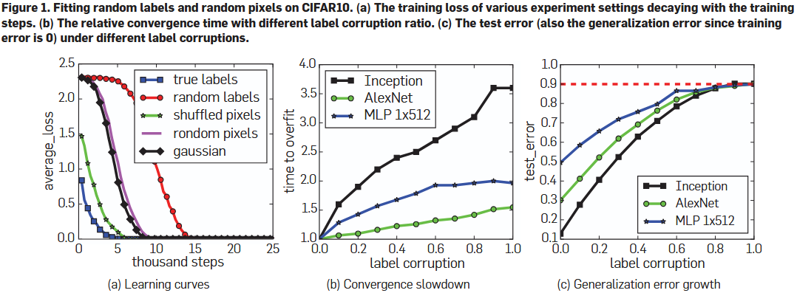
- Shows that while true labels converge quickest, random labels etc. also converges eventually
- Convergence takes longer as labels are more corrupted
- Generalization becomes worse as labels are more corrupted

Natural data often has long-tail distribution
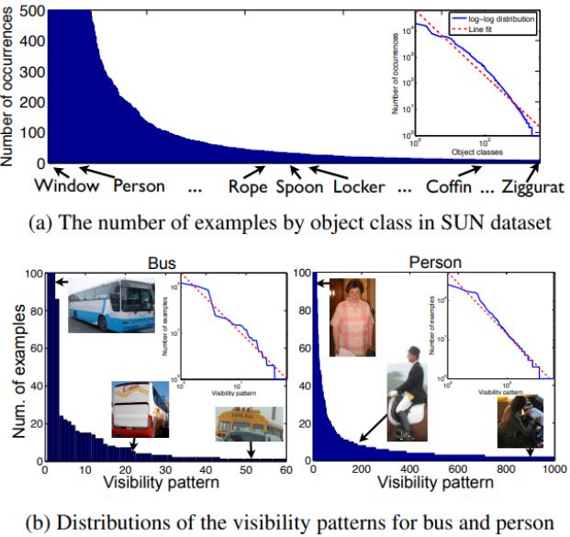
Memorization often occurs due to these atypical cases, and studies have shown that simply removing these cases significantly reduces performance, due to the long-tail theory.

An example of removing atypical examples hurting performance is the use of sarcasm. The word great can be given a positive label in most cases, however the case “oh great” would give a negative label, and removing it would give the model the inability to handle such cases.

Privacy attacks in ML
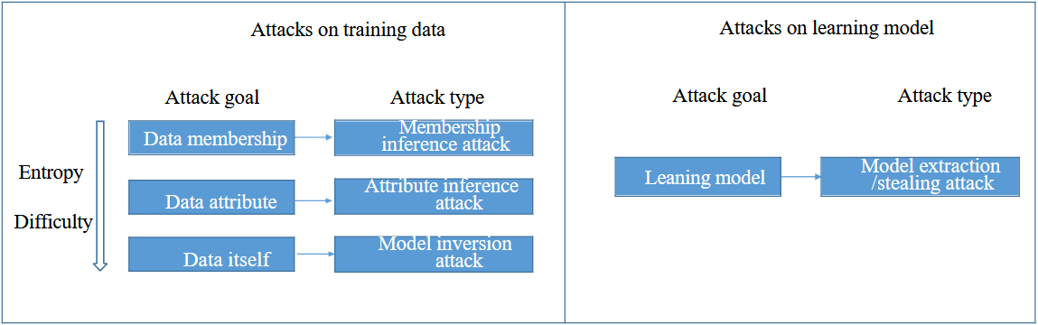

Membership inference attacks
Feature distinguishability for member and non-member
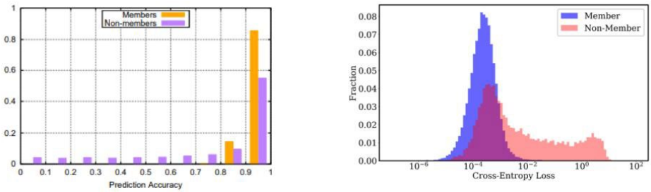
Members generally have a higher accuracy.

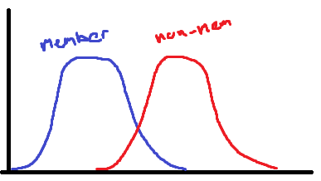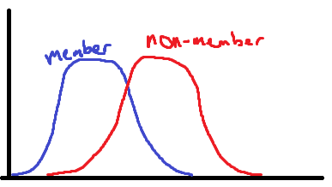
A bigger overlap between the accuracy of members and non members represents both a more private and a more performant model. It is more generalizable and more private, due to the overlap representing less confidence in knowing whether it is a member or not.

Differential privacy

Topologies
Ring:
Star:
Fully-connected:
- The most private/secure of the various topologies
  - An attacker would have to compromise N-1 nodes to know your secret
- All nodes are connected to each other
  - If you have shared your secret with at least one honest node, your secret is safe
- Fairly secure network, as nodes usually have a good amount of neighbours
- Attackers would need to compromise all neighbouring nodes to gain your secret
Mesh:
Line:
Tree:

Noise distributions
Uniform:
- Very accurate, but does not satisfy Differential Privacy!
- It has bounds (eg. -5/+5), which makes it vulnerable (0 probability for extreme values)
- Square because all values are equally likely to occur within bounds.
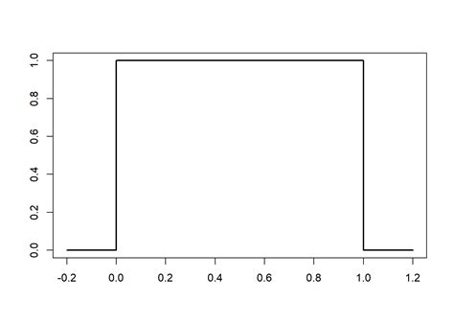

Laplace:
- Sharp spike at 0
- Long heavy tails (Big error values occur more often)
- Less accurate than Gaussian, but more private!
- Epsilon-differential privacy (Privacy always holds)
- Infinitesimal: lower values in the bounds get closer and closer to zero
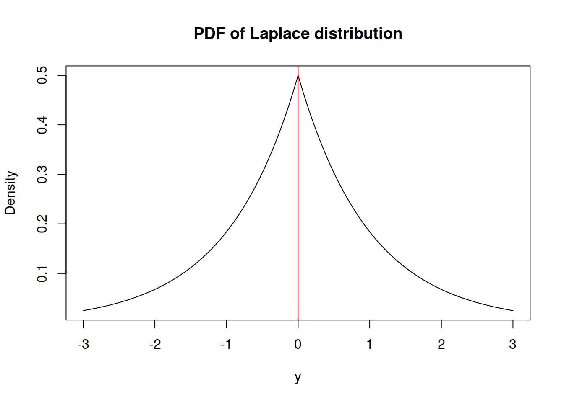
Gaussian:
- Less sharp spike
- Tails drop much faster (Avoids huge error values, and less big error values)
- Wider center = more smaller noises
- Epsilon and Delta-differential privacy (Break privacy with probability Delta, but be much more accurate the rest of the time)
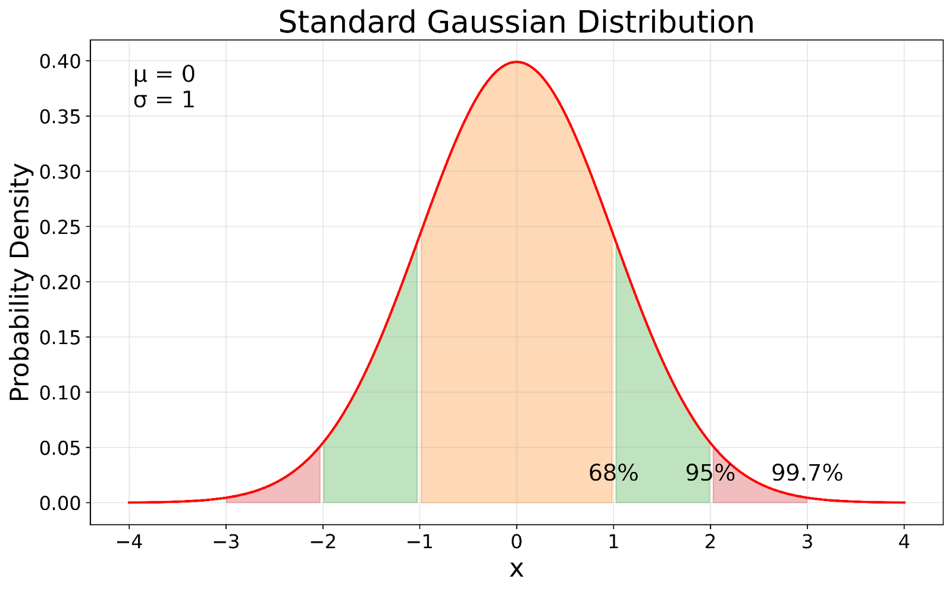

Logic (Input L, R → Out) | Encryption Rule (Keys → Encrypted Output) | Resulting Ciphertext
0 AND 0 → 0 | Encrypt 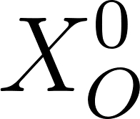 using keys 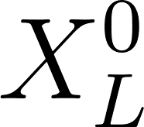 and 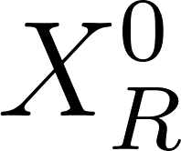 | 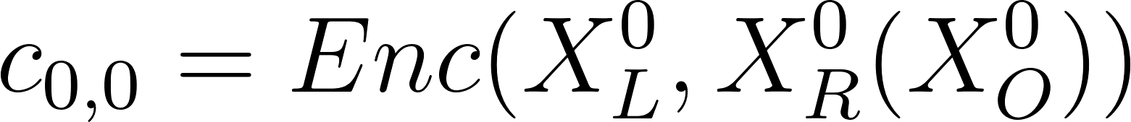
0 AND 1 → 0 | Encrypt using keys and 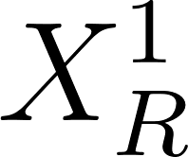 | 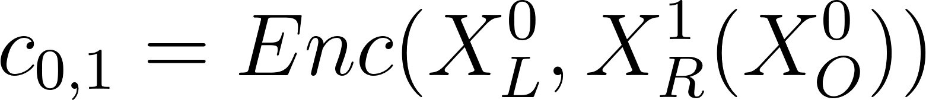
1 AND 0 → 0 | Encrypt using keys 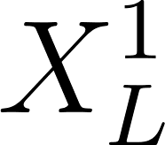 and | 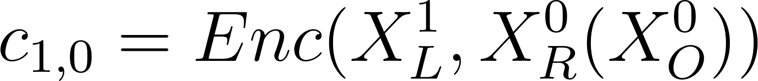
1 AND 1 → 1 | Encrypt 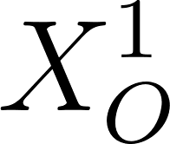 using keys and | 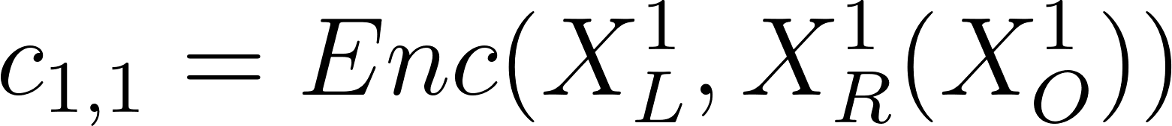
- The Evaluator receives the table shuffled.
- Suppose the Evaluator holds strings (Input was 1) and (Input was 0).
- They try to decrypt all 4 rows.
- Only Row 3 (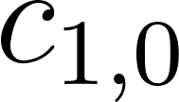) works because the keys match.
- Result: They unlock string . They don't know it represents "0", they just know it's the key for the next gate.

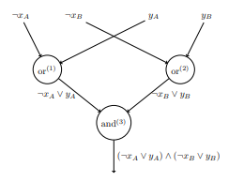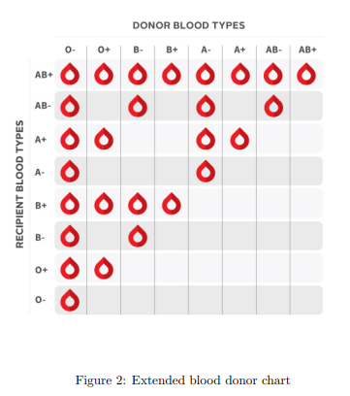

 | ¬A ¬B | ¬A B | A ¬B | A B
¬A ¬B | 1 | 1 | 1 | 1
¬A B | 0 | 1 | 0 | 1
A ¬B | 0 | 0 | 1 | 1
A B | 0 | 0 | 0 | 1

 | ¬A ¬B | ¬A B | A ¬B | A B
¬A ¬B | 1 | 1 | 1 | 1
¬A B | 0 | 1 | 0 | 1
A ¬B | 0 | 0 | 1 | 1
A B | 0 | 0 | 0 | 1



