Pricing Danish Mortgage Bonds using Machine learning for estimation

Morten Søby Willendrup

Last compiled on 28 januar, 2022

# Preliminary Content

## Acknowledgements

I want to thank a few people.

## Preface

This is an example of a thesis setup to use the reed thesis document class (for LaTeX) and the R bookdown package, in general.

## Dedication

You can have a dedication here if you wish.

## Abstract

The preface pretty much says it all.

Second paragraph of abstract starts here.

# Abstract

Kind words go a long way

# 1 Introduction

Mortgage bonds have a long history in Denmark, originating from 1797 where a fire in Copenhagen destroyed most of the city in 1795, this event initiated the first mortgage bank(Jensen 2013). The general idea on how the mortgage system in Denmark has since only seen minor changes thus a source of high stability. The idea being the system that instead of having a one-to-one relationship between the borrower mortgage loan and the investors mortgage bond. The Danish mortgage system is structured such that the mortgage bond issuer pools the mortgage loan 1.1

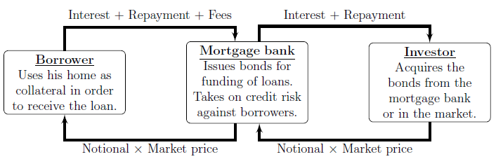

Figure 1.1: Simplified illustration of the relationships and payment streams between the homeowner, the mortgage bank and the investor in the Danish mortgage system.

# 2 Theory

# 3 Data

# 4 Estimation

# Discussion

# Conclusion

# (APPENDIX) Appendix

# 5 The First Appendix

This first appendix includes all of the R chunks of code that were hidden throughout the document (using the include = FALSE chunk tag) to help with readibility and/or setup.

**In the main Rmd file**

# This chunk ensures that the thesisdown package is  
# installed and loaded. This thesisdown package includes  
# the template files for the thesis.  
if (!require(remotes)) {  
 if (params$`Install needed packages for {thesisdown}`) {  
 install.packages("remotes", repos = "https://cran.rstudio.com")  
 } else {  
 stop(  
 paste('You need to run install.packages("remotes")",  
 "first in the Console.')  
 )  
 }  
}  
if (!require(thesisdown)) {  
 if (params$`Install needed packages for {thesisdown}`) {  
 remotes::install_github("ismayc/thesisdown")  
 } else {  
 stop(  
 paste(  
 "You need to run",  
 'remotes::install_github("ismayc/thesisdown")',  
 "first in the Console."  
 )  
 )  
 }  
}  
library(thesisdown)  
# Set how wide the R output will go  
options(width = 70)

**In Chapter ??:**

# Roadmap

## Timeline

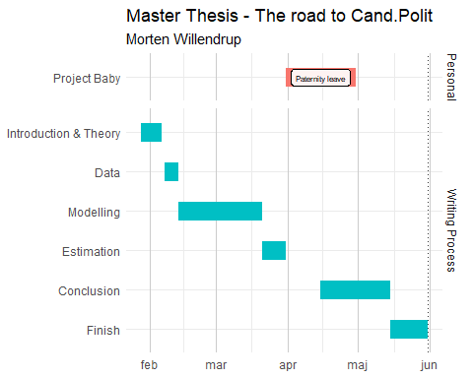

## Introduction

Need to write a full introduction of the Danish Mortgage Market, furthermore leave space for a brief walkthorugh of the thesis

## Theory

Relevant theory should be Machine Learning, which is relevent should be discussed in detail

## Data

Get data from DST.  
Get data from Nasdaq.  
Get data from Danske Bank Asset Management

# References

Angel, Edward. 2000. *Interactive Computer Graphics : A Top-down Approach with OpenGL*. Boston, MA: Addison Wesley Longman.

———. 2001a. *Batch-File Computer Graphics : A Bottom-up Approach with QuickTime*. Boston, MA: Wesley Addison Longman.

———. 2001b. *Test Second Book by Angel*. Boston, MA: Wesley Addison Longman.

Jensen, Bjarne Astrup. 2013. *Rentesregning: Særtryk Af 6. Udgave*. Djøf Forlag.