The precision during training: 82.22 % (it is evaluated by validation data)

The precision during testing: 74.87 %

These two precisions are shown in the picture below:

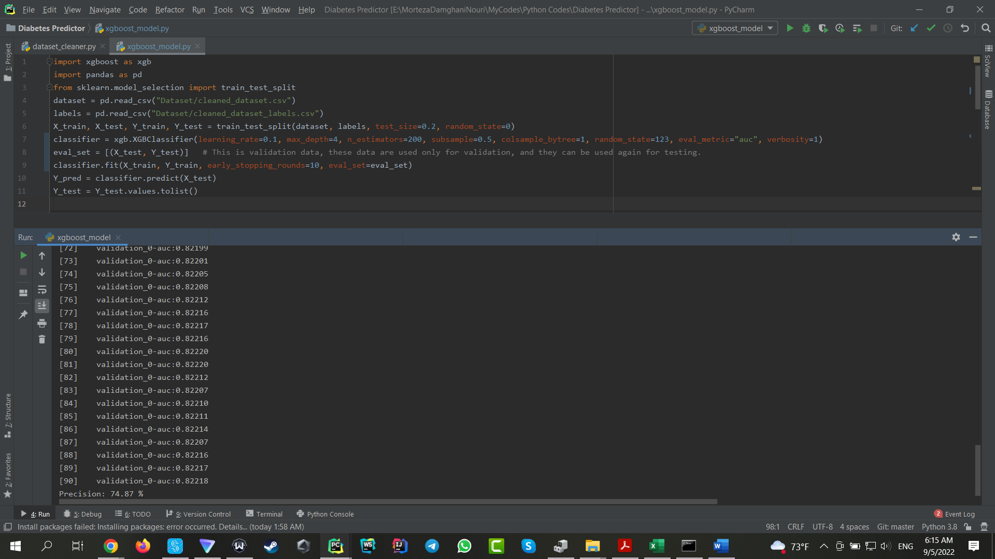

Confusion Matrix:

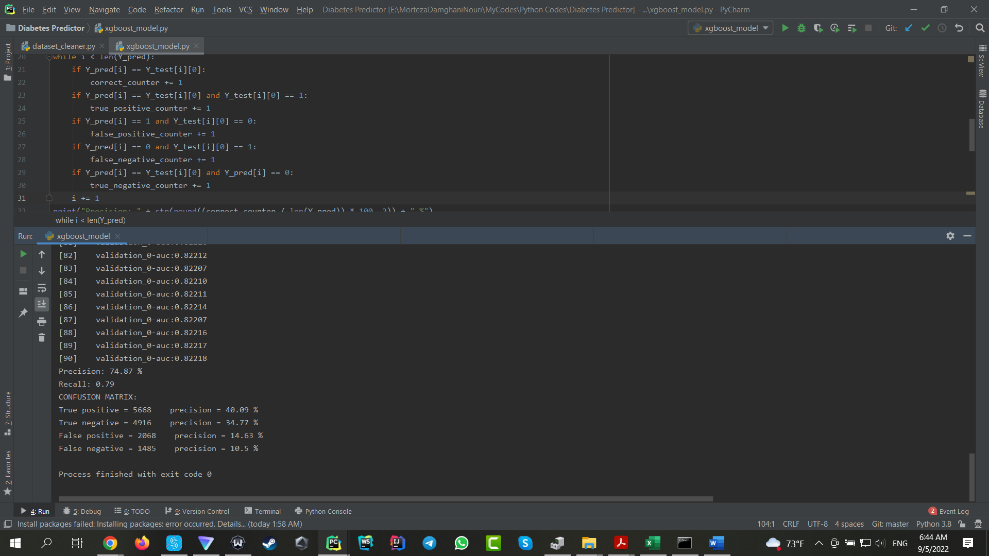

The best model parameters are shown in the picture below:

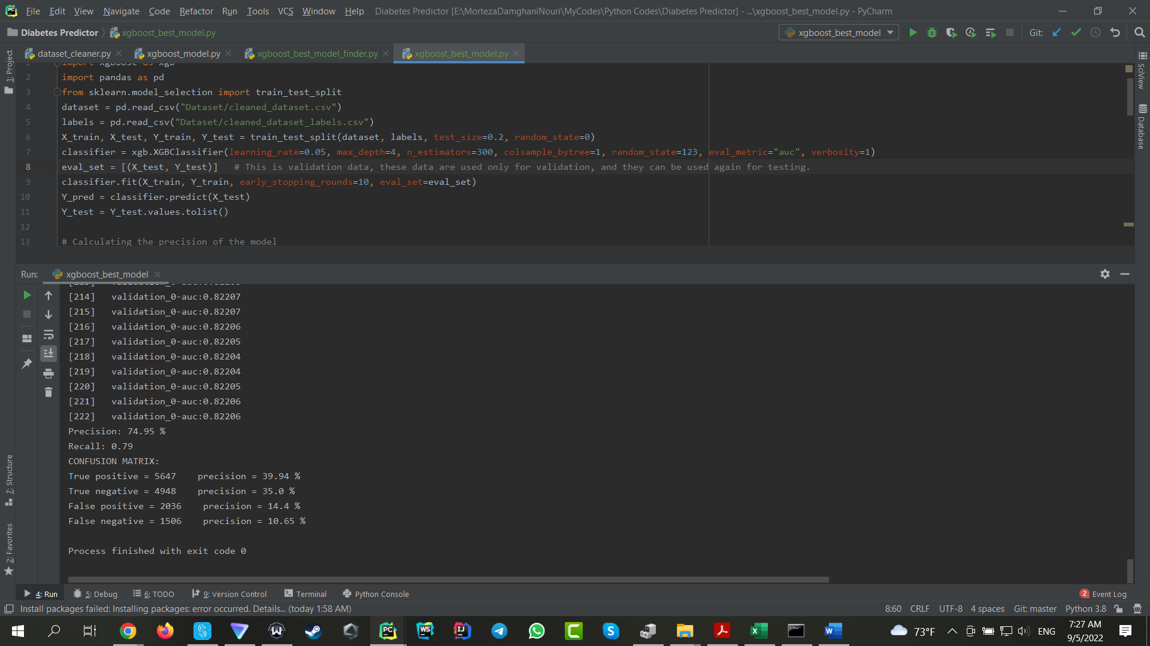

According to the above picture, the best precision is 74.95 %