CAD-IT Developer Test
Excel, XML, XSLT & HTML
Euan Morton

To run application and obtain desired output:
1: Run the command 'node excel_reader.js'. This reads the excel file and outputs the xml.
2: Edit the 'interactivity.js' file and edit lines 25 and 26 to point to the local files of the XML and XSL.
3: In the directory of your chrome install run 'chrome.exe –allow-file-access-from-files'
https://stackoverflow.com/questions/4819060/allow-google-chrome-to-use-xmlhttprequest-to-load-a-url-from-a-local-file/18137280#18137280
This is to avoid having a CORS error.
3: Open dist/index.html

Expected output:
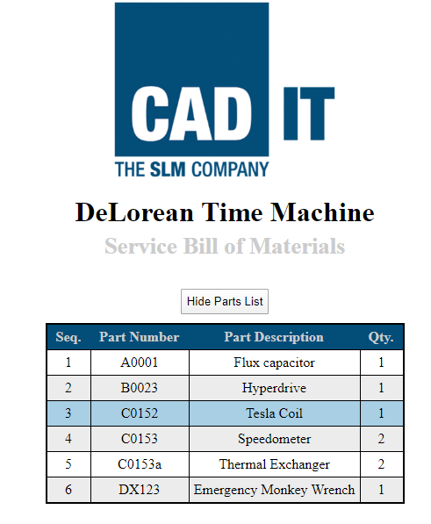

Requirements for application to work:
Instructions given for application are taylored for a windows platform using chrome as the browser.

Improvements to be made to application:
Due to time constraints and inexperience with XSLT, many improvements could be made to the application.
For starters 'excel_reader.js' lacks versitility. It would be unable to output good (if any) XML if the input excel file was formatted differently. This could be rectified by adding some ability for user input apon running. Application could ask for user to input an excel file as well as per each sheet of the excel file get the user to specify the direction of the headers (x or y axis). This would let the application know how to format the XML.
Although the application parses data to XML it is not properly formatted for XMLHttpRequest to read as XML. This requires “<?xml version="1.0" encoding="ISO-8859-1"?>” at the top of the file.
The XSLT file could do with more dynamic styling. Most of the css has been hard coded in the css file.
The creation of HTML from the XSLT file was made using code from https://www.w3schools.com/xml/xsl_client.asp. This could also be improved to have this done programatically in the application as using local files as URL strings for XMLHttpRequest is not ideal.

