AgentGS: Empowering Earth Science Agents with Plan Composition and Completion over Skill Hypergraphs

Abstract
Complex geoscientific tasks often require multiple tools to work together and exchange intermediate results across computational steps. Existing methods commonly plan around specific tools, tying workflows to particular implementations, whereas reusing entire strategies makes it difficult to combine local steps from different strategies according to task requirements. We present AgentGS, a method for capability composition and tool orchestration over skill hypergraphs. AgentGS uses a three-layer Skill–Capability–Tool representation to decouple task strategies, reusable operations, and concrete tools, allowing it to organize an operational workflow before selecting its implementations. The skill hypergraph connects strategies through shared capabilities and provides a structured basis for composition across strategies. Given selected strategies, the system expands their required operations and prerequisite steps. When the current operation chain lacks necessary intermediate steps, it searches for feasible connecting branches along dependencies declared by other strategies. By jointly checking step dependencies, data compatibility, and tool availability, the system incorporates branches that satisfy the constraints without ambiguity, thereby reusing local steps from other strategies. It then selects concrete tools, propagates task data and intermediate results, and locally recovers failed steps. AgentGS can also organize newly composed capability workflows into candidate Skills for subsequent registration and reuse. On GeoToolEval, which contains 603 evaluation records across ten geoscientific domains, AgentGS achieves a mean Final Answer Score (FAS) of 0.8731. Ablation experiments show that hierarchical planning and missing-capability completion both improve task performance, with prerequisite expansion, capability completion, and execution recovery being particularly helpful for multistep tasks.
Keywords: LLM Agents, Compositional Planning, Tool Orchestration, Skill Hypergraph, Scientific Agent

1 Introduction
From climate change and critical minerals to energy resources and disaster risk, Earth science seeks to derive testable scientific conclusions from observational data. These research frontiers are data intensive, computationally demanding, and interdisciplinary. Geoscientific research is shifting from traditional empirical inference and mechanistic simulation toward predictive systems science driven jointly by big data and artificial intelligence [19]. In this emerging paradigm, research capability depends not only on the scale of data and models, but also on the ability to organize distributed data, tools, and methods into reproducible, traceable analytical workflows.
Traditional geoscientific analysis relies heavily on researchers manually connecting data-processing stages. Data are distributed across databases, publications, and repositories, while differences in reporting standards impede comparison and integration [19]. Researchers typically locate data, align them spatially or temporally, derive variables, perform statistical modeling, and verify the results. Resource and disaster analyses may additionally combine data retrieval, spatial processing, and interdisciplinary models. This process is time consuming, labor intensive, difficult to scale, and difficult to reproduce. Scientific agents built around large language models (LLMs) offer an opportunity to automate these workflows: they translate natural-language tasks into multistep execution plans, coordinate multiple tools, and have shown considerable promise in scientific analysis [5, 4]. Geoscientific workflows, however, have a defining feature that distinguishes them from ordinary question answering: later operations depend on artifacts produced by earlier steps. Model memory or a single tool call is insufficient to complete the entire processing chain. The value of scientific agents for geoscientific research therefore depends on their ability to reliably orchestrate multistep tool chains and produce conclusions grounded in execution.
Existing geoscientific agents have begun to support multistep tool execution using established frameworks such as ReAct [16]. For example, GeoAgent [1] and Earth-Agent [5] use planning–execution–reflection architectures to process Earth science data through multiple calls. These studies establish the feasibility of multistep tool use, but important limitations remain when such agents are expected to orchestrate complete analytical workflows. In complex workflows, their basic execution units are typically individual calls, individual tools, or entire Skills. Planning directly around tool names couples the plan to changes in tool interfaces. Reusing an entire Skill, in turn, restricts reuse to predefined workflows and prevents task-specific extraction and recombination of local operations from different strategies. Operation-level reuse and preservation of usage constraints remain unresolved in geoscientific settings. An open question is how to select and combine the capabilities required for a task at a finer operational granularity, preserve their prerequisites and usage constraints, and match them to suitable concrete tools.
A second challenge is the need for a benchmark that can assess tool orchestration by geoscientific agents. Evaluation has evolved from testing knowledge to examining execution processes. Early work centered on knowledge questions and multiround scientific conversations. EarthSE, for example, evaluates geoscientific reasoning through question answering and exploratory dialogue [15], but does not require actual tool execution and therefore cannot assess the analytical process itself. More recently, GeoBenchX [6], Earth-Bench [5], and GeoAgentBench [17] explicitly examine multistep tool use and execution; the latter two also evaluate processes and final outcomes. A critical gap nevertheless remains: no existing benchmark comprehensively covers geoscientific research themes while jointly assessing composition and orchestration across tools within geoscientific tasks. Consequently, current evaluations cannot adequately distinguish answering a geoscientific question from completing its analytical workflow within the same task, or attribute orchestration failures to specific stages. This limits the diagnostic evidence available for methodological improvement.
To address these two challenges, we introduce AgentGS, a tool-orchestration method based on hierarchical capability composition, and GeoToolEval, a benchmark for geoscientific tool-workflow orchestration. AgentGS provides a method for acquiring orchestration capabilities, while GeoToolEval provides an evaluation setting for complete geoscientific tool chains. Our main contributions are as follows:
- We propose AgentGS, a geoscientific tool-orchestration agent based on a Skill–Capability–Tool hierarchy and hypergraph-based missing-capability completion. It supports operation reuse across strategies, constrained tool selection, and completion of missing capabilities to improve tool use and task completion.
- We construct GeoToolEval, the first benchmark to assess composition and orchestration across tools for ten geoscientific research-frontier themes, comprising 603 evaluation records. Its combination of single-step and multistep tool-use tasks jointly examines tool dependencies, composition across tools, and final answers within the same task, providing diagnostic signals for attributing orchestration failures.
- On all 603 GeoToolEval records, AgentGS achieves a mean Final Answer Score (FAS) of 0.8731 and substantially outperforms the evaluated frontier geoscientific language models and agents. Analyses of multistep tasks show that the proposed strategies supply necessary operations and improve task completion and answer accuracy for complex workflows.

2 Related Work

2.1 Task Planning and Tool-Dependency Representations for Geoscientific Agents
For agent task planning, ReAct established a reasoning–action–observation loop as a foundational paradigm [16]. ToolPlanner methods support task execution over large tool collections through functional grouping [14, 10], while LLM+P and Generalised BDI Planning introduce explicit planning solvers and goal management [8, 12]. Existing geoscientific agents have adopted these general paradigms: GeoAgent uses a planning–execution–reflection architecture for GIS analysis [1], and Earth-Agent organizes multistep calls to process Earth science data [5]. These systems demonstrate the feasibility of multistep tool use. In complex analytical workflows, however, they still operate primarily at the level of individual calls, individual tools, or entire Skills, without explicitly representing operation reuse and usage constraints.
For tool-dependency representations, SciToolAgent orchestrates scientific tools through a tool knowledge graph [4], while HyperAgent constructs a tool hypergraph from input/output schemas and searches for supporting tools [18]. These approaches establish the effectiveness of tool orchestration in general settings, but have not yet been extended to geoscientific scenarios. AgentGS addresses this gap through structured planning and hypergraph representations. It organizes strategy knowledge with shared Capabilities as nodes and Skills as hyperedges, and links concrete implementations through Capability–Tool mappings. This preserves each capability’s dependencies and usage constraints within different Skills. The system can consequently reuse local operations across strategies, complete plans by retrieving dependency branches, and ground the resulting plans in concrete tool calls, integrating operation-level reuse and constraint preservation within a single representation.

2.2 Evaluation of Geoscientific Agents
Existing evaluations fall into three categories according to what they assess, reflecting a progression from knowledge to execution processes. Geoscientific question-answering benchmarks assess domain knowledge. GeoBench uses examination-style questions to evaluate geoscientific understanding [2]; EarthSE includes professional questions and open-ended scientific dialogue to assess geoscientific exploration [15]. Multistep reasoning in these benchmarks takes place at the language level and does not require actual tool calls. General scientific-agent evaluations concern code execution and data processing rather than domain-specific tool chains. Systems such as SciToolAgent, GeoAgent, and Earth-Agent demonstrate scientific data processing and analysis through tool use [5, 4, 1]. Their evaluations have begun to record execution behavior, but task structures remain predominantly question–answer pairs accompanied by code execution. Multitool orchestration benchmarks explicitly assess multistep tool use. GeoBenchX requires agents to use geospatial tools for multistage tasks and evaluates results against reference solutions [6]. Earth-Bench distinguishes autonomous planning from instruction following and records tool inputs and outputs [5]. GeoAgentBench examines invocation order, parameters, and final map artifacts in a GIS sandbox [17]. GeoNatureAgent Benchmark evaluates multitool analysis and error recovery using real APIs [3]. These benchmarks address multistep invocation and some dependency verification, but remain focused on invocation correctness within individual scenarios.
No existing benchmark jointly evaluates the complete orchestration chain—operation selection, tool dependencies, composition across tools, consumption of intermediate artifacts, and final answers—within individual tasks across multiple geoscientific themes. This prevents failures from being attributed to specific stages and limits actionable diagnostic signals. GeoToolEval offers three advantages: (1) coverage of ten geoscientific research-frontier themes, enabling orchestration to be assessed across scenarios; (2) joint evaluation of agreement with reference invocation sequences, actual use of intermediate artifacts, and final answers within the same task, extending assessment from invocation correctness to process completeness; and (3) explicit assessment of necessary-operation completion, allowing failures caused by missing capabilities to be distinguished from execution errors. A detailed comparison with existing benchmarks is provided in Supplementary Material I, [TODO: comparison material not supplied in the source].

3 Hierarchical Representation for Task Composition
The planner takes a natural-language goal $q$, task resources $X$, and registered sets $S$, $C$, and $T$, corresponding to Skills, Capabilities, and Tools. Planning first constructs a task plan containing capability instances and their dependencies, then selects an available tool and binds invocation parameters for each instance. Reusing an operation requires preserving its dependencies and applicability conditions; selecting an alternative tool requires ensuring that it implements the same operation. We connect strategies and implementations through shared capability identifiers, while retaining each instance’s Skill provenance, input roles, and candidate-tool scope. Figure 1 shows the relationship among hierarchical representation, capability completion, and tool execution.

3.1 Shared Operations and Strategy Context
A Skill is a reusable task strategy. Each Skill describes its task objective, applicable inputs, expected artifacts, and required capability steps, together with constraints, validation requirements, and recovery policies. Each step references a Capability identifier and specifies its required predecessors, whether it is mandatory or optional, and its candidate-tool scope. A Skill therefore describes a capability workflow containing mandatory and optional steps, from which operations and tool implementations can be selected according to task requirements. Generating a new Skill in this work means organizing a composed capability workflow into a new strategy description. The new content primarily consists of combinations of existing capabilities and their dependencies; it does not create new Capability definitions or Tool implementations.
A Capability defines an operation shared across strategies. Each Capability specifies its function, input/output types, preconditions, postconditions, and candidate tools in a common form. Multiple Skills can reference it, and different Tools can implement it. Mappings between Capabilities and Tools record the concrete operation and parameter constraints, distinguishing implementations with similar functions. A single Tool may also implement multiple capabilities, such as returning both an extreme value and its index. For example, deep-time geoscience and carbon-storage strategies may both reference a raster-analysis capability while restricting it to different candidate-tool sets. Sharing a capability does not imply unrestricted substitution of tools across strategies.
A Tool is a callable interface implementing an operation. Its registration includes a tool identifier, parameter schema, input/output definitions, and runtime information. Files, numerical values, and upstream artifacts required by an invocation are bound during execution. Both Skill–Capability membership and Capability–Tool implementation relationships are many-to-many. The former records the capability composition of a strategy; the latter supports tool selection after a capability plan has been formed. Whether a tool is selected and executable still depends on task requirements, instance constraints, and runtime conditions.
This separation allows the system to establish operations and dependencies before choosing concrete implementations. The same Capability can be reused by different Skills, but each instance retains the source Skill’s prerequisites and specifies its input objects and candidate-tool scope. A task-specific capability plan is represented as
$$P=\left(V,D_{d},D_{c},β\right), v_{i}=\left(c_{i},s_{i},r_{i}\right).$$
(1)
Here, $V$ is the set of capability instances, $c_{i}$ identifies the capability, $s_{i}$ records its strategy provenance, and $r_{i}$ identifies the step and its input role. $D_{d}$ and $D_{c}$ record data and control dependencies, respectively, and $β$ binds resources or upstream artifacts. Operations on different input objects are represented by distinct capability instances, even when they use the same tool; functional equivalence alone does not justify merging them. The current implementation does not yet fully support dynamically creating repeated capability instances for multiple objects.

3.2 Skill Hypergraphs and Dependencies with Provenance
The skill hypergraph is constructed from registered Skill workflows. Capabilities are its nodes, and the set of capabilities contained in each Skill forms a hyperedge:
$$H=\left(C,E\right), E=\{e_{s}:s∈S\}, e_{s}⊆C.$$
(2)
For example, Skill $S_{1}$ contains $\{a,b\}$ and Skill $S_{2}$ contains $\{b,c\}$. Both reference the shared node $b$, avoiding duplicate definitions and providing a connection for composition across Skills. Membership hyperedges describe Skill–Capability membership. Execution direction is specified separately by a provenance-bearing relation $d=\left(s,U,c\right)$: in Skill $s$, capability $c$ requires all predecessors in $U$, rather than any one of them. The plan retains the source Skill of each dependency, preventing capability sharing from automatically importing prerequisites from other Skills. Conditional ordering applies only when both steps are selected and does not introduce additional prerequisites.
Composition constructs a plan from selected capabilities and their prerequisites. Completion retrieves connecting branches from other Skills and incorporates those that pass constraint checks. Explicit Skill-compatibility relations limit the search scope for compatibility-based completion. Directed bridging searches inactive Skills for directed branches connecting endpoints in the current plan; its search conditions are given in Section 4. Membership describes capability composition, compatibility limits completion scope, and dependencies specify execution prerequisites. The ordering of members within a hyperedge is not an execution constraint.
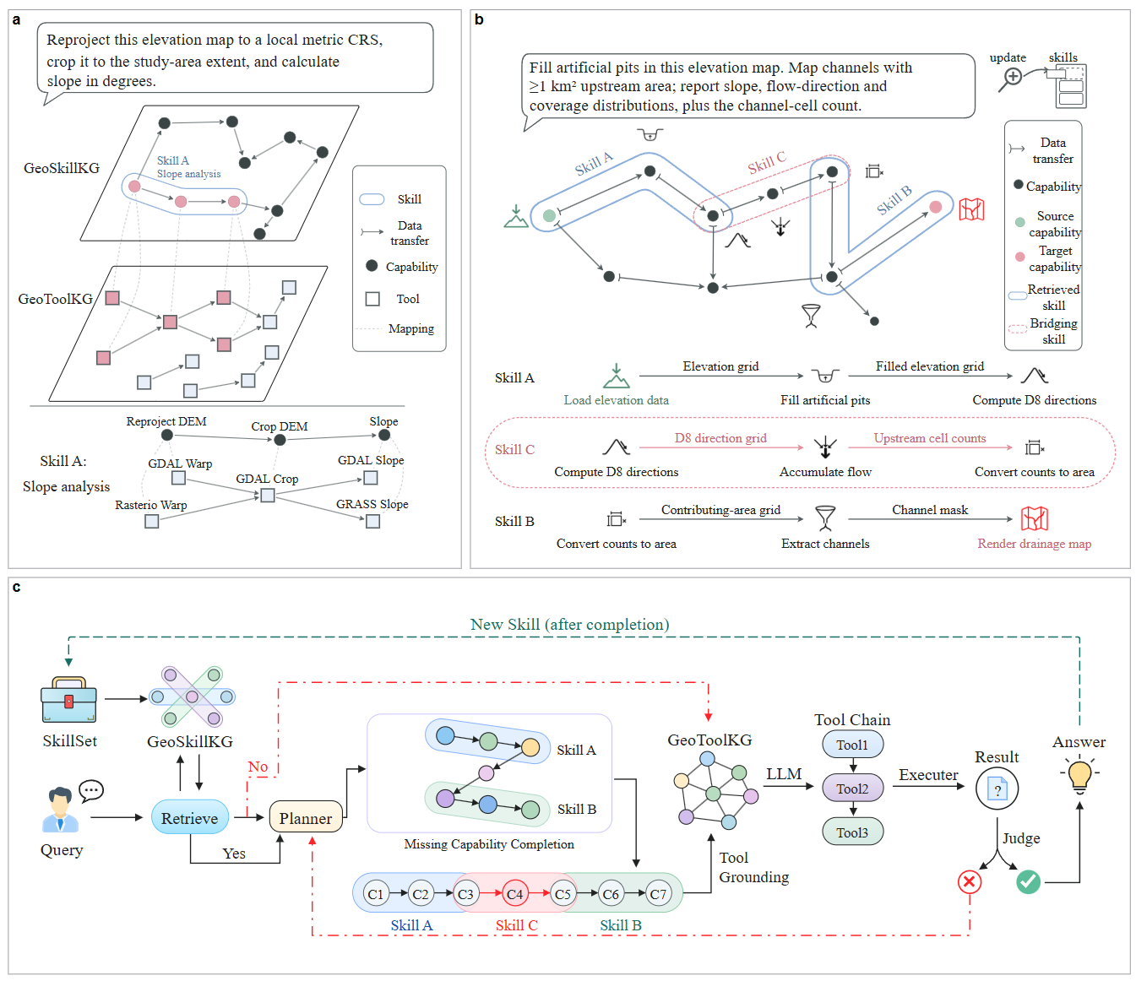
Figure 1. The hierarchical representation supplies shared operations, dependencies with provenance, and implementation scopes. Hypergraph completion refines the capability plan, and tool mappings ground it in concrete invocations.

3.3 From Capability Plans to Constrained Implementations
GeoToolKG describes tool associations. It records each tool’s domain, function, inputs, outputs, and provenance, along with recommended invocation transitions, including recommended successors and their corresponding predecessor relationships. These associations support tool retrieval and composition. Forming an executable workflow additionally requires checking parameters, artifact compatibility, prerequisites, and scientific applicability.
ToolGraph maps capabilities to implementations. It records bidirectional relationships between Capabilities and candidate Tools, with the concrete operation and parameter constraints stored on each mapping. ToolGraph describes Capability–Tool implementation relationships, whereas Tool–Tool relations in GeoToolKG describe recommended transitions. The system first constructs and completes a capability plan. It then filters the mapped tools for availability and membership in each instance’s candidate scope, and evaluates them using parameter schemas and declared semantic input/output types. Concrete artifacts are bound and validated during execution. Execution dependencies are jointly determined by explicit Skill declarations and capability-completion results.
The hierarchy connects task requirements, operation dependencies, and candidate tools, providing the basis for capability composition and missing-capability completion.

4 Hypergraph Completion and Plan Grounding
Building on the capabilities and dependencies supplied by the hierarchy, the completion algorithm identifies missing operations in the current plan and searches for additional branches that satisfy the constraints. The system first determines required capabilities and expands their mandatory dependencies, then fills missing operations, and finally chooses concrete tool implementations. All stages communicate through the capability plan $P$, preserving the strategy provenance of both instances and dependencies.

4.1 Initial Selection and Scoped Composition
Initial capability planning consists of strategy retrieval and capability selection. The system retrieves relevant Skills using the task description, domain, and input types. It selects strategies according to applicability and requirement coverage, and selects the capabilities needed for the task without automatically including every optional step. An LLM may assist selection within the candidate Skills; invalid outputs trigger a fallback to rules. The selected capabilities provide the starting point for dependency expansion and missing-capability completion.
Hypergraph Composition organizes the initially selected capabilities and their mandatory predecessors into $P$, using dependencies declared by the selected Skills. It retains each instance’s strategy provenance, candidate-tool scope, and input references. Missing Capability Completion then checks whether the plan omits required operations and whether existing operations have the necessary inputs and available implementations. On detecting a gap, the system searches for supporting capabilities, adds them to the plan, and checks again for satisfied prerequisites and conflicts with existing dependencies.
The search scope depends on the gap. When a required operation is missing, the system searches activated Skills and Skills directly compatible with them. When an existing operation has an unsatisfied input dependency, it may search multiple hops along explicitly declared Skill-compatibility relations. Directed bridging offers another route: it searches inactive Skills for branches connecting endpoints in the current plan, as described next.

4.2 Directed Bridging with a Fixed Active Boundary
Suppose the current plan selects Skills $A$ and $B$, but lacks a connecting operation. If an inactive Skill $C$ contains a path $u→m→v$, where $u$ and $v$ are selected capabilities of $A$ and $B$, the system considers this path as a candidate and inserts only the required intermediate capability $m$.
Directed bridging retrieves reusable connecting branches from inactive Skills to complete the current capability plan. Let $u$ in activated Skill $A$ lie on the output boundary of its current local workflow, and let $v$ in activated Skill $B$ lie on the input boundary: $u$ has no successor among $A$’s activated dependencies, and $v$ has no predecessor among $B$’s activated dependencies. If inactive Skill $C$ declares a directed path $u→m→v$, the system treats it as a candidate bridge and considers inserting $m$ without importing $C$’s entire workflow.
The search uses the active capability set at its start as a fixed reference. Each candidate path must come from one inactive Skill and contain at least one inactive intermediate capability. Membership relations first identify Skills containing both endpoints. The algorithm then enumerates directed simple paths along their explicit dependencies or applicable conditional-ordering relations. Capability co-occurrence and list order do not establish direction. A candidate is excluded if the current plan already contains an indirect data path from $u$ to $v$; a direct connection alone does not exclude it. The remaining candidates must pass joint-prerequisite, type-compatibility, tool-availability, cycle, and ambiguity checks before insertion is attempted. Newly inserted capabilities are not used to recursively extend this round of bridge search.
A candidate branch must satisfy the following checks before the system attempts to add it:
- Explicit execution direction. The order of each pair of adjacent capabilities must be supported by an explicit dependency or an applicable conditional-ordering relation.
- Complete prerequisites. All predecessors required by each operation must already belong to the fixed active capability set at search start or to the candidate branch.
- Compatible input/output types. After excluding generic labels such as Any and Parameter, each connection must share at least one concrete type between the upstream outputs and downstream inputs.
- Available implementations. Operations in the branch and their required predecessors must have available tools within their permitted scopes. The entry and active predecessors outside the branch retain their original candidate scopes; other nodes within the branch are checked against the Skill providing it.
- Acyclic dependencies. Adding a branch must not introduce a cycle, and the joint insertion of multiple candidate branches must also preserve acyclicity.
For an ordered endpoint pair, automatic insertion is allowed only when exactly one valid candidate branch exists. Multiple candidates trigger an ambiguity report and stop automatic completion for that pair. On insertion, the system preserves the entry instance’s original dependencies and candidate tools, and updates the exit instance’s dependencies, tool scope, and input bindings according to the branch. It then recomposes the plan. A branch is rejected if recomposition introduces a new capability outside the branch or leaves a mandatory dependency unsatisfied. Algorithm 1 summarizes this procedure. Figure 2 illustrates typical accepted and rejected cases ([TODO: figure not supplied in the source]).
$$\boxed{\text{TODO: bridge eligibility conditions}}$$
(3)
Algorithm 1. Directed Bridging from a Single Provider
Input: Plan $P$ after compatibility completion; registered knowledge; available tools
Output: Updated $P$ and acceptance/rejection records
- return if bridging is disabled, execution recovery is active, or this plan has already been searched
- Fix the active capability set and mark the plan as searched
- Enumerate active boundary endpoint pairs from different Skills; skip pairs with an existing indirect data path
- Search inactive Skills for connecting branches satisfying Equation 3 and path-validity conditions
- Deduplicate by provider and path; reject ambiguous candidates within a pair; check joint acyclicity
- Attempt each insertion: retain entry constraints and update exit dependencies, tool scope, and input bindings
- Recompose; reject insertions introducing capabilities outside the branch or leaving mandatory dependencies unsatisfied
[TODO: directed-bridging diagram] Figure 2. Directed-bridging acceptance and rejection cases. Placeholder for the missing figure in the initial manuscript.

4.3 Tool Selection and Plan Execution
Tool Grounding and Tool Execution. Tool Grounding filters candidates according to capability requirements, instance provenance, and retry constraints. An LLM may assist selection within the candidate scope when needed. Tool Execution preferentially uses rules to bind task resources, parameter values, and upstream artifacts to tool inputs, with LLM assistance when necessary. Upstream artifacts must originate from successful preceding steps and have matching types; binding failure blocks the current invocation. The final answer is generated from structured execution results, with an LLM organizing its wording when required.
Failure Recovery. After a tool failure, the system locally recovers the current capability instance while retaining successful preceding steps to avoid repeated execution. By default, it permits at most three attempts per tool and one local tool substitution. A substitute must implement the same capability, belong to the instance’s permitted candidate scope, and pass fresh checks for parameter and upstream-artifact compatibility. The system does not automatically replay calls with uncertain outcomes, partial execution, or outputs violating the schema. Recovery is confined to the existing capability plan; if continuing requires a new capability, subsequent steps are suspended.

4.4 Packaging Composed Workflows as Reusable Skills
After successful execution and result verification, the system organizes the capability workflow into a candidate Skill. It records the task objective, applicable inputs, expected artifacts, capability steps, and dependencies, and preserves each step’s candidate-tool scope and necessary constraints. Concrete file paths, reference values, and intermediate-artifact references are converted into input roles that can be rebound, allowing the strategy to operate on new task resources.
Candidate Skills are organized around capability instances and their dependencies. When the same Capability acts on different input objects, those operations remain distinct steps. Operations taken from different original Skills retain their provenance and usage constraints. Forming a candidate Skill does not automatically relax these constraints or make composed capabilities arbitrarily interchangeable.
Once registered, a candidate Skill can participate in subsequent strategy retrieval and capability planning. Reuse still requires checking applicability to the new task, selecting required steps, binding resources, and determining concrete tools. Successful execution provides evidence for one instance of the workflow, but does not establish applicability to other inputs or tasks. The effectiveness of reuse across tasks requires further validation.

5 System Architecture and Implementation
AgentGS integrates the planning and capability-completion method into an agent system with an interactive interface. It supports natural-language task input, plan construction, tool execution, and result feedback. The system organizes tool calls using task inputs and strategy knowledge, and exposes planning information, invocation records, and execution feedback for inspection and verification.

5.1 Overall Architecture
AgentGS comprises four connected components for user interaction, task orchestration, knowledge and capability support, and tool execution. Users submit natural-language questions and inspect results through the frontend. The orchestration service retrieves applicable Skills, organizes and completes required capabilities, and determines concrete tools. Knowledge and capability resources provide strategy definitions, capability-to-implementation mappings, and tool associations. The tool execution service invokes geoscientific tools through a unified interface.
These components cooperate by exchanging plans, parameters, and results. The orchestration service organizes capabilities and dependencies according to task requirements, then matches each operation to a tool satisfying its instance constraints. The execution service calls the corresponding interface by tool identifier, passes parameters and resources, and returns results or failure information. Execution feedback identifies the current step’s state and supports the decision to initiate local recovery. By organizing planning and execution separately and invoking tools through unified interfaces, the system grounds capability plans in concrete operations.
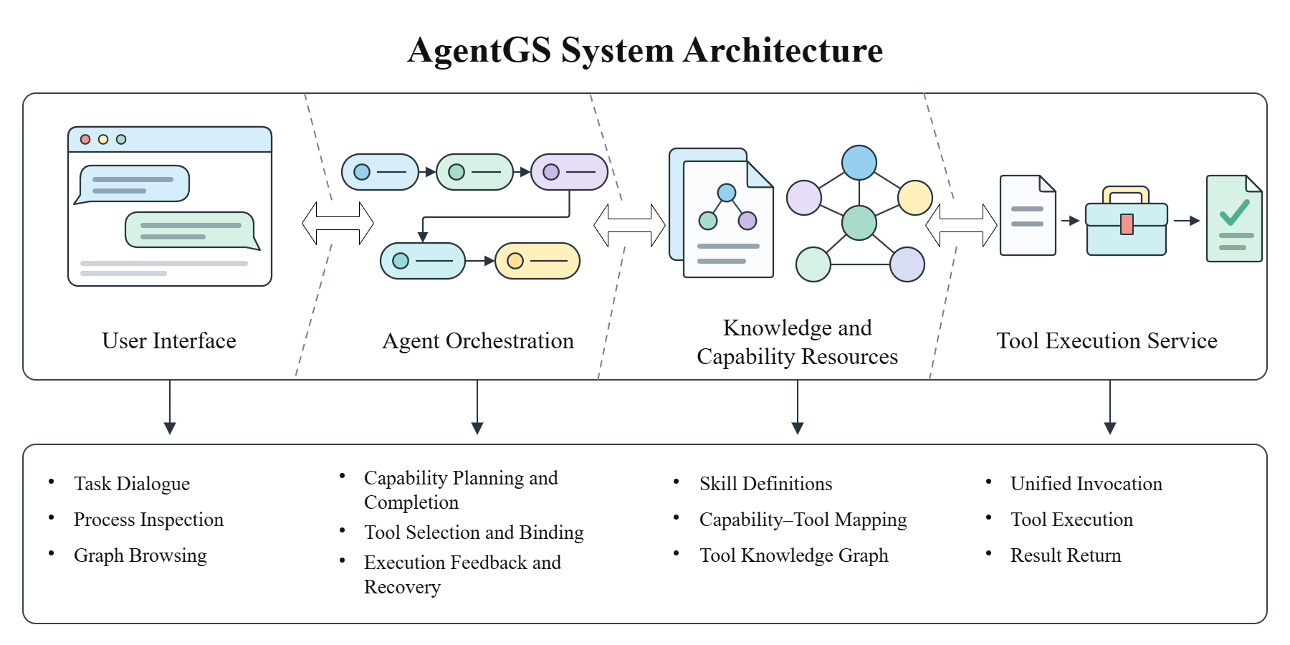
Figure 3. AgentGS architecture and main functions. The system comprises an interactive frontend, an agent orchestration service, knowledge and capability resources, and a tool execution service.

5.2 Tool Integration and Execution Management
The system separately maintains operation definitions within strategies, capability-to-tool relationships, and invocation interfaces. Integrating a tool involves registering its interface information and associating it with capabilities: the system records its function, parameters, inputs, and outputs, and maps it to corresponding Capabilities. The containing Skill constrains an operation’s prerequisites and eligible tools. Tool selection therefore considers functional matching, instance constraints, and input compatibility, ensuring that the selected tool can perform the desired operation and can be invoked at the current step.
Intermediate artifacts retain type and provenance information, including the generating tool, the corresponding step, and relevant metadata. Subsequent steps retrieve files or computed results by artifact reference and bind them to tool parameters, avoiding reliance solely on natural-language descriptions for data transfer. A tool requiring a raster file receives the corresponding file reference; a tool requiring a statistic of that raster receives the appropriate numerical value. Inputs thus match the parameter requirements.
The system stores task-planning information and tool invocation records, and reports execution states from invocation results. Recovery reuses successful preceding results and handles the failed call according to retry rules and capability-instance constraints. Users can revisit saved questions, final answers, and execution traces. These traces support checking tool choices against task requirements, following parameter propagation, and locating failures.

5.3 Interactive Interface and Process Inspection
The frontend supports task dialogue, tool-graph browsing, and configuration management. In the task-dialogue interface, users submit natural-language geoscientific questions, receive answers, and expand records to inspect planning and invocation processes. Execution feedback shows each tool call’s state, attempt count, and explanations, allowing users to identify failures or retries. The history view provides access to earlier questions, answers, and associated execution records.
The graph interface visualizes GeoToolKG tools as nodes and their recommended transitions as edges. Selecting a tool displays its function, input/output information, provenance, and recommended successors, helping users understand its operations and possible combinations. The graph shows possible transitions between tools. For a concrete task, the system follows the capability plan and checks whether each step satisfies its instance constraints and execution conditions.
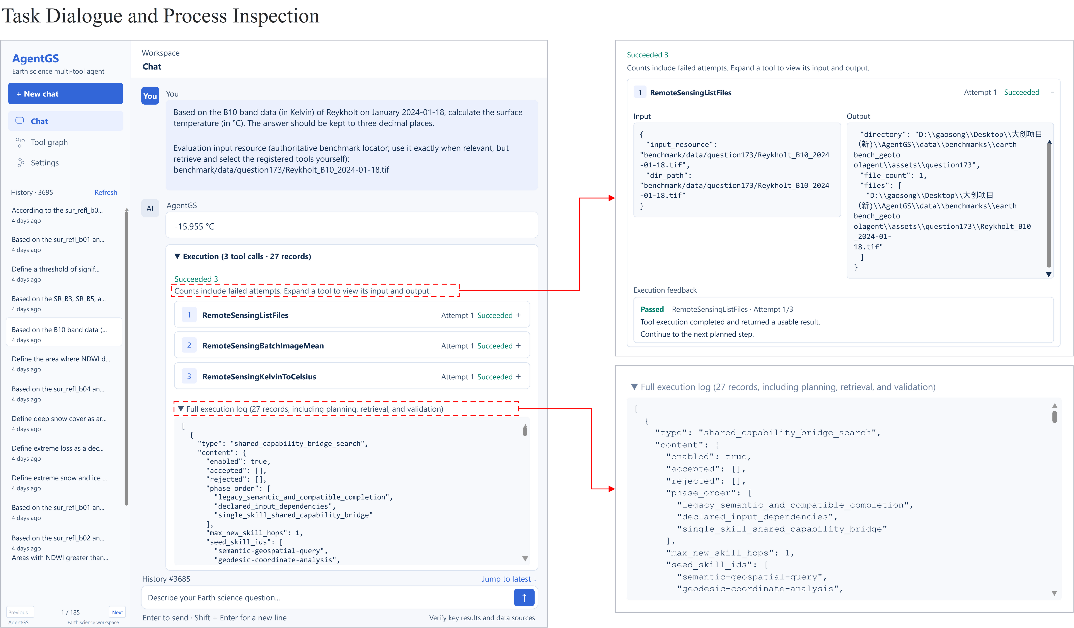
Figure 4. Task dialogue and process inspection in AgentGS. The left panel shows the task, answer, and execution records. The upper right shows one tool call’s input/output and execution feedback; the lower right shows part of the complete execution log.

6 GeoToolEval: Design and Construction
We construct GeoToolEval to evaluate tool use and multistep workflow orchestration in geoscientific tasks. Each evaluation record combines a natural-language question, input resources, reference tool invocations, and a reference answer. The benchmark integrates existing geoscientific question-answering resources and computational and analytical tasks derived from scientific data, supporting final-answer evaluation and execution-process analysis.

6.1 Evaluation Objectives and Design Principles
GeoToolEval examines whether agents select applicable operations, satisfy interstep dependencies, and use input data to produce verifiable results. Single-step tasks assess data location, parameter determination, and basic tool use. Multistep tasks examine the organization of multiple operations, transitions between steps, and use of intermediate results. Both categories are included to distinguish basic invocation performance from performance under workflow-orchestration requirements.
Task themes follow the ten geoscientific research directions discussed in the introduction, with concrete tasks determined by available data resources and executable operations. The number retained in each theme depends on available resources and screening outcomes. Domain groupings describe task backgrounds, whereas reference-chain length describes workflow composition under the current tool interfaces. These groupings support analyses by domain and invocation-chain length, respectively.

6.2 Data Sources and Task Construction
GeoToolEval is constructed in two ways: selecting tasks from existing question-answer records, and designing questions with reference answers computed from scientific data. For existing resources, the geoscientific big-data analysis theme contains 40 tasks selected from GeoQuestions1089 that concern physical geographic objects and spatial-analysis operations. The remote-sensing theme contains 49 tasks selected from Earth-Bench’s 248 tasks, retaining the original questions, choices, and reference answers while adapting the tool calls to our interfaces. Critical-mineral and climate-change tasks are selected by theme from existing habitable_earth_dataset question files. Their underlying data include USGS MRDS, paleoclimate reconstructions, NASA GISTEMP, and SSP warming summary tables.
Data-derived tasks are designed around clearly identifiable objects, variables, and computational relationships, with reference results determined through the corresponding processing and calculations. Three-dimensional Earth-structure tasks use LITHO1.0, SEMUCB-WM1, and the USGS earthquake catalog. Energy-resource tasks use mineral, power-facility, installed-capacity time-series, and population data. Tasks concerning the ocean carbon cycle use SOCAT, GLODAP, and SNAPO-CO$​_{2}$ observations. Data for the deep-time biosphere, carbon capture and storage, and natural-disaster statistics come from BioDeepTime, synthetic SCCS-OFPOSDU data, and local disaster-event tables, respectively. Table 1 identifies EM-DAT as the source of the disaster-event records.
Tasks from different sources use a common record format containing the question, input resources, reference answer, answer type, and reference tool calls. Questions specify the required analysis and returned content; input resources identify the data or objects; reference answers support outcome evaluation. Reference calls are defined from the source task’s operational requirements, map operations to registered tools, and record tool names, parameters, and relevant input/output information. Tasks taken from existing benchmarks retain source question identifiers or resource locators. Data-derived tasks retain data-location fields, derivation records, and computational scripts to document how reference results were obtained.
A reference chain represents one way to complete a task through the current interfaces. Different tool wrappers can require different numbers of calls for the same task: one tool may encapsulate multiple processing operations in a single invocation. We therefore group tasks by their reference-chain length after adaptation to our interfaces, rather than directly adopting single-tool or multitool labels from source datasets.

6.3 Task Composition and Complexity Strata
GeoToolEval contains 603 evaluation records. Table 1 summarizes their sources and reference-chain lengths. Of these records, 424 require one reference call, 119 require two or three, and 60 require at least four. The 179 multistep records account for 29.68% of the benchmark.
Table 1. GeoToolEval task sources and reference tool-invocation chain lengths. Counts refer to evaluation records.
Task theme | Main data or question sources | 1 step | 2–3 | $≥4$ | Total
Three-dimensional Earth structure | LITHO1.0, SEMUCB-WM1, USGS earthquake catalog | 85 | 15 | 0 | 100
Geoscientific big-data analysis | Selected GeoQuestions1089 subset | 40 | 0 | 0 | 40
Critical minerals | Habitable-Earth questions; MRDS and cross-theme climate data | 44 | 14 | 0 | 58
Climate change | Habitable-Earth questions; paleoclimate, GISTEMP, SSP, and cross-theme mineral data | 31 | 16 | 1 | 48
Energy resources | MRDS, GEM, OPSD, World Bank, and population data | 100 | 0 | 0 | 100
Global ocean carbon cycle | SOCAT, GLODAP, SNAPO-CO$​_{2}$ | 100 | 0 | 0 | 100
Deep-time biosphere | BioDeepTime | 12 | 7 | 5 | 24
Carbon capture and storage | Synthetic SCCS-OFPOSDU CCS–MRV data | 12 | 5 | 7 | 24
Remote sensing | Selected Earth-Bench subset | 0 | 7 | 42 | 49
Natural-disaster event statistics | EM-DAT International Disaster Database | 0 | 55 | 5 | 60
Total |  | 424 | 119 | 60 | 603
A step denotes one reference tool invocation and does not directly measure the number of scientific operations or scientific difficulty. For example, the energy-resource and ocean-carbon themes use task-level wrappers that may perform several internal processing operations in one call. Grouping by chain length therefore describes the number of calls an agent must orchestrate under the current tool packaging. Interpretation must also consider the interfaces and actual execution traces.
The critical-mineral and climate-change themes share nine cross-theme questions, which are included in both themes. Thus, 603 denotes the number of evaluation records in this version, rather than 603 distinct questions.

6.4 Evaluation Metrics and Quality Control
We evaluate outcomes using the Final Answer Score (FAS), which ranges from zero to one and retains partial-credit scores. Scoring depends on answer type: multiple-choice answers are compared after choice normalization; dates and identifiers use corresponding matching rules; scalar numerical answers use numerical tolerances; multiple numerical values and multiple text items are scored by their matches; and structured answers are compared field by field. Empty answers receive zero.
For an evaluation set containing $N$ records, mean FAS is
$$\overline{FAS}=\frac{1}{N}\sum_{i=1}^{N}{{FAS}_{i}}$$
(4)
The main experiment uses $N=603$. Domain and chain-length groups are averaged within their corresponding record sets, with failures retained. This is a task-level micro-average, distinct from a domain-balanced macro-average or the fraction of tasks receiving full credit.
Quality control addresses source traceability, record completeness, consistency of reference invocations, and sample execution checks. Construction materials retain source questions or data locators and verify correspondence among question fields, tool names, and call details. Data-derived tasks provide computational scripts and intermediate results for recalculation, while existing question-answer tasks retain source answers for comparison. Sample executions check whether data reading and tool invocation behave as expected; their validation scope is recorded separately from final-answer evaluation across the full benchmark.
Final-answer scores and execution-process analyses are reported separately. FAS measures agreement between outputs and reference results. Assessing operation selection, input binding, and use of intermediate artifacts additionally requires actual parameters, tool outputs, and execution traces. Reference chains provide a comparison basis; a different but valid invocation order is not automatically treated as incorrect.

7 Experiments
We evaluate AgentGS’s overall performance and the contribution of its components through baseline comparisons and ablations. The experimental analysis also considers generalization to new combinations of existing capabilities and substitution of tools implementing the same capability, together with runtime costs. Finally, execution cases are used to examine performance differences and causes of failure. [TODO: generalization and runtime-cost results mentioned in the initial draft are to be supplied].

7.1 Tasks and Experimental Setup
Data and evaluation scope. The main experiment uses all 603 GeoToolEval records. Ablations use a fixed subset of 57 records. All GeoToolEval experiments evaluate final answers with the FAS defined in Section 6.4, averaged over their respective evaluation sets with failures retained. To analyze workflow complexity, the main experiment additionally groups results by reference-chain length. The ablation subset is described in Section 7.4.
Run configuration. We use GPT-5.6 Terra as the backbone and compute results from the raw records of AgentGS’s first complete run over all 603 records, retaining both partial-credit and failed cases.
Baselines. We compare scientific agents and language models. Agent baselines include GeoAgent [1] and Earth-Agent [5]. Both use GPT-5.6 Terra, as does AgentGS, to compare different agent systems with the same backbone. Language-model baselines include DeepSeek V4 Pro, GPT-5.6 Terra, GPT-5.4, Qwen-Plus, and GeoGPT. These compare direct language-model answers with answers obtained by agents using tools.

7.2 Main Results and Baseline Comparison
Table 2 reports mean FAS for AgentGS and the baselines. AgentGS achieves 0.8731, exceeding GeoAgent’s 0.7804. It also outperforms the same GPT-5.6 Terra backbone answering directly, which scores 0.3137, and the other language-model baselines. We next analyze task strata and ablations to examine performance across tasks and the contributions of capability composition, hypergraph completion, and execution mechanisms.
Table 2. AgentGS and baseline performance on GeoToolEval. Mean FAS is computed over all 603 evaluation records.
Method | Mean FAS
AgentGS (GPT-5.6 Terra) | 0.8731
GeoAgent (GPT-5.6 Terra) | 0.7804
Earth-Agent (GPT-5.6 Terra) | 0.0862
DeepSeek V4 Pro | 0.5162
GPT-5.6 Terra | 0.3137
GPT-5.4 | 0.3069
Qwen-Plus | 0.2918
GeoGPT | 0.2500
Task complexity and domain differences. Grouped by reference-chain length, AgentGS achieves mean FAS values of 0.9425 for single-step tasks, 0.7557 for two- to three-step tasks, and 0.6167 for tasks with at least four steps. Figure 5 reports results by domain. Longer chains are concentrated in remote sensing, creating overlap between chain-length and domain factors. Performance differences should therefore be interpreted using both groupings.
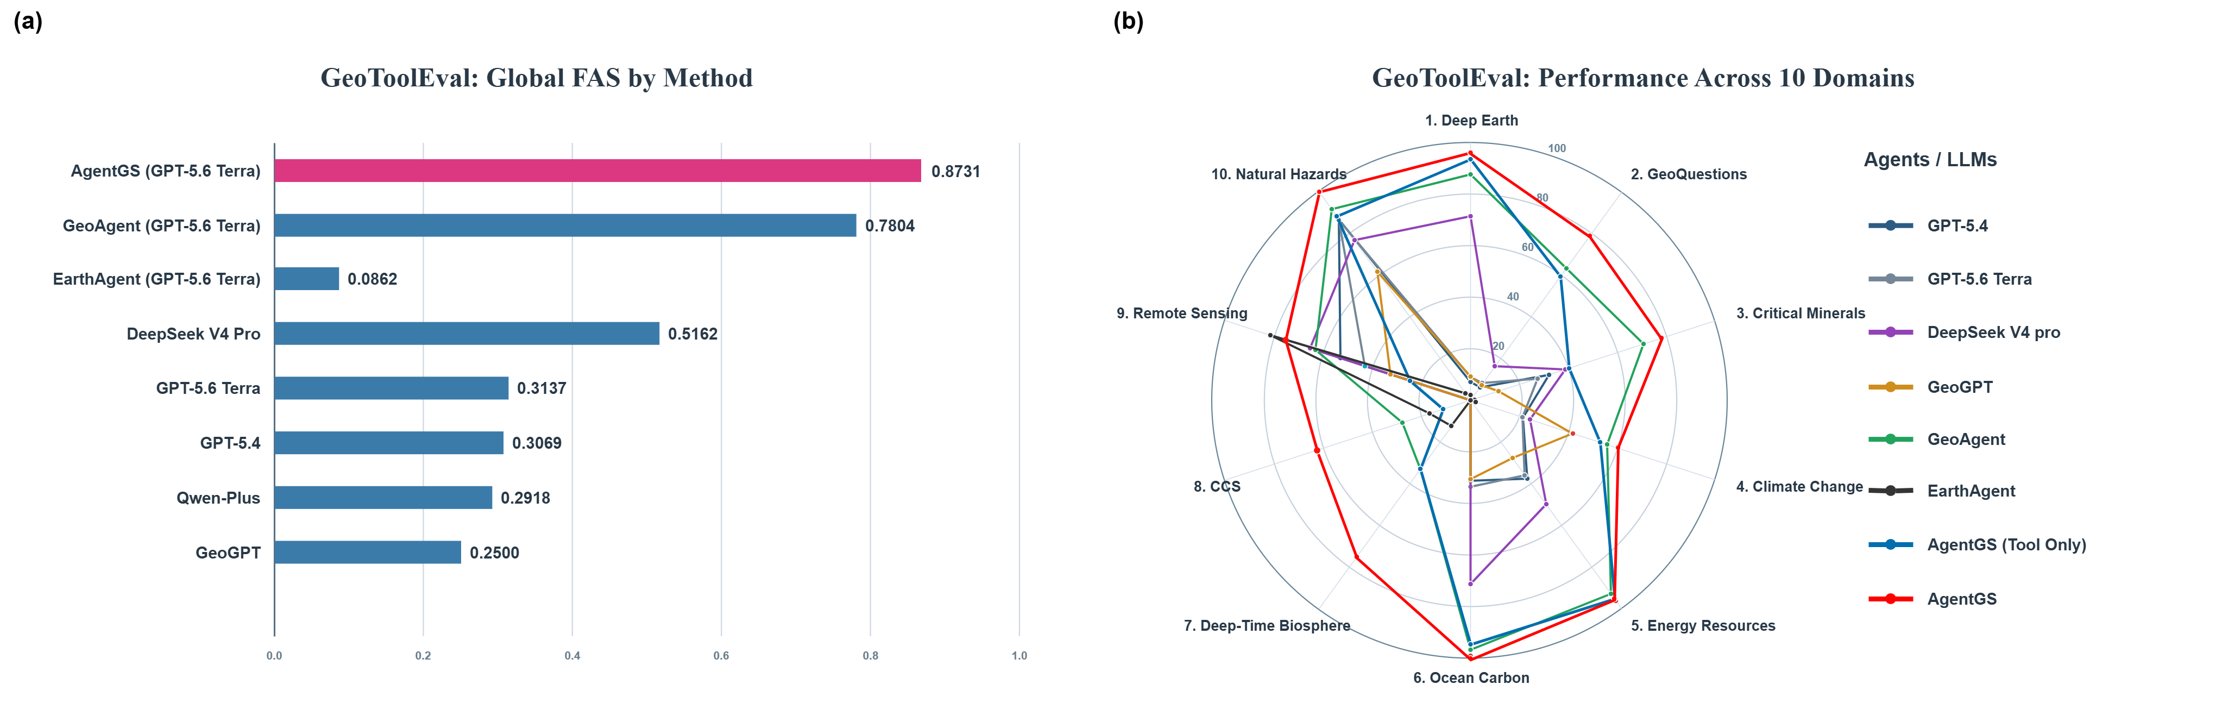
Figure 5. Overall and domain-specific performance of AgentGS and baselines on GeoToolEval: (a) mean FAS across all evaluation records; (b) mean FAS across the ten geoscientific domains.

7.3 External Evaluation on GeoBenchX
To assess applicability in a different tool environment, we conduct an external evaluation on GeoBenchX [6]. We integrate its official tool set and separately construct corresponding Skills and Capabilities. Capabilities are defined from tool functions and input/output requirements, strategy dependencies are organized, and tool mappings are established. AgentGS then performs task planning and tool orchestration.
The experiment uses [TODO: number of tasks] tasks and compares against [TODO: baseline method]. AgentGS and the baseline use [TODO: AgentGS backbone and version] and [TODO: baseline backbone and version], respectively, under [TODO: experimental conditions actually held constant]. Evaluation is performed by [TODO: judge model and score aggregation] using GeoBenchX’s reference-solution matching criterion: scores of 0, 1, and 2 indicate a mismatch, a partial match, and a match, respectively. We report mean score and full-match rate. These metrics are computed separately from GeoToolEval FAS.
As shown in Table 3, AgentGS’s mean score is [TODO: value], versus [TODO: value] for the baseline, a difference of [TODO: difference] points. Their full-match rates are [TODO: percentage] and [TODO: percentage], a difference of [TODO: difference] percentage points. [TODO: principal comparative conclusion supported by the actual results]. These results provide evidence of AgentGS’s performance in an external benchmark after integrating its official tools and constructing dedicated Skills and Capabilities.
Table 3. AgentGS and baseline results on GeoBenchX. TBD entries are reserved for the completed evaluation data.
Method | Mean score | Full-match
 | $(0$–$2)↑$ | rate $\left(\%\right)↑$
Baseline (TBD) | TBD | TBD
AgentGS | TBD | TBD

7.4 Ablation Experiments
Ablations use 57 GeoToolEval records covering all ten geoscientific domains. There are 22 single-step records, 20 with two or three steps, and 15 with at least four steps; multistep records comprise 61.40% of the subset. All configurations are evaluated on the same subset, with the full method on that subset serving as the reference. Each experiment disables or changes one mechanism. We compare mean FAS over the full subset and over its multistep records to analyze hierarchical planning, missing-capability completion, and execution mechanisms.
Hierarchical planning and predecessor expansion. A1 retains the same strategy, dependency, and tool information but plans directly at the tool level, providing a structural control for hierarchical decision making. A2 retains initial capability selection and dependency declarations while disabling automatic expansion of mandatory predecessors. It tests the contribution of explicitly inserting prerequisite operations. Since subsequent completion may restore omitted predecessors, the analysis also records plan changes and compensatory insertions.
Missing-capability completion. A3 retains gap diagnosis but disables automatic insertion of supporting capabilities, including directed bridging, to test the overall contribution of independent completion. A4 disables only directed bridging while retaining other completion mechanisms, testing the additional benefit of connecting branches from inactive Skills. Both ablations are analyzed alongside required-operation coverage, dependency satisfaction, and actual use of upstream artifacts.
Tool selection and execution recovery. A5 retains capability requirements, instance-specific candidate scopes, and execution validation, but selects the first valid candidate in a predefined fixed order. This tests the contribution of selection optimization. A6 disables local recovery after execution failures while retaining planning, tool selection, and input binding before the first execution. It tests the contribution of recovery to task completion.
Table 4. Ablation results on the fixed 57-record subset. $Δ$FAS is the full method’s mean FAS minus the corresponding configuration’s mean FAS, in percentage points; positive values indicate lower performance than the full method.
Configuration | Mean FAS | Multistep FAS | $Δ$FAS (pp)
Full method | 0.6387 | 0.5333 | —
A1: Direct tool-level planning | 0.3805 | 0.2859 | 25.82
A2: No predecessor expansion | 0.3944 | 0.2590 | 24.43
A3: No independent completion | 0.3993 | 0.2645 | 23.94
A4: No directed bridging | 0.6160 | 0.4913 | 2.27
A5: No tool-selection optimization | 0.6415 | 0.5184 | $−0.28$
A6: No execution recovery | 0.5972 | 0.4613 | 4.15
Ablation analysis. Hierarchical planning, predecessor expansion, and independent completion all have substantial effects. Relative to the full method, A1’s direct tool-level planning reduces overall mean FAS by 25.82 percentage points and multistep FAS by 24.74 points. This supports first determining capabilities and their dependencies, then selecting tools. Disabling predecessor expansion (A2) and independent completion (A3) reduces overall mean FAS by 24.43 and 23.94 points, respectively, and multistep FAS by 27.43 and 26.88 points. The larger multistep declines indicate that completing mandatory prerequisites and missing capabilities is particularly important for multistep tasks.
With the other completion mechanisms retained, disabling directed bridging alone (A4) reduces overall mean FAS by 2.27 points and multistep FAS by 4.20 points. Directed bridging therefore adds benefits beyond the existing completion mechanisms, with larger benefits on multistep tasks. Compared with disabling all independent completion, this result also indicates that bridging is an effective complement to the broader completion mechanism.
Execution mechanisms have different effects. Disabling execution recovery (A6) reduces overall and multistep FAS by 4.15 and 7.20 points, respectively, suggesting that local recovery reduces the impact of execution failures on task completion. In contrast, disabling tool-selection optimization (A5) slightly increases overall mean FAS from 0.6387 to 0.6415, while reducing multistep FAS from 0.5333 to 0.5184. These results support its benefit on multistep tasks, but do not show a consistent improvement in overall score.

7.5 Case Study
We use an illustrative case to show how the system combines capabilities from different Skills, fills missing steps, and forms concrete tool calls. Consider the task: given several remote-sensing rasters of the same region, create and return a pixel-wise mean composite, compute the mean of its valid pixels, state whether that mean exceeds a given reference value, and report the difference. The inputs represent the same variable, their spatial grids are aligned, and the reference value uses the same units as the raster values.
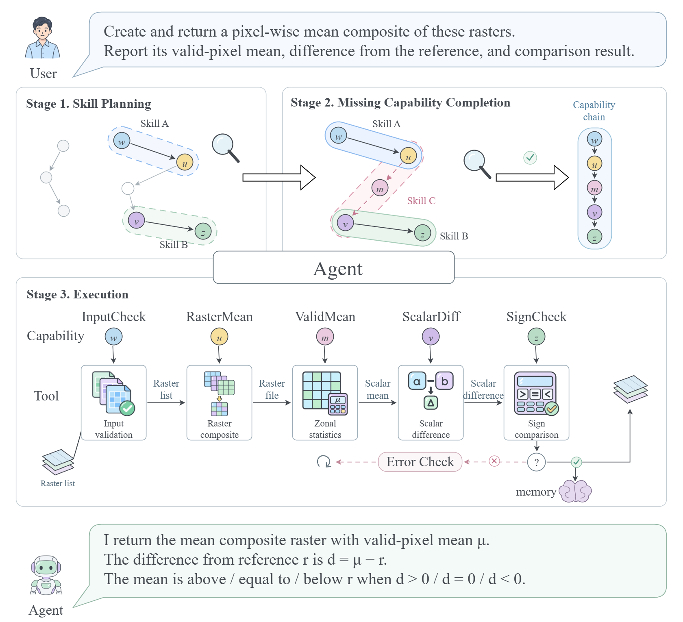
Figure 6. Cross-Skill capability composition and tool execution. Stage 1 selects $w→u$ from Skill $A$ and $v→z$ from Skill $B$. Stage 2 inserts valid-pixel mean statistics $m$ using Skill $C$’s $u→m→v$ branch. Stage 3 grounds the five-step workflow in tool calls, propagates intermediate artifacts, and returns the composite raster, mean, difference, and comparison relation. The workflow is a mechanism illustration.
Skill Retrieval returns only RasterCompose (Skill $A$) and ReferenceCompare (Skill $B$). Skill Planning selects InputCheck ($w$) and RasterMean ($u$) from the former, and ScalarDiff ($v$) and SignCheck ($z$) from the latter. InputCheck verifies the variable and spatial-grid requirements. RasterMean produces the mean raster from the validated image list, giving $w→u$. ScalarDiff returns the difference between the value under comparison and the reference; SignCheck uses that difference to determine whether the value is above, equal to, or below the reference, giving $v→z$. Hypergraph Composition expands mandatory predecessors declared by the selected strategies and retains provenance and candidate-tool scopes. At this stage, the plan consists of two disconnected fragments: compositing produces a raster file, whereas differencing requires a numerical input. The operation computing the mean of the composite is still missing.
Using $u$ and $v$ as shared endpoints, Missing Capability Completion retrieves $u→m→v$ from inactive RasterDiff (Skill $C$), where ValidMean ($m$) extracts the mean of valid pixels from the composite. Here, RasterDiff means differencing a statistic of the composite against a reference value. The query explicitly requires the mean statistic; Skill $C$ supplies reusable dependencies and usage constraints connecting it to the preceding and following operations. Under this example’s assumptions, it is the only candidate for the ordered endpoint pair satisfying prerequisite, type, tool-availability, and acyclicity requirements: $u$’s raster output is compatible with $m$’s input, and $m$’s numerical output is compatible with $v$. Insertion preserves $u$’s original constraints, adds $m$, and updates $v$’s dependencies, candidate-tool scope, and input bindings. Existing dependencies $w→u$ and $v→z$ remain. Recomposition and dependency verification connect the fragments into input validation, mean compositing, valid-pixel mean statistics, scalar differencing, and sign comparison: $w→u→m→v→z$.
Tool Grounding then selects validation, compositing, statistics, differencing, and sign-comparison tools within each instance’s candidate scope and parameter constraints. GeoToolKG associations guide candidate retrieval, but concrete invocations still require instance and input-compatibility checks. Grounding a bridge into calls additionally requires that $u$ and $v$ each correspond to exactly one endpoint instance and that their order agrees with the bridge direction. During execution, the validated image list is passed to the compositing tool. The statistics tool receives a list containing only the composite raster’s path. The returned mean and the task’s reference value are bound to differencing parameters $a$ and $b$, producing $d=a−b$. Sign comparison then compares $d$ with zero. The statistical object remains the composite created for this task, the comparison baseline remains the supplied reference, and the final relation is based on the same difference calculation.
If the zonal-statistics call fails, Failure Recovery uses the failure state and recovery rules to decide whether to retry or select an alternative within the instance’s permitted scope. Completed validation and compositing steps are retained, and the composite is reused. Calls with uncertain outcomes are not automatically replayed, and later execution is suspended if recovery requires adding a capability. Once all steps succeed, Final Answer summarizes the composite raster, valid-pixel mean, difference, and comparison relation, addressing each requested output. This case illustrates that cross-Skill completion must both connect capability steps and preserve dependencies while accurately binding task inputs and intermediate artifacts to subsequent calls.
After successful execution and result verification, the five-step workflow can also be organized into a candidate CompositeCompare Skill ($D$). It parameterizes the image list and reference value as rebindable task inputs, and retains artifact dependencies and capability usage constraints. This provides a strategy description for later reuse of the composition. Applicability to other inputs and tasks requires further verification; the example does not establish a reuse benefit for the new Skill.

8 Discussion and Conclusion
We presented AgentGS, which separates task strategies, shared operations, and tool implementations through a Skill–Capability–Tool hierarchy to support local capability composition across Skills. Hypergraph-based missing-capability completion uses dependencies carrying strategy provenance, together with type and tool constraints, to add missing intermediate capabilities. Tool selection, parameter and artifact binding, and local recovery ground capability plans in actual invocations. Composed workflows can additionally be organized into candidate Skills, providing a basis for strategy reuse in subsequent tasks.
GeoToolEval experiments demonstrate strong overall task performance and advantages in capability composition and tool orchestration on multistep tasks. Ablations further establish the contributions of predecessor expansion, missing-capability completion, and execution mechanisms. The results indicate that hierarchical capability organization and constrained plan completion can support complex scientific tasks effectively.
The method remains dependent on the coverage of registered knowledge. Structural and type constraints alone do not fully establish whether an inserted operation is necessary for a task’s objective, and local recovery is limited by the existing capability plan. Packaging a composed workflow as a new Skill preserves combinations of existing capabilities but does not automatically broaden underlying capability or tool coverage. Its effects on subsequent task performance and planning cost have not been independently evaluated. Future work will integrate task semantics and execution feedback more closely into completion and plan revision, assess the applicability and reuse benefits of new Skills across tasks, and extend generalization studies to unseen capability combinations and tool changes.

References
[1] Yuxing Chen, Weijie Wang, Sylvain Lobry, and Camille Kurtz. 2024. An LLM Agent for Automatic Geospatial Data Analysis. arXiv:2410.18792. doi:10.48550/arXiv.2410.18792
[2] Cheng Deng, Tianhang Zhang, Zhongmou He, Yi Xu, Qiyuan Chen, Yuanyuan Shi, Luoyi Fu, Weinan Zhang, Xinbing Wang, Chenghu Zhou, Zhouhan Lin, and Junxian He. 2023. K2: A Foundation Language Model for Geoscience Knowledge Understanding and Utilization. arXiv:2306.05064. doi:10.48550/arXiv.2306.05064
[3] Gabriel Diaz-Ireland, Diego Prieto-Herráez, Mario García Peces, Javier Velázquez, and Devika Jain. 2026. GeoNatureAgent Benchmark: Benchmarking LLM Agents for Environmental Geospatial Analysis Across Frontier and Open-Weight Foundation Models. arXiv:2606.12821. doi:10.48550/arXiv.2606.12821
[4] Keyan Ding, Jing Yu, Junjie Huang, Yuchen Yang, Qiang Zhang, and Huajun Chen. 2025. SciToolAgent: A Knowledge Graph-Driven Scientific Agent for Multi-Tool Integration. arXiv:2507.20280. doi:10.48550/arXiv.2507.20280
[5] Peilin Feng, Zhutao Lv, Junyan Ye, Xiaolei Wang, Xinjie Huo, Jinhua Yu, Wanghan Xu, Wenlong Zhang, Lei Bai, Conghui He, and Weijia Li. 2026. Earth-Agent: Unlocking the Full Landscape of Earth Observation with Agents. In International Conference on Learning Representations. https://arxiv.org/abs/2509.23141v3
[6] Varvara Krechetova and Denis Kochedykov. 2025. GeoBenchX: Benchmarking LLMs in Agent Solving Multistep Geospatial Tasks. In Proceedings of the 1st ACM SIGSPATIAL International Workshop on Generative and Agentic AI for Multi-Modality Space-Time Intelligence. ACM, 27–35. doi:10.1145/3764915.3770721
[7] Seungkyu Lee, Nalim Kim, and Yohan Jo. 2025. In-N-Out: A Parameter-Level API Graph Dataset for Tool Agents. arXiv:2509.01560. doi:10.48550/arXiv.2509.01560
[8] Bo Liu, Yuqian Jiang, Xiaohan Zhang, Qiang Liu, Shiqi Zhang, Joydeep Biswas, and Peter Stone. 2023. LLM+P: Empowering Large Language Models with Optimal Planning Proficiency. arXiv:2304.11477. doi:10.48550/arXiv.2304.11477
[9] Xukun Liu, Zhiyuan Peng, Xiaoyuan Yi, Xing Xie, Lirong Xiang, Yuchen Liu, and Dongkuan Xu. 2024. ToolNet: Connecting Large Language Models with Massive Tools via Tool Graph. arXiv:2403.00839. doi:10.48550/arXiv.2403.00839
[10] Yanming Liu, Xinyue Peng, Jiannan Cao, Shi Bo, Yuwei Zhang, Xuhong Zhang, Sheng Cheng, Xun Wang, Jianwei Yin, and Tianyu Du. 2025. Tool-Planner: Task Planning with Clusters across Multiple Tools. In International Conference on Learning Representations. https://proceedings.iclr.cc/paper_files/paper/2025/file/7f605d59a0dbde101518b552cb616ddf-Paper-Conference.pdf
[11] Zhaoyang Liu, Zeqiang Lai, Zhangwei Gao, Erfei Cui, Ziheng Li, Xizhou Zhu, Lewei Lu, Qifeng Chen, Yu Qiao, Jifeng Dai, and Wenhai Wang. 2024. ControlLLM: Augment Language Models with Tools by Searching on Graphs. In Computer Vision – ECCV 2024. Springer, 89–105. doi:10.1007/978-3-031-73254-6_6
[12] Felipe Meneguzzi, Ramon Fraga Pereira, and Nir Oren. 2025. Generalised BDI Planning. In Proceedings of the 24th International Conference on Autonomous Agents and Multiagent Systems. International Foundation for Autonomous Agents and Multiagent Systems, 1483–1491. doi:10.5555/3709347.3743782
[13] Guanzhi Wang, Yuqi Xie, Yunfan Jiang, Ajay Mandlekar, Chaowei Xiao, Yuke Zhu, Linxi Fan, and Anima Anandkumar. 2023. Voyager: An Open-Ended Embodied Agent with Large Language Models. arXiv:2305.16291. doi:10.48550/arXiv.2305.16291
[14] Qinzhuo Wu, Wei Liu, Jian Luan, and Bin Wang. 2024. ToolPlanner: A Tool Augmented LLM for Multi Granularity Instructions with Path Planning and Feedback. In Proceedings of the 2024 Conference on Empirical Methods in Natural Language Processing. Association for Computational Linguistics, 18315–18339. doi:10.18653/v1/2024.emnlp-main.1018
[15] Wanghan Xu, Xiangyu Zhao, Yuhao Zhou, Xiaoyu Yue, Ben Fei, Fenghua Ling, Wenlong Zhang, and Lei Bai. 2025. EarthSE: A Benchmark for Evaluating Earth Scientific Exploration Capability of LLMs. arXiv:2505.17139. doi:10.48550/arXiv.2505.17139
[16] Shunyu Yao, Jeffrey Zhao, Dian Yu, Nan Du, Izhak Shafran, Karthik Narasimhan, and Yuan Cao. 2023. ReAct: Synergizing Reasoning and Acting in Language Models. In International Conference on Learning Representations. https://arxiv.org/abs/2210.03629v3
[17] Bo Yu, Cheng Yang, Dongyang Hou, Chengfu Liu, Jiayao Liu, Chi Wang, Zhiming Zhang, Haifeng Li, and Wentao Yang. 2026. GeoAgentBench: A Dynamic Execution Benchmark for Tool-Augmented Agents in Spatial Analysis. arXiv:2604.13888. doi:10.48550/arXiv.2604.13888
[18] Zian Zhai, Xingyu Tan, Gaowang Zou, Xiaoyang Wang, and Wenjie Zhang. 2026. HyperAgent: Planning and Acting over Tool-Schema Hypergraphs for Tool-Use LLM Agents. arXiv:2608.02650. doi:10.48550/arXiv.2608.02650
[19] Yongfei Zheng. 2025. Research Forefronts in Earth Science. Chinese Science Bulletin 70, 36 (2025), 6188–6203. In Chinese. doi:10.1360/CSB-2025-5248

