Key - Used to open the backpacks.

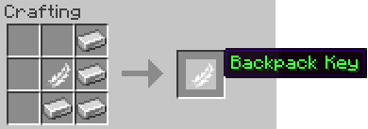

Small - Smallest of the backpacks. Size of normal chest.

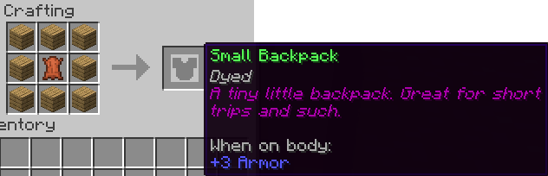

Large - A pretty dang large backpack. Size of double chest.

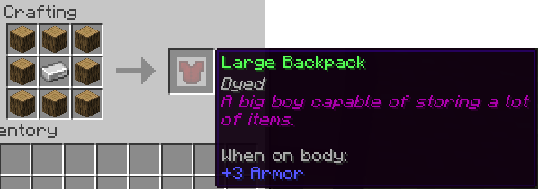

Linked - A backpack capable of interfacing with many different types of containers: chest, double chests, furnaces, etc. It works at any distance, even across dimensions. It is the ultimate backpack. To link it, hold it in your hand and left-click the desired container.

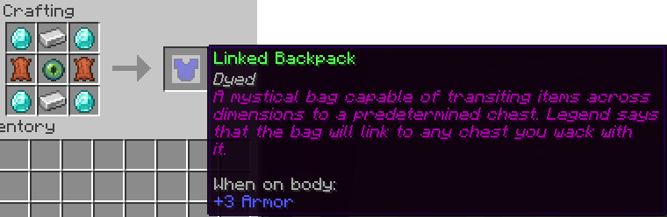

Combined - A backpack which can store multiple backpacks for quick use.

To add, place the combined backpack along with the to-be-inserted bag in a crafting grid.

To remove, see: /bp split.

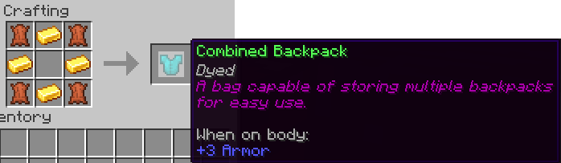

Craft - A crafting table in a backpack.

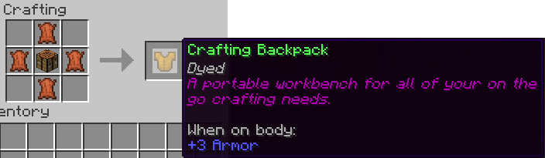

Ender - An enderchest in a backpack.

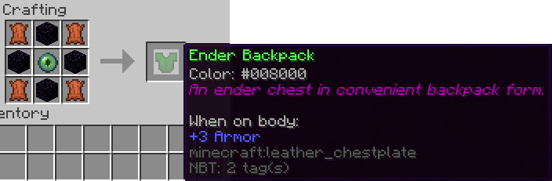

Furnace - A first of its kind portable furnace.

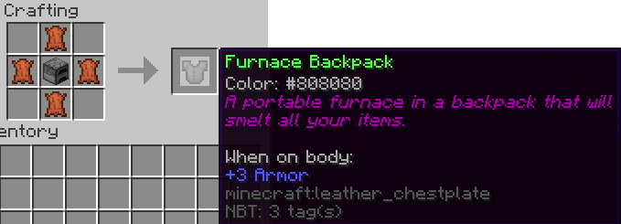

Usage

Backpacks exist as chestplate items, however, they may be combined in a crafting grid w/ any item that can be equipped in this slot. To open, right-click with a backpack key in your hand.