**Evaluation Only. Created with Aspose.Words. Copyright 2003-2022 Aspose Pty Ltd.**

Environmental Monitor Preview

Publish Date:01/26/2022

Environmental Notification Forms

|  |  |  |  |  |  |  |
| --- | --- | --- | --- | --- | --- | --- |
| EEA No. | Project Name | Municipality | Document Type | Comments Due | For Copies | MEPA Analyst |
| 16519 | Populatic Water Treatmen t Plant | MEDWAY | ENF | 02/15/2022 | Charles Caron (978) 944-2326  caronenv@aol. com | Jennifer Hughes, , Jennifer.Hughes@ mass.gov |
| 16520 | Seaport Circle | BOSTON | ENF | 03/01/2022 | Samantha Dolabany  (617) 607-6326  sdolabany@vhb .com | Alexander Strysky, (857)408-6957, alexander.strysk y@mass.gov |
| 16521 | 295 Eastern Avenue | CHELSEA | EENF | 03/11/2022 | Chuck Anastas (774) 249-8199  chuck@duranda nastas.com | Purvi Patel, (617)874-0668, purvi.patel@mass .gov |

Projects Submitted - Site Visits

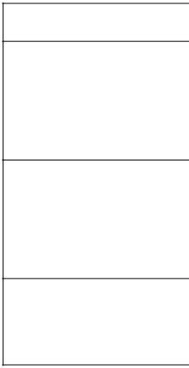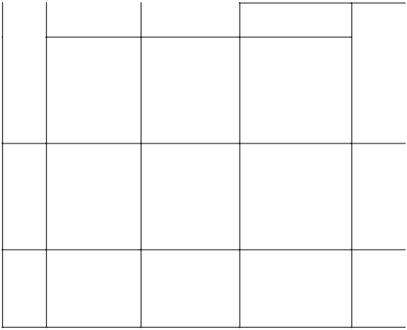

EEA Project Name Municipality Meeting Date Meeting Location

No. Time

16509 Mattapoisett MATTAPOISETT 01/26/2022 3:55 pm Remote Meeting. Please

Bogs RSVP to

Restoration Jennifer.Hughes@mass.gov Project at least one hour before the

meeting for instructions on joining the video conference or calling in by phone.

16510 Sudbury SUDBURY 02/07/2022 9:00 am REMOTE MEETING. Please

Comprehensive RSVP to

Wastewater alexander.strysky@mass.gov Management at least one hour before the Plan meeting for instructions on

joining the video conference or calling in by phone

16512 County Street NEW BEDFORD 01/27/2022 2:30 pm Remote Meeting. Please

Reconstruction RSVP to

Project christina.lyons@mass.gov at

least one hour before the meeting for instructions on joining the video conference or calling in by phone

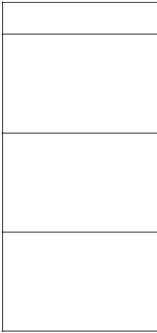

16513 Crawford RANDOLPH 02/11/2022 11:00 REMOTE MEETING. Please

Square Urban am RSVP to

Revitalization purvi.patel@mass.gov at Plan (Urban least one hour before the Renewal Plan) meeting for instructions on

joining the video conference or calling in by phone.

16514 City of Boston BOSTON 02/01/2022 1:00 pm REMOTE MEETING. Please

Resilient Fort RSVP to

Point Channel erin.flaherty@mass.gov at Infrastructure least one hour before the Project meeting for instructions on

joining the video conference or calling in by phone.

16519 Populatic MEDWAY 02/02/2022 1:00 pm Remote Meeting. Please

Water RSVP to

Treatment Jennifer.Hughes@mass.gov Plant at least one hour before the

meeting for instructions on joining the video conference or calling in by phone.

Projects Submitted - Environmental Impact Reports

|  |  |  |  |  |  |  |
| --- | --- | --- | --- | --- | --- | --- |
| EEA No. | Project Name | Municipality | Document Type | Comments Due | For Copies | MEPA Analyst |
| 16383 | Lincoln Park | WEST BRIDGEWATE | FEIR  R | 02/25/2022 | Jeffrey Bandini (508) 823-2245  JBandini@McMa honassociates. com | Erin Flaherty, (617)874-0589, erin.flaherty@mas s.gov |

Projects Submitted - Notices of Project Change

|  |  |  |  |  |  |  |
| --- | --- | --- | --- | --- | --- | --- |
| EEA No. | Project Name | Municipality | Document Type | Comments Due | For Copies | MEPA Analyst |
| 11781 | South Acton Sewer System Extensio n | ACTON | NPC | 02/15/2022 | Jack Troidl  (781) 613-0457  jTroidl@woodar dcurran.com | Eva Murray, (857)408-6381, eva.murray@mass .gov |
| 15888 | Pommogu ssett Road (Route 56)/ Mouton Pond | RUTLAND | NPC | 02/15/2022 | John Morgan  (781) 982-5490  JMorgan@chaco mpanies.com | Christina Lyons, , Christina.Lyons@ mass.gov |

|  |  |  |  |  |  |  |
| --- | --- | --- | --- | --- | --- | --- |
|  | Dam Rehabilit ation Proj. |  |  |  |  |  |
| 16384 | Whitney Pond Wells Water Treatmen t Plant | GROTON | NPC | 02/15/2022 | Chris Grillo  (617) 657-0977  cpg@envpartner s.com | Eva Murray, (857)408-6381, eva.murray@mass .gov |

Projects Submitted - Special Review Procedure Request

|  |  |  |  |  |  |  |
| --- | --- | --- | --- | --- | --- | --- |
| EEA No. | Project Name | Municipality | Document Type | Comments Due | For Copies | MEPA Analyst |

Projects Under Review - Environmental Notification Forms

|  |  |  |  |  |  |  |
| --- | --- | --- | --- | --- | --- | --- |
| EEA No. | Project Name | Municipality | Document Type | Comments Due | For Copies | MEPA Analyst |
| 16468 | Volpe Exchange Parcel Redevel opment | CAMBRIDGE | ENF | 01/21/2022 | David Hewett (978) 897-7100  dhewett@epsilo nassociates.co m | Alexander Strysky, (857)408-6957, alexander.strysk y@mass.gov |
| 16489 | Parcel 8 - NUBA Project | BOSTON | ENF | 01/21/2022 | Mitchell Fischman  (781) 760-1726  mitchfischman@ gmail.com | Alexander Strysky, (857)408-6957, alexander.strysk y@mass.gov |
| 16491 | Modera Revere Beach | REVERE | ENF | 01/21/2022 | David Hewett (978) 897-7100  dhewett@epsilo nassociates.co m | Eva Murray, (857)408-6381, eva.murray@mass .gov |
| 16494 | 754 Newport Avenue | ATTLEBORO | ENF | 02/07/2022 | Samhita Saquib (617) 607-2147  ssaquib@vhb.c om | Eva Murray, (857)408-6381, eva.murray@mass .gov |
| 16495 | Memorial Drive Reconstr uction | CAMBRIDGE | ENF | 01/27/2022 | Michael Paiewonsky  (857) 415-3920  Michael.Paiewo | Christina Lyons, , Christina.Lyons@ mass.gov |

|  |  |  |  |  |  |  |
| --- | --- | --- | --- | --- | --- | --- |
|  |  |  |  |  | nsky@stantec.c om |  |
| 16497 | Eversour ce Energy Program | CAMBRIDGE | ENF | 02/15/2022 | Michael Howard (978) 897-7100  mhoward@epsilo nassociates.co  m | Alexander Strysky, (857)408-6957, alexander.strysk y@mass.gov |
| 16502 | Riverside Labs | WESTON |

**This document was truncated here because it was created in the Evaluation Mode.**