**Evaluation Only. Created with Aspose.Words. Copyright 2003-2022 Aspose Pty Ltd.**

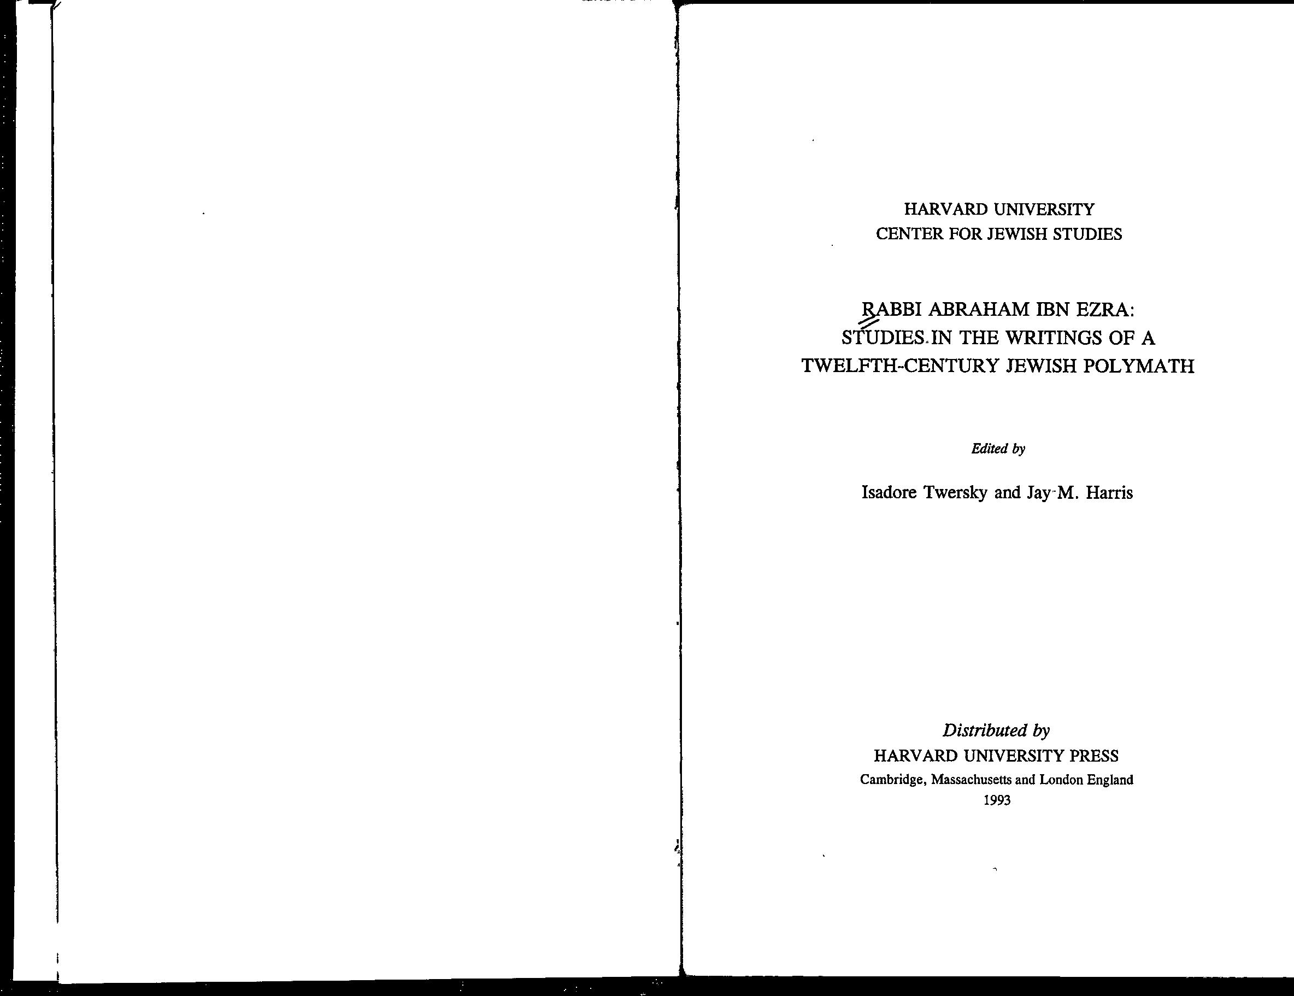

CONTENTS

Foreword  **V**

NAHUM M. SARNA

Abraham Ibn Ezra as an Exegete 1

Y. TZVI LANGERMANN

Some Astrological Themes in the Thought

of Abraham Ibn Ezra 28

URIEL SIMON

Interpreting the Interpreter: Supercommentaries on

Ibn Ezra's Commentaries 86

JAY M. HARRIS

Ibn Ezra in Modern Jewish Perspective 129

HEBREW SECTION

SIMHAH KOGUT

R. Abraham Ibn Ezra as a Philologist 1 ISADORE TWERSKY

Did R. Abraham Ibn Ezra Influence Maimonides? 21

