Cody Ferre

01/09/24

CSD-340

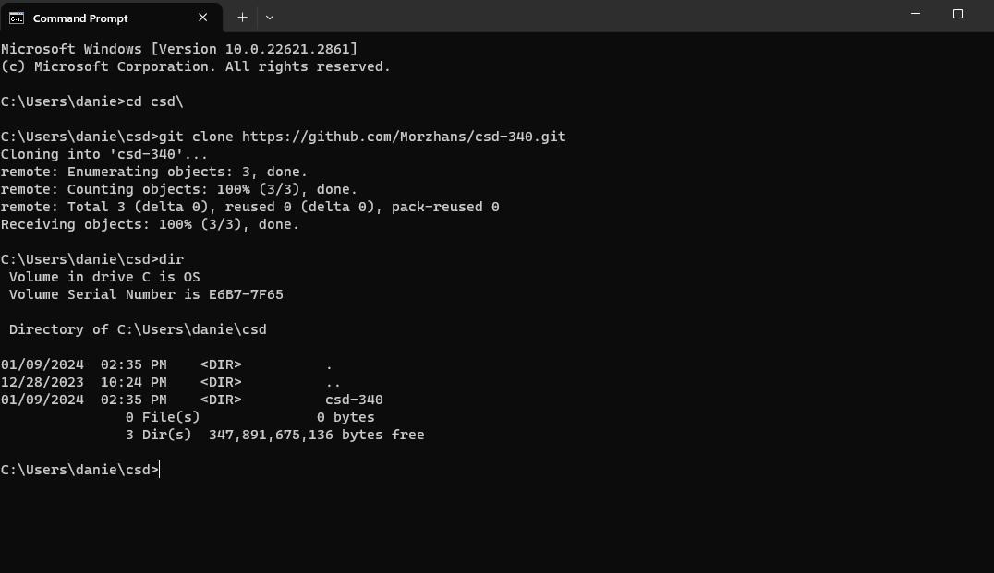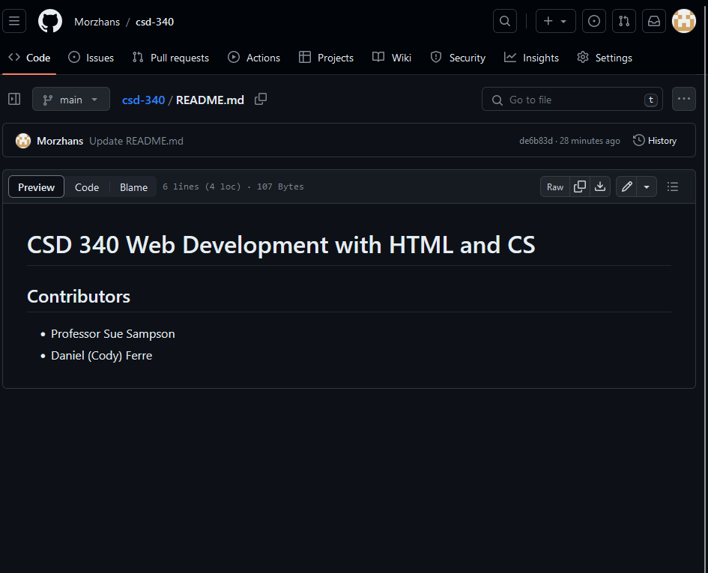

Git Hub Repository Link

https://github.com/Morzhans/csd-340/tree/main