❀ GlowWell
Beauty Clinic Management System
USER GUIDE
Online booking, customer records, staff schedules and reporting
Item | Detail
Module | Systems Development 3 (HSYD300-1)
Assessment | Summative Assessment 1 – Project (NQF Level 6, 30 credits)
Institution | Boston City Campus – Higher Education Programmes, July–December 2026
Technologies | HTML, CSS, JavaScript, PHP and MySQL
Student name
Student number

Contents
1. Introduction 2
1.1 What the system does 2
1.2 User roles 2
1.3 Demonstration accounts 2
2. Installing and starting the system 3
3. Database schema 4
3.1 Entity relationship overview 4
3.2 Relationships in plain language 4
3.3 Table and field definitions 4
4. Customer guide 8
4.1 Create an account 8
4.2 Log in 9
4.3 Book an appointment 10
4.4 Reschedule a booking 13
4.5 Cancel a booking 14
4.6 Log out 14
5. Administrator guide 15
5.1 Dashboard 15
5.2 Manage bookings 15
5.3 Manage customers 18
5.4 Manage staff 19
5.5 Staff schedules 20
5.6 Manage services 21
5.7 Reports 22
6. Security and data protection 24
7. Messages and troubleshooting 25

1. Introduction
GlowWell Beauty Clinic offers facials, massages, hair treatments, wellness and speciality services. Bookings, customer records and staff schedules used to be handled manually, which led to errors, double bookings and poor communication. The GlowWell Management System replaces this with a secure web application that runs in any browser.

1.1 What the system does
- Customers register, browse services, book appointments online, reschedule or cancel them, and receive email notifications.
- Administrators see a live dashboard, manage bookings, customers, staff, working schedules and services, and generate revenue reports.
- The system prevents double bookings automatically: only genuinely free time slots are offered, and the database rejects clashes.

1.2 User roles
Role | Can do | Cannot do
Visitor (not logged in) | View the home page and service list, register, log in | Book or see any personal data
Customer | Book, reschedule and cancel own appointments; view own booking history | See other customers or any admin page
Administrator | Everything in the Admin menu: bookings, customers, staff, schedules, services, reports | Book through the customer screen (uses Admin > Bookings instead)

1.3 Demonstration accounts
The sample database includes these accounts so every feature can be tried immediately:
Role | Email | Password
Administrator | admin@glowwell.co.za | Admin@123
Customer | thandi@example.com (also priya@, sipho@, emma@example.com) | Customer@123

2. Installing and starting the system
The system needs a web server with PHP 8 and MySQL (or MariaDB). A free package such as XAMPP or WAMP provides everything.
- Start Apache and MySQL from the XAMPP/WAMP control panel.
- Unzip the glowwell folder into the web server folder (for XAMPP this is htdocs).
- Open phpMyAdmin (http://localhost/phpmyadmin), choose Import, select the file glowwell.sql from the database folder and click Go. This creates the glowwell database, all tables and the sample data.
- If your MySQL user is not “root” with an empty password, open the file config/db.php in a text editor and enter your own MySQL username and password.
- Open a browser and go to http://localhost/glowwell/. The GlowWell home page appears.
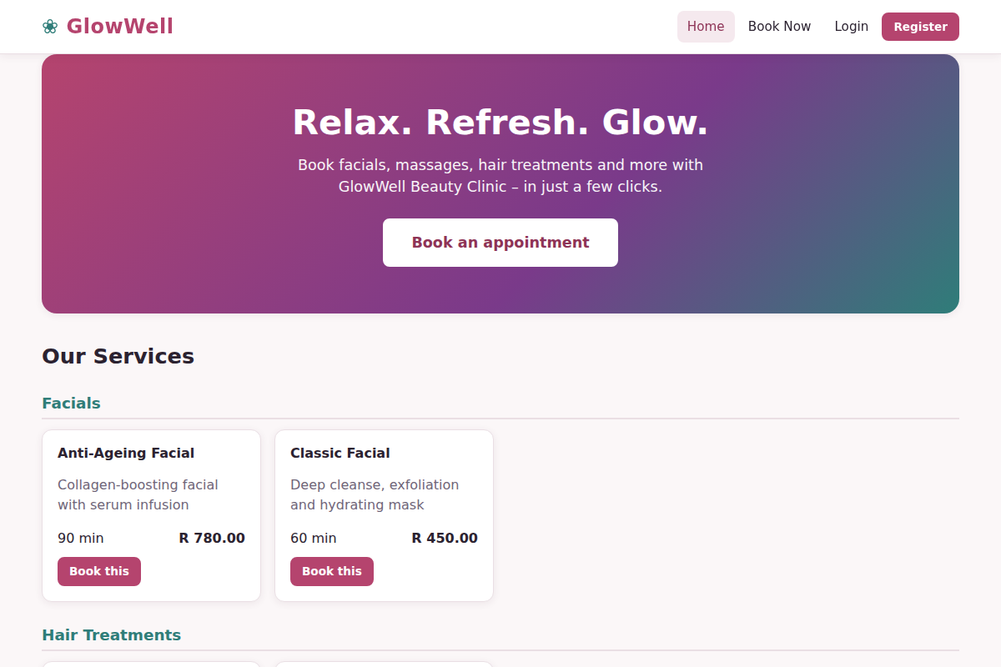
Figure 1: The GlowWell home page with the service list

3. Database schema
The database is called glowwell and contains nine related tables. It is normalised to third normal form: each fact is stored once (for example a service’s price lives only in services), many-to-many relationships use a link table (staff_services), and repeating groups such as weekly hours have their own table (staff_schedules).

3.1 Entity relationship overview
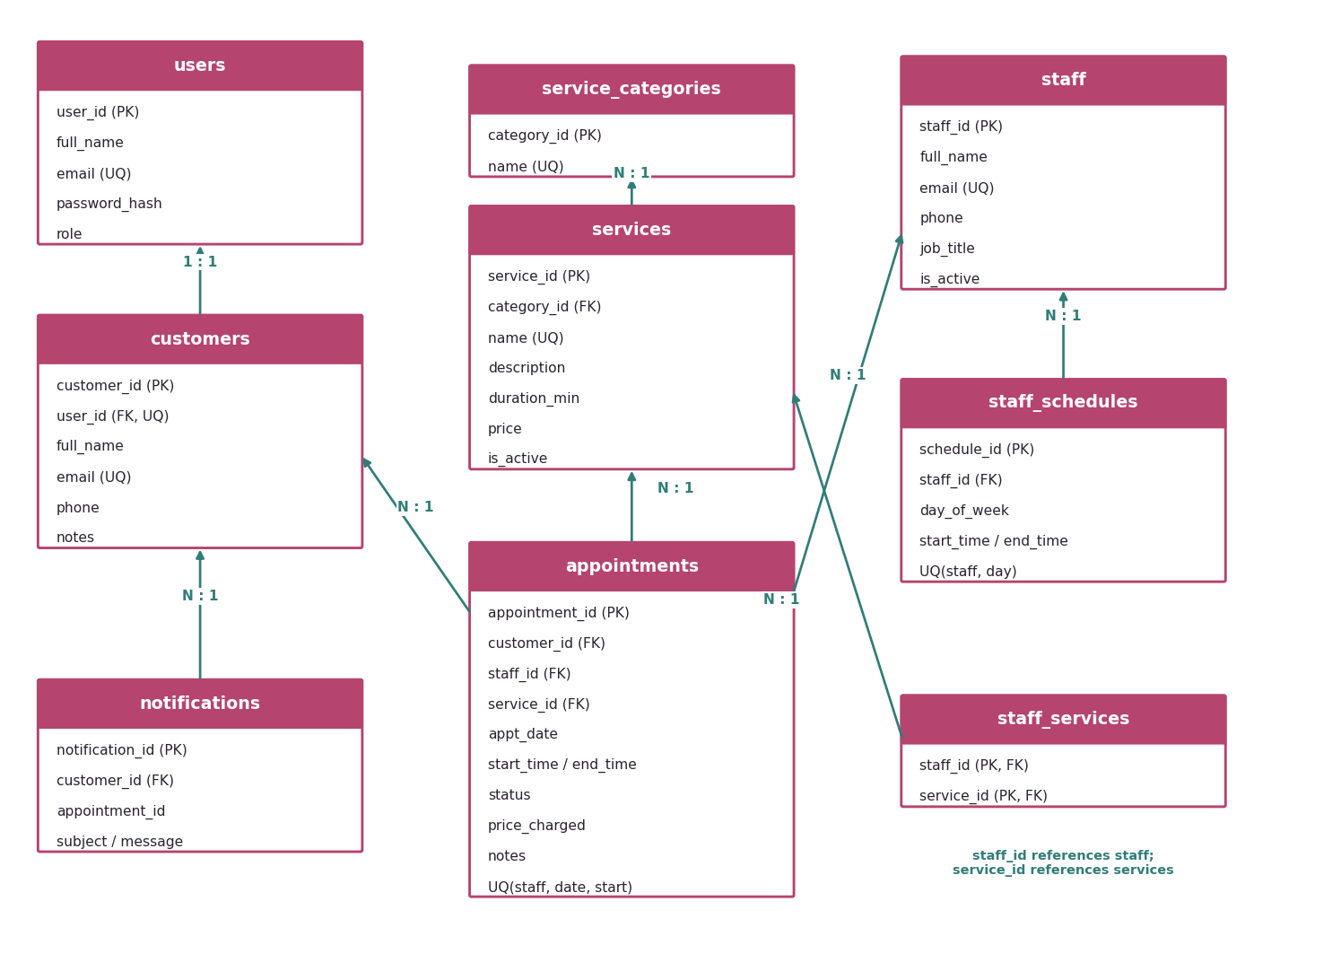
Figure 2: Entity relationship diagram (PK = primary key, FK = foreign key, UQ = unique)

3.2 Relationships in plain language
- One user account belongs to at most one customer record.
- A service category contains many services.
- A staff member can perform many services, and a service can be performed by many staff (staff_services).
- Each staff member has up to seven schedule rows – one per weekday worked.
- An appointment links one customer, one staff member and one service. Many appointments can exist for each of them.
- Each notification belongs to one customer.

3.3 Table and field definitions

3.3.1 users
Login accounts for administrators and customers. Passwords are stored as secure hashes, never as plain text.
Field | Data type | Key / constraint | Description
user_id | INT UNSIGNED | Primary key, auto-increment | Unique account number
full_name | VARCHAR(100) | Required | Name of the account holder
email | VARCHAR(120) | Required, UNIQUE | Login name; no two accounts may share one
password_hash | VARCHAR(255) | Required | Encrypted (hashed) password
role | ENUM('admin','customer') | Required, default customer | Decides which pages the user can open
created_at | TIMESTAMP | Default current time | When the account was created

3.3.2 customers
Client records. A customer may have an online login (user_id) or be a walk-in captured by an administrator.
Field | Data type | Key / constraint | Description
customer_id | INT UNSIGNED | Primary key, auto-increment | Unique customer number
user_id | INT UNSIGNED | Foreign key to users, UNIQUE, optional | Links to the login account (empty for walk-ins)
full_name | VARCHAR(100) | Required | Customer name
email | VARCHAR(120) | Required, UNIQUE | Contact email and notification address
phone | VARCHAR(20) | Required | 10-digit phone number
notes | VARCHAR(255) | Optional | Preferences or special requirements
created_at | TIMESTAMP | Default current time | Date the record was created

3.3.3 service_categories
Groups services (Facials, Massages, Hair Treatments, Wellness, Speciality).
Field | Data type | Key / constraint | Description
category_id | INT UNSIGNED | Primary key, auto-increment | Unique category number
name | VARCHAR(60) | Required, UNIQUE | Category name

3.3.4 services
Treatments offered by the clinic.
Field | Data type | Key / constraint | Description
service_id | INT UNSIGNED | Primary key, auto-increment | Unique service number
category_id | INT UNSIGNED | Foreign key to service_categories | Category the service belongs to
name | VARCHAR(100) | Required, UNIQUE | Service name
description | VARCHAR(255) | Optional | Short description shown to customers
duration_min | SMALLINT UNSIGNED | Required | Length of the treatment in minutes
price | DECIMAL(8,2) | Required | Price in Rand
is_active | TINYINT(1) | Default 1 | 1 = visible to customers, 0 = hidden

3.3.5 staff
Therapists and specialists who perform treatments.
Field | Data type | Key / constraint | Description
staff_id | INT UNSIGNED | Primary key, auto-increment | Unique staff number
full_name | VARCHAR(100) | Required | Staff member name
email | VARCHAR(120) | Required, UNIQUE | Work email
phone | VARCHAR(20) | Required | Contact number
job_title | VARCHAR(80) | Required | For example Senior Facialist
is_active | TINYINT(1) | Default 1 | 1 = can be booked, 0 = unavailable

3.3.6 staff_services
Link table: which staff member can perform which service (many-to-many).
Field | Data type | Key / constraint | Description
staff_id | INT UNSIGNED | Composite primary key; FK to staff | The therapist
service_id | INT UNSIGNED | Composite primary key; FK to services | The service they can perform

3.3.7 staff_schedules
Weekly working hours for each staff member.
Field | Data type | Key / constraint | Description
schedule_id | INT UNSIGNED | Primary key, auto-increment | Unique schedule row
staff_id | INT UNSIGNED | Foreign key to staff | The therapist
day_of_week | TINYINT UNSIGNED | UNIQUE together with staff_id | 1 = Monday ... 7 = Sunday
start_time | TIME | Required | Start of working day
end_time | TIME | Required | End of working day

3.3.8 appointments
Every booking made by a customer or administrator.
Field | Data type | Key / constraint | Description
appointment_id | INT UNSIGNED | Primary key, auto-increment | Booking number
customer_id | INT UNSIGNED | Foreign key to customers | Who the booking is for
staff_id | INT UNSIGNED | Foreign key to staff | Therapist performing the service
service_id | INT UNSIGNED | Foreign key to services | Treatment booked
appt_date | DATE | Required | Appointment date
start_time / end_time | TIME | Required | Start and calculated end time
status | ENUM('pending','confirmed','completed','cancelled') | Default pending | Progress of the booking
price_charged | DECIMAL(8,2) | Required | Price at the time of booking (used for reports)
notes | VARCHAR(255) | Optional | Customer notes
created_at | TIMESTAMP | Default current time | When the booking was made
(constraint) |  | UNIQUE (staff_id, appt_date, start_time) | The database itself refuses double bookings

3.3.9 notifications
Log of every email notification sent to customers.
Field | Data type | Key / constraint | Description
notification_id | INT UNSIGNED | Primary key, auto-increment | Unique message number
customer_id | INT UNSIGNED | Foreign key to customers | Recipient
appointment_id | INT UNSIGNED | Optional | Booking the message is about
subject | VARCHAR(150) | Required | Email subject
message | TEXT | Required | Email body
sent_at | TIMESTAMP | Default current time | When it was sent

4. Customer guide

4.1 Create an account
- On the home page click Register (top right).
- Enter your full name, email address, 10-digit phone number and a password of at least 8 characters including a number. The coloured bar under the password shows how strong it is.
- Re-type the password in Confirm password and click Register.
If something is wrong, a red message appears under the field straight away, and the server checks everything again when you submit.
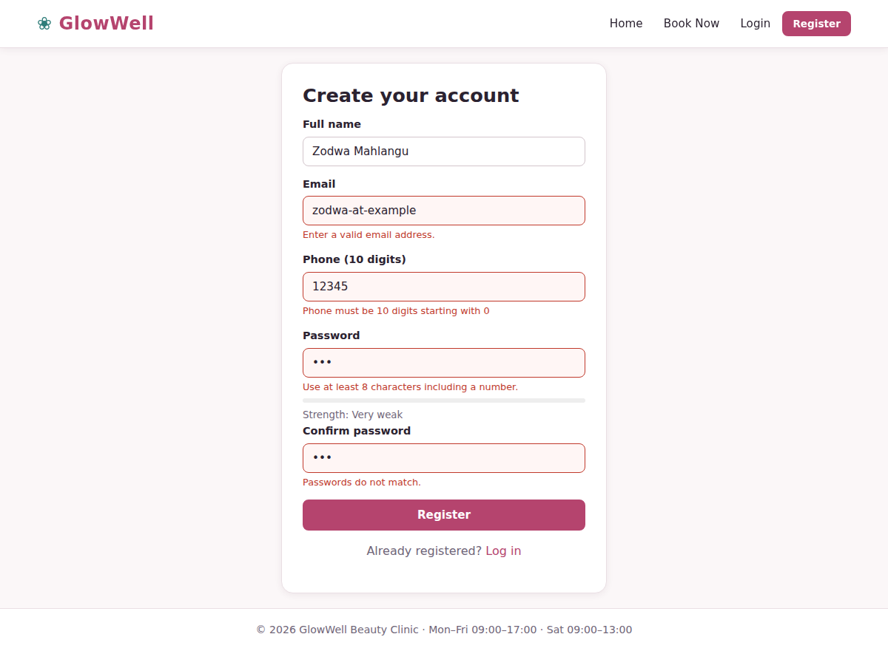
Figure 3: Registration form showing validation messages for invalid input
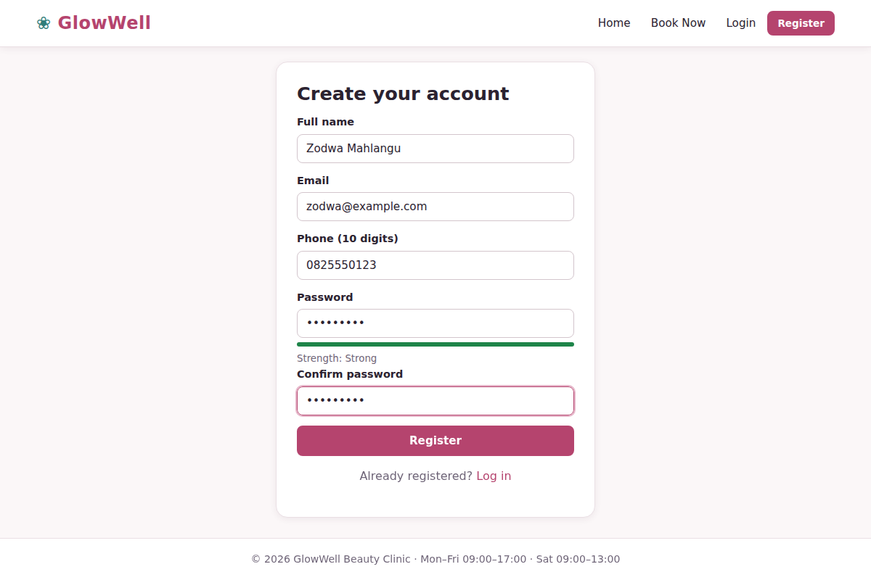
Figure 4: Registration form completed correctly (new customer Zodwa Mahlangu)
After registering you are taken to the login page with a green confirmation message.
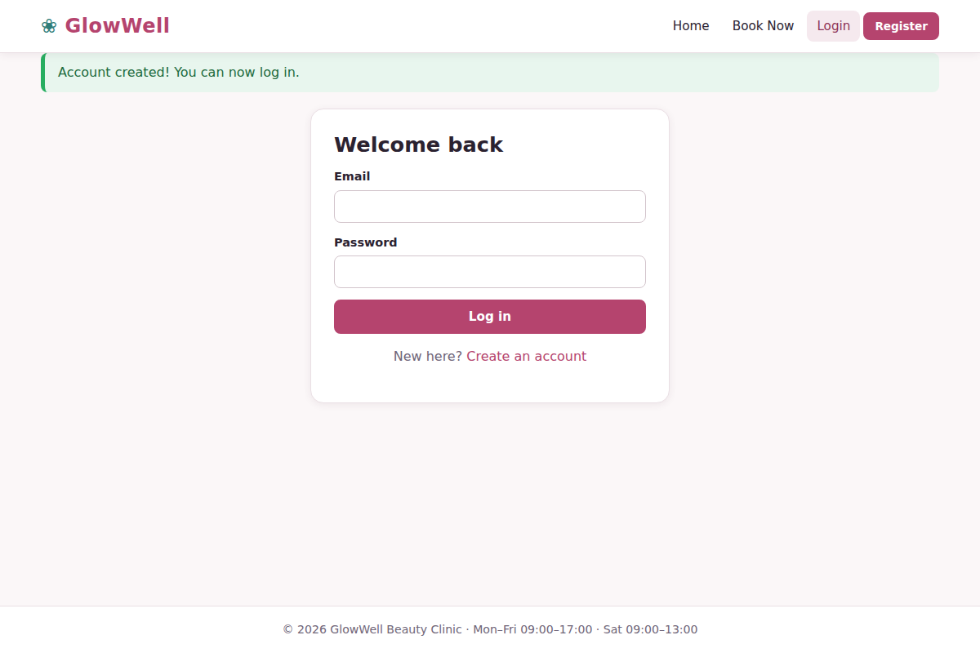
Figure 5: Login page after a successful registration

4.2 Log in
- Click Login, enter your email and password and press Log in.
- Customers land on My Bookings; administrators land on the Dashboard.
A wrong email or password shows “Incorrect email or password”. For security the message does not say which one was wrong.
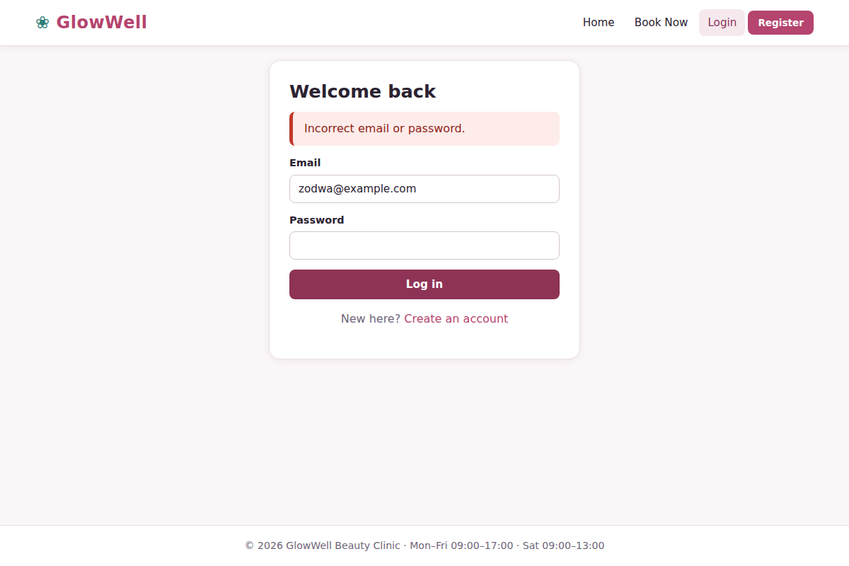
Figure 6: Login error message for incorrect credentials
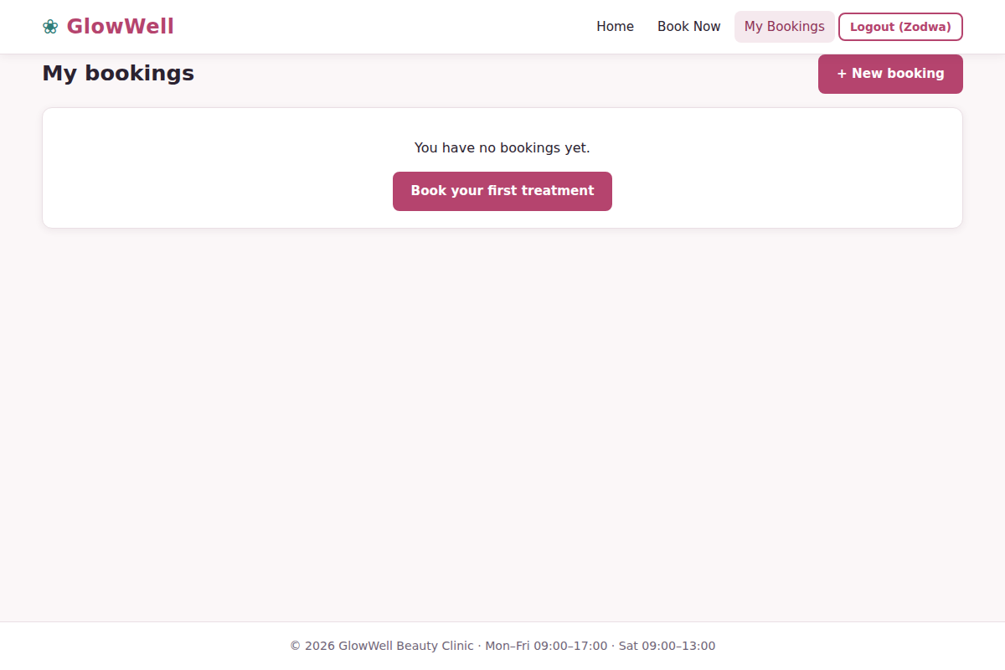
Figure 7: My Bookings for a new customer with no appointments yet

4.3 Book an appointment
- Click Book Now (or Book this on a service card on the home page).
- Step 1 – Choose a service from the drop-down list. Duration and price are shown.
- Step 2 – Choose a date. Past dates are not allowed.
- Step 3 – Pick a therapist and time. The page instantly lists every qualified therapist with their free time slots. Slots that are already booked, or outside working hours, do not appear.
- Click a time slot. It turns green and a summary line confirms your choice.
- Optionally add notes for the therapist, then click Confirm booking.
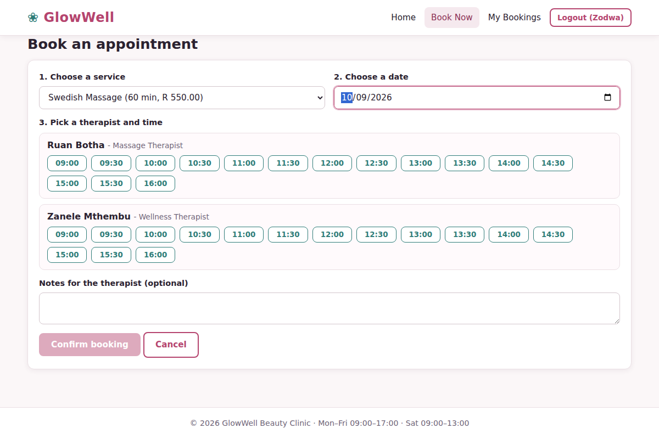
Figure 8: Available therapists and time slots for Swedish Massage on 9 October 2026
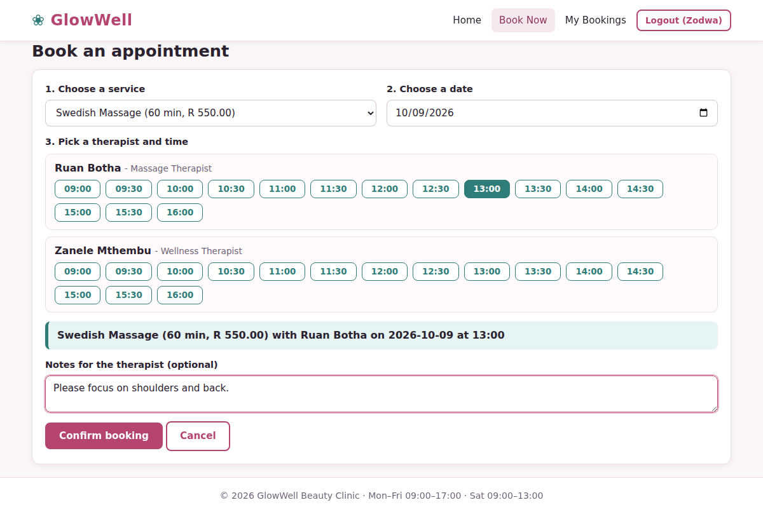
Figure 9: A time slot selected, with the booking summary and notes
You return to My Bookings with a confirmation message. The new booking has the status Pending until the clinic confirms it, and an email notification is sent.
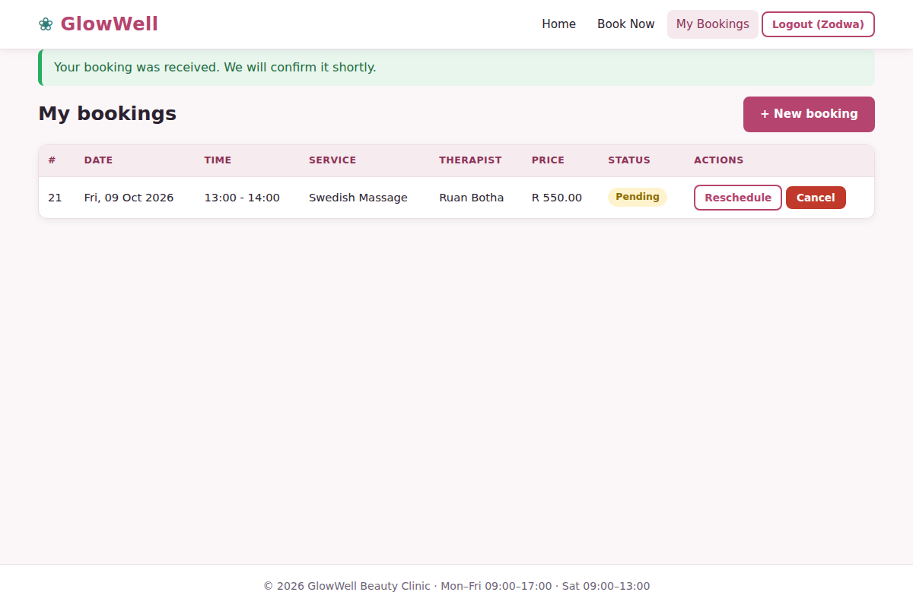
Figure 10: My Bookings showing the new pending appointment
Tip: If someone else books your slot at the same moment, the system tells you and asks you to choose another time – you can never end up double booked.

4.4 Reschedule a booking
- In My Bookings click Reschedule next to a pending or confirmed future appointment.
- The form opens with your current choice already selected. Change the service, date or time slot.
- Click Save new time. The booking returns to Pending for re-confirmation.
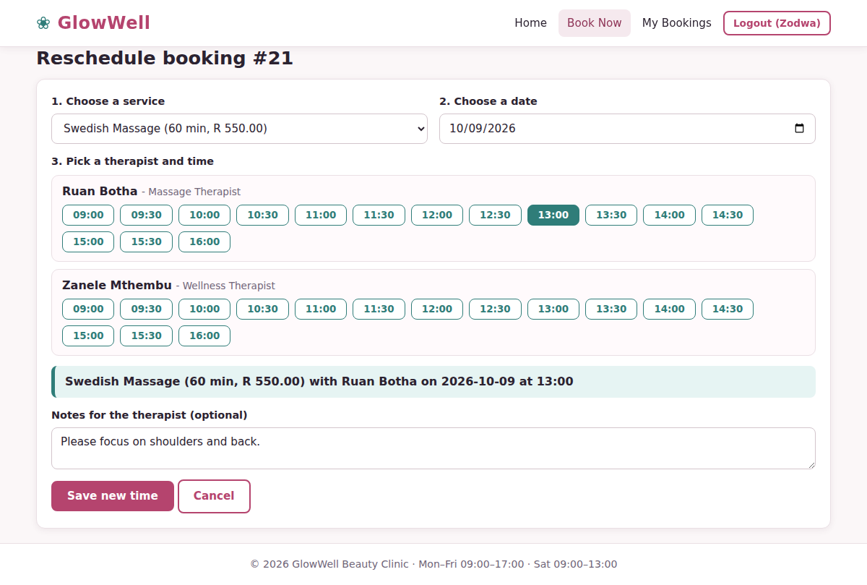
Figure 11: Reschedule screen with the current slot pre-selected
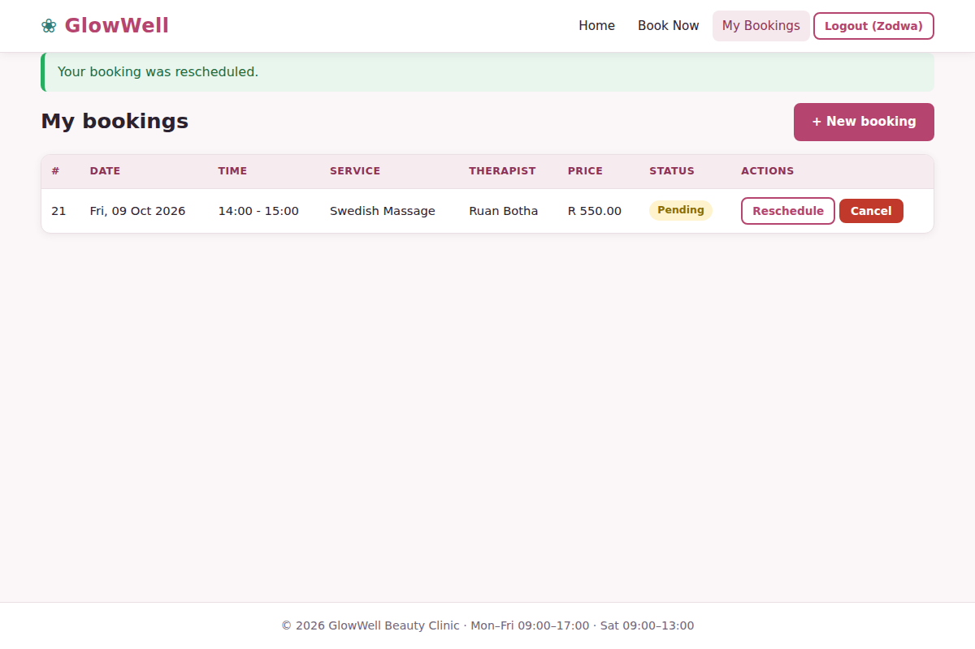
Figure 12: Booking successfully moved to a new time (14:00)

4.5 Cancel a booking
- Click the red Cancel button on the booking.
- Confirm in the pop-up window. The status changes to Cancelled and the time becomes available to others again.

4.6 Log out
Click Logout in the top-right corner when you have finished, especially on a shared computer.

5. Administrator guide
Log in with an administrator account. The menu changes to show Dashboard, Bookings, Customers, Staff, Schedules, Services and Reports.

5.1 Dashboard
The dashboard gives a snapshot of the clinic: today’s bookings, bookings waiting for approval, total customers, active staff and revenue for the current month. A chart shows the number of bookings for the next seven days, and the table lists the next appointments. The buttons on the right are shortcuts to common tasks.
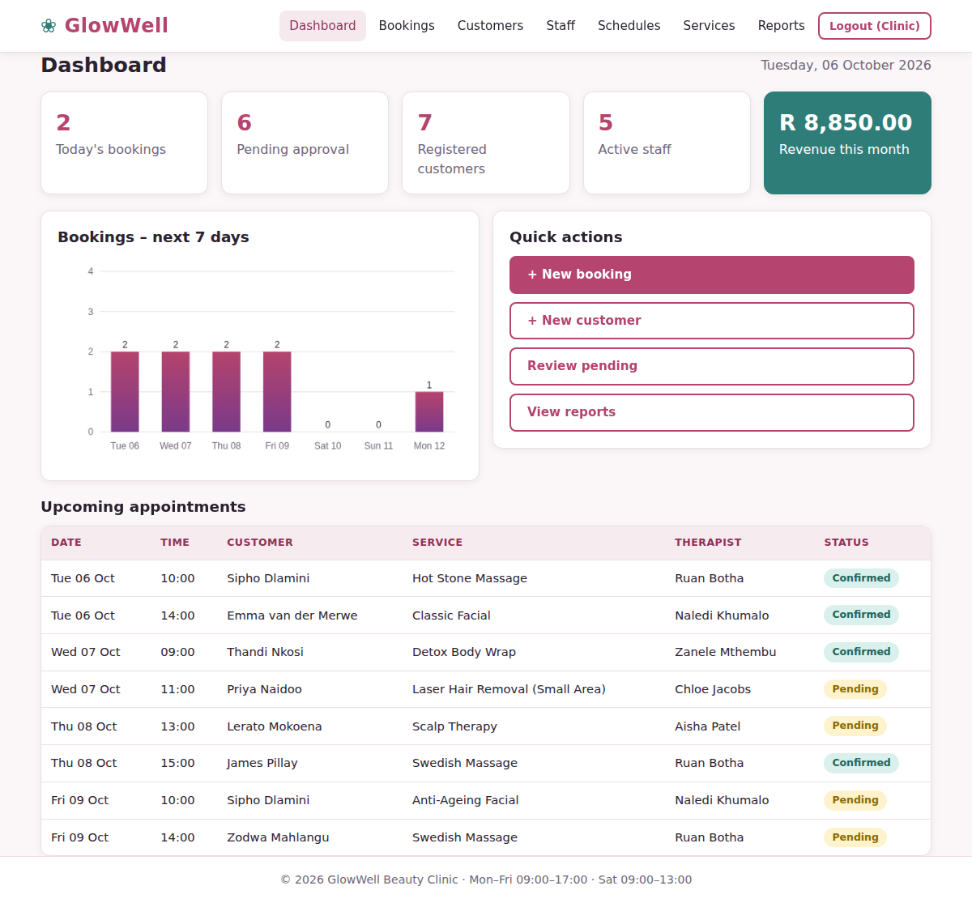
Figure 13: Administrator dashboard

5.2 Manage bookings
- Click Bookings to see every appointment, newest first.
- Use the search box, status filter and From/To dates, then click Filter. Click Reset to clear them.
- To approve or change a booking, use the status drop-down in its row. The change saves immediately and the customer receives an email.
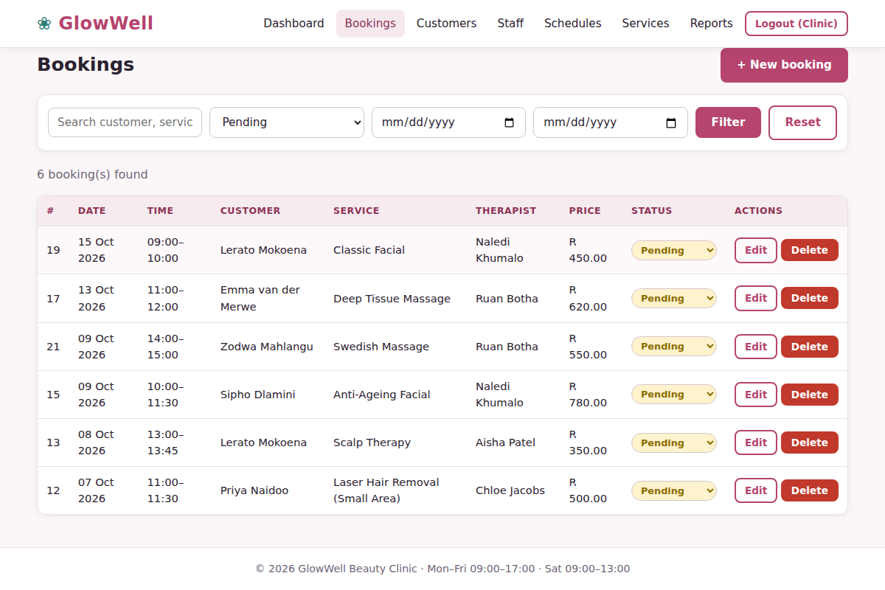
Figure 14: Bookings filtered to show only pending appointments
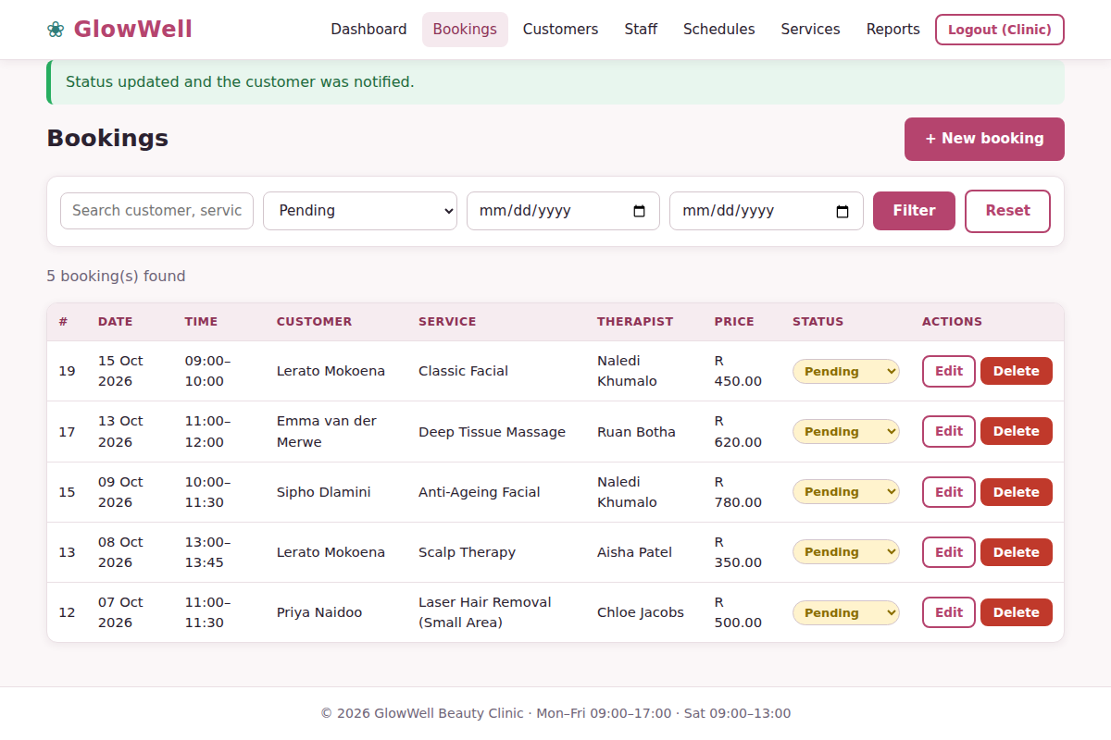
Figure 15: Status of Zodwa Mahlangu’s booking changed to Confirmed

Create a booking for a customer (for example a phone or walk-in booking)
- Click + New booking.
- Select the customer, status, service and date.
- Click an available time slot under the therapist, then click Create booking.
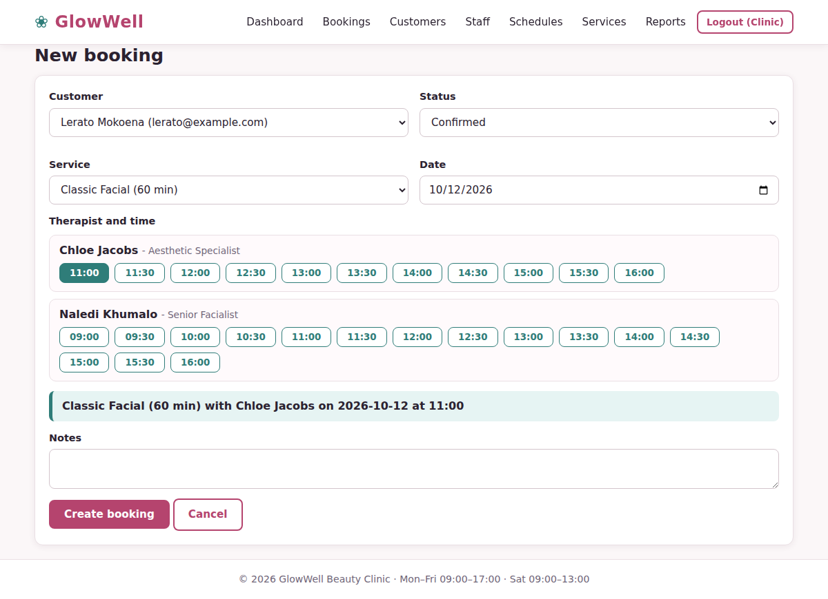
Figure 16: Creating a booking for the walk-in customer Lerato Mokoena
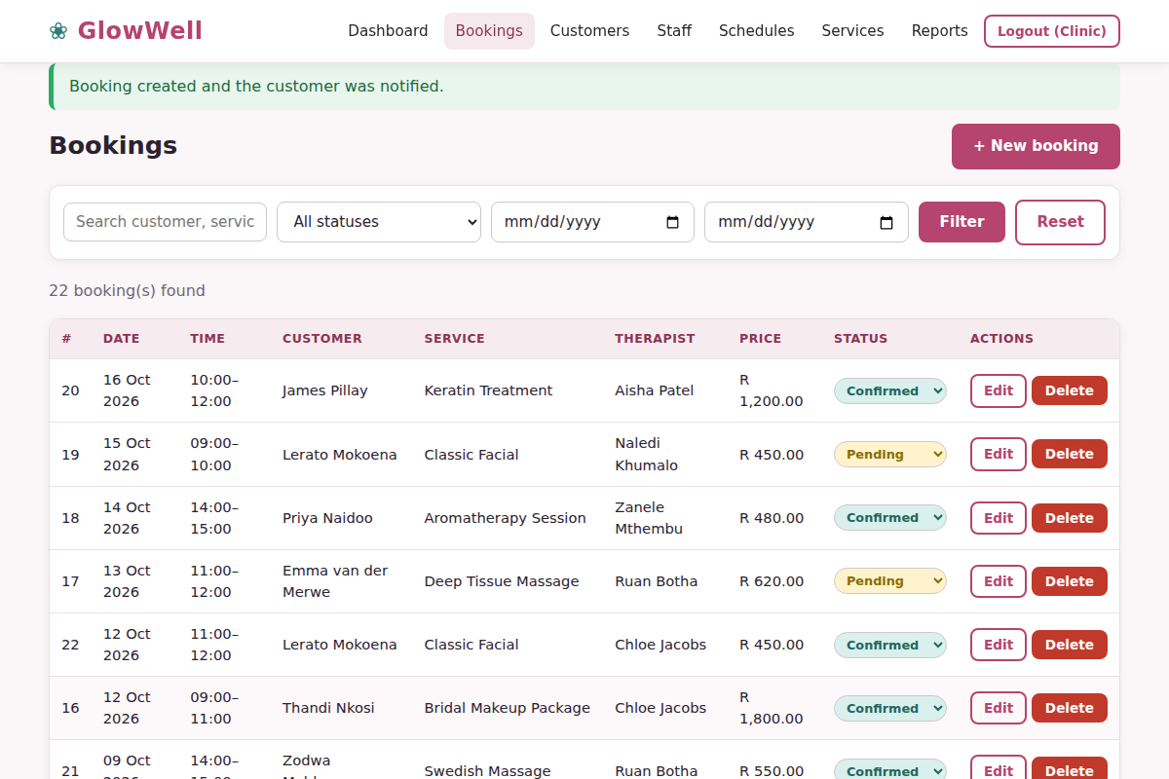
Figure 17: Booking created and the customer notified
Use Edit on any row to change a booking and Delete to remove one permanently (you are asked to confirm first). To simply cancel a booking while keeping the record, set its status to Cancelled.

5.3 Manage customers
- Click Customers to see all clients with their number of bookings and total spend.
- Search by name, email or phone number.
- Click + Add customer, complete the form and click Save customer. Use this for walk-in clients who have no online account.
- Use Edit to update details or Delete to remove a customer together with their bookings.
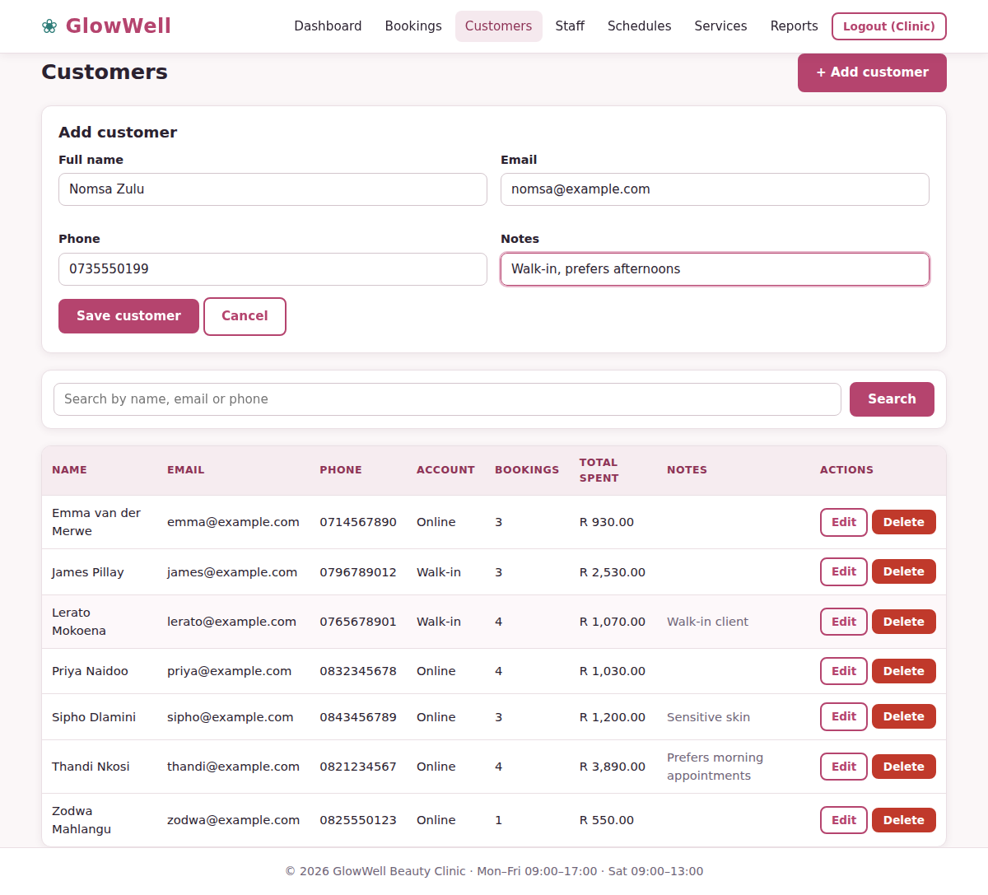
Figure 18: Adding a new walk-in customer
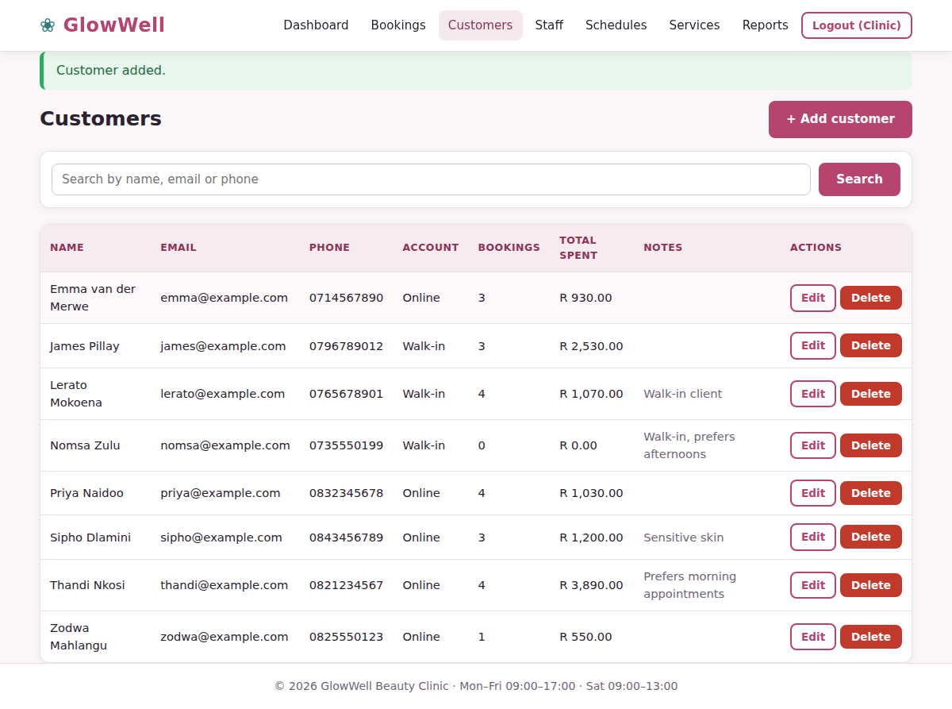
Figure 19: Customer list after the new customer was added

5.4 Manage staff
- Click Staff, then + Add staff member (or Edit on an existing person).
- Enter name, job title, email and phone.
- Tick every service this person can perform. Customers will only see this therapist for those services.
- Untick Active to stop a person being booked without deleting their history. Click Save staff member.
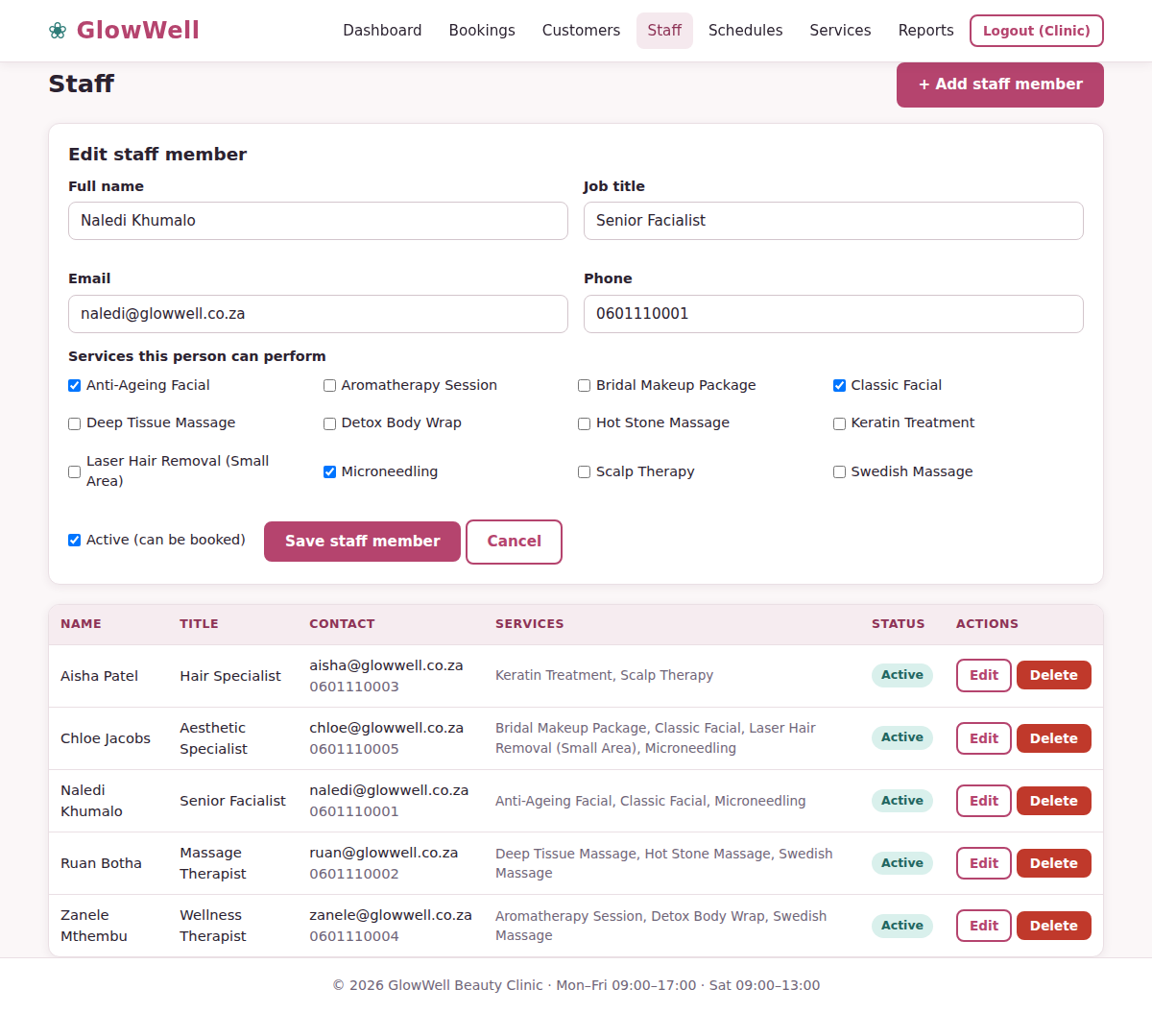
Figure 20: Editing a staff member and the services they perform
Tip: A staff member who already has bookings cannot be deleted. Mark them inactive instead.

5.5 Staff schedules
- Click Schedules. Each therapist has a weekly panel.
- Tick the days they work and set the start and end time for each day.
- Click Save schedule. Customers can only book inside these hours.
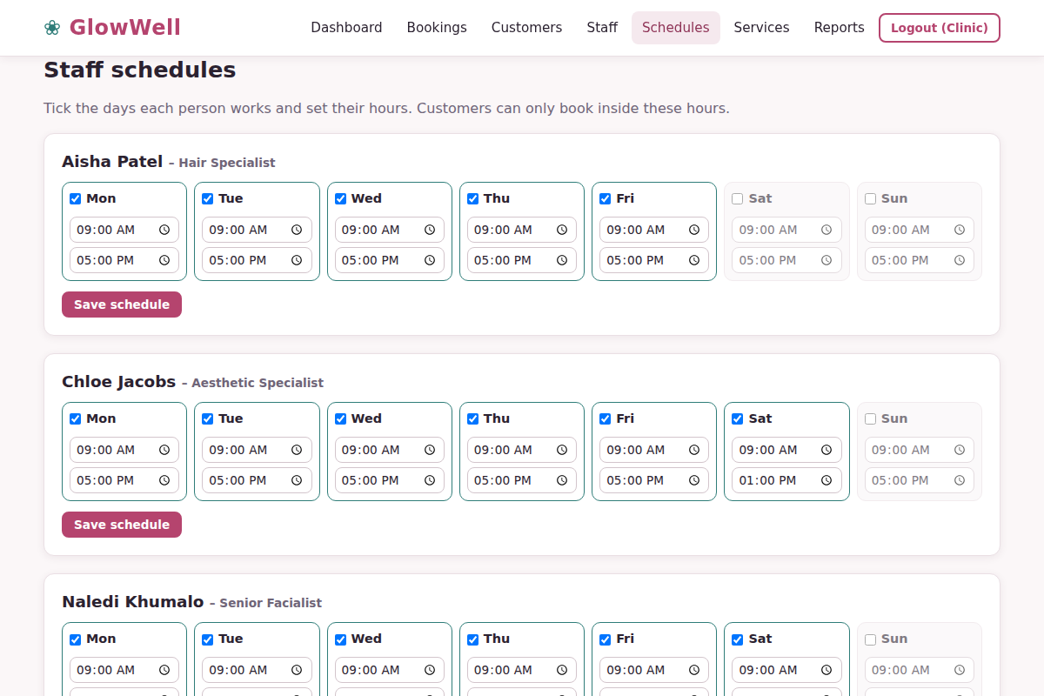
Figure 21: Weekly schedule editor for each therapist

5.6 Manage services
- Click Services to see the price list.
- Click + Add service or Edit. Choose a category, name, duration (15–240 minutes) and price.
- Untick Active to hide a service from customers. Click Save service.
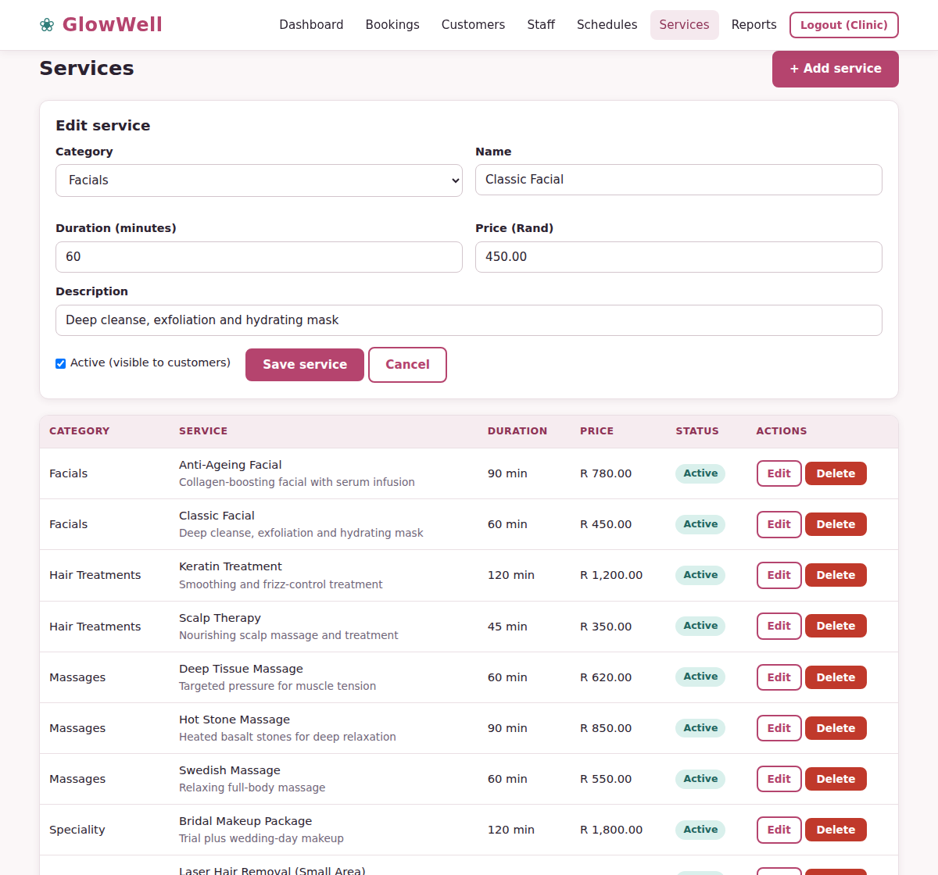
Figure 22: Editing a service

5.7 Reports
- Click Reports and choose a From and To date, then click Generate report.
- Review total bookings, revenue and average booking value, the revenue-by-category chart and the tables for therapists, top services and top customers.
- Click Print for a paper copy or Export CSV to open the detailed data in Excel.
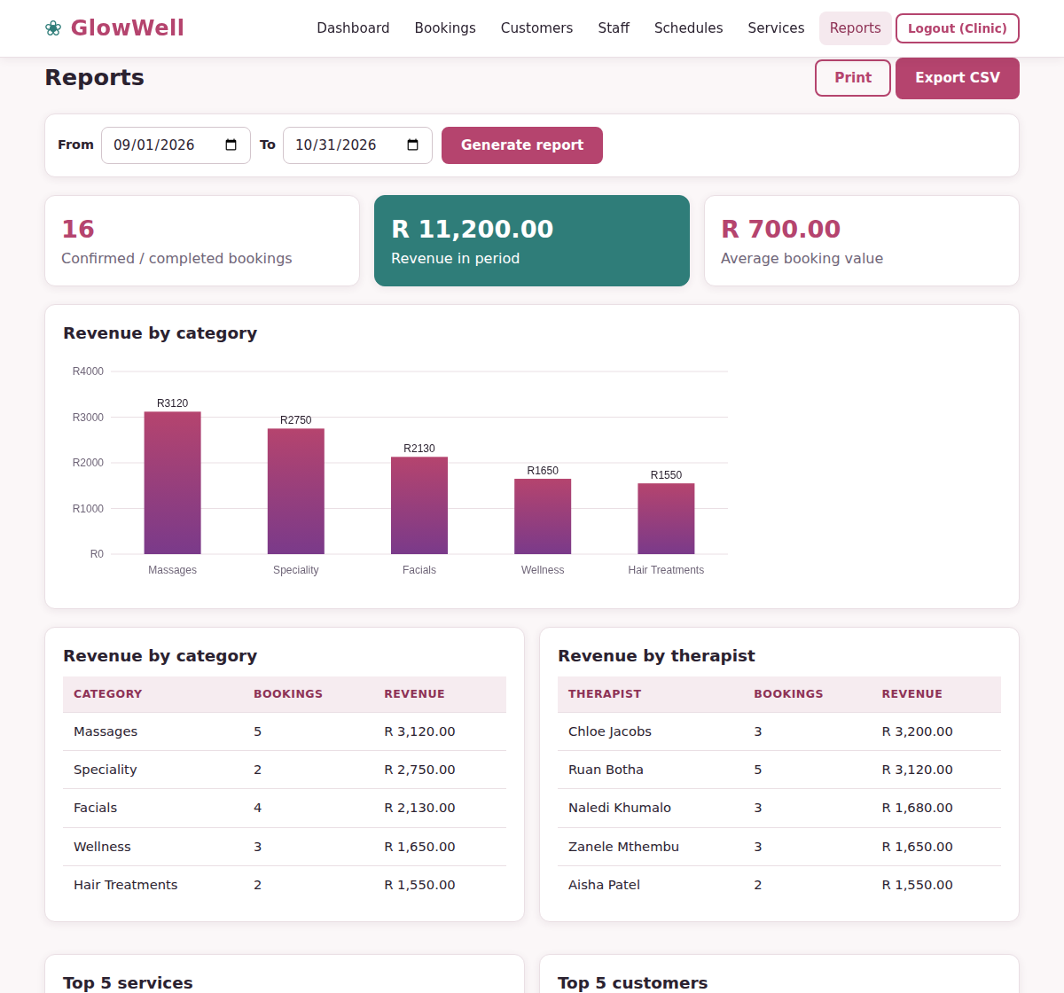
Figure 23: Revenue and booking report for September–October 2026

6. Security and data protection
- Hashed passwords – passwords are never stored or shown in readable form.
- Role-based access – customers cannot open admin pages, and each customer only sees their own bookings.
- Validated input – every form is checked in the browser for instant feedback and again on the server before anything is saved.
- Protected database access – all database requests use prepared statements, which blocks SQL injection.
- Form protection – secure tokens on every form prevent forged requests, and all displayed text is escaped.
- Safe sessions – a new session is issued at login and destroyed at logout.

7. Messages and troubleshooting
Message or problem | What it means | What to do
Please log in to continue | You opened a page that needs an account | Log in, or register first
Incorrect email or password | Details do not match an account | Re-type carefully; passwords are case-sensitive
Phone number must be 10 digits starting with 0 | Phone format is wrong | Enter for example 0821234567
An account with that email already exists | Email is already registered | Log in instead
You cannot book a date in the past | The chosen date has passed | Choose today or a later date
Fully booked or closed on this date | No therapist has a free slot | Try another day
That time slot has just been taken | Another booking was made first | Choose a different slot
Staff member has bookings and cannot be deleted | Deleting would lose booking history | Mark the person inactive instead
Database connection failed | MySQL is off or login details are wrong | Start MySQL and check config/db.php

For further help contact the clinic reception during opening hours: Monday to Friday 09:00–17:00 and Saturday 09:00–13:00.

