**Czech Technical University in Prague – Faculty of Biomedical Engineering**

**Biological Signals Processing – Summer Term 2014 – Michel Kana, PhD**

**Final Test – 15.4.2014**

**Name:** ___________________________

1. **Describe the 5 common phases of electrical conduction in the heart during one cardiac cycle**

1. **Annotate the following ECG signal: give the name of waves, intervals and segments**

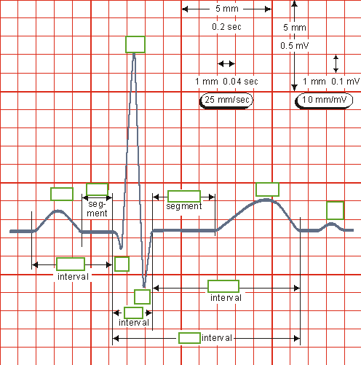

1. **Give two electrode types for ECG measurement and explain the difference between them**
2. **Suggest a functional difference between the optical isolator and the analog-to-digital converter in an ECG device?**
3. **Explain how a photoplethysmograph (PPG) sensor physically works**
4. **Annotate the following PPG signals, name and describe the parameters.**

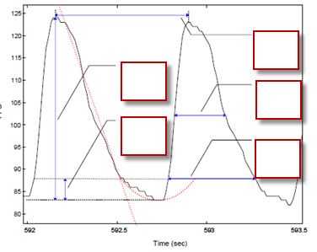 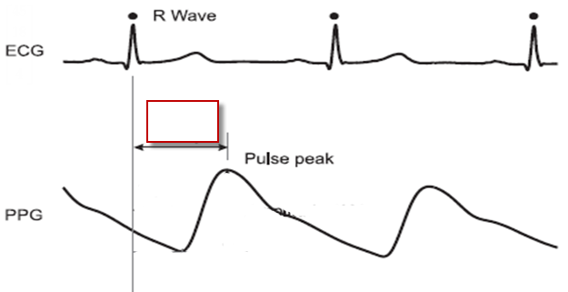

1. **What are the typical noise sources in a PPG signal and their frequency range**
2. **By which physiological principles is electrical skin conductance linked to sympathetic nervous activity?**
3. **What are the 3 major waves in a galvanic skin response signal and the physiological meaning of each of them?**
4. **Annotate the following GSR signal**

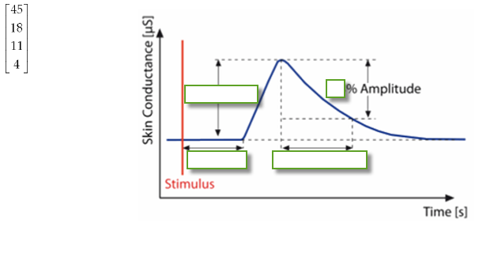

1. **What is a major noise source in a GSR signal that would normally not affect an ECG signal?**
2. **Define the physiological term “sarcomere” and explain the mechanism of contraction in a sarcomere while highlighting the role of actin, myosin and titin proteins**
3. **Name the four basic groups of waves in a normal EEG and their frequency range**
4. **Name and describe 4 major parameters that can be extracted from an EMG signal**
5. **The EMG is a very noisy signal. Explain why and give the frequency range of each noise source.**
6. **Explain the difference between inspiratory reserved volume and expiratory reserved volume**
7. **Identify biological signals, design an experiment and use the Biopac MP35 system and Biopac Student Lab PRO software in order to solve following problems. Shortly describe your approach on paper, write your final answer on paper and send your Biopac files to michel.kana@gmail.com before the end of the test**
8. The expiratory-to-inspiratory difference (*E-I*) is calculated as the difference between the maximal heart rate (in beats/min) during inspiration and minimal heart rate during expiration. The deep breathe index (*DBI*) is the average of such differences for six consecutive deep breathing cycles performed during one minute (5 seconds for each inhalation and 5 seconds for each exhalation). **What is your *DBI (beats/min)?***
9. Mean arterial blood pressure (MAP, in mmHg) can be estimated when an ECG and a PPG signal are available using the approximation $MAP=246-0.4∙PTT$, where $PTT$ is the pulse traveling time (in milliseconds). During active standing from a sitting position, it is expected to observe a drop in the mean arterial blood pressure in healthy subjects. **What is your percentage drop (%) in blood pressure during active standing?**

**Biological Signals Processing - Test – 15.4.2014 - Name:** ___________________________

1. Mental arithmetic, e.g. reverse counting should trigger a stress response that can be observed on the activity of sweat glands in the skin of fingers. A stress factor can be defined as the percentage increase of some physiological values related to the sweat glands activity. **Propose a specific measure of stress using a measurable biological signal and determine your stress factor during a 2 minutes reverse counting exercise (e.g. from 211, step 13).**
2. The masseter, one of the facial muscles of mastication is assumed to be the strongest muscle in the body, even stronger than the biceps which lie on the upper arm. **How stronger (%) is your masseter compare to your dominant biceps?**
3. During Rapid Eye Blinking Test for detecting drugs abuse and myasthenia gravis (eye muscles fatigue), the subject continuously blinks both eyes simultaneously as fast as he can, for 60 seconds. **What are the total number of your eye blinks and the average duration of each blink?**