**Czech Technical University in Prague – Faculty of Biomedical Engineering**

**Biological Signals Processing – Summer Term 2014 – Michel Kana, PhD**

**Final Test Solution – 15.4.2014**

**Name:** ___________________________

1. **Describe the 5 common phases of electrical conduction in the heart during one cardiac cycle - 3**
   1. The sinoatrial node (SA node) automatically depolarizes.
   2. Electrical activity goes rapidly to atrioventricular node (AV node) via internodal pathways.
   3. Depolarization spreads slowly across atria. Conduction slows through AV node.
   4. Depolarization moves rapidly through ventricular conducting system to the apex of the heart.
   5. Depolarization ware spreads upward from the apex.
2. **Annotate the following ECG signal: give the name of waves, intervals and segments - 4**

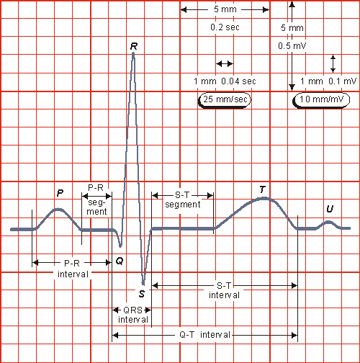

1. **Give two electrode types for ECG measurement and explain the difference between them - 2**
   1. Bipolar electrodes: record the voltage differential between the wrists and the legs.
   2. Unipolar electrodes: record the voltage difference between a reference electrode and the body surface.
   3. Plate electrodes: use metal disks held onto the skin with adhesive tape.
   4. Suction electrodes: use metal disks with a vacuum system to remain in place.
   5. Fluid column electrodes: designed to avoid direct contact with the skin
   6. Flexible electrodes: designed for infants with fine stainless steel or silver wire, attached to the skin like a small bandage.
2. **Suggest a functional difference between the optical isolator and the analog-to-digital converter in an ECG device? - 1**

Optical isolators prevent the possibility of accidental electric shock. Analog to digital converter converts a continuous voltage signal to a digital format.

1. **Explain how a photoplethysmograph (PPG) sensor physically works - 2**

A photodetector can be placed on a tissue’s surface alongside the light-emitting diode and record the light that returns back. Light intensity is attenuated by oxygenated and deoxygenated hemoglobin.

1. **Annotate the following PPG signals, name and describe the parameters. - 4**

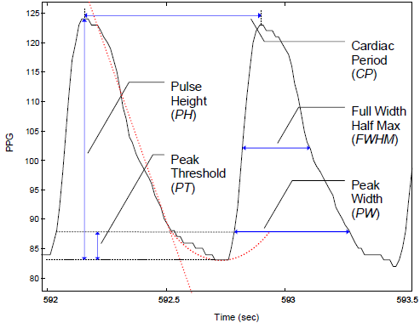 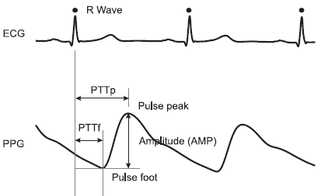

1. **What are the typical noise sources in a PPG signal and their frequency range - 3**

Movement artefacts: 0 to 20 Hz

Ambient light interference: 0 to thousands Hz

Variation in temperature: 0 to thousands Hz

Power line interference: 50 Hz or 60 Hz

1. **By which physiological principles is electrical skin conductance linked to sympathetic nervous activity? - 2**

Change in conductance occurs when sweat glands fill or empty sweat. The glands respond to sympathetic nervous stimulation.

1. **What are the 3 major waves in a galvanic skin response signal and the physiological meaning of each of them? - 2**

SCL: Skin Conductance Level. It is the baseline level and provides a measure of overall psycho-physical activiation.

NSF: Non-specific Spontaneous Fluctuations. They are not event related and are useful for calculating overall emotional state.

SCR: Skin Conductance Response. It reflects discrete environmental stimuli or events.

1. **Annotate the following GSR signal - 4**

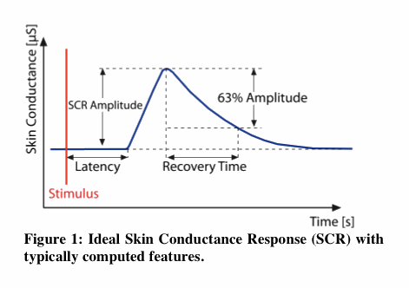

1. **What is a major noise source in a GSR signal that would normally not affect an ECG signal? - 1**

Variation in temperature

1. **Define the physiological term “sarcomere” and explain the mechanism of contraction in a sarcomere while highlighting the role of actin, myosin and titin proteins - 3**

A sarcomere is a repeating pattern of alternating myosin (thick) and actin (thin) filaments. Muscle contraction results from the sliding of the thin actin filament along the fixed myosin thick filament within a sarcomere. The elasticity of the huge titin protein (over 25000 amino acids) returns the stretched muscle to its resting length.

1. **Name the four basic groups of waves in a normal EEG and their frequency range - 2**

- beta (13 - 30 Hz)   
- alpha (8-13 Hz)  
- theta (4-8 Hz)   
- delta (0.5-4 Hz)

1. **Name and describe 4 major parameters that can be extracted from an EMG signal - 3**

RMS: root mean square of the raw EMG signal as a measure of the power

ARV: average rectified value is the mean absolute value of the rectified EMG signal: It is also called Mean Amplitude Value.

PSD: power spectral density, i.e. amount of power per unit of frequency

MPF: median power frequency of the power spectral density is an index of muscle fatigue

1. **The EMG is a very noisy signal. Explain why and give the frequency range of each noise source. - 2**

Inherent noise in electronics components (0 to thousands Hz)

Ambient noise from electromagnetic radiation (0 to thousands Hz)

Motion artifact from electrode movements (0 to 20 Hz)

Power line interference (60 or 50 Hz)

Inherent instability of signal due to noisy activity of motor units (0 to 20 Hz)

1. **Explain the difference between inspiratory reserved volume and expiratory reserved volume - 2**

Inspiratory reserved volume is the additional volume of air that can be inhaled after tidal volume is reached during inspiration (ca. 3000 mL).

Expiratory reserved volume is the additional volume air that can be exhaled after the tidal volume is reached during expiration (ca. 1100 mL).

1. **Identify biological signals, design an experiment and use the Biopac MP35 system and Biopac Student Lab PRO software in order to solve following problems. Shortly describe your approach, write your final answer on paper and send your Biopac files to kana@fbmi.cvut.cz before the end of the test**
2. The expiratory-to-inspiratory difference (*E-I*) is calculated as the difference between the maximal heart rate (in beats/min) during inspiration and minimal heart rate during expiration. The deep breathe index (*DBI*) is the average of such differences for six consecutive deep breathing cycles performed during one minute (5 seconds for each inhalation and 5 seconds for each exhalation). **What is your *DBI?* - 12**

Connect a Biopac SS4LA plethysmograph transducer plugged in the first channel.

Configure Biopac Student Lab as follows:

* Sampling rate 500 Hz
* Analog Channel CH1 should have the preset *PPG (.5 - 35 Hz).*
* Calculation Channel C1 should have the preset *Pulse Rate (from PPG)*

Instrument yourself and start recording.

Perform 5 seconds inhalation and 5 seconds exhalation six times.

Stop recording.

Use the I-beam tool in channel C1 for reading the maximal heart rate during inhalation and minimal heart rate during exhalation for each of the 6 respiration cycle.

Calculate the expiratory-to-inspiratory difference (*E-I*) for each cycle.

Calculate the deep breathe index (*DBI*) as the average of the six *E-I* values.

|  |  |  |  |
| --- | --- | --- | --- |
|  | Min HR | Max HR | E-I |
| 1 |  |  |  |
| 2 |  |  |  |
| 3 |  |  |  |
| 4 |  |  |  |
| 5 |  |  |  |
| 6 |  |  |  |
|  | | DBI |  |

1. Mean arterial blood pressure (MAP, in mmHg) can be estimated when an ECG and a PPG signal are available using the approximation $MAP=246-0.4∙PTT$, where $PTT$ is the pulse traveling time (in milliseconds). During active standing from a sitting position, it is expected to observe a drop in the mean arterial blood pressure in healthy subjects. **What is your percentage drop in blood pressure during active standing? - 12**

Connect a Biopac SS4LA plethysmograph transducer plugged in the first channel.

Connect a Biopac SS2L wire in the second channel.

Configure Biopac Student Lab as follows:

* Sampling rate 500 Hz
* Analog Channel CH1 should have the preset *PPG (.5 - 35 Hz).*
* Analog Channel CH2 should have the preset *ECG (.5 - 35 Hz).*

Instrument yourself and start recording.

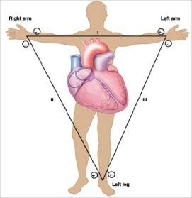

After ca. 60 seconds recording, stand up actively and resume recording for another 60 seconds.

Consider 5 seconds recording before and during standing.

Identify each cardiac cycle in the 5-seconds window before standing. Use the I-beam tool to select the region between an R-peak from the ECG and PPG-peak for each cardiac cycle. Read the time difference using the Delta-T measurement, as corresponding PTT in milliseconds. Calculate the average PTT for all cardiac cycles in the 5-seconds window before standing. Apply the formula $MAP=246-0.4∙PTT$ and calculate the mean arterial pressure.

Do the same for the –seconds time window during standing.

Calculate the percentage decrease in arterial blood pressure as follows: 100*(pressure during standing – pressure before standing)/pressure before standing.

Normally the drop in arterial pressure should trigger the baroreflex. As consequence an increased in blood pressure follows the initial decrease.

|  |  |  |  |  |  |
| --- | --- | --- | --- | --- | --- |
|  | | PTT | Mean PTT | MAP | % |
| Sitting | 1 |  |  |  |  |
| 2 |  |
| 3 |  |
| 4 |  |
| 5 |  |
| Standing | 1 |  |  |  |
| 2 |  |
| 3 |  |
| 4 |  |
| 5 |  |

1. Mental arithmetic, e.g. reverse counting should trigger a stress response that can be observed on the activity of sweat glands in the skin of fingers. A stress factor can be defined as the percentage increase of some physiological values related to the sweat glands activity. **Propose a specific measure of stress using a measurable biological signal and determine your stress factor during a 2 minutes reverse counting exercise (e.g. from 211, step 13). - 12**

Connect a Biopac SS3LA transducer in the third channel.

Configure Biopac Student Lab as follows:

* Sampling rate 500 Hz
* Analog Channel CH3 should have the preset *EDA (0 - 35 Hz).*

Instrument yourself and start recording.

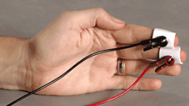

After ca. 60 seconds recording, mentally reverse count from 211 with step 13 during 120 seconds.

Stop recording.

Define stress factor as percentage increase of baseline level of skin conductance (SCL) and percentage increase of Non-specific Spontaneous Fluctuations (NSF).

Use the I-beam tool to select the 60-seconds region before mental arithmetic in channel CH3. Calculate the mean value of the signal as SCLrest.

Use the I-beam tool to select the 120-seconds region during mental arithmetic in channel CH3. Calculate the mean value of the signal as SCLstress.

Count Non-specific Spontaneous Fluctuations in the region before mental arithmentic as NSFrest.

Count Non-specific Spontaneous Fluctuations in the region during mental arithmentic as NSFstress.

Calculate the stress factor as (100*(SCLstress- SCLrest)/ SCLrest+100*( NSFstress - NSFrest)/ NSFrest)/2

1. The masseter, one of the muscles of mastication is assumed to be the strongest muscle in the body, even stronger than the biceps which lie on the upper arm. **How stronger is your masseter compare to your dominant biceps? - 12**

Connect a Biopac SS2L wire in the fourth channel.

Configure Biopac Student Lab as follows:

* Sampling rate 500 Hz
* Analog Channel CH4 should have the preset *EMG (5 - 250 Hz).*
* Calculation Channel C2 should have the preset *EMG-RMS.*

Instrument your dominant biceps and start recording.

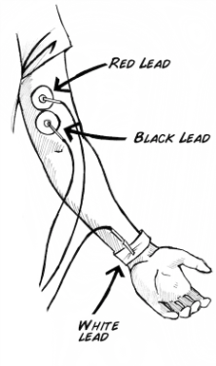 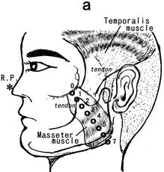 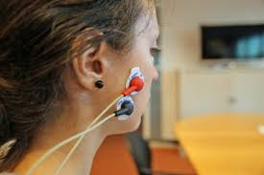

After 60 seconds recording at rest, do a maximal contraction of the biceps and record another 5 seconds.

Stop recording.

Using the I-beam tool, select the region of C2 channel corresponding to the 60-seconds rest, calculate the mean value of the signal as RMSrest. Select the region corresponding to the 5-seconds contraction of biceps and calculate the mean value as RMSforce.

Calculate the percentage increase as an indicator of force development in the biceps: 100*(RMSforce-RMSrest)/RMSrest.

Repeat the same procedure for the masseter muscle.

Compare both indicators and determine how stronger the masseter compare to biceps is.

Alternatively compare the RMSforce of the biceps to 10 times the RMSforce of the masseter, assuming that the masseter is 10 times smaller than the biceps.

1. During Rapid Eye Blinking Test for detecting drugs abuse and myasthenia gravis (eye muscles fatigue), the subject continuously blinks both eyes simultaneously as fast as he can, for 60 seconds. **What are the total number of your eye blinks and the average duration of each blink? – 12**

Connect a Biopac SS2L wire in the fourth channel.

Configure Biopac Student Lab as follows:

* Sampling rate 500 Hz
* Analog Channel CH4 should have the preset *Electrooculogram EOG (.5-35 Hz)*

Instrument one eye and start recording.

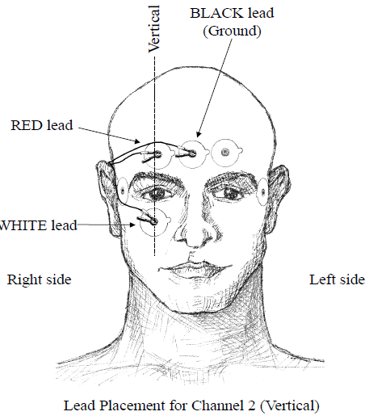

After 60 seconds recording at rest, blinks both eyes simultaneously as fast as you can, and record another 60 seconds.

Stop recording.

Using the I-beam tool, select the first peak in the EOG signal in the rapid-blinking phase. Choose menu Transform->Find Peak, set the peak threshold to the smallest peak amplitude. Click OK. Now press CTL-E to find the next peaks, repeat and count until the period of 60-sec rapid-blinking is over. The number you obtain is the total number of your eye blinks. Now divide that number by 60 in order to obtain the average duration of each blink in seconds.