**Czech Technical University in Prague – Faculty of Biomedical Engineering**

**Biological Signals Processing – Summer Term 2014 – Michel Kana, PhD**

**Entrance Test – 18.2.2014**

**Name:** ___________________________

1. **Identify the following biological signals (PPG, EEG, EOG, EMG, ECG, GSR) and give their full names**

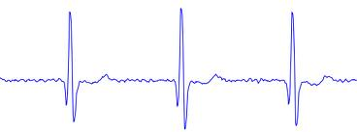 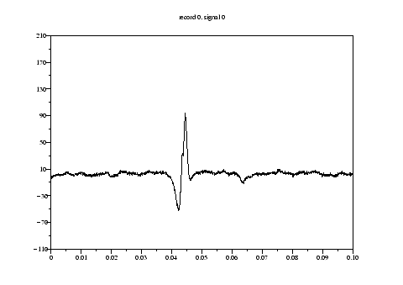 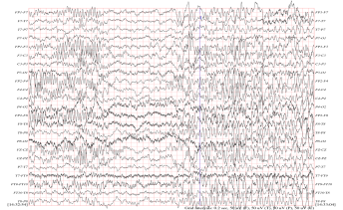

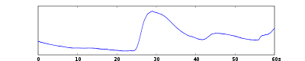 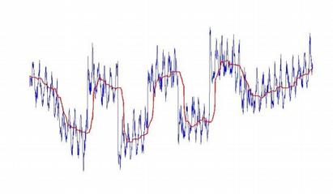 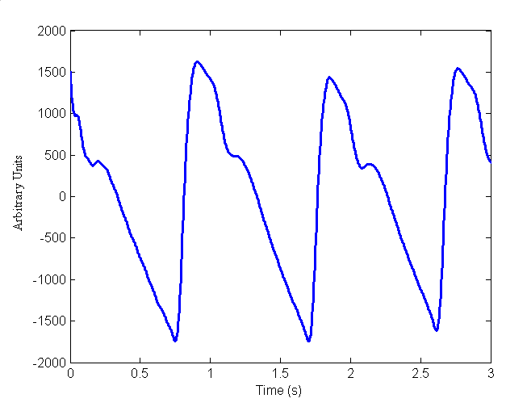

1. **Annotate the following ECG signal: name the waves, intervals and segments**

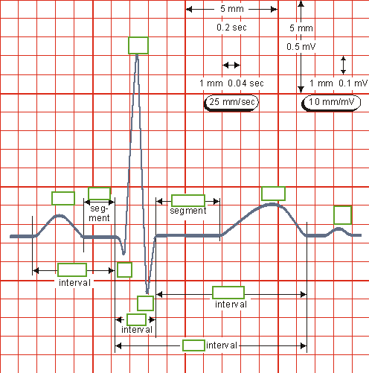

1. **Match the problem with possible algorithms for the solution**

|  |  |  |
| --- | --- | --- |
| ECG baseline wandering removal |  | Wavelet transform and singularity detection |
| Bayesian filtering |
| ECG Denoising | Derivative based algorithm |
| Over-fitting using wavelet approximation |
| Event-related potentials in EEG |  | Adapted wavelet filtering |
| Detection of QRS complex |  | Step-wise discriminant analysis |
|  | Suitable approximation of the baseline |

1. **Name the four basic groups of waves in a normal EEG and their frequency range**
2. **Answer True or False to the following questions**

* It is valid to directly compare the EMG output (e.g., integral) of a muscle across subjects.
* An EMG signal will not necessarily reflect the total amount of force (or torque) a muscle can generate.
* EMG potentials usually range between 50 μV and 30 mV.

1. **Match each signal with standard applications**

|  |  |  |
| --- | --- | --- |
| GSR |  | Monitoring of heart and respiratory rates |
|  | Eye movement measurements |
| PPG |  | Measuring blood pressure |
|  | Emotional arousal |
| EOG |  | electrical conductance of the skin |
|  | Assessment of cardiac output |

1. **Name the four nucleotides present in human deoxyribonucleic acid**
2. **Mark the following sequences as a protein, DNA or RNA sequence**

QERLDCHGFAFFGWDWWNGPRAVKSTQIITRKWFDITNNKCDEDTNKSGYKDLVSICQTG

ACAAGATGCCATTGTCCCGGCCTCCTGCTGCTGCTGCTCTCCGGGGCCACGGGCTCTGAA

AACUUCUUCUGGAAGACCUUCUCCUCCUGCAAAUAAAACCUCACCCAUGAAUGCUCACGC

1. **Shortly define the following terms**

Sampling frequency:

LTI system:

Heart rate variability:

Low-pass filter:

1. **Write a simple Matlab function that calculates the heart rate from a PPG signal**