**Czech Technical University in Prague – Faculty of Biomedical Engineering**

**Modeling and Simulation – Summer Term 2014 – Michel Kana, PhD**

**Entrance Test Solution – 18.2.2014**

**Name:** ___________________________

1. **Identify the following biological signals (PPG, EEG, EOG, EMG, ECG, GSR) and give their full names**

Electrocardiogram Electromyogram Electroencephalogram

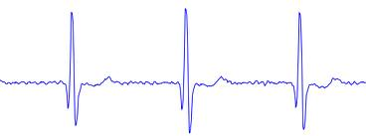 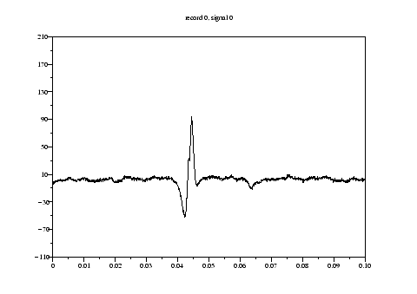 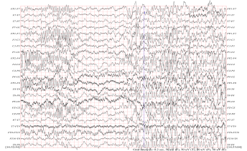

Galvanic skin response Electrooculogram Photoplethysmogram

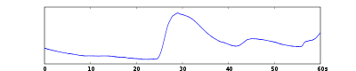 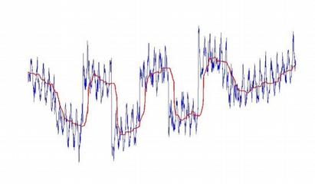 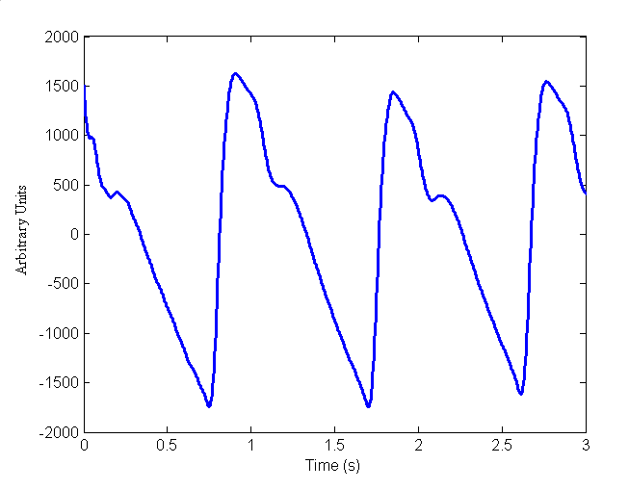

1. **Annotate the following ECG signal: name the waves, intervals and segments**

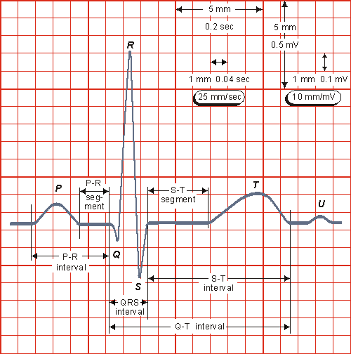

1. **Match the problem with possible algorithms for the solution**

|  |  |  |
| --- | --- | --- |
| ECG baseline wandering removal |  | Wavelet transform and singularity detection |
| Bayesian filtering |
| ECG Denoising | Derivative based algorithm |
| Over-fitting using wavelet approximation |
| Event-related potentials in EEG |  | Adapted wavelet filtering |
| Detection of QRS complex |  | Step-wise discriminant analysis |
|  | Suitable approximation of the baseline |

1. **Name the four basic groups of waves in a normal EEG and their frequency range**

- beta (>13 Hz)

- alpha (8-13 Hz)

- theta (4-8 Hz)

- delta (0.5-4 Hz)

1. **Answer True or False to the following questions**

* It is valid to directly compare the EMG output (e.g., integral) of a muscle across subjects.

False, only normalizing the measurement value against a maximal effort value makes direct comparison possible.

* An EMG signal will not necessarily reflect the total amount of force (or torque) a muscle can generate.

True, electrodes can’t pick-up all motor units that are firing.

* EMG potentials usually range between 50 μV and 30 mV.

True.

1. **Match each signal with standard applications**

|  |  |  |
| --- | --- | --- |
| GSR |  | Monitoring of heart and respiratory rates |
|  | Eye movement measurements |
| PPG |  | Measuring blood pressure |
|  | Emotional arousal |
| EOG |  | Electrical conductance of the skin |
|  | Assessment of cardiac output |

1. **Name the four nucleotides present in human deoxyribonucleic acid**

guanine, adenine, thymine, and cytosine

1. **Mark the following sequences as a protein, DNA or RNA sequence**

QERLDCHGFAFFGWDWWNGPRAVKSTQIITRKWFDITNNKCDEDTNKSGYKDLVSICQTG 🡪 Protein

ACAAGATGCCATTGTCCCGGCCTCCTGCTGCTGCTGCTCTCCGGGGCCACGGGCTCTGAA 🡪 DNA

AACUUCUUCUGGAAGACCUUCUCCUCCUGCAAAUAAAACCUCACCCAUGAAUGCUCACGC 🡪 RNA

1. **Shortly define the following terms**

***Sampling frequency***: number of samples per seconds taken from a continuous signal to make a discrete signal.

***LTI system***: linear time-invariant system, the output is a scaled and summed function of inputs and the output does not depend on time when the input was applied.

***Heart rate variability***: variation in the time interval between heartbeats.

***Low-pass filter***: process that passes low-frequency components of a signal and attenuates or remove components with frequencies higher than the cutoff frequency.

1. **Write a simple Matlab function for removing artifacts from a biological signal, e.g. ECG**



