Assessing the Compute Capacity for Lightweight HTTP Request Workloads
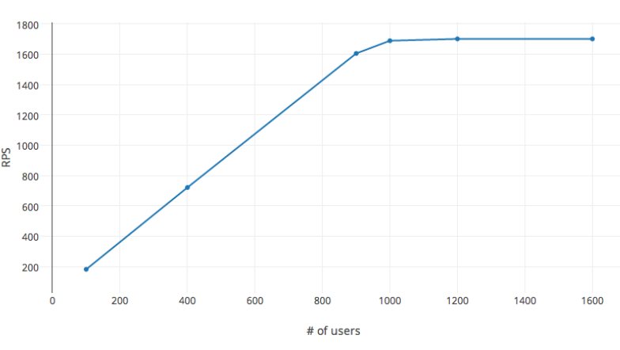
Mosaddek Shaikh
09.04.2026

INTRODUCTION
Using Blazor Server, I developed a single‑feature application capable of generating a modest volume of HTTP requests using one thread, a single HttpClient instance, and one TCP connection. To evaluate performance, the requests that intentionally returned a 404 status code were issued for three compute resources—each representing a server hosting the same application. Every request simply pings the URLs of the Blazor Server app to measure throughput.
The purpose of this application is to support the study of server‑side bottlenecks. Over time, we can connect these findings to horizontal scalability metrics through a dashboard visualization, where Blazor Server technology can be leveraged more effectively.

GitHub Location: https://github.com/Mosaddek-Shaikh/LearnBlazer

Compute Resource | SKU | URLs of the App deployed | Expected range of RPS (Requests Per Second) Supported
Personal Laptop | I9 10 Cores CPU, 64 GB RAM | http://localhost:5169/Learnblazor | 1,000 +
Shared Linux Container at render.com | 512 MB RAM, 1 shared vCPU | TheAppLink  The app is very stable. | Not published by render.com
B1(Basic) Linux VM as defined in the Azure App Service Plan. | 1 vCPU, 1GiB RAM | TheAppLink  Note: The app is stable on-and-off basis due to Azure platform issue. Working on a fix or alternatives now. | 150–350

OBJECTIVE
The objective of this application is to generate HTTP workloads to assess the machine’s capacity to handle a predefined range of load before encountering any bottlenecks—whether caused by a single HttpClient or by the server itself. The selected test range is 500–7000 RPS.

How to decide if any bottleneck is encountered?

As load increases, RPS rises until the compute resource reaches its limit. Beyond that point, throughput begins to flatten because scaling is interrupted by high resource usage, rising latency, or timeout errors (such as 503s). When this occurs, the RPS curve forms a visible plateau.

OBSERVATIONS
Compute Resource 1: Personal Laptop
Based on the screenshot below, the peak throughput of 210 RPS still appears to have additional headroom. No plateau is visible, and no bottleneck has been reached.

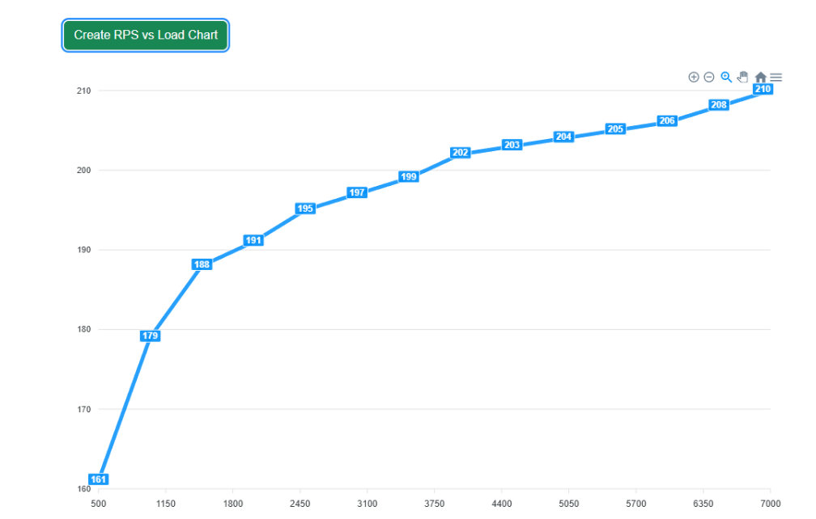
Compute Resource 2: Shared Linux Container at render.com
Based on the screenshot below, the throughput stabilizes at approximately 33 RPS, indicating a clear plateau and confirming that a bottleneck has been reached. Further root‑cause analysis is blocked because the current subscription level restricts access to detailed resource‑usage metrics.
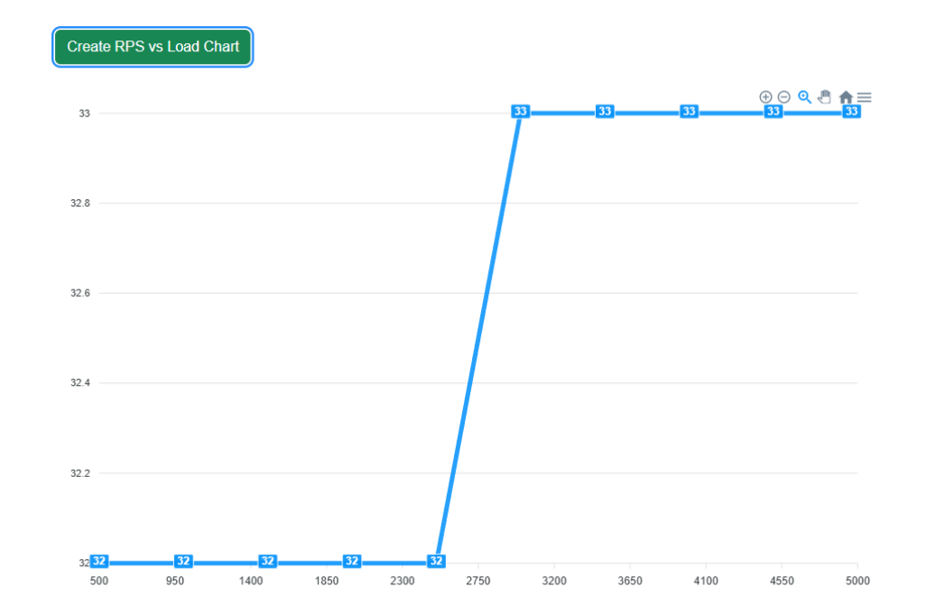

Compute Resource 3: B1(Basic) Linux VM as defined in the Azure App Service Plan.
Based on the screenshot below, the peak throughput of 169 RPS still appears to have additional headroom. No plateau is visible, and no bottleneck has been reached.

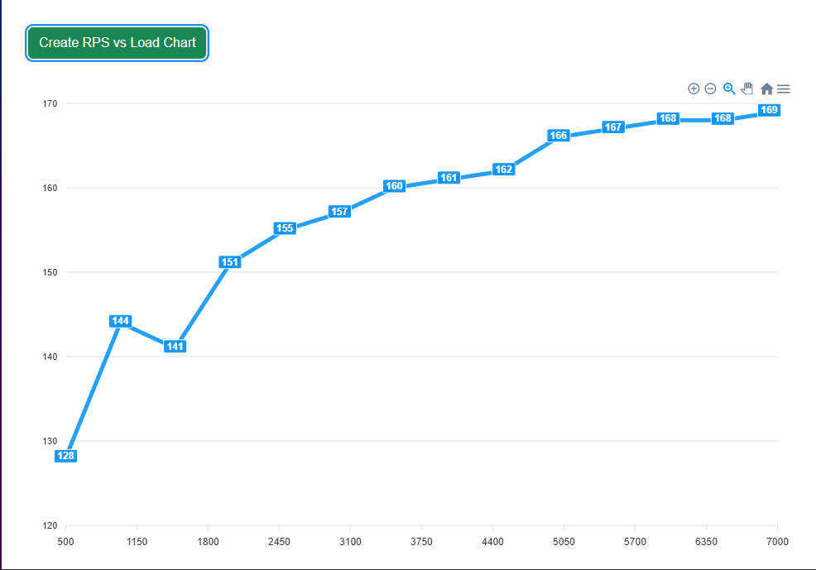

CONCLUSION
Compute Resource | SKU | Actual range of RPS(Requests Per Second) achieved | Has the load test met the objective?
Personal Laptop | I9 10 Cores CPU, 64 GB RAM | 161-210 | Yes
Shared Linux Container at render.com | 512 MB RAM, 1 shared vCPU | 32-34 | No
B1(Basic) Linux VM as defined in the Azure App Service Plan. | 1 vCPU, 1GiB RAM | 128-169 | Yes

Improvement Plan for this feature:
- Enhance the design by using multiple HttpClient instances, parallel threads, and separate TCP connections to increase throughput, evaluate CPU usage, and identify any latency risks. Use these results to pinpoint the server‑side bottleneck.
- Configure horizontal scaling on the App Service Plan or Azure Container app with autoscale rules that monitor increases in incoming HTTP traffic and adjust the instance count accordingly.
- User interaction isn’t required for capacity evaluation. The load‑testing component can be converted into a headless implementation, allowing it to run periodically. One practical approach is to refactor it into a .NET console application that can be executed directly within the CI/CD pipeline.
- Blazor Server excels as a real‑time, high‑value dashboard platform. Dashboard visualizations such as RPS‑versus‑load, RPS‑versus‑time, and charts that illustrate automatic instance scaling—showing how the system avoids bottlenecks—deliver meaningful operational insight for any organization.

