**Topic: Railway Reservation System**

A well-Known railway e-ticket service ‘CNS Limited’ wants us to design their database system. Here is all the information we have.

CNS limited has lot of passenger. Every passenger has name, address, phone number, age, gender and a unique email id. Passenger can create user account. Every account has a unique id and a secure password. Passenger can buy ticket through user account. Ticket has a reservation pin number, an issued date, a specific journey date and different prices. Ticket is identified by ticket no. The off date is also written in the ticket. Ticket gives train info. The train name, starting time and starting station are known by train info. Every Train has a unique train no. Passenger can pay the payment through brac bank card and DBBL card only. Each payment has a unique transaction id. Passenger can also view the train information without buying ticket.

**E-R DIAGRAM**

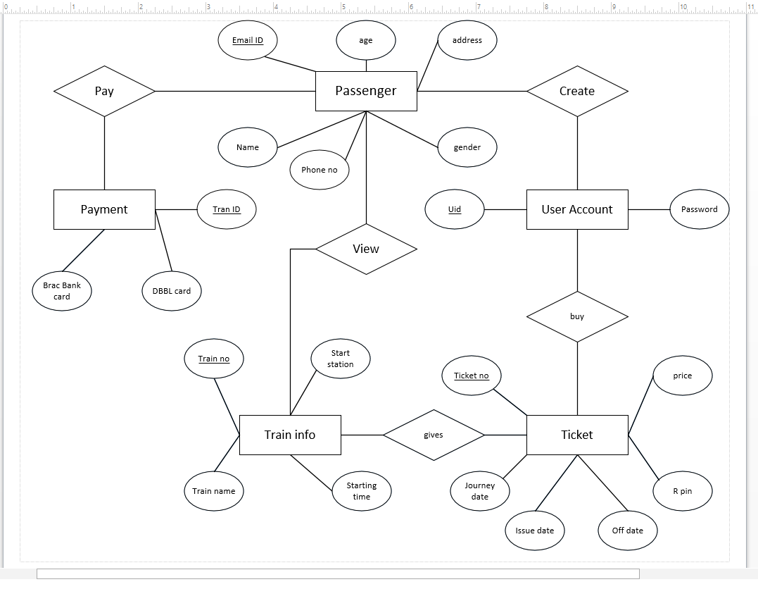

**Normalization:**

***Create:***

**UNF:**

|  |  |  |  |  |  |  |  |
| --- | --- | --- | --- | --- | --- | --- | --- |
| email_id | age | address | name | gender | password | u_id | phone no. |

**1NF:**

Passenger1:

|  |  |  |  |  |  |  |
| --- | --- | --- | --- | --- | --- | --- |
| Email_id | age | address | name | Gender | Phone_no | u_id |

User_account1:

|  |  |
| --- | --- |
| u_id | Password |

**2NF**: same  
  
**3NF**: same  
  
  
***Buy:***  
  
**UNF:**

|  |  |  |  |  |  |  |  |
| --- | --- | --- | --- | --- | --- | --- | --- |
| u_id | password | Ticket_no | price | Journey_date | r_pin | issue_date | Off_date. |

**1NF:**

user_account2:

|  |  |
| --- | --- |
| u_id | Password |

Ticket1:

|  |  |  |  |  |  |  |
| --- | --- | --- | --- | --- | --- | --- |
| Ticket_no | price | Journey_date | R_pin | Issue_date | Off_date | u_id |

**2NF**: same  
  
**3NF**: same

***View:***

**UNF**:

|  |  |  |  |  |  |  |  |  |  |
| --- | --- | --- | --- | --- | --- | --- | --- | --- | --- |
| Email_id | age | address | gender | name | phone no | Train_no | start_station | starting time | train name. |

Passenger2:

|  |  |  |  |  |  |  |
| --- | --- | --- | --- | --- | --- | --- |
| Email_id | age | address | gender | name | Phone_no | train_no |

Train1:

|  |  |  |  |
| --- | --- | --- | --- |
| Train_no | Starting_station | Starting_time | Train_name. |

**2NF**: Same

**3NF**: Same

***Gives:***

**UNF**:

|  |  |  |  |  |  |  |  |  |  |
| --- | --- | --- | --- | --- | --- | --- | --- | --- | --- |
| Ticket_no | price | R pin | off_date | issue_date | journey_date | start_station | starting_time | train_no | train_name. |

**1NF:**

Train2:

|  |  |  |  |
| --- | --- | --- | --- |
| Train no | train_name | start_station | starting_time. |

Ticket2:

|  |  |  |  |  |  |  |
| --- | --- | --- | --- | --- | --- | --- |
| Ticket_no | price | r_pin | off_date | issue_date | journey_date | train_no |

***Pay:***

**UNF:**

Email_id, age, address, gender, phone_no, name, brac_bank_card,DBBL_card, Tran_id.

Payment:

|  |  |  |
| --- | --- | --- |
| tran id | brac_bank_card | DBBL_card. |

Passenger3:

|  |  |  |  |  |  |  |
| --- | --- | --- | --- | --- | --- | --- |
| Email id | age | address | gender | phone_no | name | tran_id |

**2NF**: same

**3NF**: same

***Table Creation:***

**Create:**

create table passenger1(email_id varchar2(20),name varchar2(20)not null,address

varchar2(30)not null,gender varchar2(20),phone_no number(11)unique,u_id number(20))

alter table passenger1 add constraint pass1 primary key(email_id)

alter table passenger1 add constraint pass2 check gender(in('male','female'))

alter table passenger1 add constraint pass3 foreign key(u_id) references user_account1(u_id)

create table user_account1(u_id number(20),password number(20)not null)

alter table user_account1 add constraint user1 primary key(u_id)

**Buy:**

create table user_account2(u_id number(20),password number(20)not null)

alter table user_account2 add constraint user2nd1 primary key(u_id)

create table ticket1(ticket_no number(20),price number(20)not null,journey_date varchar2(20)not null,r_pin number(20)not null,issue_date varchar2(20),off_date varchar2(20),u_id number(20))

alter table ticket1 add constraint tic1 primary key(ticket_no)

alter table ticket1 add constraint tic2 foreign key(u_id) references user_account2(u_id)

**View:**

create table passenger2(email_id varchar2(20),name varchar2(20)not null,address varchar2(30)not null,gender varchar2(20),phone_no number(11)unique,train_no number(20))

alter table passenger2 add constraint pass2nd1 primary key(email_id)

alter table passenger2 add constraint pass2nd2 check (gender in('male','female'))

alter table passenger2 add constraint pass2nd3 foreign key(train_no) references train1(train_no)

create table train1(train_no number(20),starting_station varchar2(20),starting_time varchar2(20),train_name varchar2(20)unique)

alter table train1 add constraint tra1 primary key(train_no)

**Gives:**

create table train2(train_no number(20),starting_station varchar2(20),starting_time varchar2(20),train_name varchar2(20)unique)

alter table train2 add constraint tra2nd1 primary key(train_no)

create table ticket2(ticket_no number(20),price number(20)not null,journey_date varchar2(20)not null,r_pin number(20)not null,issue_date varchar2(20),off_date varchar2(20),train_no number(20))

alter table ticket2 add constraint tic2nd1 primary key(ticket_no)

alter table ticket2 add constraint tic2nd2 foreign key(train_no) references train2(train_no)

**Pay:**

create table payment(tran_id number(20),brac_bank_card number(20),DBBL_card number(20))

alter table payment add constraint pay1 primary key(tran_id)

create table passenger3(email_id varchar2(20),name varchar2(20)not null,address varchar2(30)not null,gender varchar2(20),phone_no number(11)unique,tran_id number(20))

alter table passenger3 add constraint pass3rd1 primary key(email_id)

alter table passenger3 add constraint pass3rd2 check (gender in('male','female'))

alter table passenger3 add constraint pass3rd3 foreign key(tran_id) references payment(tran_id)

***Data input:***

insert into passenger1(email_id,name,address,gender,phone_no,u_id) values('Samiur@gmail.com','Samiur','Rangpur','male',01758037522,100000)

insert into passenger1(email_id,name,address,gender,phone_no,u_id) values('Sajid@gmail.com','Sajid','Chuadanga','male',01758000000,100001)

insert into passenger1(email_id,name,address,gender,phone_no,u_id) values('Shadman@gmail.com','Shadman','Dhaka','male',01758000001,100002)

insert into passenger1(email_id,name,address,gender,phone_no,u_id) values('Ismita@gmail.com','Ismita','Rangpur','female',01758000002,100003)

insert into passenger1(email_id,name,address,gender,phone_no,u_id) values('Rupanzel@gmail.com','Rupanzel','Dhaka','female',01758000003,100004)

select * from passenger1

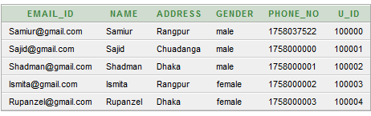

insert into user_account1 values(100000,500000)

insert into user_account1 values(100001,500001)

insert into user_account1 values(100002,500002)

insert into user_account1 values(100003,500003)

insert into user_account1 values(100004,500004)

select * from user_account1

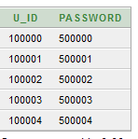

insert into user_account2(u_id,password)values(100000,500000)

insert into user_account2(u_id,password)values(100001,500001)

insert into user_account2(u_id,password)values(100002,500002)

insert into user_account2(u_id,password)values(100003,500003)

insert into user_account2(u_id,password)values(100004,500004)

select * from user_account2



insert into ticket1(ticket_no,price,journey_date,r_pin,issue_date,off_date,u_id) values(100,750,'24/09/2017',4343,'20/09/2017','Sunday',100000)

insert into ticket1(ticket_no,price,journey_date,r_pin,issue_date,off_date,u_id) values(101,850,'25/09/2017',4344,'19/09/2017','Monday',100001)

insert into ticket1(ticket_no,price,journey_date,r_pin,issue_date,off_date,u_id) values(102,950,'26/09/2017',4345,'18/09/2017','Tuesday',100002)

insert into ticket1(ticket_no,price,journey_date,r_pin,issue_date,off_date,u_id) values(103,1050,'27/09/2017',4346,'17/09/2017','Wednesday',100003)

insert into ticket1(ticket_no,price,journey_date,r_pin,issue_date,off_date,u_id) values(104,1150,'28/09/2017',4347,'16/09/2017','Thursday',100004)

select * from ticket1

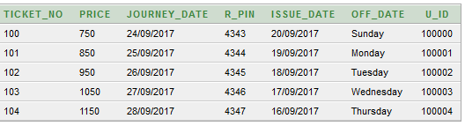

insert into train1(train_no,starting_station,starting_time,train_name) values(700,'Rangpur','8 pm','Rangpur express')

insert into train1(train_no,starting_station,starting_time,train_name) values(701,'Khulna','10 pm','Khulna express')

insert into train1(train_no,starting_station,starting_time,train_name) values(702,'Bogra','7 pm','Bogra express')

insert into train1(train_no,starting_station,starting_time,train_name) values(703,'Dinajpur','9 pm','Dinajpur express')

insert into train1(train_no,starting_station,starting_time,train_name) values(704,'Rajshahi','11 pm','Rajshahi express')

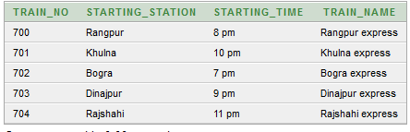

insert into passenger2(email_id,name,address,gender,phone_no,train_no) values('Samiur@gmail.com','Samiur','Rangpur','male',01758037522,700)

insert into passenger2(email_id,name,address,gender,phone_no,train_no) values('Sajid@gmail.com','Sajid','Chuadanga','male',01758000000,701)

insert into passenger2(email_id,name,address,gender,phone_no,train_no) values('Shadman@gmail.com','Shadman','Dhaka','male',01758000001,702)

insert into passenger2(email_id,name,address,gender,phone_no,train_no) values('Ismita@gmail.com','Ismita','Rangpur','female',01758000002,703)

insert into passenger2(email_id,name,address,gender,phone_no,train_no) values('Rupanzel@gmail.com','Rupanzel','Dhaka','female',01758000003,704)

select * from passenger2

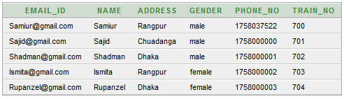

insert into train2(train_no,starting_station,starting_time,train_name) values(700,'Rangpur','8 pm','Rangpur express')

insert into train2(train_no,starting_station,starting_time,train_name) values(701,'Khulna','10 pm','Khulna express')

insert into train2(train_no,starting_station,starting_time,train_name) values(702,'Bogra','7 pm','Bogra express')

insert into train2(train_no,starting_station,starting_time,train_name) values(703,'Dinajpur','9 pm','Dinajpur express')

insert into train2(train_no,starting_station,starting_time,train_name) values(704,'Rajshahi','11 pm','Rajshahi express')

select * from train2

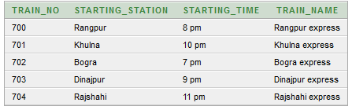

insert into ticket2(ticket_no,price,journey_date,r_pin,issue_date,off_date,train_no) values(100,750,'24/09/2017',4343,'20/09/2017','Sunday',700)

insert into ticket2(ticket_no,price,journey_date,r_pin,issue_date,off_date,train_no) values(101,850,'25/09/2017',4344,'19/09/2017','Monday',701)

insert into ticket2(ticket_no,price,journey_date,r_pin,issue_date,off_date,train_no) values(102,950,'26/09/2017',4345,'18/09/2017','Tuesday',702)

insert into ticket2(ticket_no,price,journey_date,r_pin,issue_date,off_date,train_no) values(103,1050,'27/09/2017',4346,'17/09/2017','Wednesday',703)

insert into ticket2(ticket_no,price,journey_date,r_pin,issue_date,off_date,train_no) values(104,1150,'28/09/2017',4347,'16/09/2017','Thursday',704)

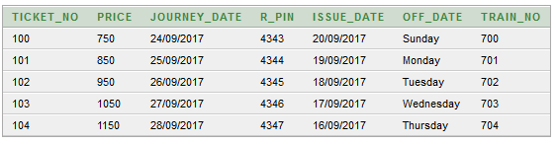

insert into payment(tran_id,brac_bank_card) values(1111,11110000)

insert into payment(tran_id,DBBL_card) values(2222,22220000)

insert into payment(tran_id,brac_bank_card) values(3333,33330000)

insert into payment(tran_id,DBBL_card) values(4444,44440000)

insert into payment(tran_id,brac_bank_card) values(5555,55550000)

select * from payment

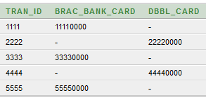

insert into passenger3(email_id,name,address,gender,phone_no,tran_id) values('Samiur@gmail.com','Samiur','Rangpur','male',01758037522,1111)

insert into passenger3(email_id,name,address,gender,phone_no,tran_id) values('Sajid@gmail.com','Sajid','Chuadanga','male',01758000000,2222)

insert into passenger3(email_id,name,address,gender,phone_no,tran_id) values('Shadman@gmail.com','Shadman','Dhaka','male',01758000001,3333)

insert into passenger3(email_id,name,address,gender,phone_no,tran_id) values('Ismita@gmail.com','Ismita','Rangpur','female',01758000002,4444)

insert into passenger3(email_id,name,address,gender,phone_no,tran_id) values('Rupanzel@gmail.com','Rupanzel','Dhaka','female',01758000003,5555)

select * from passenger3

