Web Development
Website Project Proposal
Part 1 — Discovery & Planning
Two Candidate Organisations, Compared
Full Name: Nthakgeng Mosana
Student Number: ST10495862
Group: 1
Date: 2026/09/17

Table of Contents
Introduction
Proposal 1 — Paws & Hearts Animal Rescue (Non-Profit Organisation)
1. Snapshot · 2. Where They Stand Today · 3. What We're Aiming For
4. Site Map & Features · 5. Look, Feel & Layout
6. Build Plan · 7. Investment
Proposal 2 — Golden Crust Bakery (Small Business)
1. Snapshot · 2. Where They Stand Today · 3. What We're Aiming For
4. Site Map & Features · 5. Look, Feel & Layout
6. Build Plan · 7. Investment
References

Introduction
Two independent website concepts are set out below, developed side by side so the stronger fit can be carried forward into the build. Proposal 1 looks at Paws & Hearts Animal Rescue, a Johannesburg-based non-profit; Proposal 2 looks at Golden Crust Bakery, a neighbourhood small business. Both organisations are fictional, created solely to satisfy the requirements of this module, and any resemblance to a real business or charity is unintentional.
Each proposal walks through the same seven questions: who the organisation is, where their online presence stands today, what the site needs to achieve, what pages and features get them there, how it should look and feel, how it will be built, and what it will cost. A short recommendation closes the document, naming the organisation that moves forward into the Part 1 HTML build.

Proposal 1

Paws & Hearts Animal Rescue — Non-Profit Organisation

1. Snapshot
Paws & Hearts Animal Rescue started in 2021 as little more than a handful of Johannesburg volunteers fostering animals out of their own homes. Five years on, it runs a small shelter caring for 30 to 40 animals at any given time — but its online presence hasn't caught up with its growth.
Mission: to rescue, rehabilitate and rehome abandoned and injured animals across Johannesburg.
Vision: a Johannesburg where no healthy, treatable animal is turned away for lack of a home.
The site is being built primarily for people ready to adopt, with donors and prospective volunteers as a close second audience.

2. Where They Stand Today
Right now, Paws & Hearts exists online only as a Facebook page, maintained by whichever volunteer has time that week. That comes with real strengths — a loyal, engaged following and frequent photo updates of animals in care — but also real gaps: there is no structured, searchable list of adoptable animals, no dedicated adoption enquiry form, no direct donation link, and contact details are buried somewhere in old posts. Established shelters solve this by giving every adoptable animal its own listing with a photo and a simple way to enquire (TEARS Animal Rescue, 2026); this proposal follows that same logic for Paws & Hearts.

3. What We're Aiming For
Three measurable goals anchor the site. Rather than list them as abstract objectives, each is tied directly to a number the organisation can track after launch:
Target | Success Measure | Why It Matters
15+ / month | Adoption enquiries | Shows the Adopt page is turning browsers into applicants
3+ / month | Volunteer sign-ups | Confirms the Get Involved page is recruiting, not just informing
1.5% of visitors | Donation conversion | Tracks whether the donation ask is clear enough to act on

4. Site Map & Features
Five pages carry the full site, each built around one job to do:
- Home — hero photo, one-line mission statement, an “Adopt Today” button, and a small rotating set of featured animals.
- About Us — the origin story, mission and vision, and a plain explanation of how the day-to-day rescue work happens.
- Adopt — a photo grid of every animal currently available, each showing name, age and species.
- Get Involved — a single form covering three intents at once: adoption enquiries, volunteer sign-up, and donation or sponsorship interest. Field-level validation is added in Part 3.
- Contact — phone, email, and both physical locations (the shelter and the weekend adoption pop-up), plus an embedded map.

5. Look, Feel & Layout
Colour: warm terracotta (#B85C38) on cream — chosen to feel approachable rather than clinical.
Type: a rounded, friendly heading font paired with a plain, highly legible body font (Google Fonts, 2026).
Layout: image-led and mobile-first, since the animals themselves do most of the persuading and most visitors will be on a phone.
Two low-fidelity sketches were produced before any visual design work began, in line with standard early-stage wireframing practice (Nielsen Norman Group, 2020):
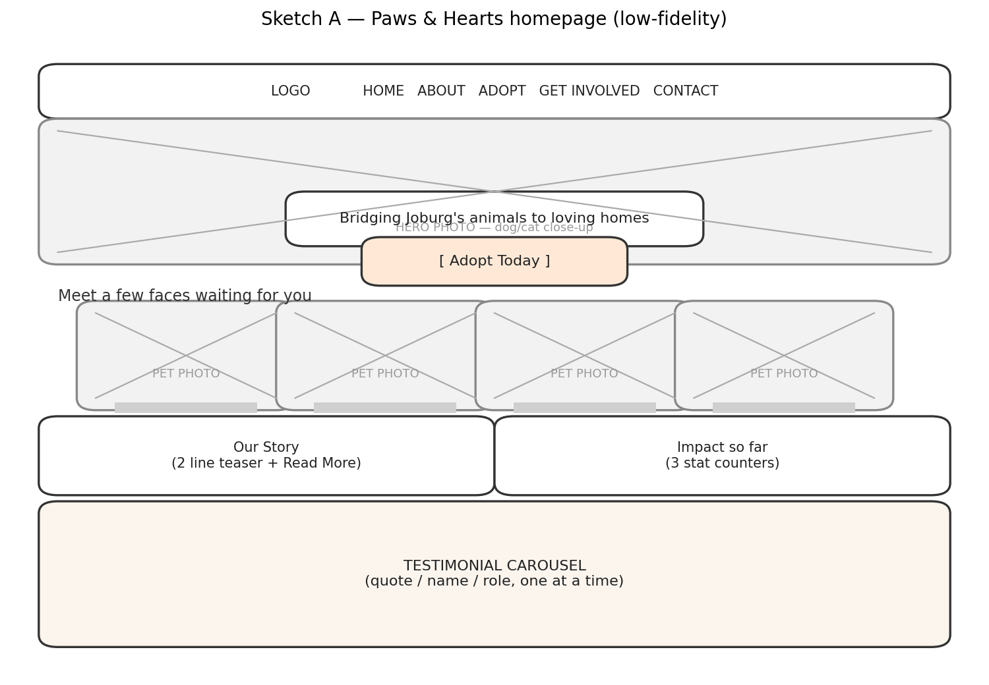
Sketch A — Homepage: hero photo, mission line, call-to-action, four featured-animal cards, story teaser, impact stats, testimonial strip.
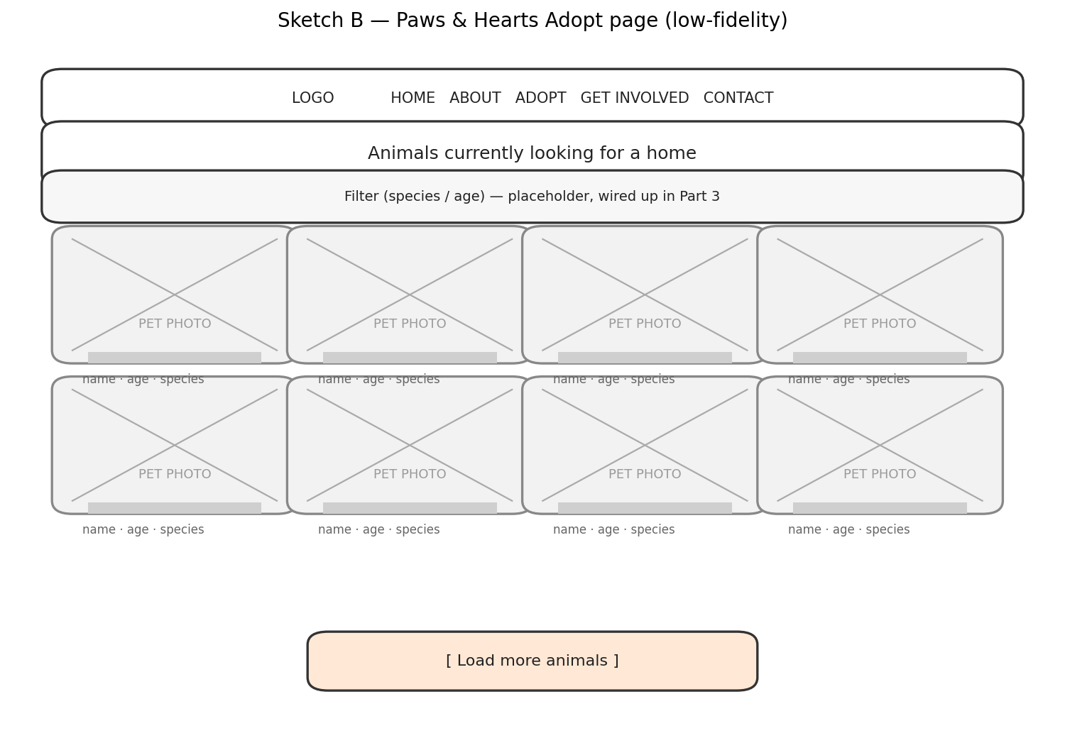
Sketch B — Adopt page: filter row (wired up in Part 3), eight-card photo grid, load-more control.

6. Build Plan
Core languages: HTML, CSS and JavaScript, layered on in that order across the module's three parts.
Hosting: an entry-level South African shared hosting plan, e.g. Afrihost (2026).
Domain: a .org.za domain, since that suffix signals non-profit status to a South African visitor.
Accessibility: semantic HTML landmarks (W3Schools, 2026) plus WCAG 2.2 AA colour contrast, checked before any styling is finalised.
Responsiveness: mobile-first CSS, added in Part 2.
Phase | Focus | Window
Part 1 | Proposal sign-off, folder structure, static HTML pages | 1 – 14 Aug 2026
Part 2 | CSS styling, responsive layout | 14 Aug – 18 Sep 2026
Part 3 | Form validation, dynamic Adopt-page filtering | 18 Sep 2026 – date TBC

7. Investment
Category | Notes | Est. Cost (ZAR)
Domain (.org.za) | Annual renewal | R199
Hosting (entry tier) | R119 × 12 months | R1,428
Imagery / icons | CC0 sources | R0
Development time | In-kind, student developer | R0
Year-one cash outlay: approximately R1,627.
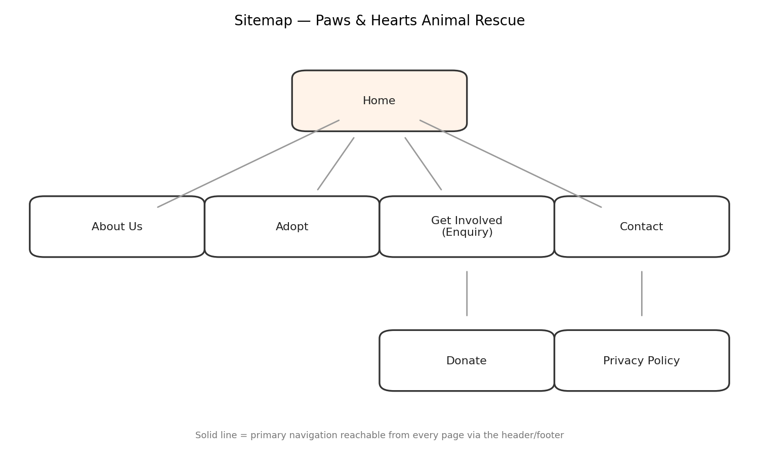
Figure PH-1 — Full sitemap for Paws & Hearts Animal Rescue.

Proposal 2

Golden Crust Bakery — Small Business

1. Snapshot
Golden Crust Bakery has been baking bread, cakes and pastries from the same family recipe for two generations, trading out of a single neighbourhood shop since 2023. Everything it sells moves through word of mouth, which works, but caps how far the business can grow.
Mission: bring fresh, handmade baked goods to the local community every day.
Vision: become the neighbourhood's automatic first choice, for a Tuesday loaf and a milestone birthday cake alike.
Two audiences share the site: everyday local shoppers, and people planning an event who need a custom cake.

2. Where They Stand Today
Golden Crust has no website at all, just a WhatsApp number on a flyer taped to the till. That means no way to check the menu or prices before walking in, no structured way to enquire about a custom cake ahead of an event, and no presence for anyone searching online before they've ever visited in person. For a small food business, that gap between existing and being discoverable is exactly what a simple, photo-led site closes.

3. What We're Aiming For
As with Proposal 1, each goal is tied to a number the owner can actually track:
Target | Success Measure | Why It Matters
20+ / month | Enquiry form submissions | Signals the custom/catering ask is working
150+ / month | Menu page views | Shows people are checking online instead of asking in-store
30%+ of orders | Repeat customer rate | Tracks whether the site builds loyalty, not just one-off visits

4. Site Map & Features
- Home — hero photo, a “View Today's Menu” button, and bestseller cards.
- About Us — the bakery's story and what sets the recipe apart.
- Menu — a full product grid with prices, including a custom-cake starting price.
- Order / Enquire — a short form for custom and catering orders (event date, size, flavour, contact details).
- Contact — both locations (the main store and the weekend market stall), trading hours, and an embedded map.

5. Look, Feel & Layout
Colour: warm brown and gold (#A6743C) on cream — a cosy, appetising palette.
Type: a soft, rounded heading font paired with a clean body font (Google Fonts, 2026).
Layout: photo-led and mobile-first, since most customers check their phone before walking in.
Two low-fidelity sketches map the same two priority pages as Proposal 1, for consistency:
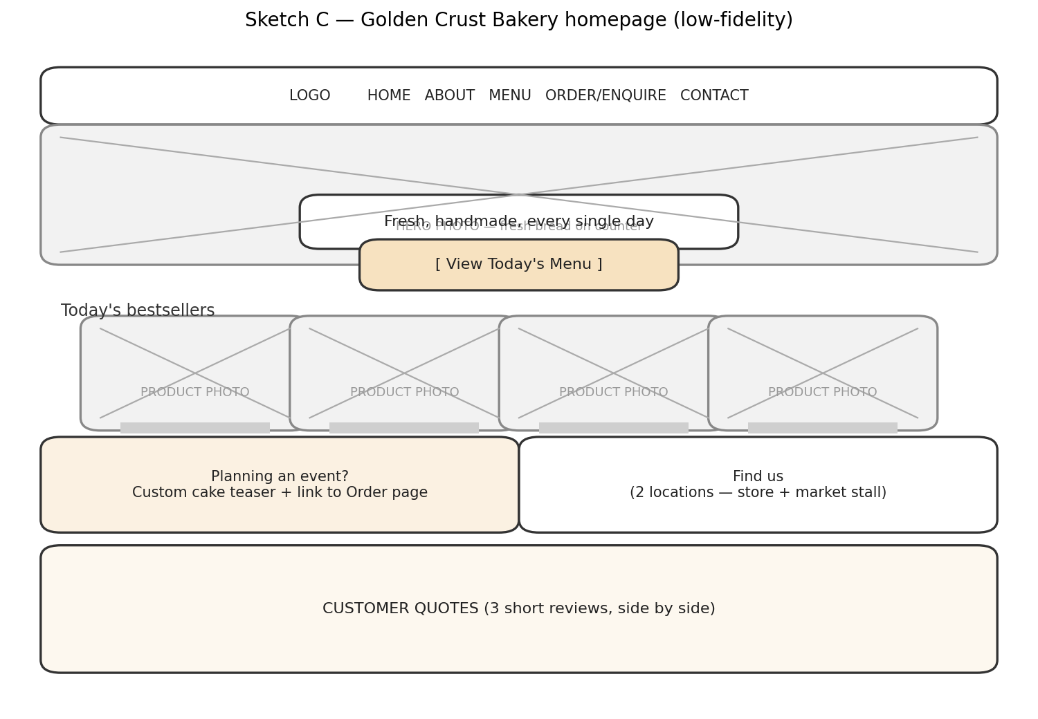
Sketch C — Homepage: hero photo, menu call-to-action, bestseller cards, custom-cake teaser, locations, customer quotes.
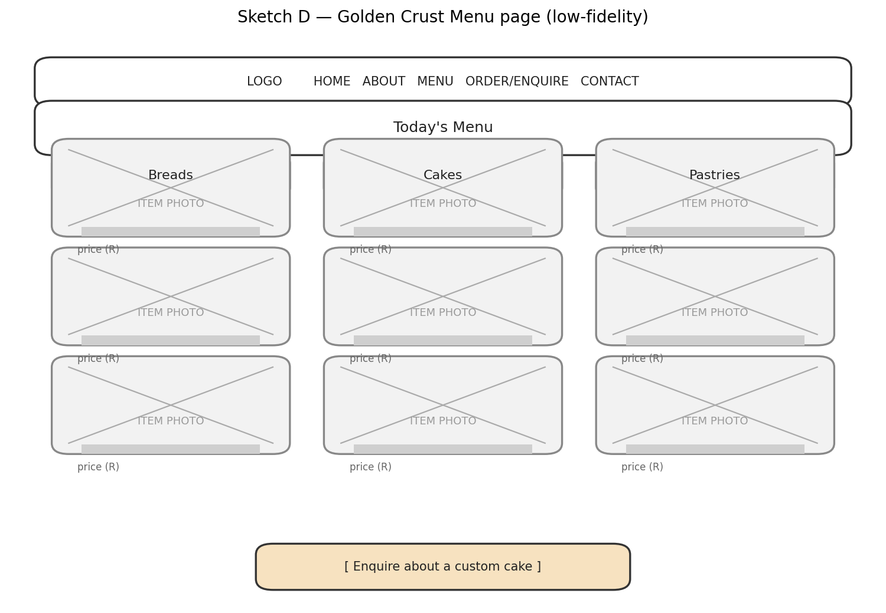
Sketch D — Menu page: three category columns (Breads, Cakes, Pastries), each with photo, name and price.

6. Build Plan
Core languages: HTML, CSS and JavaScript, in that order across the module's three parts.
Hosting: an entry-level South African shared hosting plan, e.g. Afrihost (2026).
Domain: a .co.za domain for local credibility.
Accessibility: semantic HTML landmarks (W3Schools, 2026) plus WCAG 2.2 AA colour contrast.
Responsiveness: mobile-first CSS, added in Part 2.
Phase | Focus | Window
Part 1 | Proposal sign-off, folder structure, static HTML pages | 2 – 14 Aug 2026
Part 2 | CSS styling, responsive layout | 14 Aug – 18 Sep 2026
Part 3 | Enquiry form validation, simple menu filtering | 18 Sep 2026 – date TBC

7. Investment
Category | Notes | Est. Cost (ZAR)
Domain (.co.za) | Annual renewal | R199
Hosting (entry tier) | R119 × 12 months | R1,428
Product photography | Own photos | R0
Development time | In-kind, student developer | R0
Year-one cash outlay: approximately R1,627.
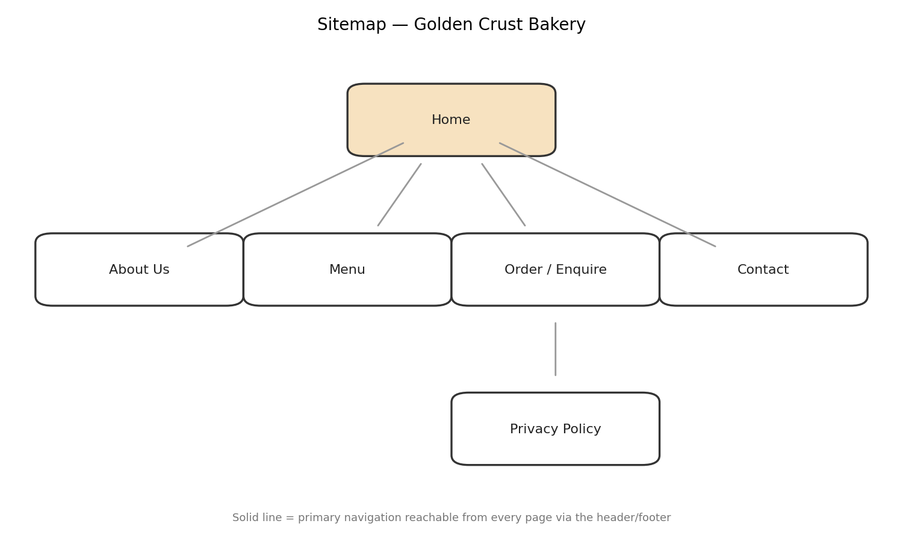
Figure GC-1 — Full sitemap for Golden Crust Bakery.

References
Afrihost, 2026. Web hosting plans. [online] Available at: <https://www.afrihost.com> [Accessed 10 August 2026].
Google Fonts, 2026. Google Fonts. [online] Available at: <https://fonts.google.com> [Accessed 10 August 2026].
Nielsen Norman Group, 2020. Low-fidelity vs. high-fidelity prototyping. [online] Available at: <https://www.nngroup.com> [Accessed 10 August 2026].
TEARS Animal Rescue, 2026. Adopt a pet. [online] Available at: <https://tears.org.za> [Accessed 10 August 2026].
W3C, 2023. Web Content Accessibility Guidelines (WCAG) 2.2. [online] Available at: <https://www.w3.org/TR/WCAG22/> [Accessed 10 August 2026].
W3Schools, 2026. HTML semantic elements. [online] Available at: <https://www.w3schools.com/html/html5_semantic_elements.asp> [Accessed 10 August 2026].

