
SYSTEM HANDBOOK
CampusLearn
High-Level Architecture and Dashboard Plan
Current student experience | Future tutor and admin experience
Running example: Lebo, a Grade 1 learner, needs help counting five apples. We follow Lebo's journey through every layer of CampusLearn.
Version 1.0 | 14 July 2026
Planning documentation only - no tutor or admin dashboard code is included

How to use this guide
This handbook describes the CampusLearn structure as it exists today and provides a high-level blueprint for the next areas: tutor dashboards, admin dashboards and role-based access. It is deliberately written so that a new team member can understand the system before touching the code.
Status labels: CURRENT means the capability is present in the repository. PLANNED means it is a design direction and still needs implementation.

Contents
- 1. The simple story: Lebo needs counting help
- 2. Current solution and folder structure
- 3. How a web request travels through CampusLearn
- 4. Data relationships and booking lifecycle
- 5. Authentication, Entra ID and application roles
- 6. Student, tutor and admin dashboard blueprints
- 7. Recommended future structure and delivery roadmap
- 8. Guardrails, acceptance criteria and glossary

Color key
Color | Meaning
Teal | User interaction or student-facing entry point
Purple | Microsoft Entra ID, roles and security
Blue | Razor Pages and presentation
Orange | PageModel or orchestration
Green | Business services and tutor actions
Navy | Database, admin oversight or durable records

1. The simple story: Lebo needs counting help
Lebo has five toy apples and wants to learn how to count them. CampusLearn behaves like a very organized school that helps Lebo find the right tutor, choose a time and remember the appointment.
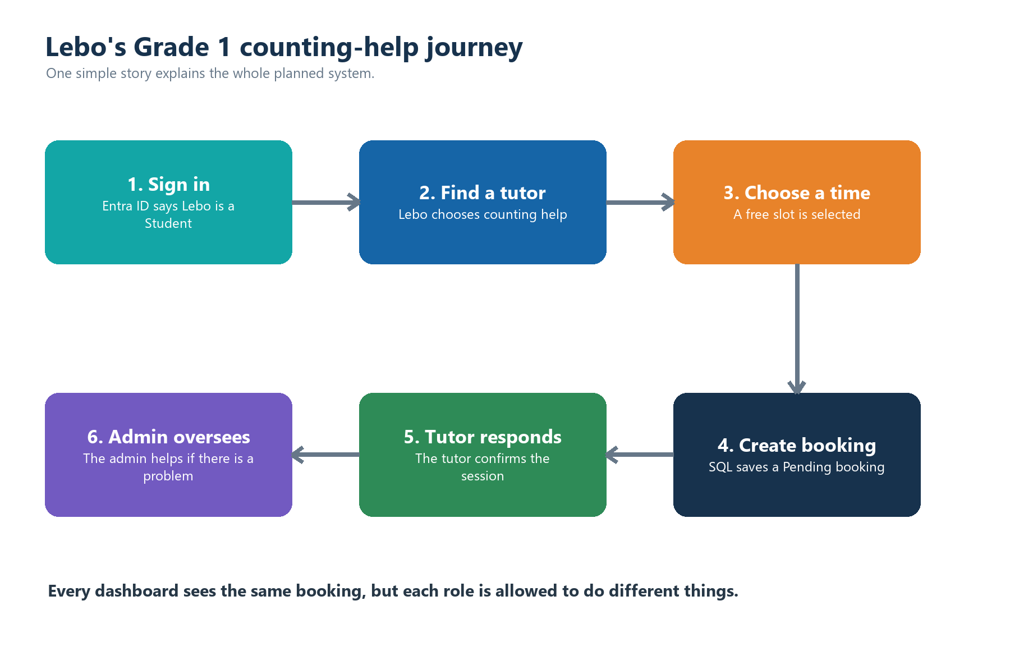
Figure 1. Lebo's journey is the running example used throughout this handbook.

The school analogy
CampusLearn part | Grade 1 explanation
Authentication | The security guard checks Lebo's school badge.
Razor Page | The classroom board shows what Lebo can see and click.
PageModel | The teacher listens to what Lebo asked for.
Service | The school office applies the rules and organizes the request.
Entity / Model | A form describes one real thing: a tutor, time slot or booking.
DbContext | The librarian knows which cupboard contains each form.
SQL Server | The locked filing cupboard remembers everything.
ViewModel | A small show-and-tell card contains only what this screen needs.

2. Current CampusLearn solution
CURRENT: The repository already supports development sign-in, tutor discovery, tutor details, available time slots, booking creation, booking lists, a student dashboard and SQL persistence through Entity Framework Core.

Current functional areas
Area | Responsibility
Account | Sign in, sign out and access denied pages.
Student | A dashboard that greets the current user and previews upcoming bookings.
Tutors | Tutor search, course-module filtering, tutor profiles and available slots.
Bookings | Booking preview, booking creation and the student's booking list.
Data | Entity Framework Core context, entity configuration, migrations and development seed data.
Authentication | Claims-based current-user access plus a development cookie sign-in mode.

Decisions completed during this work
- The shared layout now checks the authenticated ClaimsPrincipal instead of legacy session values.
- Authenticated navigation points to the student dashboard, tutors, bookings and the POST sign-out page.
- The database connection is kept outside committed configuration by using .NET user secrets.
- The Entity Framework command-line tool is installed separately and aligned with the EF Core 10.0.9 project packages.
- Microsoft Entra application roles are the recommended future source for Student, Tutor and Admin authorization.

3. Folder structure and responsibilities
The project follows a layered Razor Pages structure. Pages handle web interaction, services handle business rules, models describe data, and the Data folder connects those models to SQL Server.
Location | Layer | What belongs here
Authentication/ | Identity | Reads Entra claims and exposes the current CampusLearn user.
Data/ | Persistence | Owns ApplicationDbContext, EF mappings and development seeding.
Migrations/ | Database history | Records repeatable changes to the SQL schema.
Models/Entities/ | Domain data | Defines Tutor, Booking, CourseModule and TutorAvailability.
Models/ViewModels/ | Screen data | Carries only the fields required by a particular page.
Pages/ | Presentation | Contains Razor markup and PageModel request handlers.
Services/ | Business logic | Coordinates tutor searches and booking creation.
wwwroot/ | Static assets | Contains CSS, JavaScript, logos, icons and profile images.
Program.cs | Composition root | Registers services, authentication, authorization, Razor Pages and middleware.
appsettings*.json | Configuration | Stores non-secret defaults; secrets override these values locally.

A simplified tree
BC_CampusLearn/
|-- Authentication/ identity and current-user helpers
|-- Data/ DbContext, mappings and seed data
|-- Migrations/ SQL schema history
|-- Models/
| |-- Entities/ durable business records
| `-- ViewModels/ page-shaped data
|-- Pages/
| |-- Account/ sign-in and sign-out
| |-- Student/ current dashboard
| |-- Tutors/ search and profile pages
| |-- Bookings/ create and list bookings
| `-- Shared/ layout and shared partials
|-- Services/ booking and tutor rules
|-- wwwroot/ browser assets
`-- Program.cs application startup and wiring

4. How the folders connect
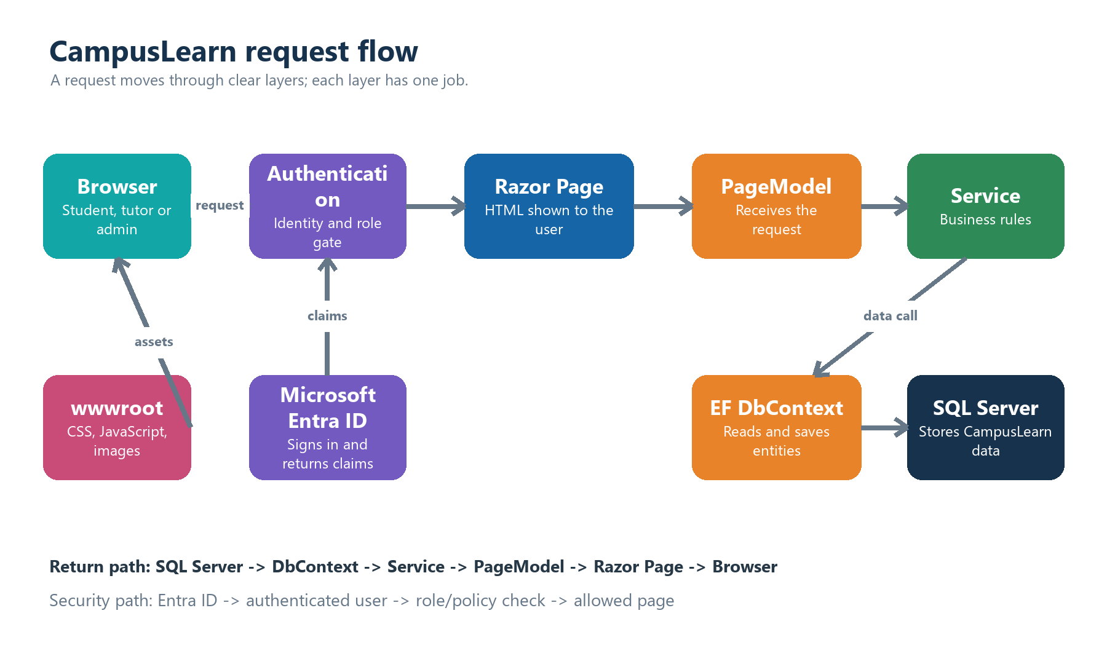
Figure 2. Main application request and response flow.

Rule of dependency
A page should not contain all the business logic, and a service should not know how HTML is drawn. Each layer passes a focused message to the next layer. This makes the system easier to test, change and explain.
- Pages depend on service interfaces and page-specific view models.
- Services depend on ApplicationDbContext and domain entities.
- ApplicationDbContext applies entity configurations and communicates with SQL Server.
- Authentication provides identity and roles before protected pages run.
- wwwroot is delivered directly to the browser and does not contain business rules.

5. One request from click to database
Example: Lebo clicks Confirm booking after selecting a free tutoring time.
- The browser sends a protected POST request to the booking page.
- Authentication confirms that Lebo is signed in. Future authorization will also require the Student role.
- Create.cshtml.cs receives the submitted slot identifier and reason.
- BookingService checks that the slot exists, is active, is not already booked and is still in the future.
- ClaimsCurrentUserService supplies Lebo's Entra object ID, tenant ID, display name and email.
- ApplicationDbContext marks the slot as booked and adds a Pending Booking entity.
- Entity Framework writes both changes to SQL Server in one save operation.
- The browser is redirected to My bookings and displays the saved result.
Concurrency protection: TutorAvailability carries a row-version value, and each slot can have only one booking. This prevents two students from successfully claiming the same slot.

What each file contributes
File type | Contribution to Lebo's booking
.cshtml | Draws the confirmation form and validation messages.
.cshtml.cs | Accepts the request and delegates the business work.
IBookingService | Defines what booking operations are available.
BookingService | Enforces booking rules and creates the record.
Booking / TutorAvailability | Represent the durable data being changed.
ApplicationDbContext | Tracks and saves the changes.
BookingConfiguration | Defines database keys, relationships and limits.

6. Data model
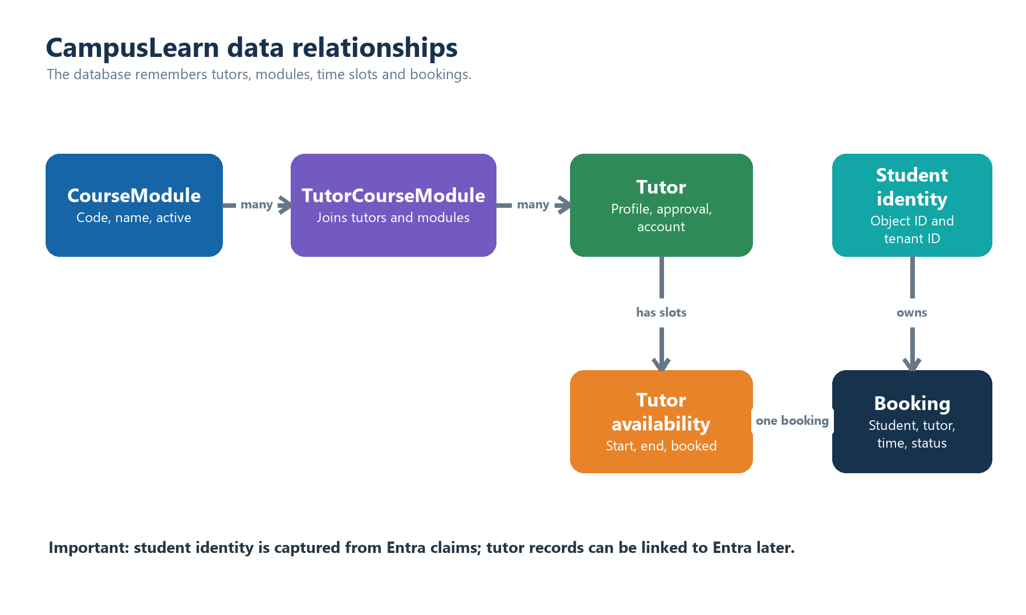
Figure 3. High-level entity relationships.

Entity responsibilities
Entity | Purpose
Tutor | Profile, approval state, active state, modules, availability and bookings.
CourseModule | A subject or course that can be linked to many tutors.
TutorCourseModule | The join record that supports many tutors per module and many modules per tutor.
TutorAvailability | One bookable start/end time with active and booked state.
Booking | The student's selected tutor, slot, reason, time and workflow status.
BookingStatus | Pending, Confirmed, Completed, Cancelled or Declined.

Planned extension: A general ApplicationUser table is optional. Entra remains the source of identity; CampusLearn should store only profile data and business data that the application owns.

7. Authentication and role-based authorization
Authentication answers: Who is this person? Authorization answers: What is this person allowed to do? CampusLearn already authenticates users; the planned dashboard expansion adds Entra application roles for authorization.
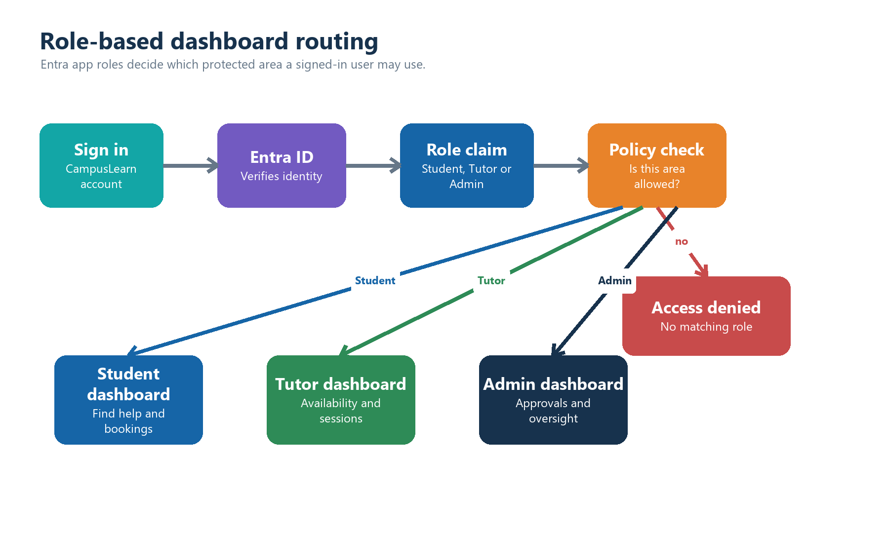
Figure 4. Planned role-based dashboard routing.

Recommended Entra application roles
Role value | Primary area | Main permission boundary
Student | Student dashboard | Browse tutors and manage only the student's own bookings.
Tutor | Tutor dashboard | Manage the linked tutor profile, slots and assigned bookings.
Admin | Admin dashboard | Approve tutors, manage reference data and oversee system activity.

Security principles
- Define roles in the CampusLearn app registration and assign them in the Enterprise application.
- Treat navigation visibility as convenience only; every protected page must also enforce authorization.
- Use the Entra object ID plus tenant ID as the stable external identity key.
- Link a Tutor record to the matching Entra identity before allowing tutor-only actions.
- Give unassigned users an access-denied experience instead of guessing a default role.
- Add matching role claims to development authentication so local testing behaves like Entra sign-in.

8. Dashboard blueprint
PLANNED: Student, tutor and admin dashboards share the same database but expose different information and commands. Role policies are the gate between them.

Shared dashboard pattern
- Identity banner: name, role and clear sign-out action.
- Summary cards: a small number of counts that lead to real lists.
- Priority work: items requiring action now.
- Recent activity: what changed and when.
- Empty states: friendly instructions when there is no data yet.
- Role-safe navigation: show only destinations the current role may use.

Role comparison
Capability | Student | Tutor | Admin
Tutor discovery | Browse | View own public profile | View and manage all
Availability | Choose a free slot | Create and manage own slots | Audit or deactivate
Bookings | View own | Respond to assigned | View and intervene
Tutor approval | No | View own status | Approve, decline, suspend
Modules | Filter tutors | Select taught modules | Create and maintain
Reporting | Personal summary | Own performance | System-wide trends

Dashboard routing rule
After sign-in, the application reads the role claim and sends the user to the matching dashboard. A user with more than one role needs an explicit priority rule or a dashboard switcher; this decision should be made before implementation.

9. Student dashboard
CURRENT FOUNDATION: A student dashboard, tutor browser and booking list already exist. The next work should refine accuracy, permissions and the overall experience.

Primary student jobs
- See the next confirmed or pending tutoring sessions.
- Find an approved active tutor by course module.
- Choose an available slot and create a booking.
- Review booking history and status changes.
- Cancel or reschedule when policy permits.

Suggested student dashboard sections
Section | Shows | Action
Next session | Tutor, module, date, time and status | Open booking details
Upcoming count | True total of future bookings | View all bookings
Tutor finder | Approved active tutors with real availability | Browse or filter
Notifications | Confirmation, decline or schedule changes | Mark as read
Recent history | Completed and cancelled sessions | Review details

Student ownership rule
Every student booking query must filter by both StudentObjectId and StudentTenantId. A student must never be able to view or change another student's booking by changing a URL or form value.

10. Tutor dashboard
PLANNED: A tutor account represents both an Entra identity and one approved Tutor record. Tutor-only actions should fail safely until that link exists.

Primary tutor jobs
- See pending booking requests and respond to them.
- Publish, update or deactivate future availability slots.
- Review today's and this week's confirmed sessions.
- Update permitted profile information and taught modules.
- Mark a session completed and add an appropriate outcome note if required.

Suggested tutor dashboard sections
Section | Shows | Allowed actions
Action queue | Pending booking requests | Confirm or decline
Today's sessions | Confirmed sessions in time order | Open learner/session details
Availability calendar | Open, booked and inactive slots | Add, edit or deactivate
Tutor profile | Biography, modules and profile links | Edit permitted fields
Performance snapshot | Completed sessions and response rate | View only

Tutor ownership rule
Tutor queries must resolve the signed-in Entra identity to exactly one Tutor record. Every slot or booking action must then be restricted to that TutorId; accepting an arbitrary TutorId from the browser is not enough.

11. Admin dashboard and admin side
PLANNED: The admin area is the operational control room. It should manage the system without bypassing auditability, ownership or data-integrity rules.

Admin dashboard overview
Card or queue | Purpose
Tutors awaiting approval | Shows applications that require a decision.
Bookings requiring attention | Highlights conflicts, complaints, declines or stale pending requests.
Active tutors and students | Provides a simple operational health view.
Sessions this week | Shows workload and demand across CampusLearn.
Recent admin activity | Records who approved, suspended or changed important data.

Admin modules
Admin module | High-level responsibility
Tutor approvals | Review profile, identity link and modules; approve, decline or suspend.
User and role view | See application-role assignments and account linkage. Role changes should remain controlled in Entra or through an approved administrative integration.
Course modules | Create, rename, activate or deactivate module reference data.
Booking oversight | Search bookings, investigate conflicts and apply documented intervention rules.
Availability oversight | Identify invalid, duplicate or stale slots; avoid silently editing a tutor's schedule.
Audit log | Record sensitive actions with actor, time, target and reason.
Reports | Demand by module, tutor utilization, booking status and completion trends.
System settings | Manage non-secret business settings and feature controls.

12. Admin permissions and workflow boundaries
Admin does not mean unrestricted database editing. Each administrative action should pass through a named service, validate the target state and create an audit record.

Tutor approval lifecycle
- A prospective tutor profile is created in a Pending state.
- An admin verifies identity linkage, profile details and selected modules.
- The admin approves or declines with a recorded reason.
- Only Approved and Active tutors are visible to students and bookable.
- Suspension hides the tutor and blocks new bookings without destroying history.

Recommended admin policies
Policy | Reason
AdminOnly | Required for all pages under the admin area.
TutorApproval | Separates approval decisions from general read-only admin access if roles expand later.
BookingIntervention | Restricts sensitive booking overrides and requires a reason.
ReportingRead | Allows reporting without granting mutation rights.

Audit rule: For high-impact actions, record who did what, when, to which record and why. The original booking or tutor history should remain explainable.

13. End-to-end example: five apples
This example connects the child-friendly story to the real system design without requiring implementation details.
Stage | What the child sees | What CampusLearn does
1. Identity | Lebo signs in with the school account. | Entra returns identity plus the Student role.
2. Student page | Lebo opens Find a tutor. | The Student policy allows access.
3. Tutor search | Lebo chooses Counting Basics. | TutorService returns approved active tutors linked to that module.
4. Tutor profile | Lebo opens Ms Naledi's profile. | Available future slots are shown.
5. Booking | Lebo chooses tomorrow at 14:00. | BookingService validates and saves a Pending booking.
6. Tutor queue | Ms Naledi sees the request. | The Tutor policy and ownership rule allow a response.
7. Confirmation | Ms Naledi confirms. | The booking becomes Confirmed and Lebo sees the update.
8. Admin view | An admin checks weekly demand. | The Admin policy allows aggregate reporting and audit access.

What changes for each role
The Booking record is shared. Lebo may view the student's copy, Ms Naledi may respond because the booking belongs to her TutorId, and an admin may oversee it because of an Admin policy. The database record is the same; authorization changes the permitted view and actions.
Simple summary: The badge says who you are. The role says which door you may open. The service checks the rules. The database remembers the result.

14. Recommended future folder shape
Keep the existing layered approach and extend it by role and business capability. This is a proposed structure, not implemented code.
Pages/
|-- Student/ Dashboard, booking details, notifications
|-- Tutor/ Dashboard, availability, booking responses, profile
|-- Admin/ Dashboard, tutor approvals, modules, bookings, reports
`-- Shared/ Layout, role-aware navigation and shared components
Services/
|-- Bookings/ Student creation plus tutor/admin workflow operations
|-- Tutors/ Discovery, ownership, profiles and approval lifecycle
|-- Administration/ Oversight, reference data and audit operations
|-- Reporting/ Read-only dashboard summaries
`-- Notifications/ Booking and status-change notifications
Models/
|-- Entities/ Add audit and notification entities only when required
|-- ViewModels/Student/ Student-shaped screen models
|-- ViewModels/Tutor/ Tutor-shaped screen models
`-- ViewModels/Admin/ Admin-shaped screen models

Service design rule
Prefer role-neutral business names where possible. For example, BookingWorkflowService can expose confirm, decline, cancel and complete operations while authorization and ownership determine who may call each operation.

15. High-level delivery roadmap
Phase | Theme | High-level outcome
Phase 1 | Identity foundation | Define Entra app roles, assignments, development role claims, access-denied behavior and role-based navigation.
Phase 2 | Authorization boundaries | Protect Student, Tutor and Admin folders; add ownership checks for bookings, tutors and slots.
Phase 3 | Tutor foundation | Link Entra identities to Tutor records; build tutor dashboard, action queue and availability management.
Phase 4 | Booking workflow | Add confirm, decline, cancel and complete transitions with validation and notifications.
Phase 5 | Admin foundation | Build tutor approval, module management, booking oversight and audit log.
Phase 6 | Reporting and polish | Add accurate counts, performance summaries, accessibility, responsive behavior and test coverage.

Suggested implementation order
- Decide exact role values and whether one person may hold multiple roles.
- Define policy names and ownership rules before designing dashboard buttons.
- Build shared workflow services before duplicating logic across role pages.
- Create tutor capabilities before admin oversight of those capabilities.
- Add audit and reporting after the underlying state transitions are stable.

16. Guardrails and current backlog

Technical guardrails
- Never trust a role, TutorId, StudentObjectId or booking owner supplied by the browser.
- Always query ownership using the authenticated claims and server-side relationships.
- Only Approved and Active tutors with valid future slots should be bookable.
- Use UTC-aware DateTimeOffset values and show times consistently for the user.
- Keep connection strings and Entra secrets out of committed appsettings files.
- Use database constraints and concurrency protection in addition to page validation.
- Keep dashboard counts accurate and separate totals from preview lists.
- Make destructive or high-impact admin actions explicit, confirmed and audited.

Known items from the current review
Item | Why it matters before expansion
Duplicate dashboard navigation | Authenticated users currently have more than one dashboard link in the shared layout.
Booking cancel route | The cancel link must use a tutor identifier, not an availability identifier.
Upcoming count | The dashboard preview is limited to three and should not be presented as the total.
Tutor approval validation | Direct booking requests must also check Tutor.IsApproved and Tutor.IsActive.
Fresh database setup | The team needs one documented migration and seed workflow for new developers.

Definition of done for each dashboard
- The correct role is required on the server, not only in the menu.
- Ownership checks prevent cross-user data access.
- Loading, empty, validation, success and error states are designed.
- Counts match their labels and link to the underlying records.
- Mobile and keyboard navigation are usable.
- Critical services and authorization paths have automated tests.

17. Glossary and team handoff
Term | Plain-language meaning
Authentication | Proving who the user is.
Authorization | Deciding what an authenticated user may do.
Claim | A fact in the signed-in identity, such as object ID, tenant ID or role.
App role | A CampusLearn-specific role defined in Microsoft Entra ID.
Razor Page | A .cshtml screen paired with a PageModel.
PageModel | The server-side request handler for a Razor Page.
Service | A component that applies business rules and coordinates data access.
Entity | A durable business object stored in the database.
ViewModel | A page-specific shape containing only what the page needs.
DbContext | Entity Framework's unit for querying and saving entities.
Migration | A versioned description of a database schema change.
Policy | A named authorization rule, such as AdminOnly.
Ownership check | A server-side rule proving the requested record belongs to the signed-in user.

Local development handoff
The development environment uses a local cookie identity, user secrets for the DefaultConnection value and Entity Framework migrations to build the database. The development identity must gain a configurable role claim when role-based dashboards are implemented.

Final picture
CampusLearn in one sentence: A signed-in learner finds an approved tutor, books a safe time slot, receives a tutor response, and can be supported by an authorized administrator - with every step protected by roles, ownership rules and a shared database record.
End of high-level system handbook

