**Lucrare de laborator nr.3**

**Nume:** Moscalu Daniel Vladimir

1. **Construirea topologiei logice de retea din laboratorul nr2.**
2. **Explicati cum lucreaza protocolul STP in cadrul topologiei curente:**

In cadrul protocolului STP noi putem identifica 3 roluri:

1. **root**(radacina) – este ales switch-ul cu cel mai mic identificator de radacina **BID**(BridgeID) care se seteaza dupa parametrul **priority**. In cazul in care in retea sunt 2 switch-uri cu acelasi nr de prioritate, se va alege ca root switch-ul cu cel mai mic nr de **MAC**.
2. **designated**(desemnat) – portul utilizat pentru a trimite traficul din VLAN catre radacina.
3. **alternate**(alternativ) – este portul de rezerva in cazul in care portul desemnat devine indisponibil.

Comenzile utilizate pentru demonstratie:

* show spanning-tree
* show spanning-tree vlan <vlan-nr>

Aratati cum se deplaseaza packetul ICMP catre server si inapoi fiind transmis de la:

1. PC6

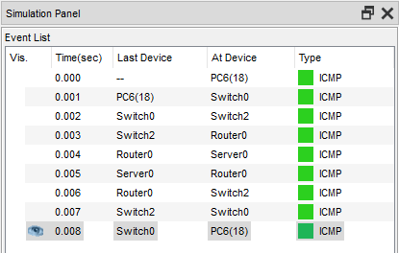

1. PC10

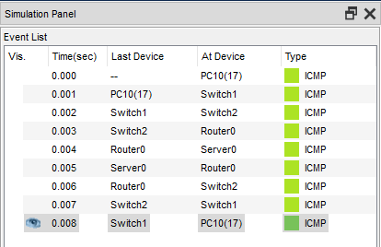

Protocolul STP functioneaza independent pentru fiecare VLAN.

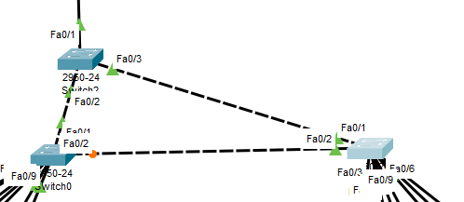

In imaginea de mai sus putem observa ca portul Fa0/2 este alternativ iar switch0 este radacina.

Output de la switch0:

Switch0#show spanning-tree

VLAN0001

Spanning tree enabled protocol ieee

Root ID Priority 32769

Address 0000.0C87.30C3

Cost 19

Port 1(FastEthernet0/1)

Hello Time 2 sec Max Age 20 sec Forward Delay 15 sec

Bridge ID Priority 32769 (priority 32768 sys-id-ext 1)

Address 0090.21D7.54C7

Hello Time 2 sec Max Age 20 sec Forward Delay 15 sec

Aging Time 20

Interface Role Sts Cost Prio.Nbr Type

---------------- ---- --- --------- -------- --------------------------------

Fa0/1 Root FWD 19 128.1 P2p

Fa0/2 Altn BLK 19 128.2 P2p

VLAN0016

Spanning tree enabled protocol ieee

Root ID Priority 32784

Address 0000.0C87.30C3

Cost 19

Port 1(FastEthernet0/1)

Hello Time 2 sec Max Age 20 sec Forward Delay 15 sec

Bridge ID Priority 32784 (priority 32768 sys-id-ext 16)

Address 0090.21D7.54C7

Hello Time 2 sec Max Age 20 sec Forward Delay 15 sec

Aging Time 20

Interface Role Sts Cost Prio.Nbr Type

---------------- ---- --- --------- -------- --------------------------------

Fa0/1 Root FWD 19 128.1 P2p

Fa0/2 Altn BLK 19 128.2 P2p

Fa0/3 Desg FWD 19 128.3 P2p

Fa0/4 Desg FWD 19 128.4 P2p

VLAN0017

Spanning tree enabled protocol ieee

Root ID Priority 32785

Address 0000.0C87.30C3

Cost 19

Port 1(FastEthernet0/1)

Hello Time 2 sec Max Age 20 sec Forward Delay 15 sec

Bridge ID Priority 32785 (priority 32768 sys-id-ext 17)

Address 0090.21D7.54C7

Hello Time 2 sec Max Age 20 sec Forward Delay 15 sec

Aging Time 20

Interface Role Sts Cost Prio.Nbr Type

---------------- ---- --- --------- -------- --------------------------------

Fa0/5 Desg FWD 19 128.5 P2p

Fa0/6 Desg FWD 19 128.6 P2p

Fa0/7 Desg FWD 19 128.7 P2p

Fa0/1 Root FWD 19 128.1 P2p

Fa0/2 Altn BLK 19 128.2 P2p

VLAN0018

Spanning tree enabled protocol ieee

Root ID Priority 32786

Address 0000.0C87.30C3

Cost 19

Port 1(FastEthernet0/1)

Hello Time 2 sec Max Age 20 sec Forward Delay 15 sec

Bridge ID Priority 32786 (priority 32768 sys-id-ext 18)

Address 0090.21D7.54C7

Hello Time 2 sec Max Age 20 sec Forward Delay 15 sec

Aging Time 20

Interface Role Sts Cost Prio.Nbr Type

---------------- ---- --- --------- -------- --------------------------------

Fa0/8 Desg FWD 19 128.8 P2p

Fa0/9 Desg FWD 19 128.9 P2p

Fa0/1 Root FWD 19 128.1 P2p

Fa0/2 Altn BLK 19 128.2 P2p

1. **Setati root pentru Switch0 in cadrul vlan 16 si 18. Deasemenea pentru Switch1 setati root in cadrul vlan 17.**

Comenzile utilizate:

* config terminal
* interface vlan <nr-la-vlan>
* spanning-tree vlan <nr-la-vlan> root primary
* Switch# show spanning-tree vlan <nr-la-vlan>

Comanda show spanning-tree rulata de pe Switch2 ne arata ce prioritati au Switch-urile 0 si 1 pe vlan-urile 16,17,18:

Switch2#show spanning-tree

VLAN0001

Spanning tree enabled protocol ieee

Root ID Priority 32769

Address 0000.0C87.30C3

This bridge is the root

Hello Time 2 sec Max Age 20 sec Forward Delay 15 sec

Bridge ID Priority 32769 (priority 32768 sys-id-ext 1)

Address 0000.0C87.30C3

Hello Time 2 sec Max Age 20 sec Forward Delay 15 sec

Aging Time 20

Interface Role Sts Cost Prio.Nbr Type

---------------- ---- --- --------- -------- --------------------------------

Fa0/1 Desg FWD 19 128.1 P2p

Fa0/3 Desg FWD 19 128.3 P2p

Fa0/2 Desg FWD 19 128.2 P2p

VLAN0016

Spanning tree enabled protocol ieee

Root ID Priority 24592

Address 0090.21D7.54C7

Cost 19

Port 2(FastEthernet0/2)

Hello Time 2 sec Max Age 20 sec Forward Delay 15 sec

Bridge ID Priority 32784 (priority 32768 sys-id-ext 16)

Address 0000.0C87.30C3

Hello Time 2 sec Max Age 20 sec Forward Delay 15 sec

Aging Time 20

Interface Role Sts Cost Prio.Nbr Type

---------------- ---- --- --------- -------- --------------------------------

Fa0/1 Desg FWD 19 128.1 P2p

Fa0/3 Desg FWD 19 128.3 P2p

Fa0/2 Root FWD 19 128.2 P2p

VLAN0017

Spanning tree enabled protocol ieee

Root ID Priority 24593

Address 0030.F2E6.CE5C

Cost 19

Port 3(FastEthernet0/3)

Hello Time 2 sec Max Age 20 sec Forward Delay 15 sec

Bridge ID Priority 32785 (priority 32768 sys-id-ext 17)

Address 0000.0C87.30C3

Hello Time 2 sec Max Age 20 sec Forward Delay 15 sec

Aging Time 20

Interface Role Sts Cost Prio.Nbr Type

---------------- ---- --- --------- -------- --------------------------------

Fa0/1 Desg FWD 19 128.1 P2p

Fa0/3 Root FWD 19 128.3 P2p

Fa0/2 Desg FWD 19 128.2 P2p

VLAN0018

Spanning tree enabled protocol ieee

Root ID Priority 24594

Address 0090.21D7.54C7

Cost 19

Port 2(FastEthernet0/2)

Hello Time 2 sec Max Age 20 sec Forward Delay 15 sec

Bridge ID Priority 32786 (priority 32768 sys-id-ext 18)

Address 0000.0C87.30C3

Hello Time 2 sec Max Age 20 sec Forward Delay 15 sec

Aging Time 20

Interface Role Sts Cost Prio.Nbr Type

---------------- ---- --- --------- -------- --------------------------------

Fa0/1 Desg FWD 19 128.1 P2p

Fa0/3 Desg FWD 19 128.3 P2p

Fa0/2 Root FWD 19 128.2 P2p

Deplasarea packetului ICMP catre server si inapoi de la:

1. PC6

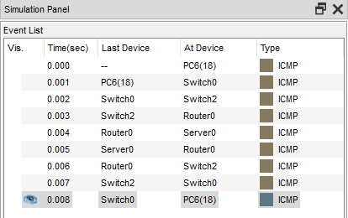

1. PC10

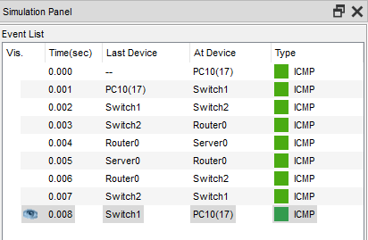

1. PC7

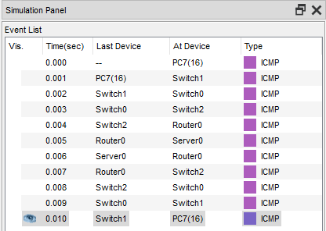

1. **Construieste topologia dupa imagine:**

Comenzile folosite:

1. Switch(config) # int range fa 0/1, fa 0/2
2. channel-group 1 mode active
3. ex
4. interface port-channel 1
5. sw tr enc dot1q (doar pe L3)
6. switchport mode trunk