Task 0 : Explain what you are doing/ going to accomplish

In version 0.1 I will try and set up the base html and networking python functionality.

Task 1: Sketch interface design

*Draft a rough design for the interface that allows the user to trigger functionality in task 1, while also annotating where the information in task 2 will be displayed. Create another sketch listing the interface widgets used to create the interface.*

Task 2: Identify any classes required

*N/A*

Task 3: Identify information to be displayed

*At the moment nothing more that the basic design and layout of the page*

Task 4: Identify user inputs

*N/A*

Task 5: Identify any constants or existing data if required

*N/A*

Task 6: Identify indexed data structures

*N/A*

Task 7: Determine what calculations are necessary

*N/A.*

Task 8: Develop a modular structure for your program

*Describe any functions that the computer program will have, identifying any sub-functions where required.*

Import important bottle functions

Route the page ‘index’ on ‘/’

Def index page function:

Do nothing

Run the website with port ‘399’

Task 9: Define the functions identified

*Describe the functions for both the main program and any classes in terms of input and/or output where required. You may choose to do this with flow charts or pseudo-code (not Python code!). Add in additional steps or explanations using sequential, conditional, iterative statements where required. Identify global and/or local variables.*

N/A

Task 10: Address any relevant implications such as usability, functionality, legal/ethical requirements.

*N/A.*

Task 11: Document test cases for testing the program

*Document any testing that can be used to test your program. If any input is inputted using the keyboard, describe the expected input, plus any exceptional, boundary or invalid cases.*

Tested the running of the program by searching “localhost:399” in browser window. The page opens and is functioning as far as I need

Task 12: Refine the plan

*Note any modifications here when iterating through the development cycles.*

*N/A.* Worked perfectly first try

Task 13: Document testing

*Show screenshots of your program working with descriptions of each image. These images should test the tests cases listed above.*

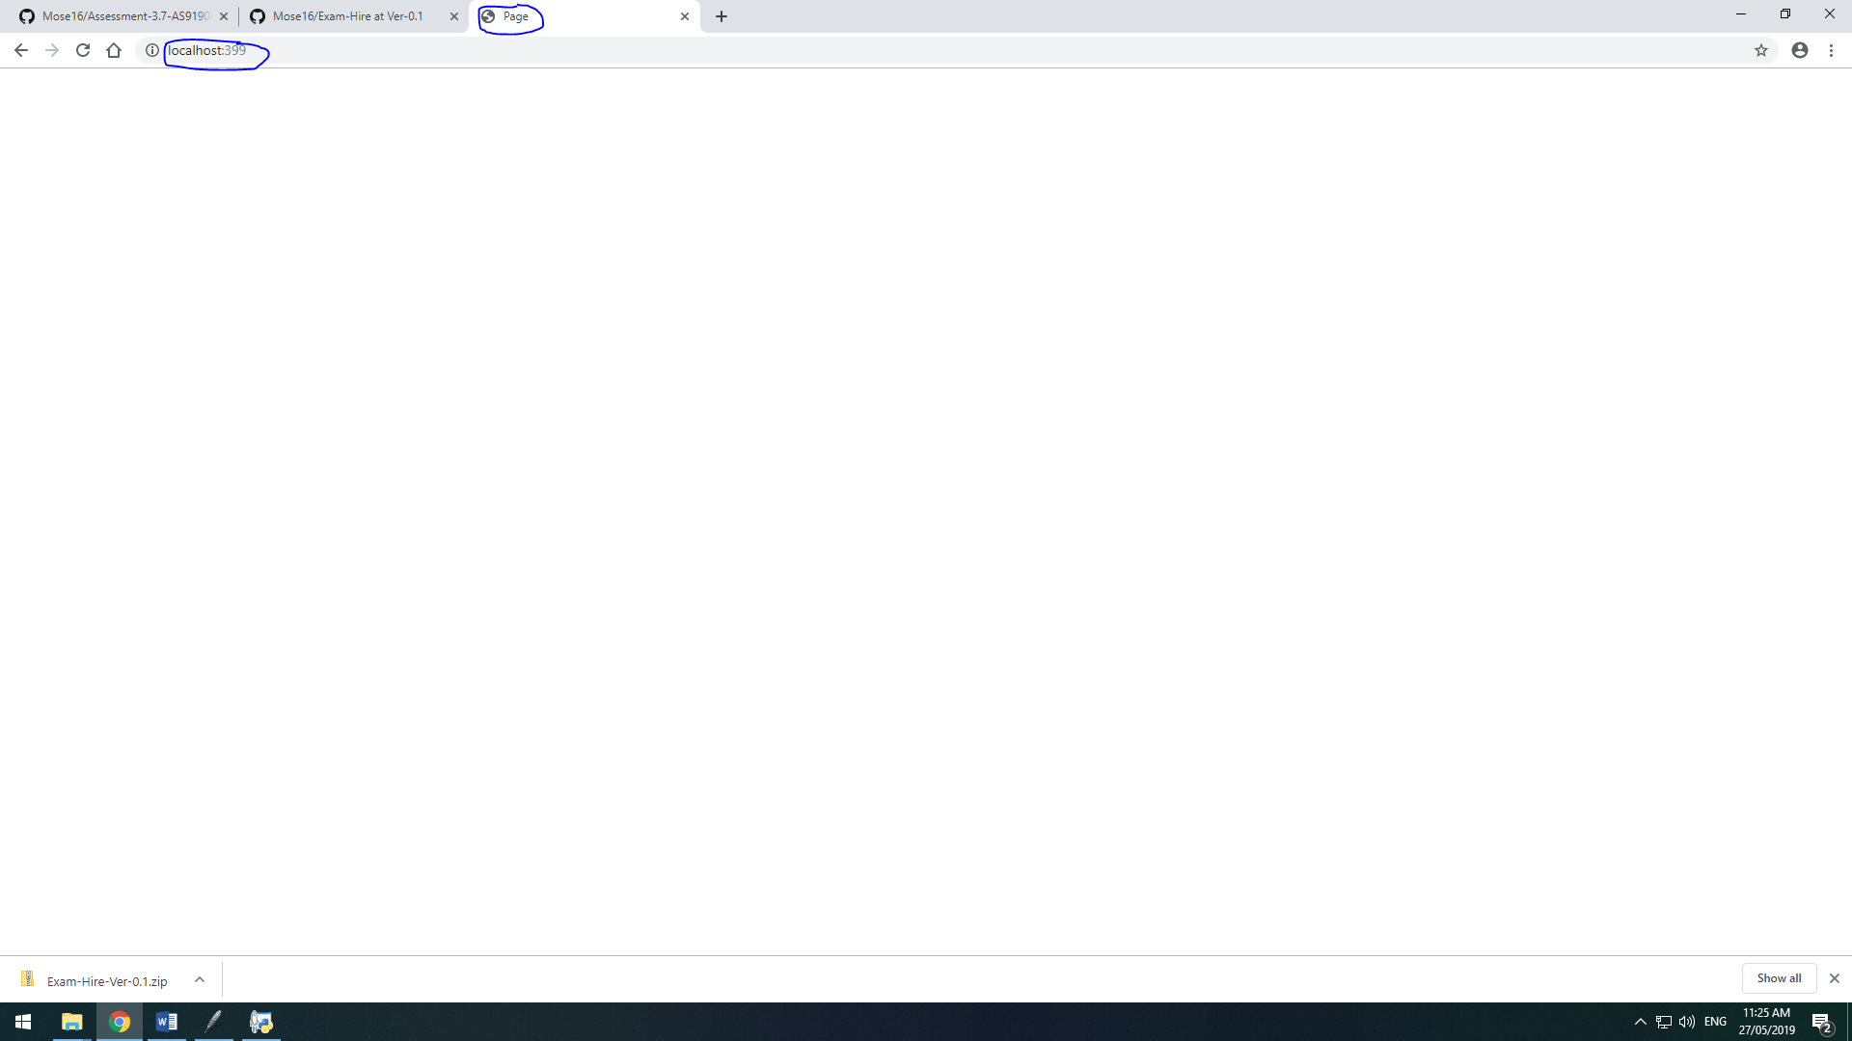

Task 14 : Evaluation

*How did your version turn out*

Perfectly fine, no hick ups.